Paula Williams
Evolutionary Theory and The Environment Unit Plan
Bowling Green City Schools

State Indicators: Seventh Grade Life Science
(Only Primary State Indicators are listed, many other indicators that have been previously taught are incorporated throughout this unit)

1) Investigate the great diversity among organisms

2) Recognize that in sexual reproduction new combinations of traits are produced which may increase or decrease an organism’s chances for survival.

3) Explain how variations in structure, behavior or physiology allow some organisms to enhance their reproductive success and survival in a particular environment.

4) Explain how the diversity of species is developed through gradual processes over many generations. (e.g. fossil record)

5) Investigate how an organism adapted to a particular environment may become extinct if the environment, as shown by the fossil record, changes.

6) Formulate and identify questions to guide scientific investigations that connect to science concepts and can be answered through scientific investigations.

Unit Overview:

After completing the Earth’s Water Unit, Cellular Biology Unit, The Animal Unit, and The Heredity Unit students are now ready to look closely at the concepts of Natural Selection, Adaptations, Sexual Reproduction, and Variations in Nature. Students will begin to understand how various adaptations that are passed on through sexual reproduction can benefit an organism and increase in frequency in an environment. The idea of fitness and selection will become part of the student’s vocabulary. Students will solidify the ideas that changes in an organism are a result of changes in the genes. That these changes are genetic variations and allow organisms to be more successful in nature and often result in speciation. Students will identify the steps necessary for a fossil to form, how they are recovered and analyzed, and the role that fossils play as evidence of evolution. Students will revisit the idea of human impact and recognize how negative human impact can serve as an agent of evolution, and how conservation and restoration may reverse this impact. Students will participate in a service learning project while spending two days at our local nature park. The goal of the two days is three-fold including nature appreciation, more content, and service learning.

Paula Williams
Unit Rationale
Teaching Evolution Through Unifying Science Content and Process.

One of the most important themes and concepts in biology is the theory of evolution by natural selection. Every branch of biology is built around this central theme. Whether the concept be predator –prey relations through mimicry and camouflage, the resistance of bacteria because of overuse of antibiotics, the exploration of the fossil record, the homologies between vertebrates, the development of the eye, or Darwin’s discoveries on the Galapagos islands, all of these themes are directly linked to the concept of evolution through natural selection. Because evolution is the framework for all biological disciplines, the state of Ohio has added Evolutionary theory to the science content standards at grade 7 and continues to build in content, difficulty, and relationship as the students get older. Likewise the NSTA recognizes that evolution has not been emphasized in science curricula in a manner commensurate to its importance because of official policies, intimidation of science teachers, the general public's misunderstanding of evolutionary theory, and a century of controversy.(NSTA, 2003)

Knowing that with evolution, controversy and personal conflict follow, evolution needs to be taught from the ground up. When teachers teach the components of evolution, through sound scientific examples and evidence, students will be able to build a framework of evidence and factual information while building scientific processing skills. Often in the past, evolution was taught later in the science years, and personal and family views interfered with the science evidence and content. I believe that if science teachers K-12 actively engage students in the standards laid out by the state of Ohio from ages 6 through adulthood that we will be developing stronger science minds that will enter the community, the universities, and the work force.

Teaching from the ground up implies that teachers will teach the components of natural selection, fossil formation, fossil evidence, common ancestors, examples of evolution, and the agents that encourage and increase the rate of evolution all before presenting the controversial idea of evolution to students. Teachers can be teaching evolution without ever implanting an inter-conflict for students.

Evolution isn’t just a central theme in biology, it is a method of gathering information, making predictions and inferences, testing data, using and developing new technologies, recognizing shortcomings, and making sense of the information at hand. While teaching evolution from the ground up through small steps in science content and inquiry process, we are helping students develop strong science background and great problem solving skills.

References:

Ohio Department of Education. (2003). Academic content standards for science. Columbus,OH: Author.

National Research Council. (1996). National science education standards. Washington, DC: National Academy Press.

NSTA Position Statement, The teaching of Evolution. (July 2003). Website: http://www.nsta.org/about/positions/evolution.aspx

Rutledge, L., & Mitchell, M.A. (2002, Jan.) High School Biology Teachers’ Knowledge Structure, Acceptance & Teaching of Evolution. The American Biology Teacher, 64(1), 21-28. NSTA recognizes that evolution has not been emphasized in science curricula in a manner commensurate to its importance because of official policies, intimidation of science teachers, the general public's misunderstanding of evolutionary theory, and a century of controversy.

Annotated bibliography
Paula Williams
Seventh Grade Science

Resource: A Guide to Ohio Streams

Sanders,R.E. (Eds,). 2001. A guide to Ohio Streams. Columbus, Ohio: Ohio Chapter of American Fisheries Society.

This Book provides students with great pictures, easily read text, charts, graphs, societal problems, possible solutions, and animal diversity in Ohio. As a seventh grade teachers we use this book two ways, the first is to obtain content knowledge and the second to pre-assess research skills. As the science teacher, the book is a great resource for discovering about the aquatic ecosystems in Ohio, the problems that Ohioans face regarding pollution, possible solutions, conservation and restoration methods, as well as animal diversity in Ohio. We use this book to pre-asses using a glossary, using the index, reading charts and graphs, finding meaning from key words, and other skills needed to find information in non-fiction text. Teaching full inclusion, I have a wide range of reading levels, this book is very visual and the text is easy to read.

In the Evolution and Environment Unit, we revisit the last two chapters of the book as we gain information about humans being agents for evolution, both positively and negatively. Humans impact organisms through pollution, restoration, and conservation. This book discusses the positives of management of our natural areas.

Resource: Biology Text, Asking About Life

Tobin, A.J.,Duskin J.(1998).Asking About Life. Saunders College Publishing: New York.

This textbook is an oldie but goody! This textbook has a copyright date of 1998, but is very visual and has many classic science examples. The book contains an evolutionary timeline that helps teachers understand the major events in evolutionary history. The book is written at a post high school reading level and provides background content to help teachers sharpen their science vocabulary and concepts while planning lessons and before presenting to students.

Resource: PBS Evolution

WBGH Education Foundation, (2001). Darwins Dangerous Idea. Retrieved May 15, 2009, from Evolution library. Website: http://www.pbs.org/wgbh/evolution/library/02/1/l_021_01.html

I often introduce major players in science history. I introduce Darwin as the most controversial scientists and use this video clip to set the tone for the controversy. It sets the time and mood which Darwin lived, and shares his controversy. It takes 8 minutes to view, and discuss. I think it helps kids understand the times which Darwin lived, and how that time set the tone for the controversy. I also use a time line to relate Darwin to Robert Hooke, Leuwenhoek, Mendel, and the cell theory.

Resource: Video Clips
WBGH Education Foundation, (2001). Genetics Tool Kit. Retrieved May 15, 2009, from Evolution library. Website: http://www.pbs.org/wgbh/evolution/library/04/2/l_042_02.html

This video clip is a great example of evidence for evolution. The video clip discusses embryonic development among vertebrates and the many homologies that exist. The video is a quick and easy visual of development. This video can be added to a series of lab stations easily as it only takes about 15 minutes to read the questions that they will need to answer, view twice, and then answer the questions, or used as an explore activity to gather background knowledge regarding development.

Resource: Video Clips
WBGH Education Foundation, (2001). Whale Evolution. Retrieved May 15, 2009, from Evolution library. Website: http://www.pbs.org/wgbh/evolution/library/03/4/l_034_05.html

Just as above, this video clip is used in a lab extension on Fossil formation and what fossils tell us. When discussing evolution, students are not offended by whale evolution. They are amazed by the whales. This web video discusses formation of fossils, what can be gained by studying fossils, and how we can use the fossils to assess the past. It takes 15 minutes if used as a station. It is also great for class discussion when used as an engagement. These video clips help struggling readers grasp the content without overwhelming them with the difficult reading that can appear in text.

Resource: NSTA Position Statement, The Teaching of Evolution.

This website along with other NSTA links form this site will provide the support and advise for 7-12 science teachers that fear or have faced the controversial topic of evolution in the public school classroom. For years teachers have avoided or tip-toed through the topic of evolution, but with the help of this site teachers can gain the knowledge and the confidence to teach one of the major frameworks of biology.

NSTA Position Statement, The Teaching of Evolution. (July 2003). Website: http://www.nsta.org/about/positions/evolution.aspx

Learning Outcome
Paula Williams
* letter in front signifies the level of Blooms’ Taxonomy

Darwin
Objectives:

- E - Students will identify Darwin and learn why his ideas were and still are very controversial.
- K - Students will review the contributions of the scientists we have studied this year.
- S - Students will formulate questions that Darwin might have had as he discovered many new species unlike the animals of his home land.
- K - Students will define and give examples of competition, overproduction, variation, adaptation, and natural selection.
- A - Students will use the idea of fitness and apply it to the emperor penguin and the sea turtle.
- K - Students will define evolution as a mechanism of change in the natural environment.
- A - Students will compare Darwin’s discoveries to other great scientists.

Evidence for Evolution

- C - Students will recognize common homologies among organisms that live in various habitats around the world.
- A - Students will identify how organisms are classified based on common characteristics.
- A - Students will use the levels of classification to determine relationships and common ancestors.
- C - Students will explain how scientists use these homologies to make sense of the origins of living things on earth.
Fossil Record

- C - Students will identify the steps in fossil formation
- A - Students will calculate age of fossils using radioactive dating of rock layers.
- E - Students will evaluate land geology based on fossil evidence.
- C - Students will explain climatic changes based on geologic evidence.
- C - Students will classify fossils based on homologous structures.

Examples of Evolution
Adaptations Evolutionary Success

- C – Students will recognize between camouflage, mimicry, symbiosis, and defense mechanisms.
- C - Students will identify the advantage the mimic has in nature.
- A – Students will compare and contrast Bateson and Mullerian mimicry.
- C - Students will explain symbiotic relationships and describe the dependence of organisms on one another.
- C - Students will explain how adaptations can lead to reproductive success.

- C - Students will recognize adaptations that allow organisms to be successful in one environment, and explain how this adaptation may limit the organism if the environment changes.

Agents of Evolution

- K - Students will define succession and recognize it as a means of restoration.
- C - Students will explain why human involvement is essential to healthy succession in Northwest Ohio.
- C - Students will identify native vs. invasive species, and explain why native flora species attract native fauna species.
- C - Students will identify changes in the environment that happen slowly and changes in the environment that happen rapidly.
- E - Students will justify the need for biodiversity in a healthy ecosystem.
- C - Students will explain examples of competition and overproduction as it relates to succession.
- E - Students will argue the need to manage and protect Wintergarden Park as a part of our city.
- Students will participate in land management as part of a service learning project at Wintergarden park.

Lesson #1 Meet Darwin

Objectives:

Students will identify Darwin and learn why his ideas were and still are very controversial.
Students will review the contributions of the scientists we have studied this year.
Students will formulate questions that Darwin might have had as he discovered many new species unlike the animals of his home land.
Students will define and give examples of competition, overproduction, variation, adaptation, and natural selection.
Students will use the idea of fitness and apply it to the emperor penguin and the sea turtle.
Students will begin to see evolution as a mechanism of change in the natural environment.

Time Frame: 3-4 days
Materials :
Large photos of the scientists listed below.
30 pictures that clearly demonstrate animal variations and adaptations.
Questioning Board for Posting Student Questions. ( I often use a tri-fold board)
Visual of Darwin’s finches
Internet capabilities and projector
Coloring pages of hummingbirds and flowers

Evolution and the Environment Pretest

Engage: Show identified pictures of Jane Goodall, Madem Curie, Robert Hooke, Issac Newton, Anton van Leeuvonhoek, Jean Lamarck and now Charles Darwin. Ask the students to tell why each of these scientists is famous. Tell the kids that each of these scientists have shaped their learning, but state that Darwin the “New Guy” is by far the most controversial in scientific history.
Ask students why he is the most controversial, what do they know about him?
This will allow some misconceptions to surface!

Share Darwin’s Quote, and ask students to explain what he meant by this quote.

Darwin’s Quote: “It is not the strongest of the species that survives, nor the most intelligent that survives. It is the one that is the most adaptable to change.”

Ideally students will say things like evolution, survival of the fittest, natural selection, competition, and predator prey relations. Students might connect tolerant and sensitive species from our Earth’s Waters Unit.

Explore: I spy with my science eye.
*Tell students that Darwin left his homeland of England and set out on a five year voyage to investigate the great diversity among organisms. Explain to students that Darwin was shocked and amazed by the diversity he found. Explain that Darwin returned to England with more questions than he could answer, and that he tested and investigated the evidence he gained for over 20 years.
*Tell them that they are about to feel as Darwin, as they observe the following organisms in nature. Set up I spy with my science eye in the classroom, ask students to look at the picture, locate the organisms, name the organism, and to identify the adaptation that is being expressed. The pictures include camouflage, mimicry, defense, warning colors, reproduction, and competition. After the students identify the adaptation ask them to express the advantage to the organism in a sentence or two.
* Lastly ask the students to pose any questions they have or want answered on the question board at the front of the classroom.

This is a collection of many pictures over the years that express many amazing animal characteristics, adaptations, and behaviors. The kids love to look at the pictures and often ask is this real? I typically number the pictures 1-12 and place one on each classroom desk. I then cover the picture with a plain piece of copy paper so each picture is a surprise and the students only concentrate on their picture. I usually time the activity, just to keep the pace moving!
After the activity I hang all the pictures on the front bulletin board so that we can come back to them during discussion. You would be amazed how often kids visit the bulletin board.

Explain:
* After completing I Spy have kids read pages 136-145 in your textbook, and list the factors that Darwin identified as part of Natural Selection.
(Over production, competition, and variation)
What organism does your textbook use to explain these four factors? Sea Turtle!
(Always give students a purpose for reading or the reading assignment is interpreted as no homework)

* show the students the video clip on the evolution web site about Darwin. http://www.pbs.org/wgbh/evolution/library/02/1/l_021_01.html
What question does Darwin Pose?
What mystery is Darwin trying to solve?

* Create a Power point presentation that provides the information below but is interactive and allows the students to provide the information gained from their reading and our discussion during and after the explore. The power point helps teach note taking and organization of information for these young scientists.
*Who was Darwin? Where did he study? What did he study?
*What did he believe? How did he test his belief?

*Theory of Evolution: Organisms share a common ancestor that has changed over time because of genetic variation and selection.
*Variation is the result of sexual reproduction. Variations are the result of a genetic change. In order for an organism to change it must be a change in the DNA.

*Darwin would say that slight changes in the DNA over time allowed the organism to be more successful in its natural environment, it might have been more successful in obtaining food, escaping predators, blending in with surroundings, obtaining a mate, and or depending territory. As a result this member of a species was able to reproduce and pass on his genes to the next generation.

*Members of a species without this variation may struggle for food, protection from predators, sexual success and therefore may not survive long enough to reproduce.

*Darwin defined this ability to be successful in the natural environment as Natural Selection. He defined the organisms that survive and reproduce as more fit!
*He defined the theory that organisms have adapted from a common ancestor through slight changes in their genetic make-up as evolution.

* Use Darwin’s finches to demonstrate this idea. Show a picture of the finches, the mainland and the G. islands, ask students to make observations about the birds. Ask students to predict why the birds beaks might be different. Record all student ideas on the board. (Don’t tell them because of the food supply)

Introduce the idea that variations over time lead to speciation: Speciation is when organisms are isolated for a long time and evolve different traits. They can be isolated by habitat, water, or a geographic barrier (Mountain Range).

*Define evolution, natural selection, fitness, overproduction, competition, variation, adaptation, and speciation.

Exit Ticket: Darwin’s Finches only give 3-4 minutes!

Extension: Components of Natural Selection
Set up 6 pictures at six different lab stations and have the students look at the following examples from nature and use their scientific mind, vocabulary, knowledge from reading, and our classroom discussion to classify and explain the components of natural selection in each. Many of these pictures are extensions of the Eye Spy game that the kids have already participated in.

Overproduction:
Example #1 Frogs lay thousands of eggs in water. Each mound in the water is a clump of frog eggs, the females lay thousands of eggs into pond each spring. The eggs will absorb waster from the pond and continue to develop.
Example #2 Butterflies lay many unprotected eggs on plants.

Variations: Peppered moth, Use peppered moth pictures from I spy with my science eye game. Ask students to predict which would be more successful in each environment. Ask questions about predators and camouflage.

Mouse Phenotypes, Use picture of female mouse with her litter of babies. Ask students to discuss how the variations of phenotypes might benefit or hinder the success of the offspring.

Competition: Elephant Seals Use elephant seal pictures and a brief description of elephant seal behavior.

Competition: Picture of female Emperor Penguins competing for a mate. Students already know that there are fewer males than females and those females compete to win over the available males at the nesting ground.

* Have students share their answers with their peers and add any questions they may have to the questioning board.

Homework: Extra Credit
Challenge: Encourage students to find a picture in a magazine, on the internet, or an old book that demonstrates an adaptation that leads to selection. This is a great way to increase your library of pictures and examples. Be sure to have students include the resource they found the picture, so that you can go get a better or larger copy.

Evaluate: Variations lead to Selection
Build the best Humming Bird: Use coloring pictures of hummingbirds and flowers, shrink and enlarge the flowers and birds using your copy machine and color the pictures to represent variations that may lead to selection in their habitat. Use beak length, feather color, and wing speed to discuss fitness.
Students will build their bird out of the body sizes, beaks, and then choose the humming birds food supply and color the bird to blend in with the flowers. Lastly the kids will write a paragraph explaining the fitness of their bird.
(Note: this takes a lot of time, have kids complete most coloring in academic assist or at home!

For Homework:
* Grizzly bear and salmon activity from my textbook company. The activity used the salmon population to demonstrate overproduction, variation, adaptation, and selection. This homework assignment takes the average student about 8-10 minutes.

* Exit Ticket Darwn’s Tortoises, and overproduction.

* Lastly I would have the students look closely at the question board. Divide the questions and have students work in groups to answer the questions that they have learned. Have groups share their answers, and then discuss where they might find the answers to the questions that are still unanswered. Are these questions testable, can they be answered with science?

Resources For Labs and Activities:

Sample Extension Station:
Actual picture is larger. All station models are at least 81/2 x 11.

Frogs Lay Eggs in Water

Look at the picture and identify the
component of natural selection that each
is representing. Lastly, write 3-4
sentences explaining this
component of Natural Selection as it relates
to the picture. I have given you space to
organize your information. Remember to
write like a scientist.

Jane Goodall Robert Hooke
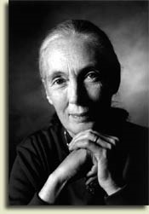
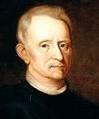

Madam Curie Jean Lamark
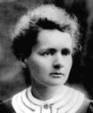
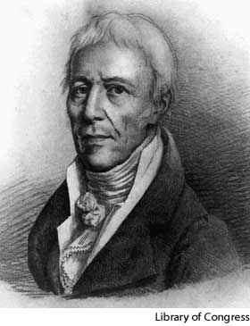
Anton van Leeuvonhoek
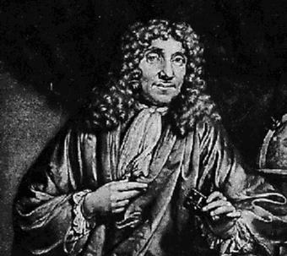
Note that these pictures are in a power point format with pictures names and contributions to science all coming in separetly.

Sir Isaac Newton Albert Einstein
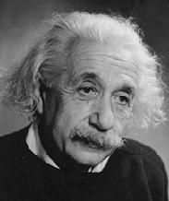
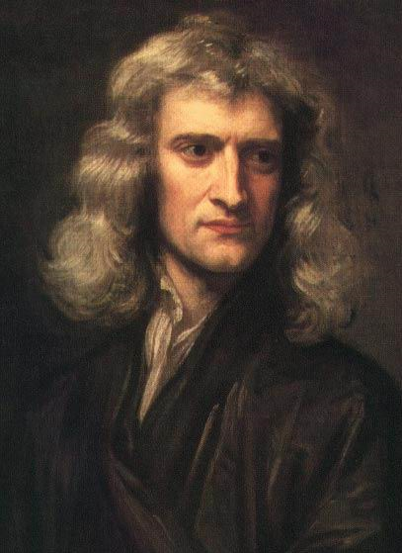

Charles Darwin
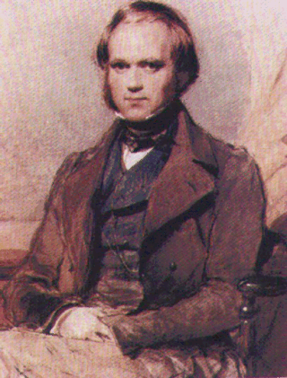

“It is not the strongest of the species that survives, nor the most intelligent that survives. It is the one that is the most adaptable to change.”

These are the hummingbird pictures that I altered by enlarging, shrinking, and cutting. The kids re-drew portions, by tracing and changing the flowers and birds. Some kids drew from scratch, just remind them that you are grading the science first and the art is secondary. This was fun, but time consuming!
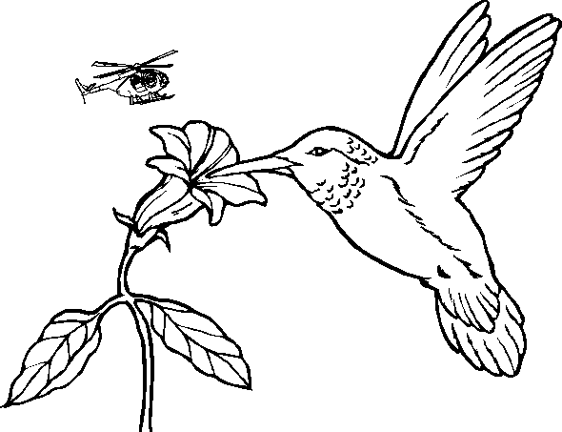

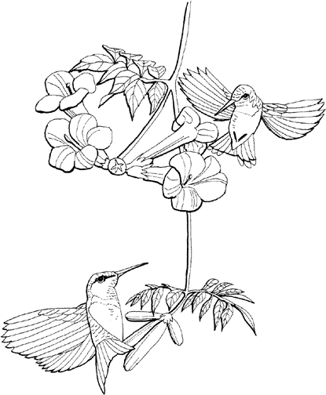

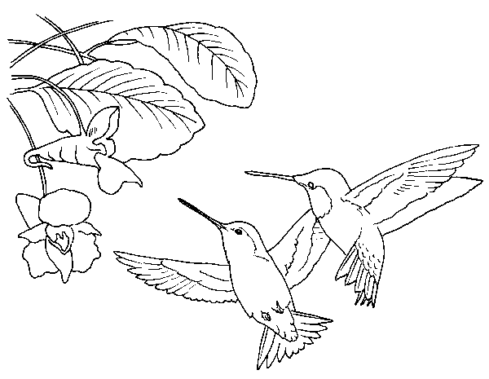

Eye Spy with My Science Eye
Directions: There are 12 pictures of amazing animals under the copy paper on your student desks, you are going to move through the classroom and look at each picture individually. Do not look at your classmates pictures. You will get a chance to see all 12 pictures. While looking at the pictures you will need to do three things for each picture.
- Name or classify the animal.
- Identify the adaptation that is being expressed by the organism.
- Describe the advantage of this adaptation to the organism.
Before Beginning: Star the number of the picture that you start at.
- Name _____________________ Adaptation: ___________________
Advantage of Adaptation: ___________________________________
________________________________________________________
________________________________________________________
2 Name _____________________ Adaptation: ___________________
Advantage of Adaptation: ___________________________________
________________________________________________________
________________________________________________________
3. Name _____________________ Adaptation: __________________
Advantage of Adaptation: ___________________________________
________________________________________________________
________________________________________________________
4. Name _____________________ Adaptation: ___________________
Advantage of Adaptation: ___________________________________
________________________________________________________
________________________________________________________
5. Name _____________________ Adaptation: ___________________
Advantage of Adaptation: ___________________________________
________________________________________________________
________________________________________________________

- Name _____________________ Adaptation: ___________________
Advantage of Adaptation: ___________________________________
________________________________________________________
________________________________________________________
- Name _____________________ Adaptation: ___________________
Advantage of Adaptation: ___________________________________
________________________________________________________
________________________________________________________
8. Name _____________________ Adaptation: ___________________
Advantage of Adaptation: ___________________________________
________________________________________________________
________________________________________________________9. Name _____________________ Adaptation: ___________________
Advantage of Adaptation: ___________________________________
________________________________________________________
________________________________________________________
10. Name _____________________ Adaptation: ___________________
Advantage of Adaptation: ___________________________________
________________________________________________________
________________________________________________________
11. Name _____________________Adaptation:___________________
Advantage of Adaptation: ___________________________________
________________________________________________________
________________________________________________________12. Name _____________________ Adaptation:___________________
Advantage of Adaptation: ___________________________________
________________________________________________________
Name __________________________ Period ___________

Components of Natural Selection
Directions: Look at the 5 pictures at the lab stations 1-5 and identify the component of natural selection that each is representing. Lastly, write
3-4 sentences explaining this component of Natural selection as it relates to the picture. I have given you space to organize your information.

Picture #1 Frog Eggs in Water

Organize your ideas: Write Like a Scientist:

_________________________________ _________________________________ _________________________________ _________________________________
_________________________________
_________________________________
_________________________________

Picture #2 Peppered Moth
Organize your ideas: Write Like a Scientist:

_________________________________ _________________________________ _________________________________ _________________________________
_________________________________
_________________________________
_________________________________

_________________________________ _________________________________
_________________________________
_________________________________
_________________________________

Picture #3 Mouse Phenotypes
Organize your ideas: Write Like a Scientist:

_________________________________ _________________________________ _________________________________ _________________________________
_________________________________
_________________________________
_________________________________

_________________________________ _________________________________
_________________________________
_________________________________
_________________________________

Picture #4 Elephant Seals
Organize your ideas: Write Like a Scientist:

_________________________________ _________________________________ _________________________________ _________________________________
_________________________________
_________________________________
_________________________________

_________________________________ _________________________________
_________________________________
_________________________________
_________________________________

Picture #5 Female Emperor Penguins
Organize your ideas: Write Like a Scientist:

_________________________________ _________________________________ _________________________________ _________________________________
_________________________________
_________________________________
_________________________________

_________________________________ _________________________________
_________________________________
_________________________________
_________________________________

Eye Spy Rubric: 24 total points.
Each pictures is worth 2 points.
First Point: Students have attempted to name the organism in the picture and recognize the adaptation.
Second Point: Students have recognized the adaptation as an advantage and expressed it clearly to the reader.

Exit Ticket Rubric: Extended Response. I tell the students that a scientist not only knows the answer, but can explain why the answer is correct and give an example to support the answer. Exit tickets are an easy way to score student understanding.
Each ticket is worth 4 points.
- Response starts with a topic sentence that defines vocabulary or answers the question.
- Question is answered correctly.
- Explanation of answer is clearly stated.
- Example of answer is provided or supportive detail in given.

Extension Rubric: Components of Natural Selection
Each picture is worth 6 points. 30 points total
2 points: Correct component of Natural Selection is identified.
4 points: Clear concise explanation of the component and its impact on the natural environment is provided by the students.

Lesson #2
What Do We Have In Common? Evidence for Evolution.
Indicator:

1) Investigate the great variety diversity among organisms.

2) Explain how the diversity of species is developed through gradual processes over many generations. (e.g. fossil record)

Objectives:
Students will recognize common homologies among organisms that live in various habitats around the world.
Students will identify how organisms are classified based on common characteristics.
Students will use the levels of classification to determine relationships and common ancestor.
Students will begin to understand how scientists use these homologies to make sense of the origins of living things on earth.
Time: 3-5 days. (This is a longer lesson, the movement from the lab to the classroom back to the computer lab adds an additional day.)
Materials:
Toy (Small replicas of actual organisms)
Chart or pictorial of embryonic development of typical vertebrates.
Skeletons or replicas of skeletons of typical vertebrates.
(Turtle, frog, human, dog, and chimp)
Chart of Homologies among vertebrates. E. Britannica has great color coded chart that is large and easy to read.
Pictures of horse evolution
6 fossils or portions of fossils. I use a snake, a rodent, a vertebrate foot, a trilobite, fish, and a mollusk.
Poster of pictures of marine mammals and coastal marine mammals. Poster must include large color photo and common name of the organism.
Grolier and Britannica Online Encyclopedias or other comparable resource
Computer with Internet access

Engage: Similarities in Embryonic Development.

Show students the first stage of embryonic development among 8 common vertebrates. Ask students to match the embryo to its name. Once the first predictions are made, give the students the second stage of embryonic development. Have them identify how the fish and amphibians differ from the reptiles and mammals. Ask them to change any of their predictions based on the new evidence. Lastly show the students the third stage of embryonic development for the five mammals and the tortoise.
Post a picture of all organisms as adults, why do they look so similar in the beginning of development, yet so different in the end?

Explore: Stations Lab Activity:
Station #1 Using simple toy animals ask students to classify organisms based on a common characteristic.

Ask students to separate the following animals into groups that scientists could not argue. Next ask them to identify the characteristic that they used to classify the animals.

Bottle Nosed Dolphin Giraffe Zebra Gray wolf
Lion Bengal Tiger Orca Beluga Whale
Blue Whale Right-sided Dolphin Gazelle Coyote

Have groups compare and discuss their results. Are the groups the same for all students? Why or Why not? Are your characteristics scientific and observable and testable? Beware seventh graders may put stripes as a classification, they could also separate by size. The groups discussion is essential to clear up the idea of classification by common characteristic.
During discussion lead students to review the levels of taxonomy and what they tell scientists. Pull in embryonic levels of development to help understand vertebrata as a sub-phyum.

Station #2 Homologous Structures in Organisms.
(Understand that during dissection my students have already learned 25 bones of the human body and compared those 25 bones to the grass frog. )

Using the skeleton of the human being, their knowledge of the bones of their body, and the bones of a typical grass frog ask students to identify using the color key and label the femur, humorous, the maxilla, scapula, and the clavicle on the following vertebrate skeletons. Challenge the students to label any other bones that are homologous.

Station #3 Which group do I belong?
Using Grolier ( Grolier is perfect for the inclusion classroom because it has leveled reading, your lower readers can choose a level comfortable for them, and your grade level readers are all set, and if you like you can challenge those that need just that!) read the overview of the two orders Cetacean and Pinnipids and classify the organism on the poster into the correct scientific order
.
Homework: Use the two articles printed from Grolier to justify why a Manatee would not be classified as either.

Station #4 What do fossils tell us? Set out 6 fossils for students to handle and observe. Ask students to list four steps to how fossils are formed. Ask them to predict what each fossil is, and where this animal might have lived.
(My students have already learned about symmetry, position of eyes on head, types of teeth and energy roles. Hopefully they will use this knowledge to make their predictions.)

Read pages 148- 153 Evidence for Evolution:
Purpose for Reading:
Why are dogs are more similar to the gray wolf than to coyotes.
What is meant by a common ancestor?

Explain: Homologous Structures in Vertebrates
What do these homologies tell scientists?
Vertebrate embryonic development: http://www.pbs.org/wgbh/evolution/library/04/2/l_042_02.html
* Show the quick video that expands from the engagement and discuss the similarities among the development of these four organisms. Use the textbook pictures to add to the discussion.
* Evolution of the hoofed animals. Horse pig and zebra evolution
Look at examples and have students point out the homologies and the changes in the organisms over time.
* Fossil Evidence: pass around fossils to the students, ask them what scientist can learn from the fossil, how old the fossil is, and how fossils are formed. Be sure students have a clear idea of these concepts before moving on.

* Whale evolution http://www.pbs.org/wgbh/evolution/library/03/4/l_034_05.html
Show video and read article as a class. Discuss the information about homologies and evidence of the common ancestor. Review the formation of the fossil. Ask students to describe the process of the whale becoming a fossil.

Common ancestors: Define what is meant by the common ancestor, use examples of branching trees to help students understand the idea of common ancestors. As a class use the animals from their reading to create a branching tree.

Read Pages 155 -163 in textbook for homework. Tell the students there are three things they need to learn from their reading:
- How many years ago the first mammal appeared.
- Explain and give examples of how fossils form.
- Tell how fossils are dated.

Extension : Identifying homologies of vertebrates.
Give students printed color copies of the Homologies chart from both their textbook and the E. Britannica Website. Have students answer questions about structure and function of bones. Have them write a paragraph explaining what these homologies tell scientists.

Next have students visit the http://anthro.palomar.edu/evolve/evolve_3.htm and have them read through the introduction and answer the questions in their packet. Ask them to click on the pictures and links to investigate the evidence that scientist have collected over the last 200 years.

* This web site starts out simple and easy to follow but gets more complex. This is a perfect way to challenge the advanced student while still providing essential skills to the slower learner.

Evaluation and Review: When questions are answered and discussion of answers is complete, ask students to watch the Transitional Tetrapod Fossil short video.

Have students formulate three questions they have regarding the information they have read using this website and our previous discussions about Evolution. I will use these questions to build a review lesson before going on to lesson #3 and the formal chapter test. I often refer to this transition lesson as cleaning up the muddy waters. Often I can differentiate at this point, hitting the essential skills (below grade level), Just Right (grade level), and the challenge (above grade level no muddy waters). Differentiation takes time to set-up, but once it is planned and implemented it is ready to go for the next year!

Name __________________
Period ___________
Note that directions change from pre-post test!

Evolutionary Theory and the Environment
Pre/Post Test

Directions: This is a pre-assessment, which is a measure of what you have already learned as a scientist. The purpose of this test is for your teacher to see what you already know, and to design lessons to help you learn the content. Remember to do your best, and to answer each question. To help recognize the difference between a guess and previous knowledge please circle any question that you just guess.
Good Luck!

Part #1 Fact or Fiction: Read each statement carefully and write Fact or Fiction on the line in front of the statement. Remember that facts are true and fiction is not.

- ______________ If an organism stops using a body structure, over time that body structure will disappear.
- ______________ Plants that share habitats often compete.

- ______________ Variations in color patterns may help or hinder an organism’s success in nature.
- ______________ Variations among organisms are the result of harmful mutations.

- ______________ Adaptations are changes in the genetic code of organisms that allow the organism to be more successful than other members of the same species.
- ______________ Plants and animals need O₂, energy, water, living space, and proper temperature in order to be successful in nature.
- ______________ Mammals from different continents have different bone and muscle groups.
- ______________ Sexual reproduction results in variations in offspring.

Part #2 Vocabulary: List an example of each of the following vocabulary words. Be sure your example is informative. The first one is done for you.

Observation: Billy noticed that the red bird blended in with the leaves of the red maple.

Data: __________________________________________________________________

Mutualism: ______________________________________________________________

Variation: _______________________________________________________________

Overproduction: __________________________________________________________

Camouflage: _____________________________________________________________

Mimicry: _______________________________________________________________

Adaptation: ______________________________________________________________

Parasitism: ______________________________________________________________

Part #3 Multiple Choice: Read each question carefully and choose the best answer. Remember to circle the questions that are a true guess, and cross out any choice that you know is not possible.

- Charles Darwin is a famous scientist because of his ideas about________________.

a. genetics b. geology
c. natural selection d. scientific method

- Scientists use the observations they make and the data they collect to make _______________________.

a. inferences b. facts
c. classifications d. laws

- Over the years, new scientific discoveries have been made because of the development of _____________________.

a. colleges b. better scientists
c. technology d. laws

- Which of the following penguin adaptations does not increase the fitness of the species?
a. diving great depths b. layers of modified feathers
c. brood patch d. production of one egg.

- Define fitness from the scientific prospective:

_________________________________________________________________

_________________________________________________________________

- Which of the following scientists was famous for the naming and discovery of cells?
a. Gregor Mendel b. Jane Goodall
c. Robert Hooke d. Anton van Leeuvonhoek

- Which invention allowed cells to be discovered?

a. telescope b. microscope
b. computer d. stethoscope

- When organisms reproduce in nature their _______________ are passed on to their offspring.

a. looks b. cells
c. genes d. blood

- Whales, birds, snakes, and dogs, all have common _____________________.

a. teeth b. body coverings
c. body temperatures d. skeletons

- Geologic evidence can provide scientists with information about

a. common ancestors. b. climatic conditions.
c. age of organisms. d. all of the above.

19. The theory of evolution states that ……

- humans evolved from chimps.
- organisms evolved from a common ancestor.
- organisms change because of environmental changes.
- organisms that are the most complex are the most successful.

Part #4 Short Answer: Each question is worth two points.

20. In the documentary The March of the Penguins, what was meant by Morgan Freeman’s statement, “One tribe stands alone?”

______________________________________________________________

______________________________________________________________

______________________________________________________________

______________________________________________________________

- Explain in 2-3 sentences how fossils are formed.

______________________________________________________________

______________________________________________________________

______________________________________________________________

______________________________________________________________

Part #5 Extended Response: Remember that extended response questions are worth 4 points and should begin with a topic sentence, answer the question, state a fact that supports your answer, and relate to the real world.

- Knowing that monarch butterfly larvae only feed on milkweed plants and that painted lady butterflies commonly feed on flowering thistle, describe what will happen in an ecosystem where these plants are plentiful or absent.

______________________________________________________________

______________________________________________________________
______________________________________________________________

______________________________________________________________

______________________________________________________________

______________________________________________________________

______________________________________________________________

______________________________________________________________

- Choose either the garlic mustard or the wild blue lupine at Wintergarden Park to justify the need for management of our natural ecosystems.

______________________________________________________________

______________________________________________________________
______________________________________________________________

______________________________________________________________

______________________________________________________________

______________________________________________________________

______________________________________________________________

______________________________________________________________

