Fifth Grade Improvisation Unit

Progressive sub-unit: Melody, Form, Harmony

Andrea Coulson

Frank Elementary

Perrysburg Schools

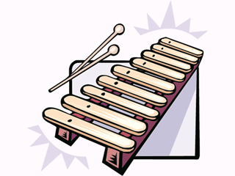

Statement of Purpose

A quality elementary music education program works to serve the needs of the students while developing competent musicians. According to the National and State Standards, students must learn to improvise in the music classroom. Along with learning the fundamentals of reading and writing music, creative improvisation in the elementary general music classroom is integral to developing the skills necessary for further musical study. These skills allow students to expand their interests, attitudes, and appreciation towards music.
Although improvising is included in national and state standards, teachers often have difficulty incorporating improvisation into elementary music lessons. There is a lack of research devoted to techniques for teaching improvisation, and therefore implementation of improvisation in the classroom has become a challenge. Research has shown, however, that allowing students to explore sound and invent melodies is significant to the development of musical skills (Whitcomb, 2007). In addition, improvising addresses skills necessary throughout life as it encourages children to take risks and make decisions. It also allows students to express feelings through the creation of original musical ideas.
Since improvisation is so valuable, it is necessary to incorporate opportunities for improvisation in the general music classroom. At the fifth grade level, students have the ability to create improvisations that are structured and pattern-oriented. By improvising with patterns, students learn fundamentals of melody, rhythm, and harmony. When creating original music, students learn to be instinctive, to listen, analyze, and evaluate. In addition, improvising in small groups helps students develop communication and social skills (Kratus, 1991).
By completing the improvisation lessons of this unit, students will learn elements of music by exploring sounds and creating original music. Using xylophones, metallophones, and glockenspiels, students will also collaborate with classmates to produce improvisations that demonstrate knowledge of melody, form, style, rhythm, and harmony. This unit is designed to either stand alone, or portions may be incorporated separately throughout the year. In addition, lessons may be split over two or more class periods to ensure student success.
The following lessons progress in difficulty and focus on elements of melody, form, and harmony. They include process-oriented and product-oriented improvisation. Using the project-based lesson plan model, students will identify concepts and skills and then create original music using these skills as a guide. The final products differ from student to student, as many answers are acceptable. This model gives the student the freedom to create original music that is meaningful to them, while still adhering to certain parameters. It allows for practice time within the class and significant opportunities to share musical creations with others. The structure of the project-based model allows students to grow and develop musically.

References
Kratus, J. (1991). Growing with improvisation. Music Educators Journal, 78(4), 35-40.
Ohio Department of Education. (2008, June 27). Retrieved June 20, 2009, from http://education.ohio.gov/GD/Templates/Pages/ODE/ODEDetail.aspx?page=3&TopicRelationID=1700&ContentID=1388&Content=51507
The National Association for Music Education. (2008). Retrieved June 20, 2009, from http://www.menc.org/resources/view/national-standards-for-music-education
Whitcomb, R. (2007). Improvisation in elementary general music: a survey study. Kodaly Envoy, 34(1), 5-10.

Curriculum Design Objectives:

- Students will identify components of musical questions and answers. Comprehension
- Students will correctly read musical notation. Comprehension
- Students will identify elements of rhythm to include in patterns (notes and rests). Memory/recall
- Students will improvise a melody using the given rhythm, playing with correct technique and a steady beat. Application
- Students will aurally identify tonic and dominant chords. Comprehension
- Students will improvise a melody using either the tonic or dominant chord. Application

Unit Objectives:

In this unit students will:

Lesson 1:
- Notate a rhythm that corresponds with the poem “I Wish.” Comprehension
- Improvise a melody using the given rhythm, playing with correct technique and a steady beat. Application
Lesson 2:
- Identify components of musical questions and answers. Comprehension
- Improvise question and answer phrases using these components, playing with correct technique and a steady beat. Application
- Improvise question and answer phrases with a partner. Application
Lesson 3:
- Sing the melody of “Hush Little Baby” Memory/recall
- Aurally identify tonic and dominant chords. Comprehension
- Improvise a melody using either the tonic or dominant chord. Application/Synthesis

Performance Pre-Assessment:
Before instruction, students will be given time to freely improvise on a barred instrument with no parameters. Through observation, the instructor will determine the level of improvisation of each student based on the quality of current improvisation. Video documentation may be used if necessary. The following assessment guide will be used for evaluation:

Student Name | Exploration: student tries different sounds loosely structured | Process-Oriented: student produces more cohesive patterns; not organized in mode/meter | Product-Oriented: student uses structural elements such as tonality/rhythm

Reference:
Kratus, J. (1991). Growing with improvisation. Music Educators Journal, 78(4), 35-40.
Fifth Grade Improvisation Unit Written Pre-Assessment
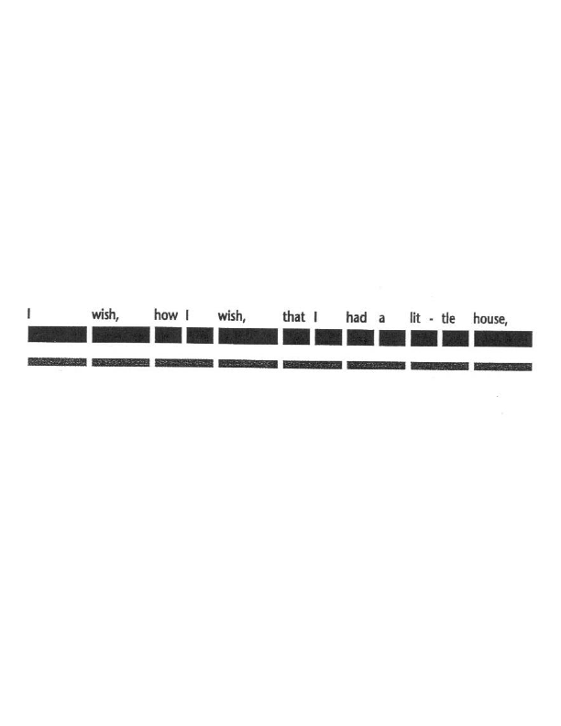
Name________________________________________

- When playing barred instruments, should you alternate mallets or play with the same mallet?

- Using quarter notes and eighth notes, notate the rhythm of this sentence.

- What is a musical question?

- What is a musical answer?

- If C is do, which THREE pitches make a TONIC chord?

- If C is do, which FOUR pitches make a DOMINANT chord?
Fifth Grade Improvisation Unit Written Pre-Assessment
Name________Key________________________________

- When playing barred instruments, should you alternate mallets or play with the same mallet?
When playing barred instruments, you should alternate mallets whenever possible.

- Using quarter notes and eighth notes, notate the rhythm of this sentence. Note: Students will draw notes; they are represented here by “1/4” and “1/8”

¼ ¼ 1/8 1/8 ¼ 1/8 1/8 1/8 1/8 1/8 1/8 ¼

- What is a musical question?
A musical question sounds unfinished and is a determined length.
- What is a musical answer?
A musical answer is the same length as the question, involves portions of the question, and sounds finished.
- If C is do, which THREE pitches make a TONIC chord?
C, E, G
- If C is do, which FOUR pitches make a DOMINANT chord?
G, B, D, F

Lesson 1: Improvising on a given rhythm

Guiding Questions:
- How is rhythm used in poetry? It reflects the natural speech pattern; It is notated using notes and rests
- What does it mean to improvise? Improvisation is a creative interpretation that, while includes parameters, is generally not planned.
Lesson Summary:
After reading the poem, “I Wish”, students will notate the corresponding rhythm. Using Orff instruments, students will improvise a melody. Students will only use pitches of the C pentatonic scale. Students will take turns sharing performing improvisations for the class.

Estimated Duration: 1 hour
Procedures:
Preparation:

Objective 1: Notate rhythm of poem (15 min.)
- Pass out poem “I Wish” and read together.
- Speak each line of the poem in rhythm.
- While speaking, pat the rhythm of the words, alternating hands.
- Without speaking, just pat the rhythm of the words (still alternating hands.)
- Have students determine the rhythm of each line of the poem using quarter notes and eighth notes.
- Notate this pattern on the board.
Practice/Performance:
Objective 2: Play this rhythm on barred instruments. (25 min.)
- Students move to barred instruments set to C pentatonic scale.
- Review technique for using mallets.
- Students choose one bar and play the rhythm of the first line of “I Wish.”
- Students choose two bars and play the same rhythm, improvising any combination of the two bars.
- Gradually increase to include all remaining bars of the instrument. Students choose the number of bars and the order in which they are played.
- Give students individual time to explore and improvise. Assist individually as needed.
- Students take turns playing improvisations individually.
- Repeat this process for each line of the poem.
Extension (20 min.):
- Students play individually, each playing a different line of the poem in sequence.

Assessment: Aural/visual observation using the Performance Rubric for Lesson 1

Materials:
- Poem “I Wish”
- Barred instruments/mallets

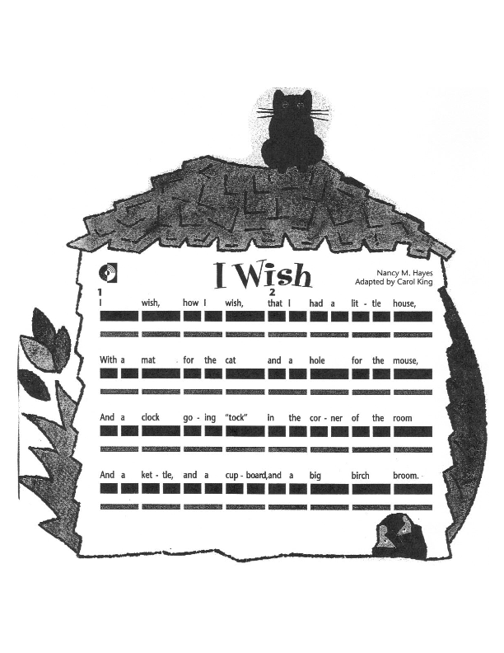

Reference:
Boyer-White, Rene, Campbelle-duGard, Margaret, deFrece, Robert, Goodkin, Doug, Henderson, Betsy M., & Jothen, Michael, et al. (1998). Share the music: grade four. New York: McGraw-Hill.
Name____________________________________

Lesson 1: Improvising on a given rhythm

Rubric
Student accurately plays given rhythm. | 3  Student plays rhythm with complete accuracy. | 2  Student plays rhythm with 1-2 mistakes. | 1  Student plays with 3 or more mistakes.
Student plays with a steady beat. | 3  Student plays with a steady beat. | 2  Student plays part of the rhythm with a steady beat. | 1  Student does not play with a steady beat.
Student plays with correct technique (holds mallets correctly, “bounces” mallets off bars, alternates mallets) | 3  Student plays with correct technique. | 2  Student plays with partially correct technique. | 1  Student plays with incorrect technique.

Lesson 2: Improvising Musical Questions and Answers
Guiding Questions:
- What are musical questions and answers? A musical question sounds unfinished and is a determined length; A musical answer is the same length as the question, involves portions of the question, and sounds finished.
- How can a partner be helpful when improvising in this form? Partners can use the creativity of each other to create new improvisations.
Lesson Summary:
Students will identify similarities and differences between questions and answers. Through discussion, students will identify characteristics of question and answer phrases as it relates to music. They will first improvise a four-beat phrase. As students progress through the lesson, they will alternate with a partner, each playing a question or answer phrase.
Estimated Duration: 1 hour
Procedures:
Preparation:
Objective 1: Identify components of musical questions and answers (10 min.)
- Discuss similarities and differences between questions and answers.
  - Inflection of voice (questions: upward inflection, answers: downward inflection)
  - Often same length
  - Often share common words

- Discuss components of musical questions and answers.
  - Question sounds unfinished; answer sounds finished
  - Phrases are the same length
  - Answers use some elements of the question
Practice/Performance:

Objective 2: Play question and answer phrases (20 min.)
- Using a C pentatonic scale, demonstrate playing a four-beat question phrase. Students identify this phrase needs to end on a pitch other than do.
- Demonstrate playing a four-beat answer phrase. Students identify this phrase needs to end on do.
- Playing at the same time, students play a four-beat question phrase with correct technique, ending on any pitch other than do (C).
- Playing at the same time, students play a four-beat answer phrase with correct technique, ending on do (C).
- Repeat as necessary until students can comfortably play each phrase.
Objective 3: Improvise question and answer phrases with a partner (20 min.)
- Students sit next to a partner. One student is assigned to improvise a question phrase. The other student is assigned to improvise an answer phrase.
- Students assigned question phrases play improvisations at the same time.
- Students assigned answer phrases play improvisations at the same time.
- Partners volunteer to play question and answer improvisations.
Extensions (10 min.):
- Students play eight-beat phrases with a partner.
- Students take turns playing solos, alternating question and answer phrases.
Assessment: Aural/visual observation using the Performance Rubric for Lesson 2
Materials:
- Barred instruments/mallets

Name_________________________________________

Lesson 2: Improvising Musical Questions and Answers
Rubric
Student plays four-beat question/answer phrases ending on correct pitch; answers contain part of question | 3  Student plays phrases correctly | 2  Student plays phrases with 1-3 mistakes | 1  Student plays phrases with 4 or more mistakes
Student plays with a steady beat. | 3  Student plays with a steady beat. | 2  Student plays part of the phrase with a steady beat. | 1  Student does not play with a steady beat.
Student plays with correct technique (holds mallets correctly, “bounces” mallets off bars, alternates mallets) | 3  Student plays with correct technique. | 2  Student plays with partially correct technique. | 1  Student plays with incorrect technique.

Lesson 3: Improvising with Tonic and Dominant Chords
Guiding Questions:
- What is harmony? Harmony includes playing (or singing) different parts at the same time (no dissonance)
- What is the difference between tonic and dominant chords? Tonic chords are built on “do”, while dominant chords are built on “so”
- How can these chords be used to improvise an accompaniment? These chords can be used to add a harmonized background to the melody.
Lesson Summary:
Students will sing “Hush Little Baby” and distinguish between tonic and dominant chords in the key of C major. Students will identify the tonic chord as “home” and the dominant chord as “away.” Students will identify the letter names of the pitches used in each chord. Using the barred instruments, students will improvise a melody using either tonic or dominant chords. Students will use these melodies as an accompaniment for “Hush Little Baby.”
Estimated Duration: 1 hour

Procedures:
Preparation:
Objective 1: Sing the melody of “Hush Little Baby” (5 min.)
- Pass out “Hush Little Baby”
- Play the melody on the piano accompanied by I and V7 chords.
- Students echo-sing the melody
- Students sing the melody while the teacher accompanies using I and V7 chords.
Practice/Performance:
Objective 2: Aurally identify tonic and dominant chords (10 min.)
- Students listen as the teacher plays the melody and accompaniment again.
- Students raise hands each time a chord change is heard.
- Students identify the chords with the home tone (do), the tonic chords. Students will call these chords “home” because they sound finished.
- Students identify the dominant chords as “away” because they do not sound finished.
- Students determine through listening that the order of the accompaniment chords are I, V7, V7, I.
Objective 3: Improvise a melody using either the tonic or dominant chord. (30 min.)
- Students move to an instrument
  - Some instruments contain pitches of the tonic chord (CEG)
  - Some instruments contain pitches of the dominant chord (GBDF)
  - Students identify the letter names of the pitches in each chord.
- Students playing the tonic chords improvise a four-beat melody, using quarter notes, eighth notes or half notes.
- Students playing the dominant chords improvise a four-beat melody, using quarter notes, eighth notes or half notes.
- As a class, improvise four-beat melodies in the order I, V7, V7, I.
- Students work in pairs to improvise a four-beat accompaniment; one person plays tonic chord; the other plays the dominant chord.
Extension (15 min.):
- Students play improvisations as accompaniment for “Hush Little Baby” (teacher sings melody.)
Assessment: Aural/visual observation using Performance Rubric for Lesson 3
Materials:
- “Hush Little Baby” handout
- Barred instruments/mallets
- Piano (or other keyboard)

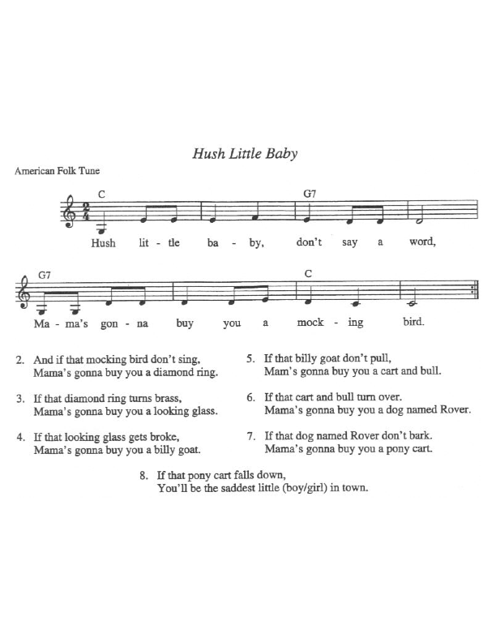

Reference:
Wiggins, J. (2001). Teaching for musical understanding. New York: McGraw Hill.

Name_________________________________________

Lesson 3: Improvising with Tonic and Dominant Chords
Rubric
Student plays tonic/dominant chords at appropriate time | 3  Student correctly plays tonic/dominant chords at appropriate time | 2  Student plays tonic/dominant chords with 1-3 mistakes | 1  Student plays tonic/dominant chords with 4 or more mistakes
Student plays with a steady beat. | 3  Student plays with a steady beat. | 2  Student plays part of the phrase with a steady beat. | 1  Student does not play with a steady beat.
Student plays with correct technique (holds mallets correctly, “bounces” mallets off bars, alternates mallets) | 3  Student plays with correct technique. | 2  Student plays with partially correct technique. | 1  Student plays with incorrect technique.

Performance Post-Assessment:
After instruction, students will be given time to freely improvise on a barred instrument with the given parameters of each lesson in this unit. Through observation, the instructor will determine the level of improvisation of each student based on the quality of current improvisation. Video documentation will be used for the students’ future reference. The following assessment guide will be used for evaluation. In addition, after viewing the video, students will complete a self-evaluation to reflect on the improvisational skills learned in this unit. A class discussion of these questions and answers will also provide feedback to both the instructor and students.
Student Name | Exploration: student tries different sounds loosely structured | Process-Oriented: student produces more cohesive patterns; not organized in mode/meter | Product-Oriented: student uses structural elements such as tonality/rhythm

Reference:
Kratus, J. (1991). Growing with improvisation. Music Educators Journal, 78(4), 35-40.
Student Self-Evaluation:
Name___________________________________________________________________

Answer the following questions after viewing your improvisation performances.

1. What is improvisation?
________________________________________________________________________________________________________________________________________________
2. What is easy about improvising? ________________________________________________________________________________________________________________________________________________
3. What is challenging about improvising?
________________________________________________________________________________________________________________________________________________
4. How do you decide what to play when you improvise?
________________________________________________________________________________________________________________________________________________
________________________________________________________________________
Fifth Grade Improvisation Unit Written Post-Assessment
Name________________________________________

- When playing barred instruments, should you alternate mallets or play with the same mallet?

- Using quarter notes and eighth notes, notate the rhythm of this sentence.

- What is a musical question?

- What is a musical answer?

- If C is do, which THREE pitches make a TONIC chord?

- If C is do, which FOUR pitches make a DOMINANT chord?
Fifth Grade Improvisation Unit Written Post-Assessment
Name________Key________________________________

- When playing barred instruments, should you alternate mallets or play with the same mallet?
When playing barred instruments, you should alternate mallets whenever possible.

- Using quarter notes and eighth notes, notate the rhythm of this sentence. Note: Students will draw notes; they are represented here by “1/4” and “1/8”

¼ ¼ 1/8 1/8 ¼ 1/8 1/8 1/8 1/8 1/8 1/8 ¼

- What is a musical question?
A musical question sounds unfinished and is a determined length.
- What is a musical answer?
A musical answer is the same length as the question, involves portions of the question, and sounds finished.
- If C is do, which THREE pitches make a TONIC chord?
C, E, G
- If C is do, which FOUR pitches make a DOMINANT chord?
G, B, D, F

References
Boyer-White, Rene, Campbelle-duGard, Margaret, deFrece, Robert, Goodkin, Doug, Henderson, Betsy M., & Jothen, Michael, et al. (1998). Share the music: grade four. New York: McGraw-Hill.
Scott, J. K. (2007). Me? teach improvisation to children?. General Music Today, 20(2), 6-13.
Volz, M. D. (2005). Improvisation begins with exploration. Music Educators Journal, 92(1), 50-53.
Wiggins, J. (2001). Teaching for musical understanding. New York: McGraw Hill.

