Instructional Design
Eric Carle Book Study: Language Arts
By: Abby Leimgruber
Rationale
Kindergarten is a critical time for every child. This is the time when we learn our ABC’s, numbers, counting, shapes, rules and how to communicate and get along with others. All of the concepts that are learned throughout school stem from the beginning concepts taught in kindergarten. English Language Art concepts (such as knowing that the alphabet is used to form words) are especially important for children to know. If a child does not have the proper English Language Arts skills he/she will struggle not only in school but when he/she becomes a working member of society. According to Foster and Miller there are four basic stages in literacy, which kindergarten students should be on the path towards the second stage by the start of the year. (2007). If a child is not on this path, they fall behind. “Children who are not on a typical developmental trajectory experience failure and fall behind in their acquisition of general knowledge and vocabulary” (Foster & Miller, 2007). Being able to read and write is a key concept that will be used throughout a child’s whole school career. As a kindergarten teacher, it is our job to help students learn these skills and build and improve them for the future.
Helping teach students the key concepts of English Language Arts is exactly what this subunit of the Eric Carle Book Study: cross-curricular unit does. These lessons help teach students skills they will use throughout their school years and on into the future in a fun and child-centered way. This subunit will help children, through the use of familiar books written by Eric Carle, with their communication skills (by asking and answering questions), improve their writing and sequencing skills and help encourage retelling which are all skills needed in the future. These lessons introduce/help build these skills in ways that are related to the students. Children will read/listen to an Eric Carle book during each lesson and do a related activity. Eric Carle does a great job creating books that are not only educational, but also every individual who reads them can relate to the story somehow. Throughout this subunit students will discover the many number of ways Eric Carle picture books can be used to help tie ordinary activities, like writing and asking questions, into fun, hands-on activities that can be related to everyday experiences.
All of the lessons found in this instructional design were constructed using the basic lesson planning model as noted in chapter 8 of Leigh Chiarelott’s book Curriculum in Context. The basic lesson planning model was used to construct these lessons because it is a simple way of organizing one-day lessons, while still keeping an engaged and active learning environment. Kindergarten students have a very short attention span and the basic lesson planning model (with the time intervals) helps to keep the activities moving at a pace where students will not get distracted or off-task.

.

Works Cited
Foster, W., & Miller, M. (2007, July). Development of the Literacy Achievement Gap: A Longitudinal Study of Kindergarten Through Third Grade. Language, Speech, & Hearing Services in Schools, 38(3), 173-181. Retrieved June 15, 2009, from Academic Search Complete database.
Ohio Department of Education. (2001). Academic content standards k-12 english language arts. Columbus, OH: Author.

Unit Outcomes
Lesson 1 – Learning about Eric Carle
- Students will be able to identify one fact they learned about Eric Carle from the class discussion. (knowledge)
- Students will be able to ask questions about Eric Carle (comprehension)
Lesson 2 - Sequencing
- Students will be able to put events of a story in sequential order. (comprehension, analysis)
Lesson 3 - Retelling
- Students will be able to retell the first 5 pages of the story The Very Clumsy Click Beetle. (knowledge)
Lesson 4 - Writing a description
- Students will be able to write a 1-2 word description (comprehension)
- Students will be able to read their sentence orally (knowledge)
Lesson 5 - Writing, illustrating and reading sentences
- Students will be able to illustrate a picture to represent the sentence. (analysis)
- Students will be able to write a 1-2 words to finish a sentence. (comprehension)
- Students will be able to read their sentence orally (knowledge)

Pre-assessment
Because this is a kindergarten pre-assessment teacher will read assessment to each child individually during centers

Name:_____________________________________________________________
Anticipation Chart on Eric Carle--- Answer the following questions
Yes |  | No
 | - An author is a person who writes books? | 
 | - An illustrator is a person who makes the pictures in books?
 | - Eric Carle is an author and an illustrator?
 | - Eric Carle’s favorite color is red?

- What is retelling (student will give teacher response orally)
- I like to ___________________________________ at home.

6. How do you make a snowman?

______ ______ _______ _______
Pre-assessment
Because this is a kindergarten pre-assessment teacher will read assessment to each child individually during centers

Name:_________KEY____________________________________________________
Anticipation Chart on Eric Carle--- Answer the following questions
Yes |  | No
- An author is a person who writes books?
Yes
- An illustrator is a person who makes the pictures in books?
Yes
- Eric Carle is an author and an illustrator?
Yes
- Eric Carle’s favorite color is red?

No

- What is retelling (student will give teacher response orally)
- I like to __Multiple Answers, Answers may vary____________________ at home.

6. How do you make a snowman?

__2___ __1___ ___4____ ____3__
Lesson Plan- Day 1: Learning about Eric Carle
Pre-assessment: anticipation chart and sequencing chart, Give Friday before the sub unit begins during centers
Concept:
- Learning about Eric Carle, asking questions, listening to peers, comparing Eric Carle’s life with own

Objectives:
- Students will be able to identify one fact they learned about Eric Carle from the class discussion
- Students will be able to ask questions about Eric Carle

Lesson Procedures: (25-30 minutes)
Introductory Activity: (5-7 minutes)
- Call students over to the rug.
- Ask students what they think an author and illustrator are. Discuss how people can be authors and illustrators
- Pull up the picture of Eric Carle (slide 1, Eric Carle Day 1 file) on the smart board
  - Ask students who they think this person is.

Developmental Activity: (15-20 minutes)
- Have a discussion with the children about Eric Carle, using the smartboard slides as a guide. Read the questions to the students that appear on the screen, choose a student to come up and answer (slides 2-7).
  - If answer is incorrect, continue calling students up to choose an answer until the correct answer is revealed.
  - Close smart board file (DO NOT SAVE)
- Discuss how Eric Carle’s’ life might be similar to students
- Instruct students to get out crayons, Pass out What I learned about Eric Carle worksheet, read instructions to students (explain to students the meaning of fact)
- Walk around while children are drawing and have them explain their picture to you.
- If they do not finish their picture after 5-7 minutes, let them know they can finish it during centers time.

Concluding Activity: (5 minutes)
- Collect worksheets, have student put away crayons and get ready for a prediction activity as a small group (tables)
  - Open prediction activity on computer (prediction activity file), click on slide 1. Read day 1 clues to students
    - I am long
    - I have hair on my back
- Allow students a minute to talk with one another to decide which book the table is going to choose (cooperative effort)
- Pull up slide 2
  - Call one student from each table up to move the book chosen by the table into the chart.
  - SAVE smart board file before closing
- Review some of the facts that students learned today about Eric Carle.

Assessment:
- Students will be assessed through their illustration. Were students able to illustrate a picture that included one or more facts discussed throughout the lesson? Students will also be assessed through one-on-one explanation. While students are creating their pictures, is the student able to tell the one (or more) fact(s) learned/illustrated on their paper?

Materials/Resources:
- Smart Board
- Computer/jump drive (Eric Carle day 1 and Prediction Activity file)
- Books by Eric Carle (The Very Hungry Caterpillar, The Little Cloud, The Very Clumsy Click Beetle, The Very Busy Spider, The Very Quiet Cricket, The Very Lonely Firefly)
- Eric Carle facts from www.eric-carle.com
- Crayons ( a set for each person)
- What I learned about Eric Carle worksheet

Lesson 1 Smart Board Slides
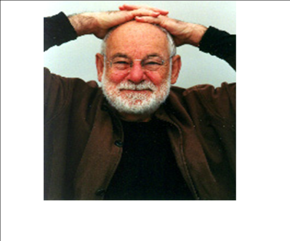

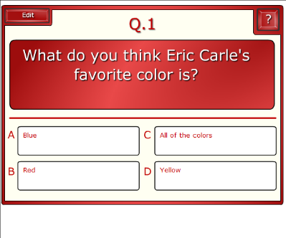

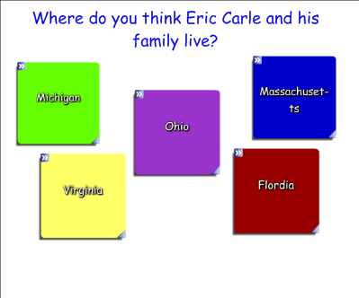

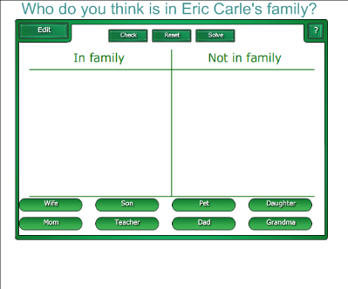

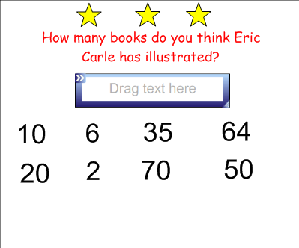

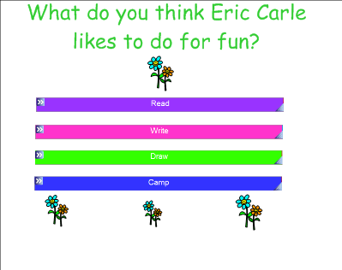

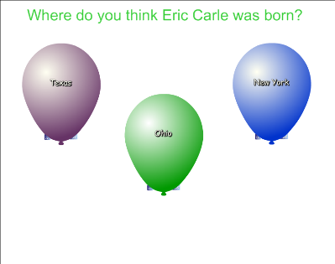

Prediction Activity
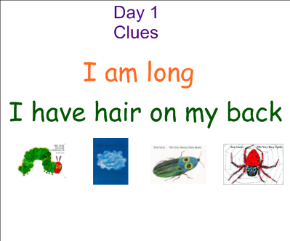

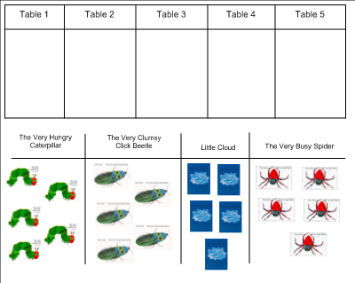
What I learned about Eric Carle

Name: ____________________________________________________
Directions: Using your crayons draw one thing (fact) that you learned about Eric Carle

Lesson Plan- Day 2: Sequencing
Content: Sequencing, sequencing helps with retelling

Objectives:
- Students will be able to put events of a story in sequential order

Procedures: (25-30 minutes)
Introductory Activity: (5 minutes)
- Call students over to the carpet area
- Talk about the prediction slide from the previous day, review the clues then show the results (have day 1 slide (slide 1 and 2) from Prediction Activity File opened on smartboard)
- Show the front cover of The Very Hungry Caterpillar, have students predict what will happen in the story

Developmental Activity: (15-20 minutes)
- Read the story, The Very Hungry Caterpillar and ask questions along the way
  - Why do you think the caterpillar is hungry? (pg. 3)
  - What do you think he is hungry for? (pg. 3)
  - What do you think happens next? (pg.20)
- Open Eric Carle Day 2 file, slide 1
  - Explain the term sequencing (putting things in order)
  - Discuss the importance of "beginning" and "end" in sequencing
- Introduce class caterpillar (slide 2)
  - Call students up one at a time to sequence the food correctly from the story. Students can look back at the story for help if need be. Each student will move a piece of food into a part of the caterpillar's body.
Concluding Activity: (5 minutes)
- Recap lesson, review importance of beginnings and ends in sequencing, review sequencing the book "The Very Hungry Caterpillar"
- Have children return to their seats to complete mini prediction activity
  - Open prediction activity on computer, click on slide 3. Read day 2 clues to students
    - There is an animal on the cover
    - The animal has two big eyes
- Allow students a minute to talk with one another to decide which book the table is going to choose (cooperative effort)
- Pull up slide 4
  - Call one student from each table up to move the book chosen by the table into the chart. (different student from yesterday)
- SAVE smartboard file before closing

Assessment:
- Students will be assessed mainly through observation. Did the children participate in the group sequencing activity? Did they put the foods in the correct order? Did they listen attentively to the story? Complete the checklist during the activity or quickly after the activity when the students are returning to their seats to start the mini prediction activity.
Resources:
- The Very Hungry Caterpillar by: Eric Carle
- The Very Hungry Caterpillar: Literature Ideas: www.prekfun.com/Theme_Pages/G_L/Literature_Themes?VeryHungryCaterpillar
- Smartboard
- Computer/jump drive (Eric Carle Day 2 and Prediction Activity File)
- Assessment Checklist

Lesson 2 Smart Board Slides
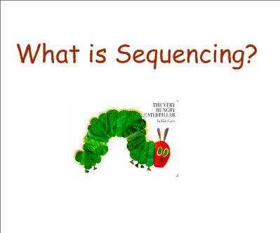

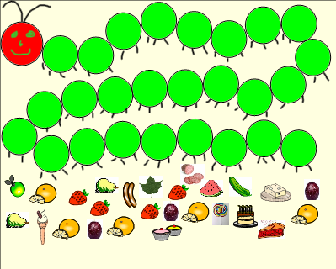

Prediction Activity

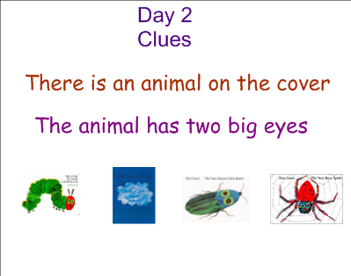
Checklist Date: ______________

√ + = Student was on target, following all directions
√ = Student was somewhat on target, following most directions
√ - = Student was not on target, not following directions

Student | Did the student participate in the group sequencing activity? | Was the student able to choose the correct food in the correct order? | Was the student listening to the story being read?

Lesson Plan- Day 3: Retelling
Content: Retelling a story, why is it important, summarizing

Objectives:
- Students will be able to retell the first 5 pages of the story The Very Clumsy Click Beetle by: Eric Carle

Procedures: (25-30 minutes)
Introductory Activity: (5 minutes)
- Call students over to the carpet area
- Talk about the prediction slide from the previous day, review the clues then show the results (have day 2 slide (slide 3 and 4) from Prediction Activity File opened on smart board)
- Hold up the book The Very Clumsy Click Beetle. Allow children to provide their prediction of what the story is about

Developmental Activity: (15 -20 minutes)
  - Start tape player of The Very Clumsy Click Beetle. The tape will tell you when to turn the pages
- Discuss the story and the term retelling
  - Allow students to return to their tables, getting out crayons as they return
- Pull up Eric Carle day 3 file
- Pass out the "Very Clumsy Click Beetle" worksheet
  - Have students complete worksheet, modeling how and where to start on the smartboard (if students are having a hard time, direct students as a whole class to each individual box)
  - Once students are finished with their pictures call on five children to share
  - Instruct students to put away materials, collect worksheets.

Concluding Activity: (5 minutes)
- Review retelling: What is retelling, Why is it important?
- Complete mini prediction activity
  - Open prediction activity on computer, click on slide 5. Read day 3 clue to students
    - There is not an animal on the cover
- Allow students a minute to talk with one another to decide which book the table is going to choose (cooperative effort)
- Pull up slide 6
  - Call one student from each table up to move the book chosen by the table into the chart. (different student from yesterday)
SAVE smart board file before closing

Assessment:
- Students will be assessed through their completed drawings. Were the students able to retell the story using their pictures. The pictures will be graded with the star system used in the classroom. If the student completed the paper, they receive a star but if there are errors, discuss them with the student during centers time. They will also be assessed through a checklist.

Materials/Resources:
- The Very Clumsy Click Beetle by: Eric Carle
- Tape Player
- Book on Tape
- The Very Clumsy Click Beetle worksheet
- Crayons
- Smart board
- Computer/jump drive (Eric Carle day 3, prediction activity file)

Lesson 3 Smart Board Slide
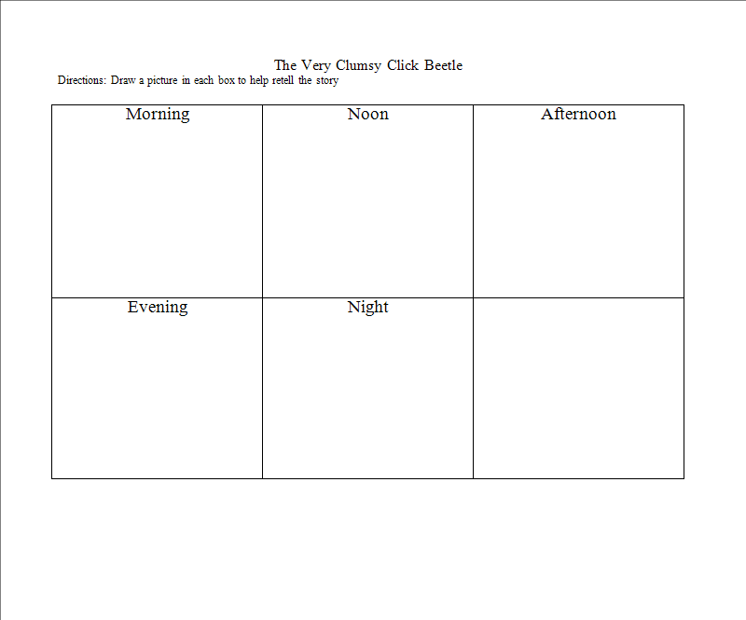

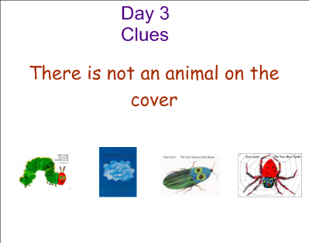
Prediction Activity

Checklist Date: ______________

√ + = Student was on target, following all directions
√ = Student was somewhat on target, following most directions
√ - = Student was not on target, not following directions

Student | Was the student listening to the story being read? | Comments | Paper grade

The Very Clumsy Click Beetle
Directions: Draw a picture in each box to help retell the story

Morning | Noon | Afternoon
Evening | Night

Lesson Plan- Day 4: Writing a description

Content: Writing using inventive spelling and descriptive words

Objectives:
- Students will be able to write a 1-2 word description
- Students will be able to read their sentence orally

Procedures: (25-30 minutes)
Introductory Activity: (5 minutes)
- Call students over the to the circle area
- Talk about the prediction slide from the previous day, review the clues then show the results (have day 3 slide (slide 5 and 6) from Prediction Activity File opened on smart board)
- Hold up the book The Little Cloud, Allow children to provide their prediction of what the story is about

Developmental Activity: (15-20 minutes)
- Read the story The Little Cloud by Eric Carle
- After the story ask a couple of questions (focusing on what the clouds in the book looked like)
  - Have you every looked at a cloud and it looked like something else?
  - What did you see?
- Explain to students the cloud project, (students will create a cloud out of paper and write one word to describe it), have students return to their seats.
- Pull up Eric Carle Day 4 file. Demonstrate to students how to fill in the sentence strip after they have completed their cloud. (remind students to use inventive spelling) (right-left modeling)
- Call on two students to pass out a piece of blue and white construction paper sentence strip, a pair of scissors and a bottle of glue to each student.
- Instruct students to cut out a cloud from the piece of white construction paper, glue it on the blue paper. Walk around and help students who are struggling
- When children are finished with the cloud, instruct to glue sentence strip on bottom of blue paper. Read sentence to them. Instruct students to finish the sentence (invented spelling is permitted)
  - Walk around observing the children writing. If a child’s word/words are unreadable scribe underneath the child’s writing.
- When children are completed, ask a couple of children to share their pictures with the rest of the class.

Concluding Activity: (5 minutes)
- Review lesson
  - Ask students to tell one thing they learned today
- Have each student vote on the favorite book they heard in class for the week.
  - Pull up favorite book file (slide 1)
  - Call students one at a time to come up and vote.
  - SAVE BEFORE CLOSING

Assessment:
- Students will be assessed through their completed description. Was the child able to write a word that described what the cloud looked like? The pictures will be graded with the star system used in the classroom. If the student completed the paper, they receive a star but if there are errors, discuss them with the student during centers time. Students will also be assessed on a checklist.

Resources:
- The Little Cloud by: Eric Carle
- White Construction Paper- one piece for each student
- Blue Construction Paper- one piece for each student
- Pencils (Enough for all students)
- Sentence “This cloud looks like __________”. printed off for each student
- Scissors- one pair for each student
- Computer/jump drive (Eric Carle Day 4 and Favorite book file)
- Smartboard

Lesson 4 Smart Board Slide



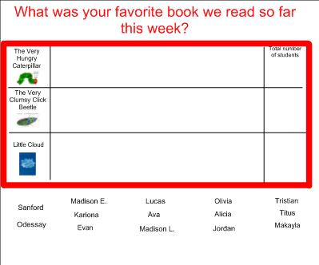

Checklist Date: ______________

√ + = Student was on target, following all directions
√ = Student was somewhat on target, following most directions
√ - = Student was not on target, not following directions

Student | Was the student listening to the story being read? | Did the student write from left to right? | Re-read on writing?
Day 5 – Writing, illustrating and reading sentences
Post-assessment: anticipation chart and sequencing chart, Give during centers today
Content: Writing using inventive spelling and descriptive words

Objectives:
- Students will be able to write a 1-2 words to finish a sentence
- Students will be able to illustrate a picture that represents the sentence
- Students will be able to read their sentence orally

Procedures: (25-30 minutes)
Introductory Activity: (5 minutes)
- Gather students to the carpet area
- Pull up Favorite Book file on smartboard
  - Discuss Favorite Book chart with students.
- Discuss what could be done with favorite books (re-read, draw pictures of them, make a book like it)

Developmental Activity: (15-20 minutes)
- Explain that students will be making a class book based on the book that had the most votes on the chart, explain what a class book is if students do not know.
- How can we make a class book that is like ______(book that won)________
  - Allow children to make suggestions
- Have children get crayons from the shelf and return to their tables
- While students are returning to their seats pass out the white paper and the sentence strips
- Once students are seated, model how to glue sentence strip to paper, have students follow your direction to glue theirs on
- Pull up Eric Carle day 5 file (slide 1, 2 or 3 depending on book that won). Model to students how to fill in the sentence
  - Have the children fill in a word at the end to complete the sentence
  - Invented spelling is permitted
- Model drawing a picture that represents what students wrote
- Walk around the room observing the children as they are working
  - Take notes if necessary
- Once students are finished with their pictures, have them return to the carpet
- Once everyone is seated have each student share and read their page of the class book
  - Allow each child to share their picture and read their sentence.

Concluding Activity: (5 minutes)
- Wrap up the lesson and unit
  - I would like you to think back to yesterday, what book did we read? (The Little Cloud)
    - Who is the author and illustrator of The Little Cloud? (Eric Carle)
  - Can anyone tell me who are the authors and illustrators of our class book? (us)
- After sharing collect pictures and bind into a book
Assessment:
- Students will be assessed through their completed page of the class book. Was the child able to write a word that completed the sentence and illustrate a picture that goes with the sentence? They will also be assessed through a checklist.
Resources:
- White paper (one piece for each student)
- Sentence strip (one for each student)
- Pencils (Enough for all students)
- A set of crayons (one for each student)
- Glue (one bottle for each student)
- Large paper with voting results
- Plastic binding to bind book (the spiral plastic binding)
- Computer/Jump Drive (favorite book file)
- Smartboard

Lesson 5 Smart Board Slides

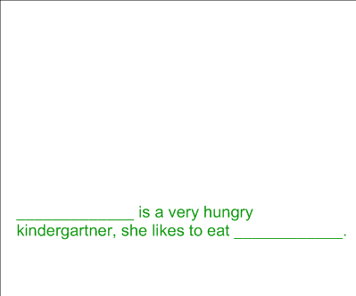

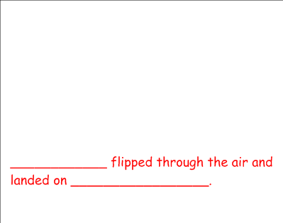

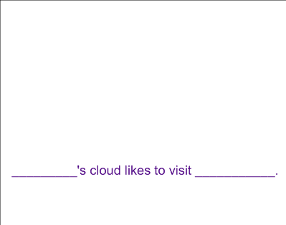
Checklist Date: ______________

√ + = Student was on target, following all directions
√ = Student was somewhat on target, following most directions
√ - = Student was not on target, not following directions

Student | Did the student complete his/her sentence? | Did the student write from left to right? | Did the student follow directions?

Post Assessment
Because this is a kindergarten pre-assessment teacher will read assessment to each child individually during centers
Name:_____________________________________________________________
Anticipation Chart on Eric Carle--- Answer the following questions
Yes |  | No
 | - An author is a person who writes books and an illustrator makes the pictures in books?
 | - Eric Carle was born in Ohio?
 | - Eric Carle is an author and an illustrator?
 | - Eric Carle’s favorite color is red?

- What is retelling (student will give teacher response orally)
- I like to ___________________________________ at home.
- How do you make a snowman?

_______ _______ ________ ______
Post Assessment
Because this is a kindergarten pre-assessment teacher will read assessment to each child individually during centers
Name:______Key_______________________________________________________
Anticipation Chart on Eric Carle--- Answer the following questions
Yes |  | No
- An author is a person who writes books and an illustrator makes the pictures in books?
Yes
- Eric Carle was born in Ohio?
No
- Eric Carle is an author and an illustrator?
Yes
- Eric Carle’s favorite color is red?

No

- What is retelling (student will give teacher response orally)
- I like to ____Answers may vary______________________ at home.
- How do you make a snowman?

___2____ ___1____ ___4_____ ___3___

