**Attachment A**

**Relationships for Congruency and Similarity**

**Name _______________________________ Date ________________________**

**Directions:** Write what you know about congruent and similar figures in the appropriate column. In the box, write questions that you have about the relationship between congruency and similarity.

|  |  |
| --- | --- |
| **What I know about congruency…** | **What I know about similarity…** |
| *Questions I have about the relationship between congruency and similarity…* |  |

**Attachment B**

**Congruent Figures**

2.

. 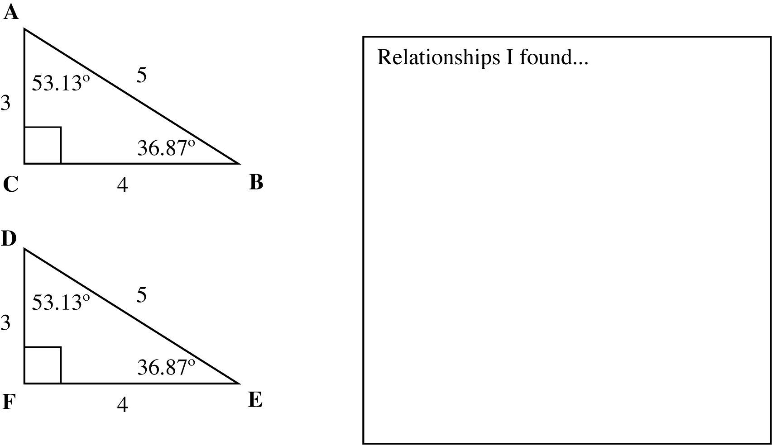

7.

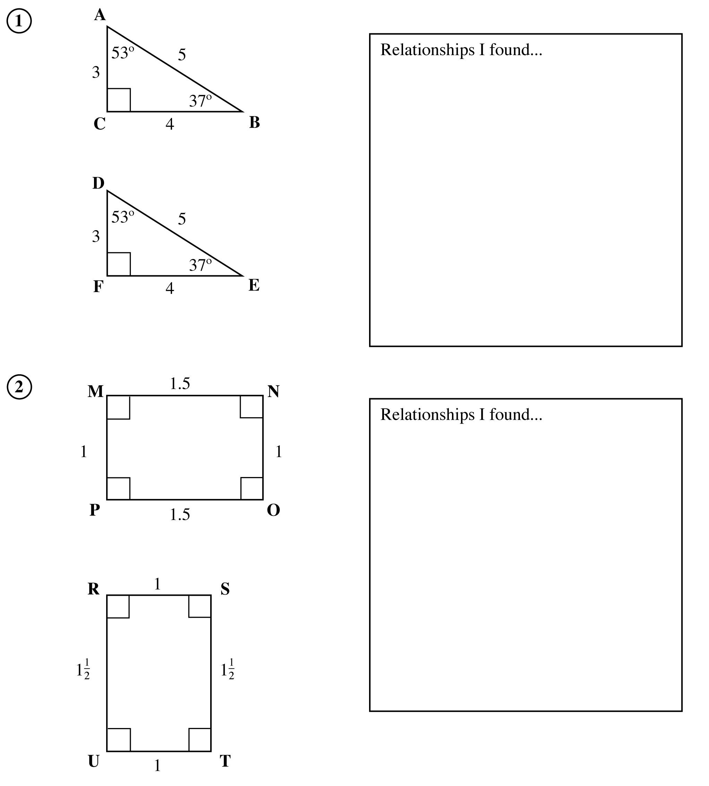

**Attachment B (continued)**

**Congruent Figures**

9.

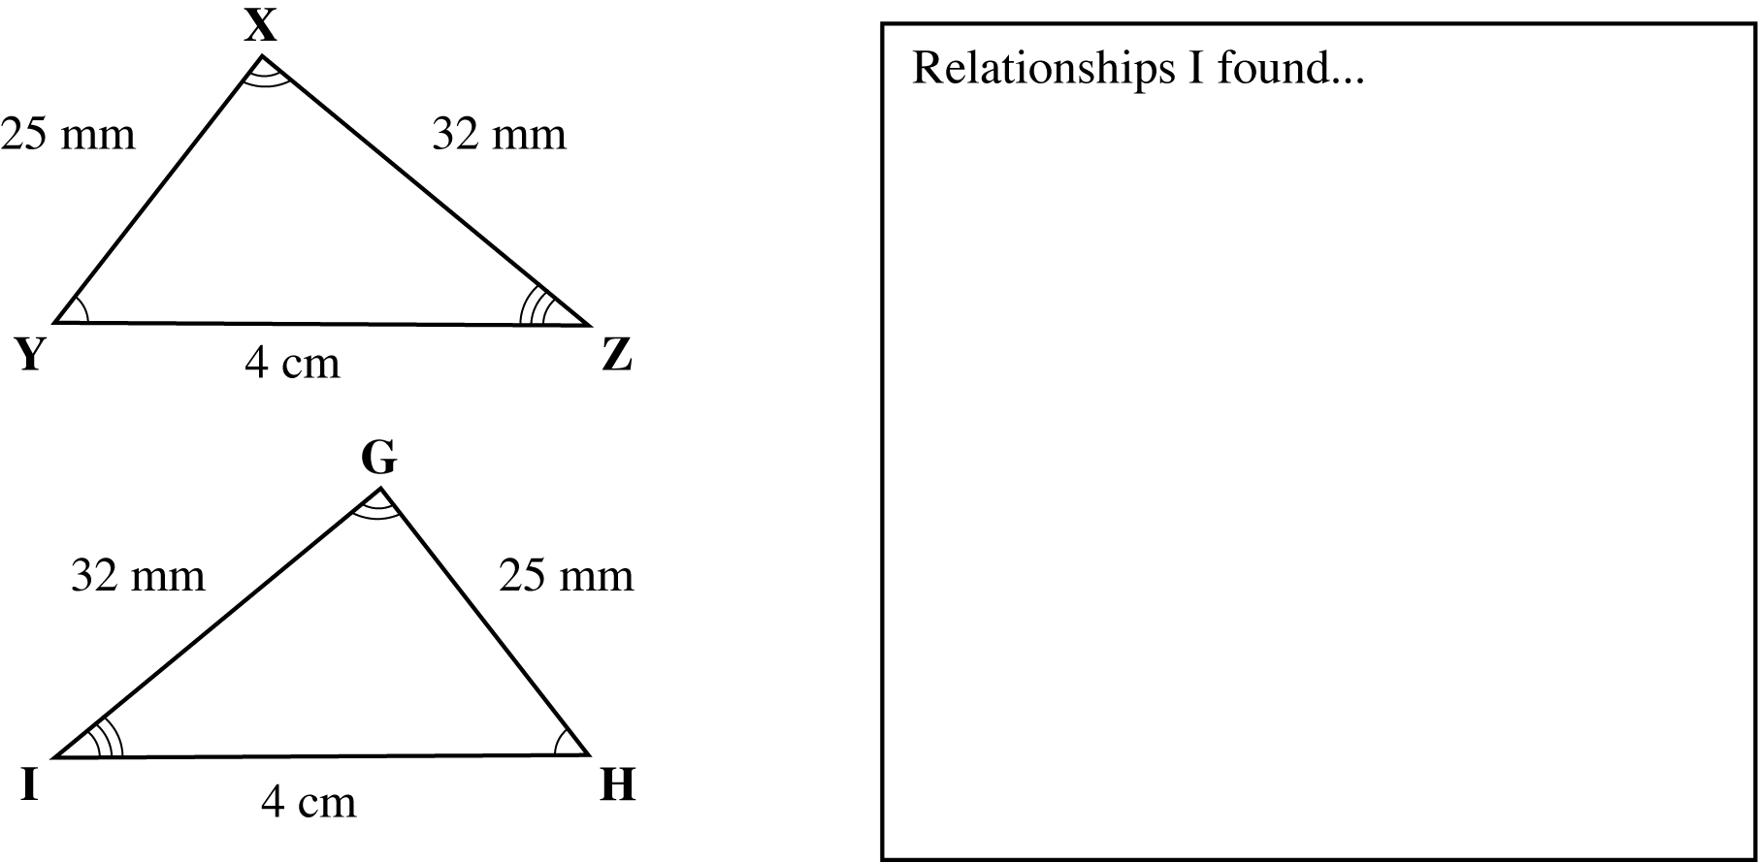

11.

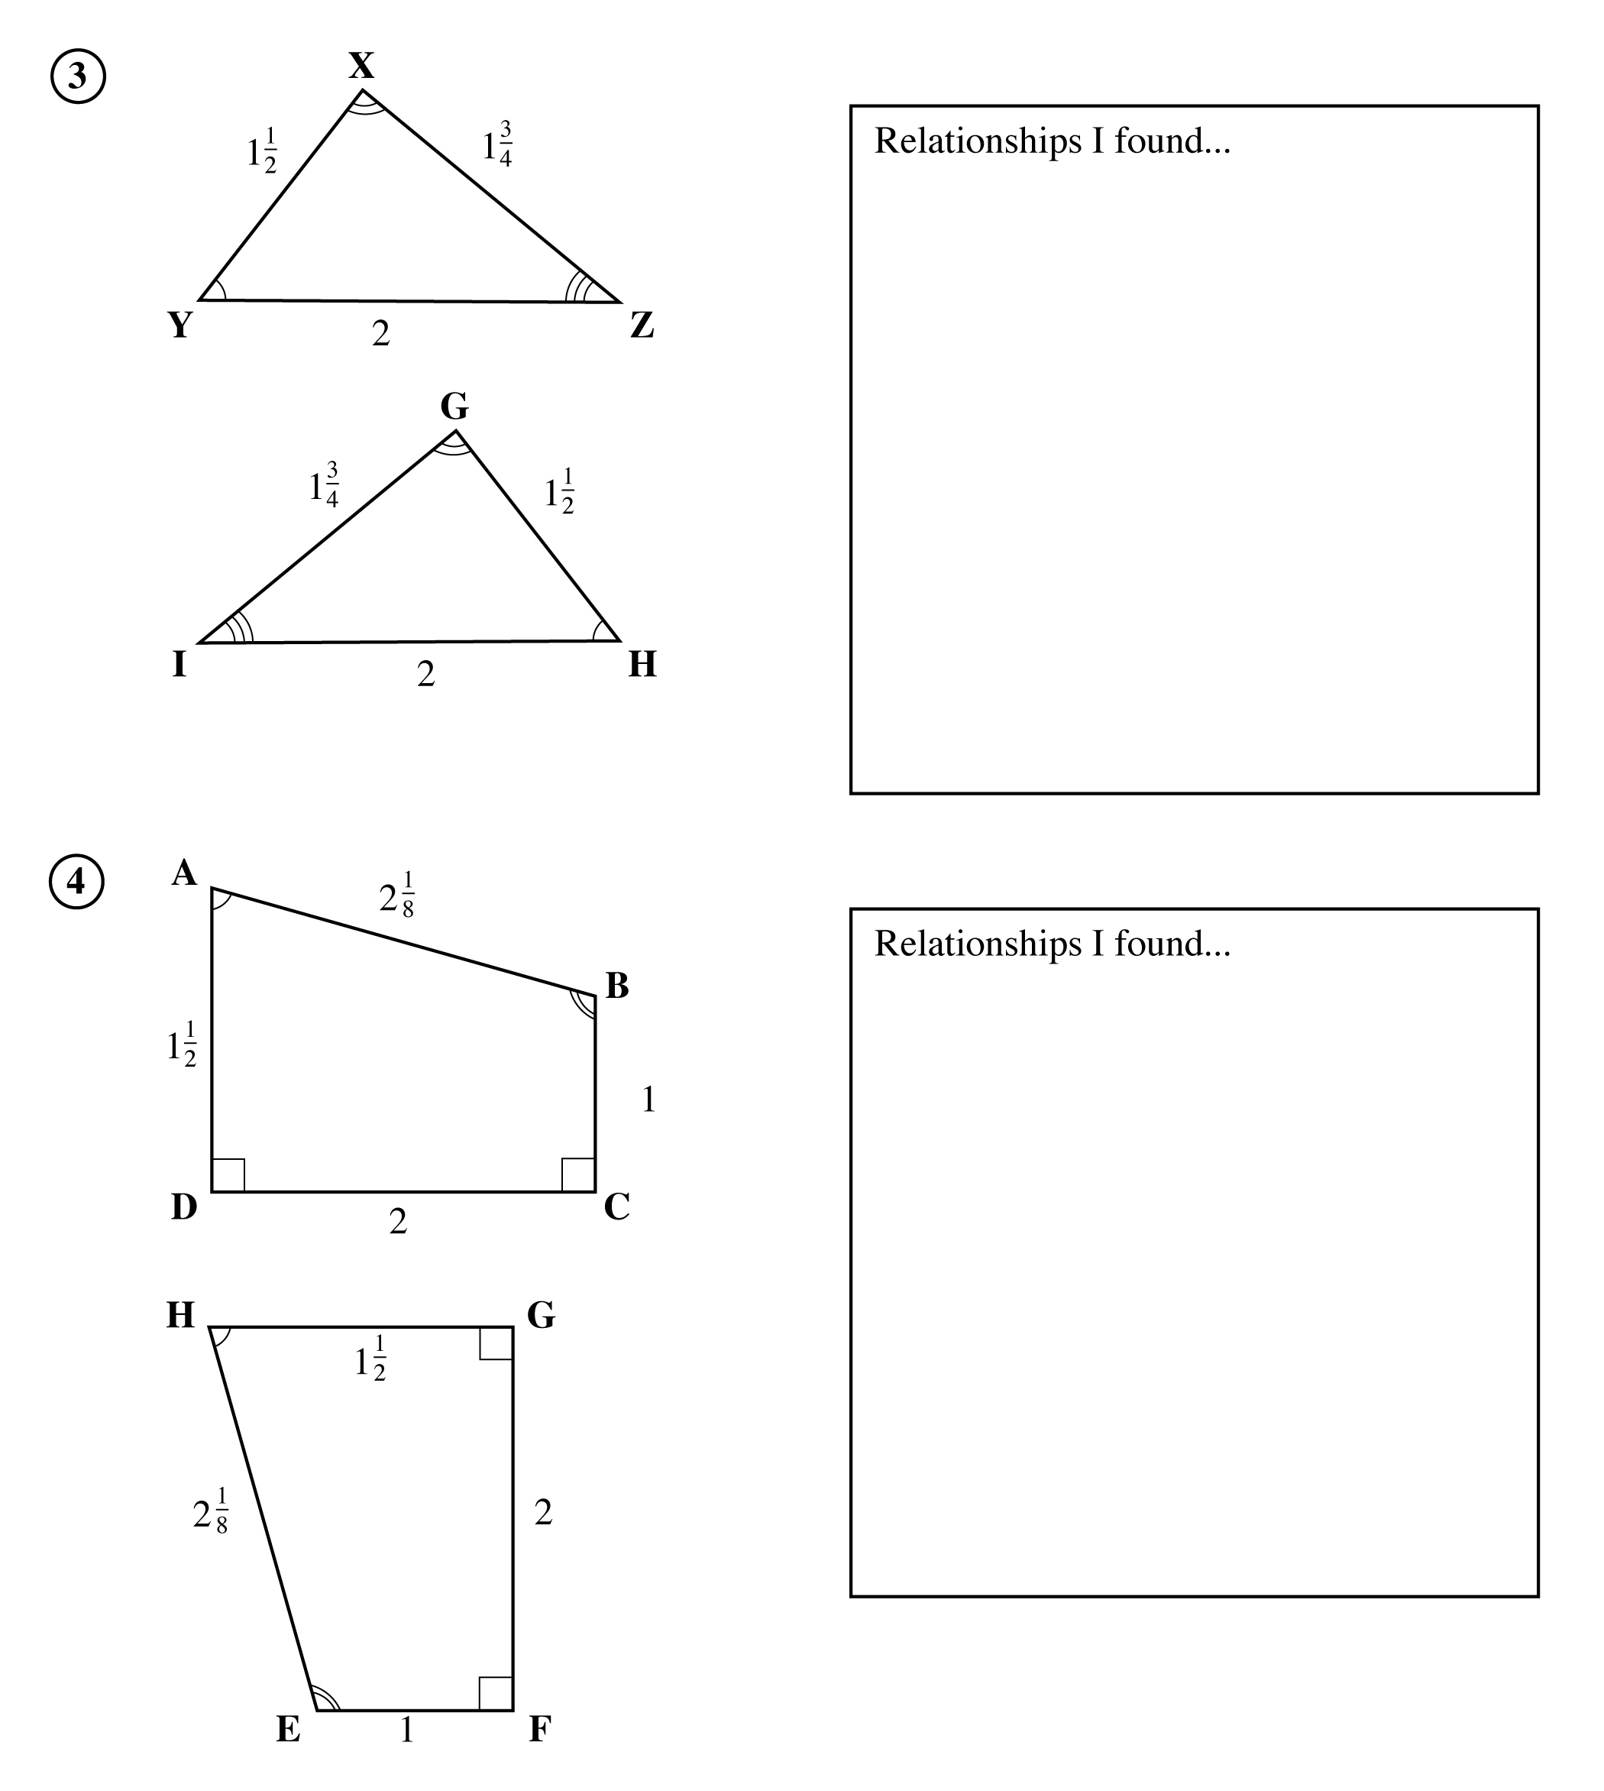

**Attachment C**

**Similar Figures**

1.

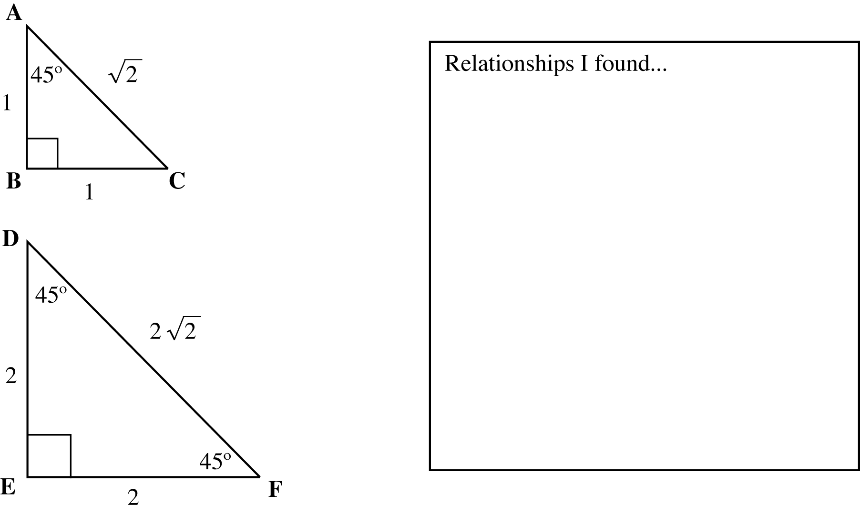

4.

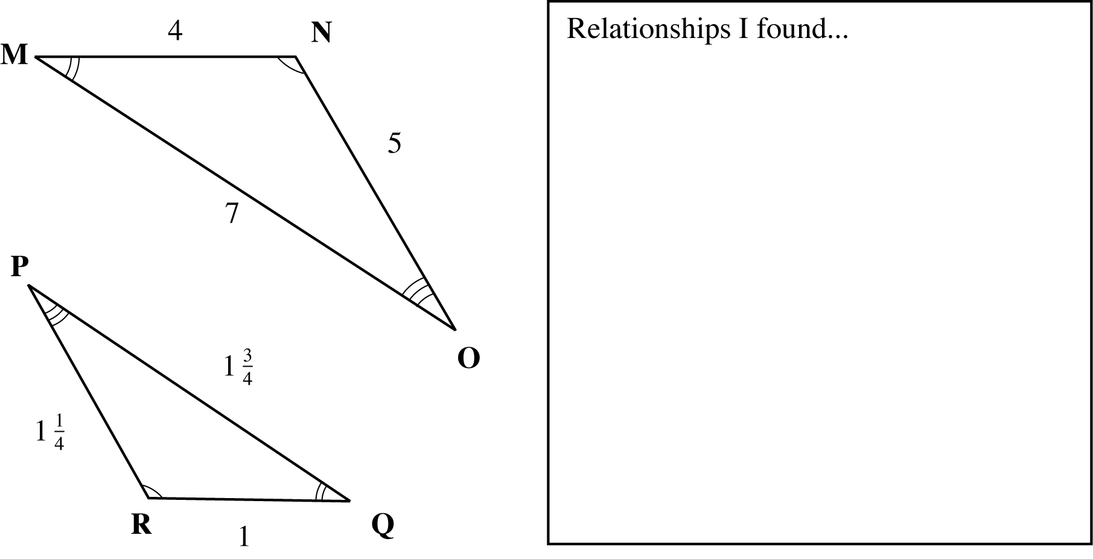

**Attachment C (continued)**

**Similar Figures**

6.

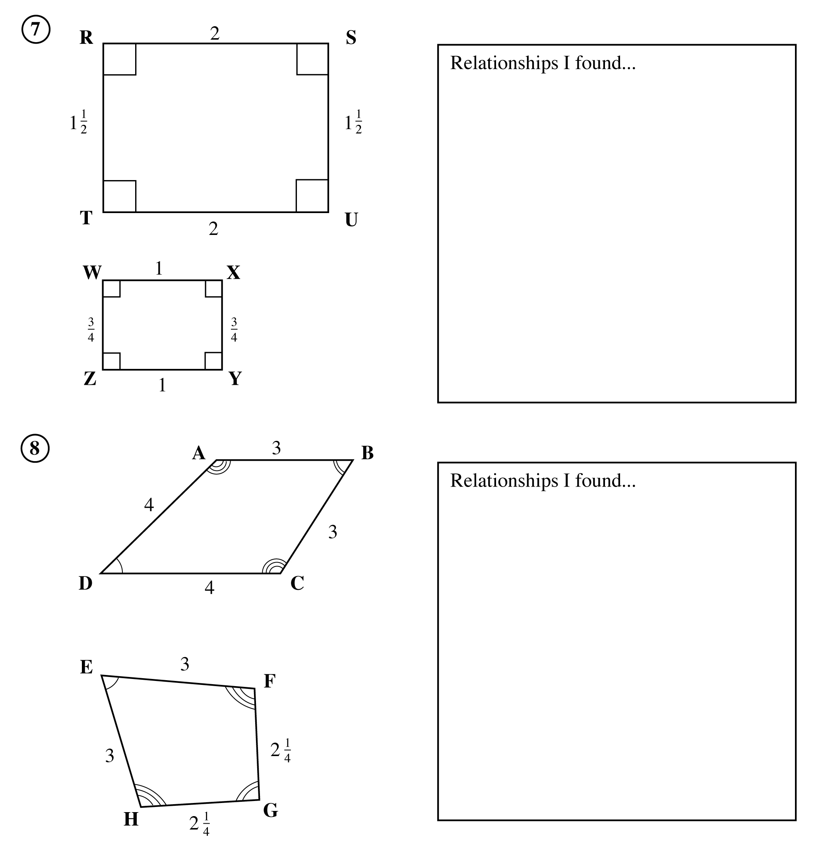

10.

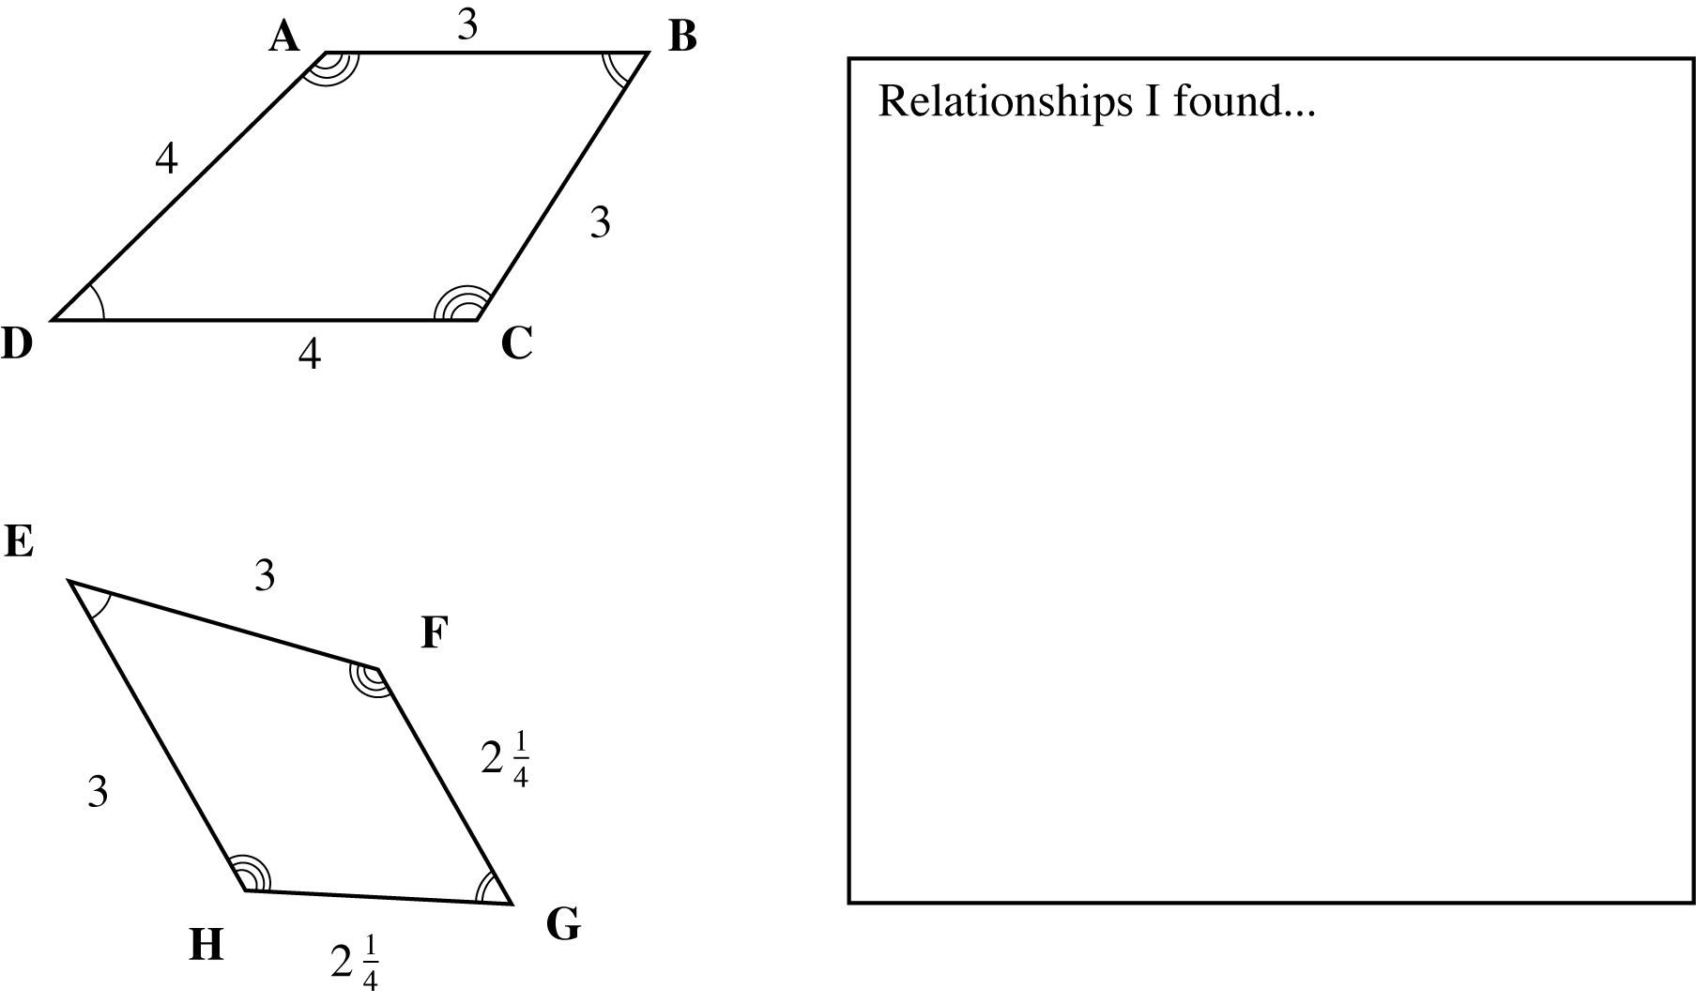

**Attachment D**

**Pairs of Figures**

3.

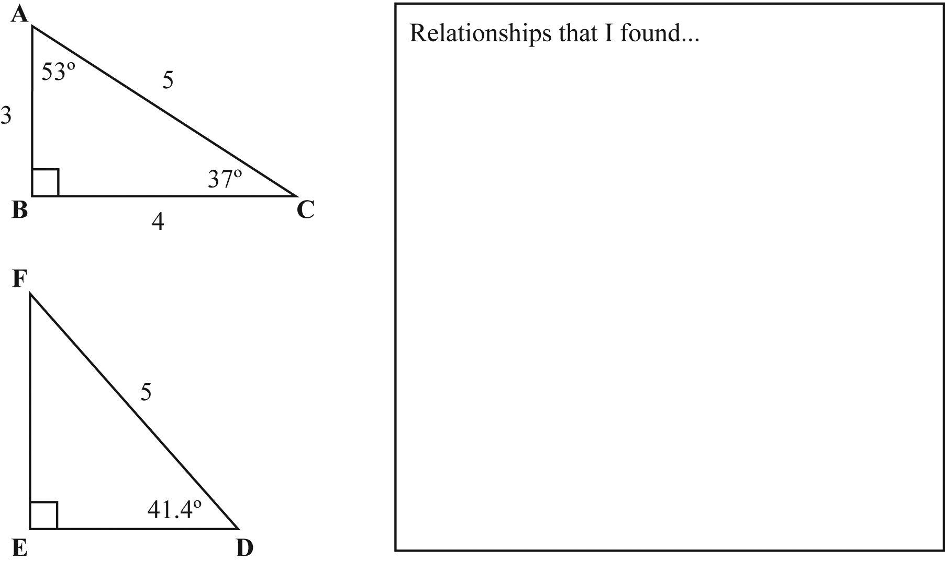

5.

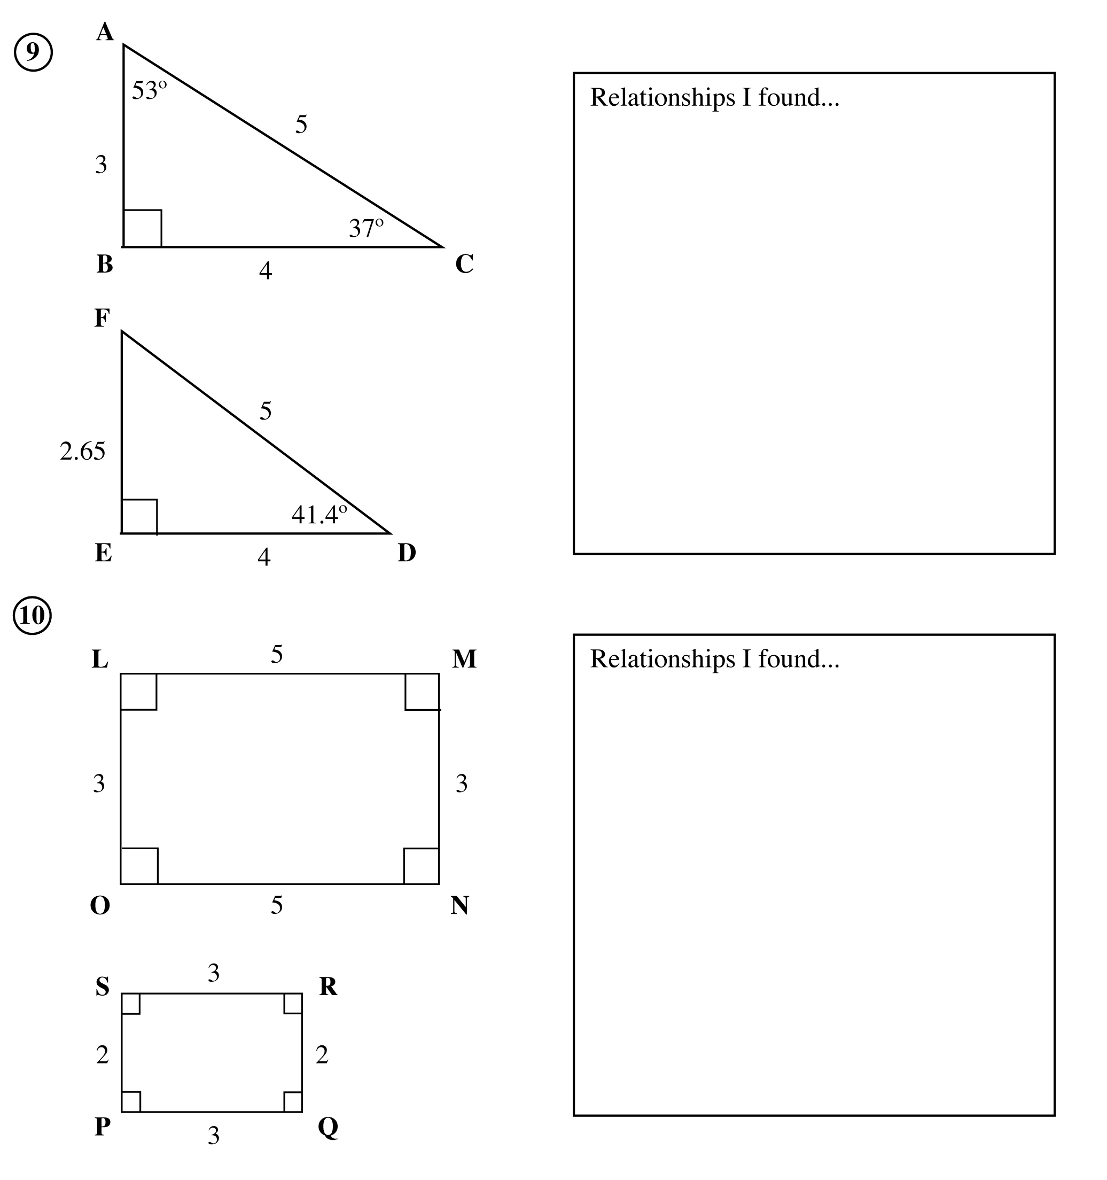

**Attachment D (continued)**

**Pairs of Figures**

8.

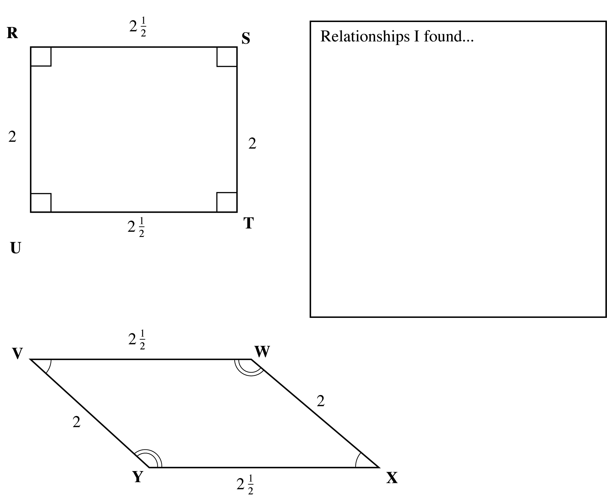

**Attachment E**

**Using Relationships to Solve Problems**

**Name_______________________________ Date__________________________**

**Directions:** Describe all relationships and find missing values for each pair of congruent or similar triangles. Give the ratio between corresponding sides and angles.

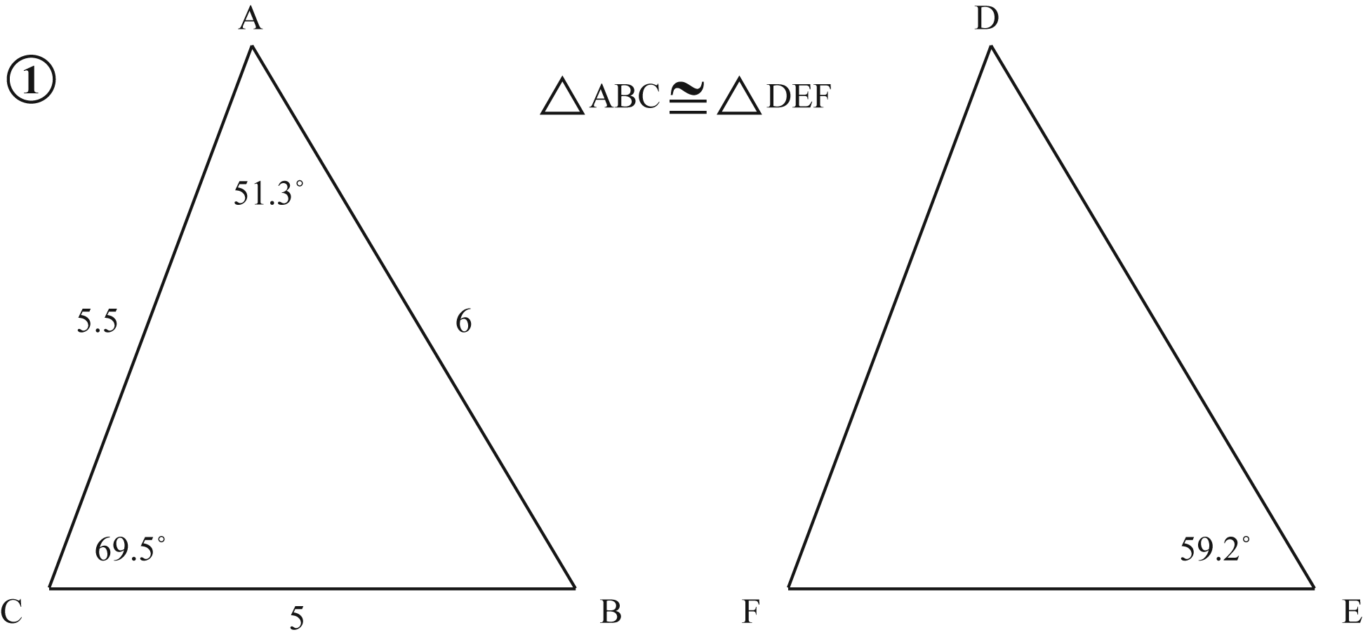

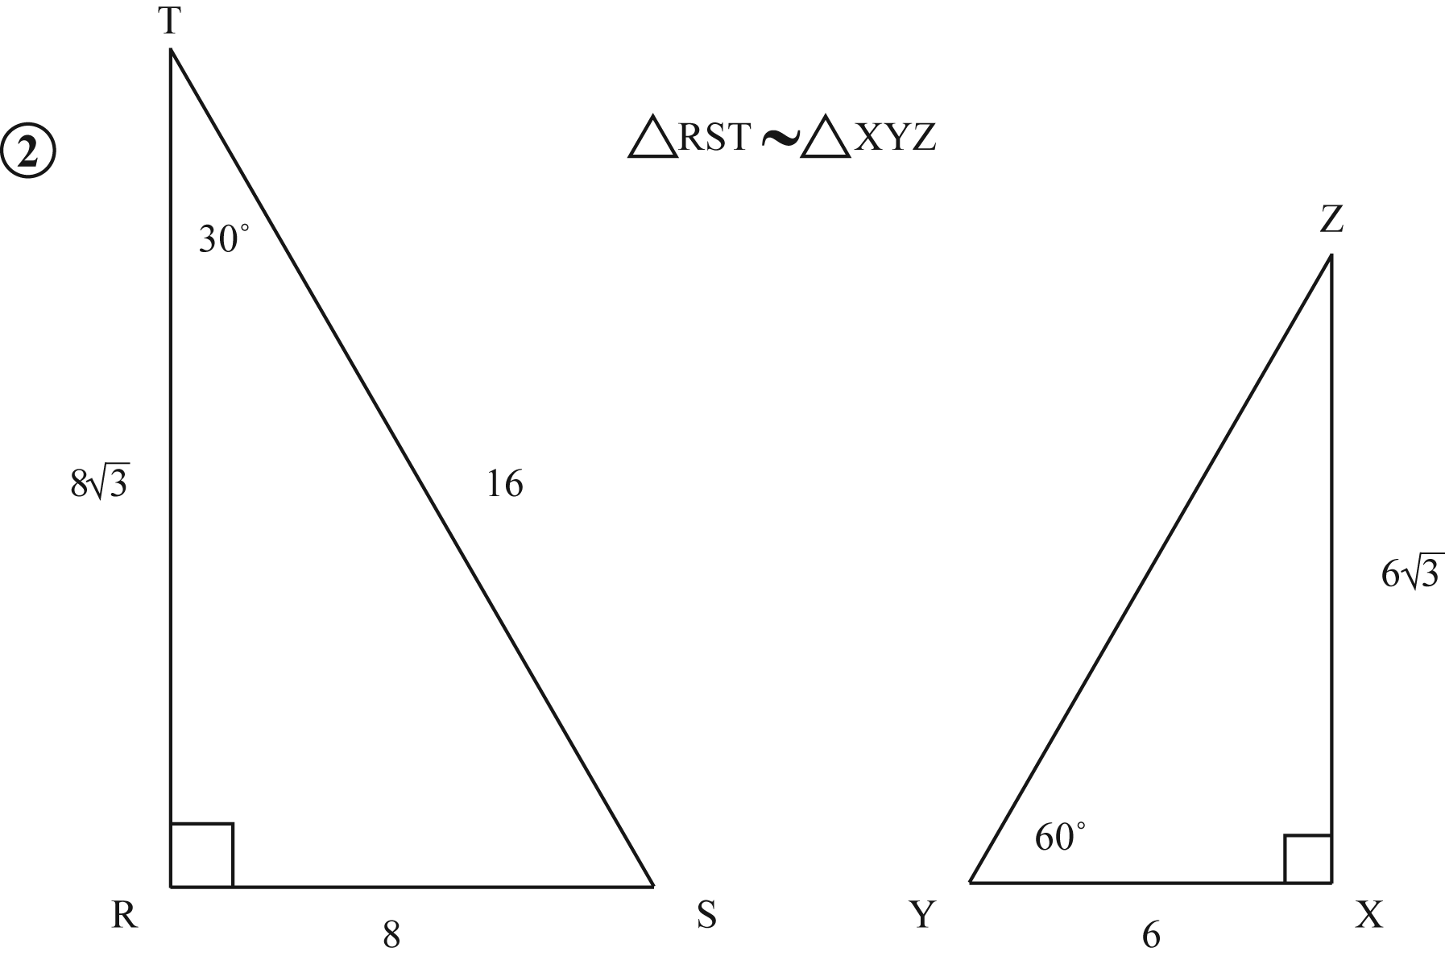

**Attachment F**

**Finding Relationships Among Triangles**

**Name_______________________________ Date__________________________**

**Directions:** Tell whether each pair of figures is similar, congruent, both or neither. Explain which side and angle relationships support your answer. State the ratio of corresponding sides and corresponding angles if the figures are congruent or similar.

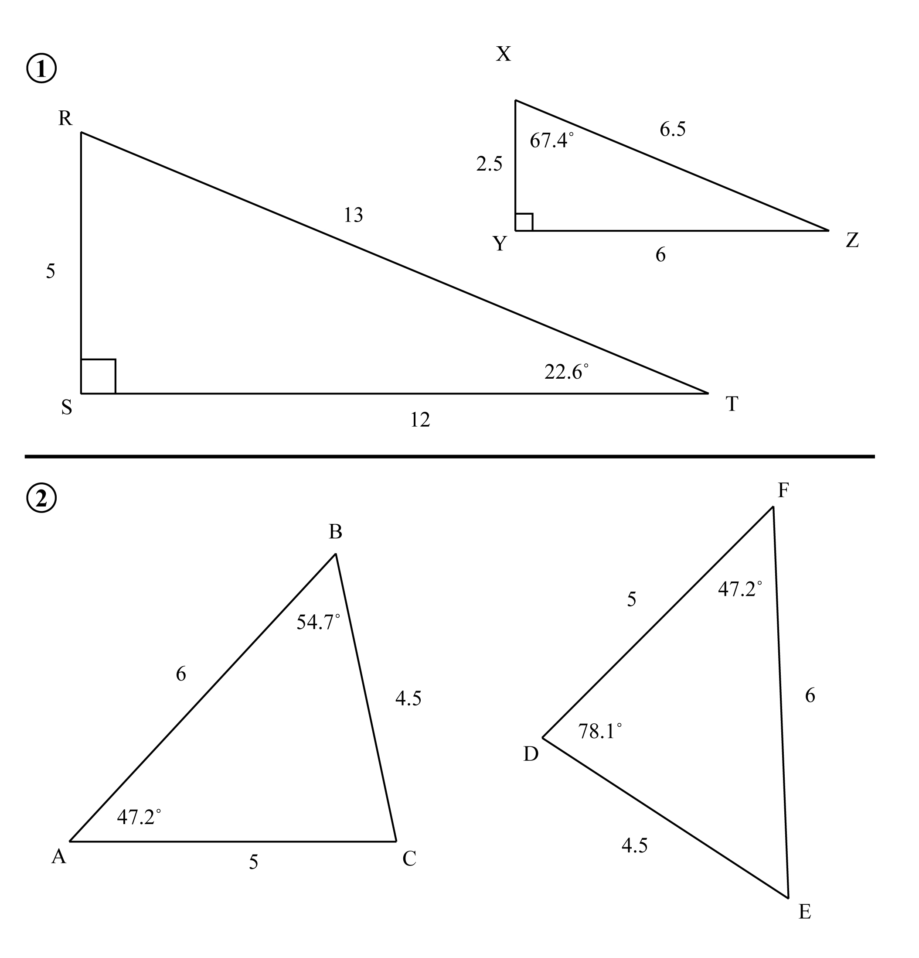

Attachment F cont’d

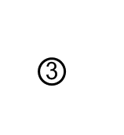

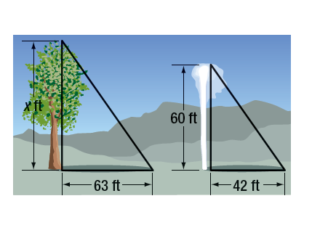Old Faithful in Yellowstone National Park shoots water 60 feet into the air that casts a shadow of 42 feet. What is the height of a nearby tree that casts a shadow 63 feet long? Assume the triangles are similar.

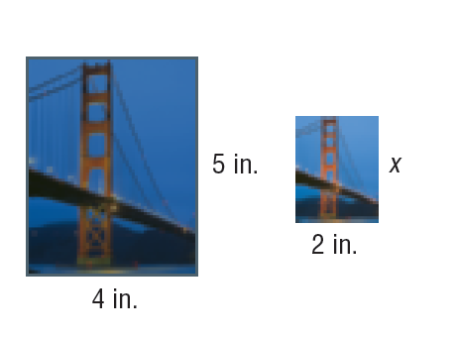Destiny wants to resize a 4-inch wide by 5-inch long photograph for the school newspaper. It is to fit in a space that is 2 inches wide. What is the length of the resized photograph?

SHADOWS A flagpole casts a 20-foot shadow. At the same time, Humberto, who is 6 feet tall, casts a 5-foot shadow. What is the height of the flagpole? Assume the triangles are similar.