What’s with all these squares?
Attachment B

Directions: Use the grid paper, make three squares: one with an area of 9, one with an area of 16, and one with an area of 25. Label the first square A, the second square B, and the third square C. Next, try to arrange the squares so that they form a triangle in the middle. You want to connect the squares by their vertices (corner to corner)

Chart 1:

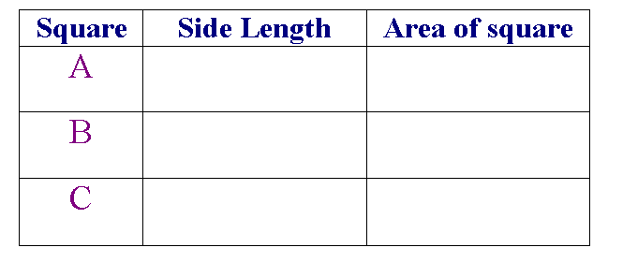
Pythagorean Theorem

a² + b² = c²

In a right triangle, the sides that are adjacent to the right angle are called ____. The side opposite the right angle (the longest side) is the __________.

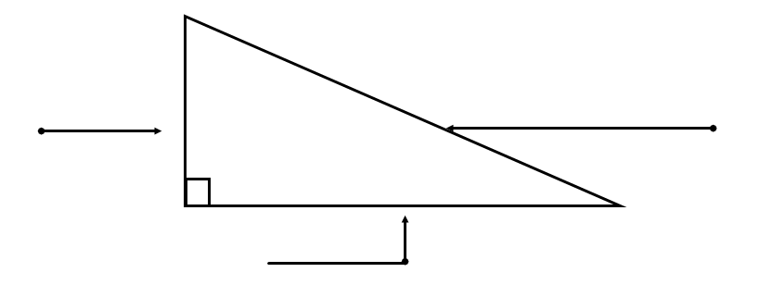

Pythagorean Theorem
Name ___________________________________
Attachment C
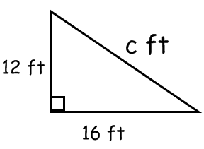
1.

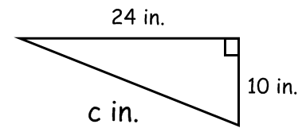
2.

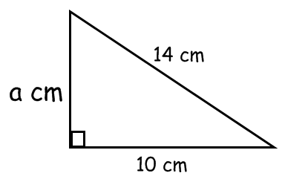
3.

4. A pathway cuts diagonally through the garden. What is the length of the pathway?

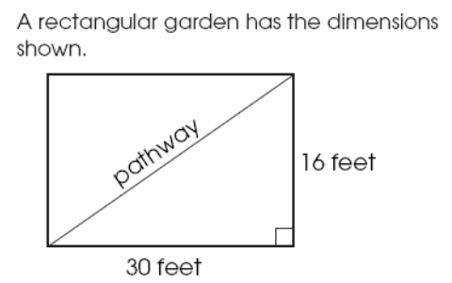

Attachment D
Triangle Problems

Name_______________________________ Date__________________________

Directions: Answer each of the following problems in the space provided.

- If a right triangle has two legs that are 5 feet and 12 feet, what would be the measure of the hypotenuse?

- What is the distance between the two points if the length of a side of each square represents one square mile?
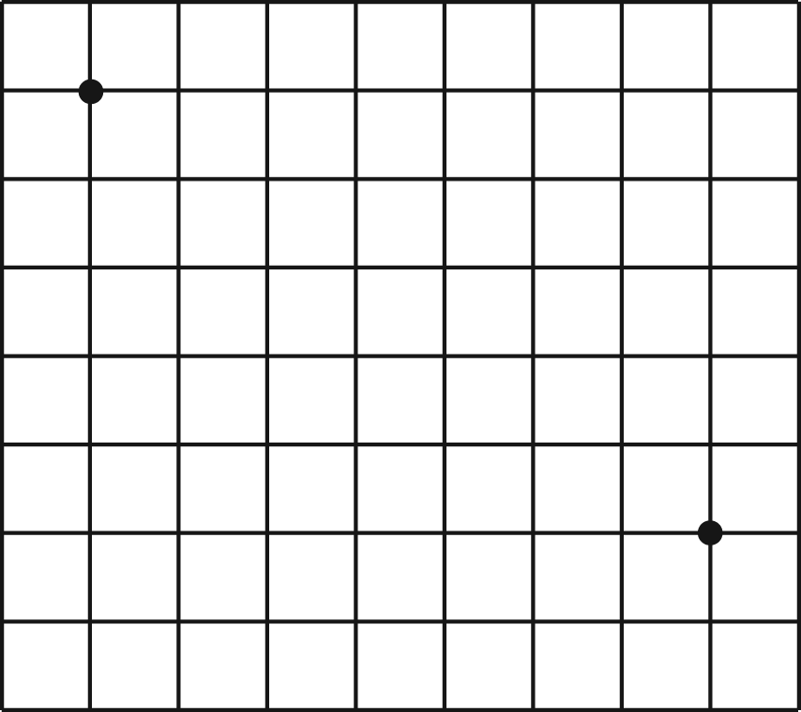

- A rope that is 15 feet long is stretched from the top of a pole to the ground at a spot that is 9 feet from the base of the pole. Draw a diagram, and calculate the height of the pole.

- The mast is in the center of Bill’s sailboat and is 15 feet high. A rope is tied from the top of the mast to the very front of the boat. The length of this rope is 17feet. Find the entire length of Bill’s sailboat.

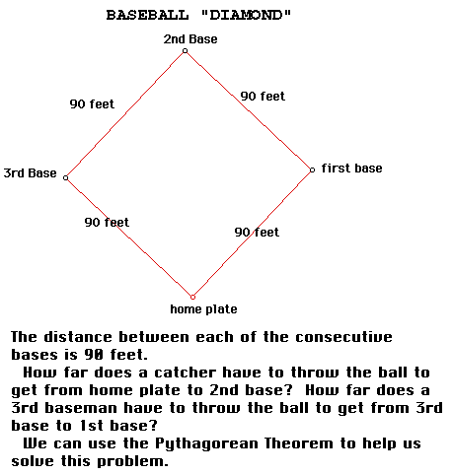
Taken from http://www.geom.uiuc.edu/~demo5337/Group3/bball.html

- You are at your grandma's house for the weekend but you've decided you're ready to go home. Your mom says the only way you can come home is if you tell her exactly how many miles is the shortest distance from Grandma's before you can leave. She tells you that your street and Grandma's street meet to form an L at your school. Grandma's house is two miles east of your school and your house is one mile north of your school. She also tells you the shortest distance home does not involve passing your school again. How can you do this? Why not let Pythagoras help you home?

