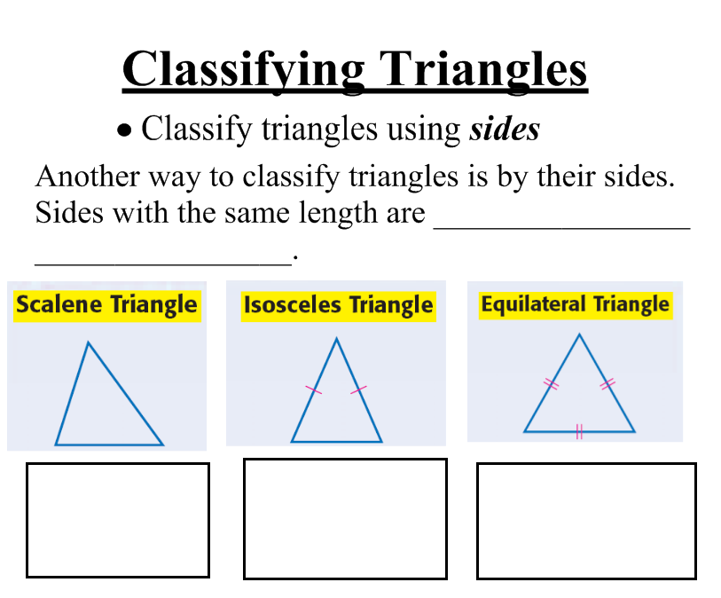
Directions: Use the three previous triangles to decide which triangle’s characterizations best fit the pictures. Make sure to describe why you placed that triangle in the spot.
Attachment B
Reason: Reason: Reason:

Classify each triangle as scalene, isosceles, or equilateral.

1. Side A = 24 cm., Side B = 26 cm., Side C = 26 cm

2. Side A = 17 cm., Side B = 17 cm., Side C = 17 cm.

3. Side A = 21 cm., Side B = 15 cm., Side C = 17 cm.

Triangles can also be classified by its ________________________.
Attachment C

- Since every triangle has at least two acute angles, one way you can classify a triangle is by using the third side.
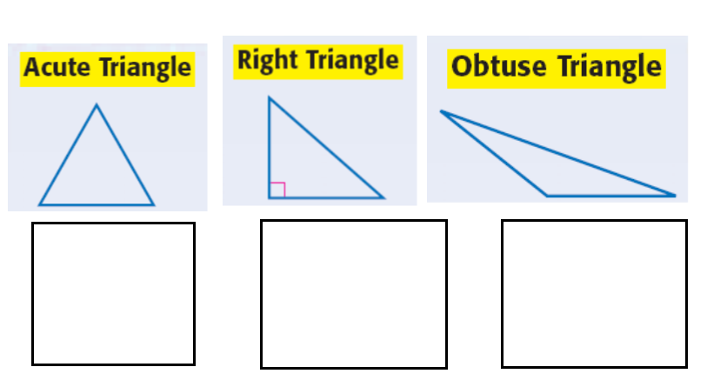

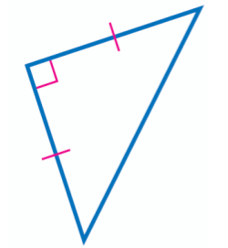
Classify each triangle by its angles and by its sides.


1. 2.

__________________________ _____________________________

3. A triangle with angle measures 55°, 75°, and 50°

_________________________________

