Lori Pfeiffer
Bowling Green State University
EDTL 7100
Instructional Design
Kindergarten Social Studies
Citizenship Rights and Responsibilities

June 21, 2009

Statement of Purpose

According to the curriculum guidelines released by the National Council for Social Studies (NCSS) states in 1979 that “The basic goal of a social studies education is to prepare young people to be humane, rational, participating citizens in a world that is becoming increasingly interdependent.”
Our Kindergarten standards require students to identify the actions of a good citizen, yet I feel that our current social studies unit does not provide enough material that allows students to fully grasp the true meanings of the eight attributes listed in the learner outcome section. Having worked in a public inner-city school system for the past 3 years I have noticed that most of my students have not attended a pre-school or daycare. These students are entering kindergarten with low academic skills as well as social skills. The students that I teach participate in the free lunch program and come from low income housing developments. Their sense of community and ability to relate to “being a good citizen” is such an abstract concept that showing them a picture or reading them a story about the actions of a “good citizen” does not create a lasting impression of citizenship for these little ones.
On April 21, 2009, President Barack Obama signed the Edward M. Kennedy Serve America Act at an elementary school in Washington DC. The Serve America Act reauthorizes and expands national service programs administered by the Corporation for National and Community Service, a federal agency created in 1993. President Obama encourages all who can to participation in a private or public form of a service project.
My purpose for adding onto the current Social Studies Unit 1 is to engage students in an ongoing thinking process about character education and to create a sense of classroom community by having them participate in a service project for their school or for a local charity. While researching information about classroom communities, I came across a quote that I believe captures my intentions.
“Children learn morality by living it. They need to be in a community –to interact, form relationships, work out problems, grow as a group and learn directly, from their first-hand experiences, lessons about fair play, cooperation, forgiveness, and respect for the worth and dignity of every individuals.”
(Lickona 1992, 90)
Through the facilitation of the Harcourt Social Studies curriculum partnered with a classroom community design built into their daily routine, teachers can encourages students to become productive citizens in their school community. Students can participate in a civic project centered on the eight values that will benefit their school environment and local community. Students will gain the necessary life skills that will mold them into productive adult American citizens.

Topic: Kindergarten Social Studies - Lori Pfeiffer
Unit One: Being a Good Citizen
Lesson 1: I Follow the Rules
Citizenship Rights and Responsibilities
Unit Objectives
- Students will participate and cooperate in classroom activities (knowledge)
- Students will take personal responsibility to follow directions and rules (application)
- Students will demonstrate the ability to make choices and take responsibility for personal actions (application)
- Students will discuss that attributes and actions of a good citizen with emphasis on: (comprehension)
    - Trust
    - Respect
    - Honesty
    - Responsibility
    - Fairness
    - Compassion
    - Self-control
    - Compassion
- Defines attributes of a good citizen (knowledge)
- Identify the purpose for having rules (knowledge)
- Recognizes consequences of breaking rules (knowledge)
- Explains how rules help people get along with each other and stay safe (knowledge)
- Describes the benefits of cooperating, taking turns, and sharing (comprehension)
- Identifies ways to resolve conflict (application)
- Recognize that citizens have a responsibility to follow rules and laws (comprehension)
- Applies the importance to taking responsibility for one’s choices and actions (application)
- Identifies a problem and offers meaningful solutions (application)
- Demonstrates examples of choices and consequences through stories and role-playing (comprehension)
- Identifies pro’s and con’s of making choices (comprehension)
- Participates in a group community service project (analysis)

Sub-Unit Objectives: I Follow the Rules; Being a Good Citizen
      - Students will define the attributes of a good citizen (knowledge)
      - Students will distinguish the differences between a good citizen and someone who does not follow the rules. (analysis)
      - Students will illustrate a picture of themselves acting like a good citizen (comprehension)
      - Students under the guidance of the teacher will develop a list of classroom rules. (application)
Pre-Assessment
Lori Pfeiffer K-Social Studies

Chart 1 Chart 2
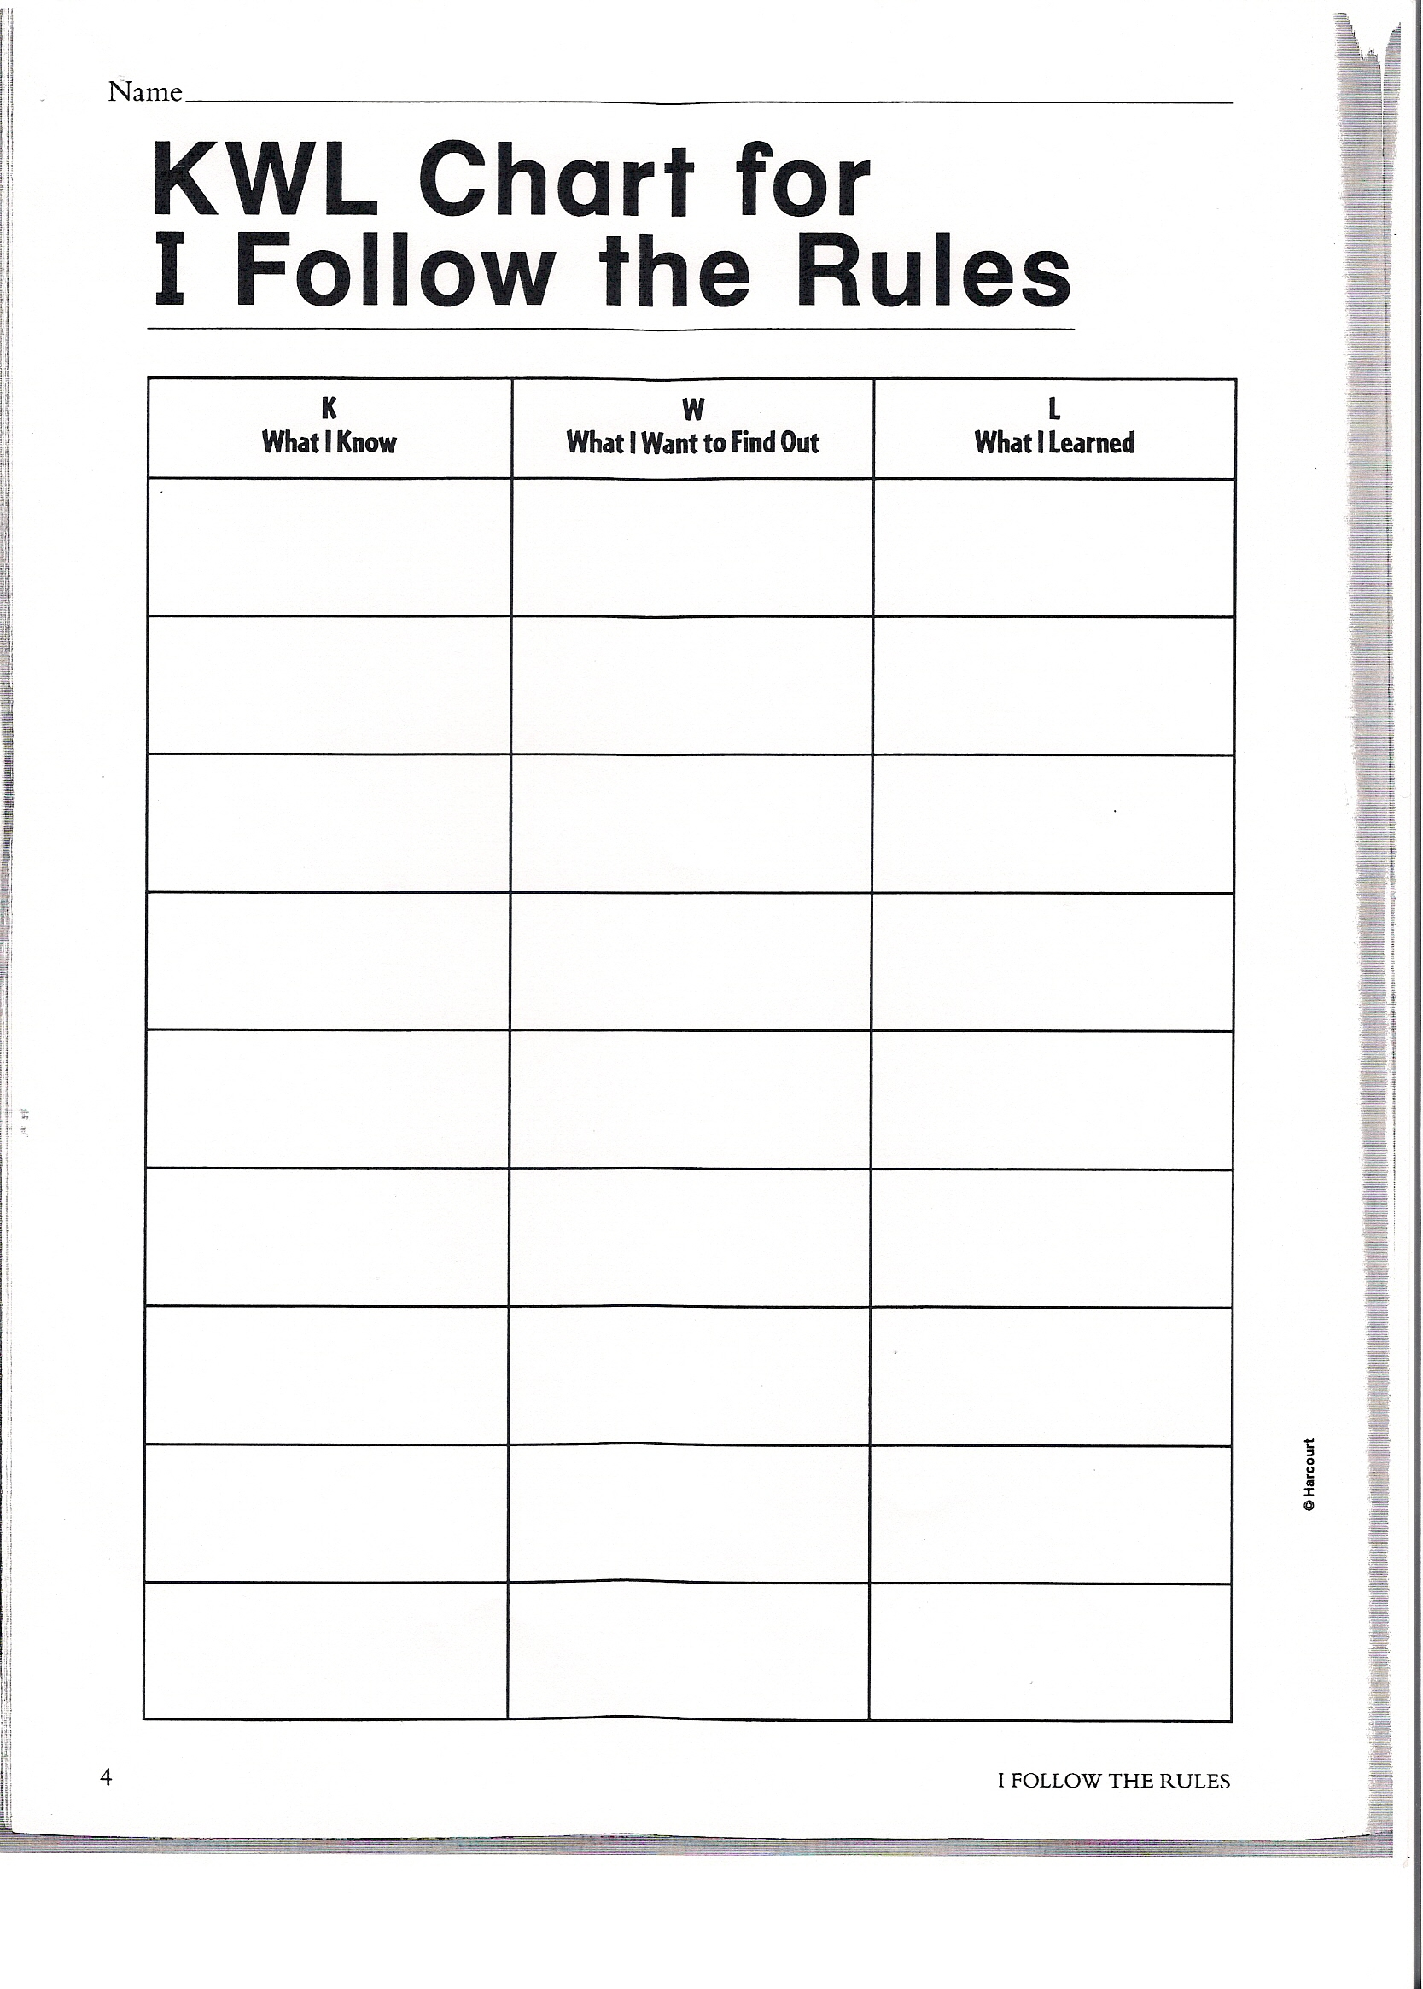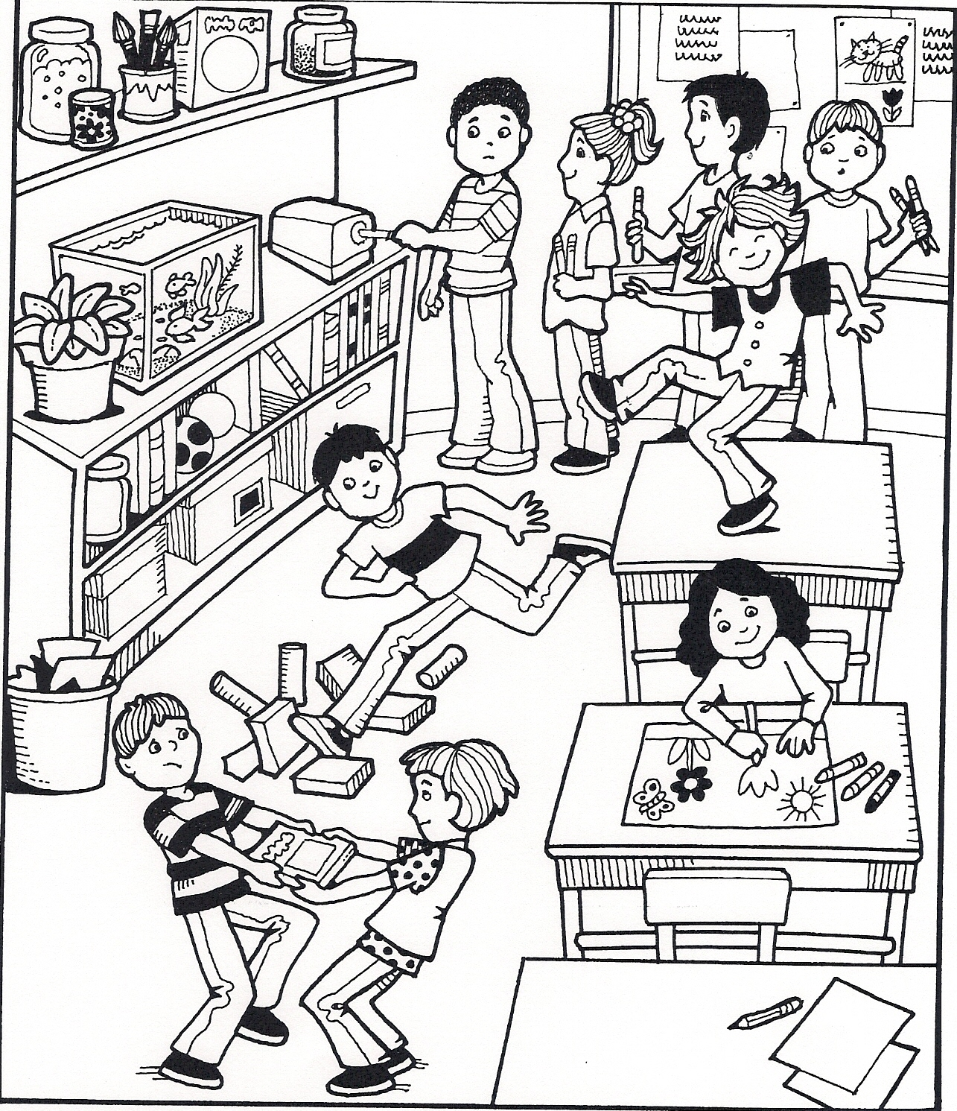
Berson,, M., Howard, T., & Salinas, C, (2007). Ohio Social Studies-Our World, Now and Long Ago. Orlando, Florida: Harcourt.

When working with kindergarten students I prefer to use a KWL chart accompanied by a picture that relates to the topic we are covering in our lesson. I post pictures on the white board using the LC projector in one of two ways; 1- scan text book material by saving it to my computer or 2- post pictures via the internet.
As you can see, both charts are Harcourt textbook created material from the current social studies unit adopted by the district. The KWL chart that accompanies this unit is a perfect tool to assess student’s prior knowledge of what being responsible and respectful in a classroom environment looks like.
As stated earlier, I use the LC projector to post charts and photos on the white board which allows me to keep a copy on my desktop so that I can refer back to any material necessary for additional lessons.
By listening to the student responses to the KWL chart I will be able to identify the needs of the students as a group to plan future lessons regarding classroom rule.

Lori Pfeiffer K-Social Studies
Sub-Unit to Citizens Rights and Responsibilities
C-Map: Responsibility
Lesson One: (15-20 minutes) I Follow the Rules-1
Objective
To activate and organize students’ prior knowledge through the use of a KWL chart relating responsibility.
Concepts/Skills
- Students will hear the story “No, David: by David Shannon as a way to focus learning towards rules and why they need to be followed. (Shannon, David (1998). No, David. New York, New York: Scholastic Inc.)
- As a group, students will be lead in a discussion using a KWL chart and photo to determine how some children are taking responsibility for their actions and how other students are not.
Material
- No, David by David Shannon (Shannon, David (1998). No, David. New York, New York: Scholastic Inc..)
- KWL Chart pg. 4 and Photo: Homework and Practice Book pg. 5 – Taking Responsibility (Berson,, M., Howard, T., & Salinas, C, (2007). Ohio Social Studies-Our World, Now and Long Ago. Orlando, Florida: Harcourt.)
- Use of the LC Projector / Teacher Computer
- White board and Expo markers

Open/Lesson
- Read “No, David” by David Shannon
  - Define responsibility: being accountable for your actions. A responsible person follows through with obligations and displays self control. (clarify definition as needed)
  - Lead students in a short 3-5 minute discussion over No, David.
    - Did David always follow the rules?
    - What are some rules that David did not follow in his home?
    - What could David do to be more “responsible”?
    - Continue with the KWL chart and Photo of “Taking Responsibility” (5-10 minutes).
  - Begin by filling the in “K” on the KWL chart relating to the picture
    - Allow students to go up to the white board to use the Expo marker to make and “X” on students that are being responsible.
  - Continue with the “W” on the KWL chart relating to the picture
  - Keep Chart for the final lesson.
Closure/Informal Assessment
- Conclude discussion by having students name two or three rules that they need to follow at home or in school.
- Summary: Rules keep us safe. Rules make sure that everyone is treated fairly and helps us treat each other with respect.

Lori Pfeiffer K-Social Studies
Sub-Unit to Citizens Rights and Responsibilities
C-Map: Responsibility

Lesson Two: (20-30 minutes) I Follow the Rules-2
Objective
- Students will identify the attributes of a good citizen
Concept/Skill
- Students will demonstrate their understanding of the facts presented in the lesson by stating in the own words what it means to follow the rules and to be a good citizen by acting in a responsible manner.
Material
- Leveled Reader: I Follow the Rules (Berson,, M., Howard, T., & Salinas, C, (2007). Ohio Social Studies-Our World, Now and Long Ago. Orlando, Florida: Harcourt.)
- KWL Chart and Photo from lesson 1
- Use of the LC Projector / Teacher Computer
- White board and Expo markers
- Digital Camera
Open/Lesson
- Reread “No, David” by David Shannon
- Review KWL Chart and update as needed
- Ask students to explain what rules are used for and why it is necessary to follow the rule both in and outside of school
- Introduce the following vocabulary words: community, group, law, responsibility and rule. Use and informal KWL question and answer to determine level of understanding.
- Read the leveled reader “I Follow the Rules” from the Harcourt series
  - Questions to check for comprehension as you read
    - Where are the children playing?
    - What rules do you think they are following?
    - What are signs help us in our community to follow rules? (define community as needed)
    - What are people doing (recycling) – Why is recycling an important responsibility. (define responsibility as needed)
Closure/Activity
- Create a list by asking students about what kinds of rules they will follow in school and in the classroom. Possible answers: Wash hands after restroom, stand in line, walk in hallways etc. (keep list for lesson 3)
- Divide students up into groups by colored tables. Have students pose for a picture showing how to follow the school rules. Develop and post in the classroom as quick reminders.
- Close by returning to circle area, and tell the students that they are citizens that are part of a classroom community. Good citizens follow rules and laws to help them stay safe and to treat others fairly.
Lori Pfeiffer K-Social Studies
Sub-Unit to Citizens Rights and Responsibilities
C-Map: Responsibility
Lesson Three: (15-25 minutes) I Follow the Rules-3
Objective
- Involve students in creating classroom rules
Concept/Skill
- To involve students in the process of making classroom rules will enable them to understand through participation what it means to be a “good citizen”.
Material
- KWL Chart and Photo from lesson 1, List of rules from lesson 2
- Use of the LC Projector / Teacher Computer
- White board and Expo markers
- Poster writing paper-for rules
- Photos of students modeling behavior
- “Good Citizen” page 6 (Berson,, M., Howard, T., & Salinas, C, (2007). Ohio Social Studies-Our World, Now and Long Ago. Orlando, Florida: Harcourt.)
Open/Lesson
- Reread “No, David” and “I Follow the Rules”
- Review vocabulary words from lesson two
- Complete the KWL chart
- Show students the photos of them following the rules of the school and classroom.
- Use the list from lesson 2 to create a set of classroom rules.
- Lead students by restating why we have rules and why it is important to follow the rules.
- Remind them to be specific and how some rules might need to be more detailed.
- Keep rules positive; we can walk in the hallways, I will sit in my seat, I will speak softly in the classroom, etc.
Closure
- Discuss where the rules should be posted
- Discuss that rules sometimes get broken and that there are consequences for those that break the rules. (This will be discussed in a later lesson involving fairness)
- End by having student’s complete page 6, “Good Citizen”. Students will draw a picture of themselves on the award showing one way that they are acting like a good citizen.
- Pull students aside to ask them to identify the actions of a good citizen, write down their response. Standard / Benchmark question for 2, 3, and 4th quarter. Keep paper in student portfolio.

Post-Assessment
Lori Pfeiffer K-Social Studies

Chart 3
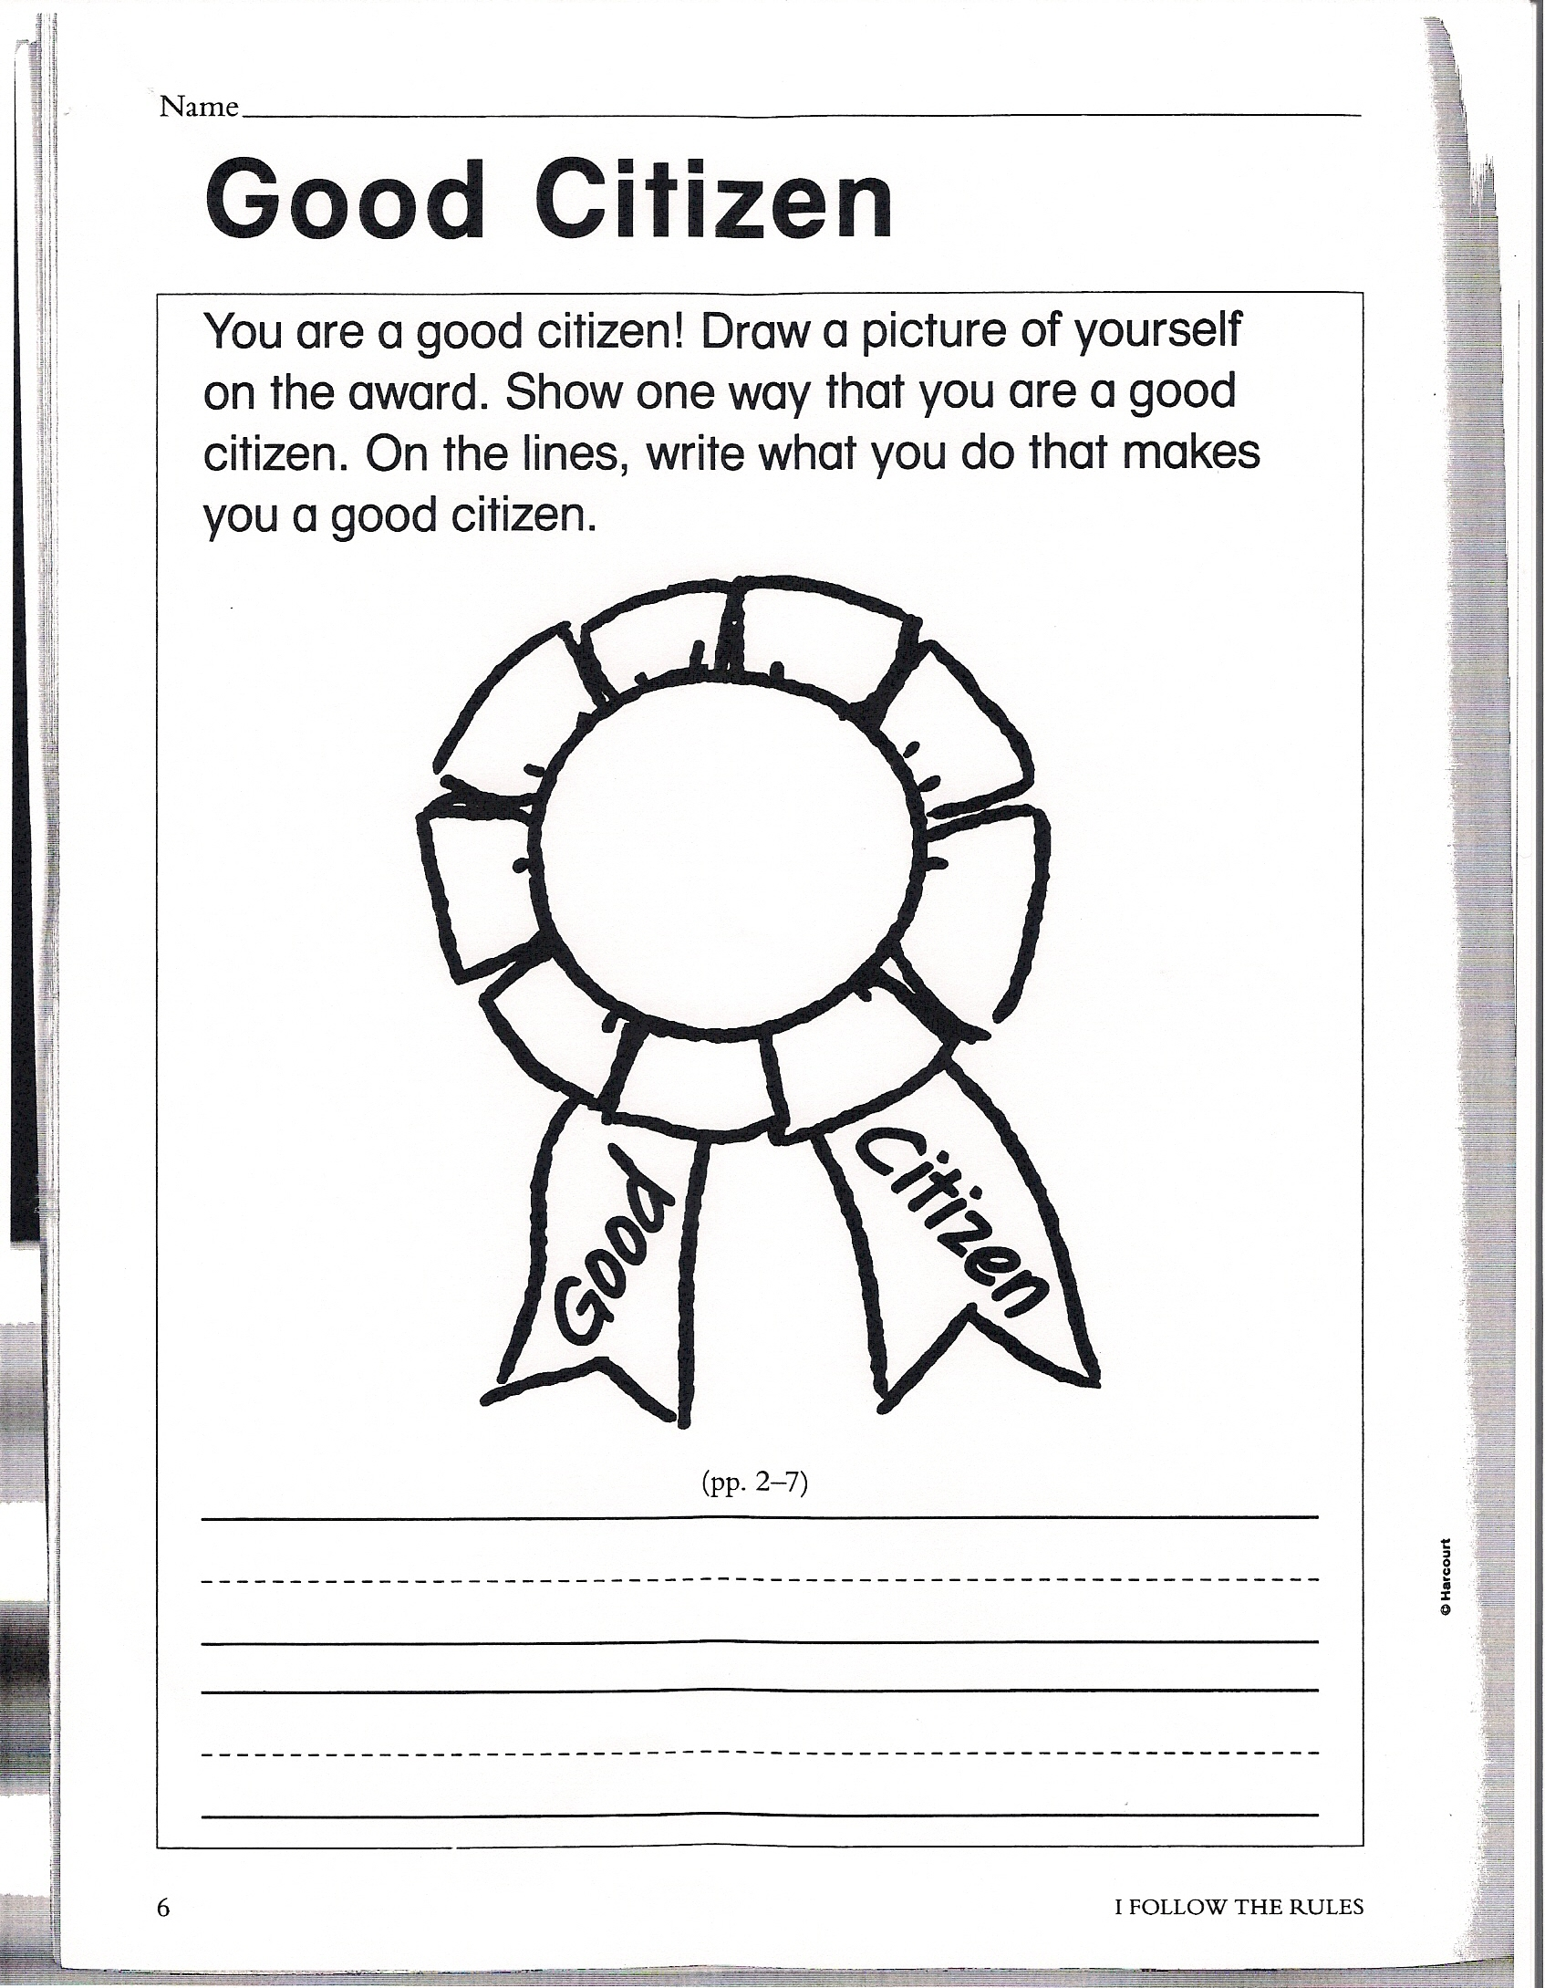

Berson,, M., Howard, T., & Salinas, C, (2007). Ohio Social Studies-Our World, Now and Long Ago. Orlando, Florida: Harcourt.

As a way to end the sub-unit for responsibility I feel that students need to illustrate what they learned as a way to organize the information taught in earlier lessons.
Keeping this page in student portfolio allow for the teacher to have a point of reference when filling out the grade card for the semester as well as a guide for future lessons.
A quote that I found while researching information for this topic and had referred to in the Statement of Purpose paper, I feel is a great way to end this project:
“Children learn morality by living it. They need to be in a community –to interact, form relationships, work out problems, grow as a group and learn directly, from their first-hand experiences, lessons about fair play, cooperation, forgiveness, and respect for the worth and dignity of every individuals.”
(Lickona 1992, 90)
Allowing students to actively participate in a classroom community teaches students the value of being a good citizen in their community. As illustrated on the C-Map, teaching responsibility is one of many steps to reaching such a goal.

