Rationale

Language and literacy are the fundamentals of any society as a means to communicate, share ideas, and function in any culture. These are basic skills that are necessary to advance the learning process and become productive members of society. The inability of our students to read and write affects the progression of our country.
In the world of fast food and advancing technology, the United States is changing and the workforce is requiring more and more of its employees to contend with other countries. An article written in Reading Research Quarterly in 1987 stated, “Researchers have identified substantial mismatches between workers’ skills and job demands and between job and school literacy skills”. The article further states, “20 percent of the adult population, or 30 million people, have serious difficulties with common reading tasks” (Kaestle & Stedman, 1987). This dilemma needs to be addressed in schools and steps taken to ensure our future workforce has the proper basic training.
This instructional design project targets the problem of literacy skills by building on the abilities students already have to teach them new concepts that they will utilize to become lifelong learners. The state of Ohio requires students to answer literal, inferential, evaluative, and synthesizing questions to demonstrate comprehension (2004). This particular skill set will help students in job interviews, scholarship opportunities, communication with co-workers, and social skills in general to name a few. According to the textbook, “CTL curriculum designs place content/knowledge needs within the context of learner and societal needs” (Chiarelott, 2005).
Standards are the origin for this instructional design project. The lesson plans are patterned after the 5-E learning cycle model in chapter eight. This will allow students to link concepts they already know to new ideas and then explore those new concepts. Students will be made aware of what standards they are learning before the lesson begins. Teaching a standards based curriculum is one way teachers can “identify key concepts, skills, attitudes, and values that provide the foundational context for curriculum” (Chiarelott, 2005). Using the state standards as a guide to map out curriculum makes lesson planning more precise and focused enabling the students to receive the information they need.

References

Chiarelott, Leigh. (2005). Curriculum in context. Bowling Green: Wadsworth Publishing.

Kaestel, C.F., & Stedman, L.C. (1987). JSTOR: Reading research quarterly: literacy and reading performance, 22(1), 8-46.

Ohio Department of Education. (2004). Academic content standards k-12 english
language arts. Columbus, OH: ODE.

Rohman, G. (1965). JSTOR: College composition and communication, 16(2), 106-107.
Subunit Learner Outcomes
Reading Process
Concepts of Print, Comprehension Strategies, and Self-Monitoring Strategies

- Students will predict or hypothesize as appropriate from information in the text, substantiating with specific references to textual examples that may be widely separated sections of the text. (Synthesis)

- Students will make critical comparisons across texts, noting author’s style as well as literal and implied content of text. (Analysis)

- Students will summarize the information in texts, recognizing important ideas and supporting details, and noting gaps or contradictions. (Knowledge)

- Students will select, create, and use graphic organizers to interpret information in texts (Comprehension)

- Students will answer literal, inferential, evaluative, and synthesizing questions to demonstrate comprehension of grade-appropriate print texts, electronic and visual media. (Comprehension)

*All outcomes are categorized using Bloom’s Taxonomy

Name_______________________ Date________ Period___
Sick
by Shel Silverstein
"I cannot go to school today,"
Said little Peggy Ann McKay.
"I have the measles and the mumps,
A gash, a rash and purple bumps.
My mouth is wet, my throat is dry,
I'm going blind in my right eye.
My tonsils are as big as rocks,
I've counted sixteen chicken pox
And there's one more--that's seventeen,
And don't you think my face looks green?
My leg is cut--my eyes are blue--
It might be instamatic flu.
I cough and sneeze and gasp and choke,
I'm sure that my left leg is broke--
My hip hurts when I move my chin,
My belly button's caving in,
My back is wrenched, my ankle's sprained,
My 'pendix pains each time it rains.
My nose is cold, my toes are numb.
I have a sliver in my thumb.
My neck is stiff, my voice is weak,
I hardly whisper when I speak.
My tongue is filling up my mouth,
I think my hair is falling out.
My elbow's bent, my spine ain't straight,
My temperature is one-o-eight.
My brain is shrunk, I cannot hear,
There is a hole inside my ear.
I have a hangnail, and my heart is--what?
What's that? What's that you say?
You say today is. . .Saturday?
G'bye, I'm going out to play!"
6th Grade Pretest- Reading Process

Directions: Read the poem “Sick” above and answer the questions below.

- What is the author’s purpose for writing this poem?
  - To entertain
  - To inform
  - To persuade
d) To express ideas or opinions

- Predict in one to two sentences what Peggy Ann will do next.

- Summarize the poem “Sick”.

- Name one illness that Peggy Ann says she is suffering from.

- What do you think instamatic flu is?

- Based on the vocabulary that Peggy Ann uses, how old do you think she is? Explain your answer and be specific.

- Using the diagram below:
  - Identify what type of diagram this is (give the name)
  - Compare and contrast the illnesses that Peggy Ann says she has by life threatening and non-life threatening

______________________

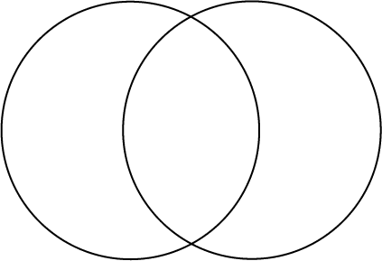

- Have you ever faked sick to get out of going somewhere? Explain in detail if you have or have not and your reasoning.

- Based on what you know, what does this line from the poem mean “My 'pendix pains each time it rains?”

10. If you had to write one more line to add to the end of this poem, what would it be?

Lesson Plan #1: Predicting/hypothesizing

Unit Objectives
- Students will predict or hypothesize as appropriate from information in the text, substantiating with specific references to textual examples that may be widely separated sections of the text. (Synthesis)
- Students will answer literal, inferential, evaluative, and synthesizing questions to demonstrate comprehension of grade-appropriate print texts, electronic and visual media. (Comprehension)

Time Period Objectives
- Students will complete their pretest.
- Students will make predictions about the story based on the title alone.
- Students will make predictions about the story as it is read to them.
- Students will hypothesize and support their hypothesis with facts.
- Students will answer questions about the text to show comprehension.

Materials
- Pretest for each student.
- Copy of “The King’s Choice” for each student.
- Whiteboard and markers.
- Paper and pencil.
- Copy of predicting worksheet for each student.
- Copy of Teacher’s Copy for teacher.

Procedure
Before the lesson begins
Students will complete the sixth grade reading process pretest to assess what they know and need to know about these state standards.
(15 minutes)

Engagement
Students will predict what the story will be about based on the title “The King’s Choice”. Briefly discuss the possibilities and allow students to come up and write their predictions on the board. (5 minutes)

Activity (Exploration and explanation)
Instruct students to take out a piece of paper and a pencil. Explain to them that they will be read the story “The King’s Choice” and then asked various questions throughout the story. Students should write the answers to the questions on their paper and not discuss them until the very end. Read the story and ask the questions as stated (See Teacher’s Copy). Discuss the predictions that the students made as the story was read to them. Also, converse about the predictions that the students made on the board before they were read the story to see if any were correct.
(20 minutes)

Summary/Closure
Ask students to clear their desks and take out a pencil.
(1 minute)

Assessment (Extension and evaluation)
Ask the students to write one paragraph about a time when they use predicting in their everyday lives. You may need to help them by giving them ideas like the sex of a sibling, the outcome to a movie, or the final grade on a test. Students will then complete the predicting worksheet for homework. (6 minutes)

*Key Questions*
1- What do you think will happen next?
2- What does it mean to predict/hypothesize?

*The predicting worksheet is not included. It consists of a scenario in which a man has allergies and has to take his son on a nature hike. Students will predict what will happen to him and what he is allergic to. I could not get it to scan.

The King's Choice
(1) KING GUSTAV trotted on horseback through the woods with his royal attendants. In less than a week he must leave his country for a long journey. But which of his six councilors should he put in charge of his land, his queen and his infant son? One of the councilors was too bossy, another too young, one given to drink, one overly concerned with money, another overly concerned with his hair, and the last one was uninspiring. Any of the councilors could rise to become a fine leader, thought the King, but which one had the necessary inner strength?
(2) Suddenly, from the river's mist a form rose and took the shape of a woman. The King ordered his train to stop.
(3) The womanly form smiled. The King relaxed. She must be a fairy, thought he, and a friendly one at that. "Sire," said the Fairy in a pleasant voice, "you will have your answer."
(4) The Fairy waved her wand. While the King's train continued to the palace, the King now stood on the ground by the river, watching a likeness of his own royal self ride on his horse toward the palace. Looking down at his clothes, the King saw that he was now dressed as a common woodcutter, and in one hand he held an axe instead of a sword. The Fairy smiled and waved her wand toward the edge of the woods. Instantly, a woodcutter's cottage appeared.
(5) "What's the meaning of all this?" demanded the King, a rage beginning to build. This Fairy may not be so friendly after all.
(6) "Your Majesty," said the Fairy in the same light, sing-song voice, "soon you will have a chance to help your six councilors. Be sure to invite them to dinner at your woodcutter's cottage three days hence."
(7) She vanished. Suddenly, the King noticed on the river a boat that was starting to rock wildly, for a windstorm had come up. By the sound of the voices on board, the King recognized the voices of his own six councilors. The wind whirled about, wrapping his woodcutter's garments tightly around him. Meanwhile, the boat nearly tipped over and the voices on board shrieked.
(8) At once, the King, a strong swimmer, dove into the river and swam toward the boat. Jumping on board, he took the oars from the rowers and managed to steer the craft safely to shore.
(9) The soaked councilors, nearly giddy with relief, stepped off the boat. They clapped the woodcutter on the shoulder, thanking him again and again for saving their lives, and asked him to name his reward.
(10) Remembering the Fairy's words and his new common status, the King bowed before them and said, "In three days I plan to host a feast in my cottage for my friends. It would do me great honor if such noble guests as yourselves you would attend."
(11) "Is that all?" said one of the councilors (the one that's too concerned with money, noticed the King).
(12) "To have noblemen such as yourselves in my home would do me a great honor," repeated the King.
(13) Later that night, restored to his kingly form, King Gustav was settling down to bed when a mist again formed before him and took the shape of a woman.
(14) "Your Highness," said the Fairy in her soft voice, "invite your councilors to a royal banquet at the palace in three days to mark your departure and to announce which councilor you have selected to rule while you're away."
(15) "I haven't yet decided which one is to rule," said that King. "Besides, they cannot come - they already committed themselves to attending the woodcutter's dinner."
(16) "Indeed," said the Fairy. She vanished.
(17) Next morning, the King summoned his six councilors.
(18) "I have been giving great thought to which one of you is best suited to assume command of the land while I'm away," said he. Each of the councilors stood up a little taller, and one of them (the one too concerned with his hair) quickly ran a comb through his hair. The King continued, "I will announce my decision at a royal banquet to be held the day after tomorrow."
(19) The six councilors nervously looked at one another, realizing the conflict in the date.
(20) One of them (the one that was uninspired) spoke up. "Of-of course, sire," said he, his eyes darting right and left. "We will be there."
(21) At banquet night, the King watched his councilors file in. One, two, three, four, five… Hmm, just five? He called the five councilors before him.
(22) "Where is Lukas?" demanded the King, referring to the youngest councilor.
(23) "He is not here," said one of the councilors (the one given to drink).
(24) "And exactly why would he not attend my banquet?" said the King, his voice rising.
(25) "Apparently he had an engagement," said another, "with a woodcutter."
(26) "A woodcutter?" shouted the King. "Bring Lukas to me at once!"
(27) An hour later, a frazzled Lukas was led before the King's throne.
(28) "Exactly where were you tonight, Lukas," asked the King sternly, pointing his ringed finger at the young man's face, "when I specifically ordered you to attend my banquet?"
(29) "I had accepted an invitation to dine with a woodcutter," said Lukas, as the five councilors tittered, "or so I thought, though when I went there tonight, the cottage that had been there only a few days ago seems to have disappeared."
(30) "Not only do you stand up the King, your own royal liege!" The King was now shouting. "But you do so to attend dinner with a woodcutter, and one whose cottage isn't even there?"
(31) "Sire, I had accepted," is all he could say.
(32) "As I accept you," said the King, his shoulders dropping and his voice softening. He lifted his infant son from his queen's lap and handed the child to his youngest councilor. "Lukas, not only did you keep a commitment you had made, but you did so even at the risk of my own royal anger. Thus, you showed the inner strength to be a true leader. While I'm away, you are the one I entrust with the affairs of my kingdom, my queen, and our royal child."

TEACHER’S COPY- THE KING’S CHOICE

Pause after paragraph 1, which ends…
…Any of the councilors could rise to become a fine leader, thought the King, but which one had the necessary inner strength?
ASK- Which of the King's councilors they think might be best suited to take the King's place.
Pause after paragraph 7, which ends…
The wind whirled about, wrapping his woodcutter's garments tightly around him. Meanwhile, the boat nearly tipped over and the voices on board shrieked.
SAY- Predict what will happen next in the story.
Pause after paragraph 18, which ends…
The King continued, "I will announce my decision at a royal banquet to be held the day after tomorrow."
SAY- Predict what will happen the next day? Who will show up for the King's royal banquet, since all of the councilors have already committed to being at the woodcutter's feast? Who might be chosen at the royal banquet to take over the King's role?
Pause after paragraph 27, which reads…
An hour later, a frazzled Lukas was led before the King's throne.
SAY- Predict what might happen next in the story.

Lesson Plan #2: Author’s Purpose

Unit Objectives
- Students will make critical comparisons across texts, noting author’s style as well as literal and implied content of text. (Analysis)
- Students will summarize the information in texts, recognizing important ideas and supporting details, and noting gaps or contradictions. (Knowledge)

Time Period Objectives
- Students will complete and discuss their anticipation guides.
- Students will follow along in the text as it is being read to them.
- Students will answer questions and explore various possibilities relating to author’s purpose.
- Students will assess their individual knowledge of author’s purpose through a short practice quiz.

Materials
- Anticipation Guides for each student.
- Literature textbook for each student.
- Paper and pencil for each student.
- Whiteboard and markers.

Procedure
Before the lesson begins
Pass out a copy of the anticipation guide to each student. Have students fill them out quietly without discussion (only the me column). In small groups of three or four students, have them discuss their answers and then mark the group column. Discuss each group’s answers and write their responses on the board. (10 minutes)

Engagement
Tell students to open up their textbooks to page 378. Read the “connecting to literature” section with the students. Briefly discuss a time when you discovered and used a new approach to a problem. Review the meaning of the vocabulary words: imitate, persisted, and sentiment before you begin reading. (5 minutes)

Activity (Exploration and explanation)
Read aloud the story “Water” on pages 379-381 in the Literature textbooks as the students follow along. When finished, ask the students what they believe the author’s purpose was. Have students go back in the text and locate the words that clue them in to the author’s feelings (joy, blossom, happier, eventful, etc.) Ask them the ‘reading skill’ questions on pages 380-381. Call on various students (even if their hand is not up). Discuss questions #5-6 on page 382. (21 minutes)

Summary/Closure
Ask students to clear their desks, take out a paper and pencil, and open their books to page 383. (1 minute)

Assessment (Extension and evaluation)
1. Students will be required to read page 385 and answer questions 1-4 and the Interpretation question. (10 minutes)

*Key Questions*
1- What purpose do the details of the text support?
2- What words indicate author’s purpose?
3- What do you think the author’s purpose is and why?
4- If you had to summarize the passage in two sentences, what would you say?



The morning after my teacher came she led me into her room and gave me a doll. The little blind children at the institution had sent it and Laura Bridgman had dressed it but I did not know this until afterward. When I played with it a little while, Miss Sullivan slowly spelled into my hand the word "d-o-1-1." I was at once interested in this finger play and tried to imitate it. When I
succeeded in making the letters correctly I was
Flushed with childish pleasure and pride. Running downstairs my mother I held up my hand and made the letters for doll. I did not know that I was spelling a word or even that words existed; I was simply making my fingers go in monkey-like imitation. In the days that followed I learned. In this uncomprehending way a great many words, among them pin, hat, cup and a few verbs like sit, stand
But my teacher had been with me several weeks I understood that everything has a name.

One day while l was playing with my new doll Miss Sullivan put my big rag doll into my lap also, spelled "d-o-l-l" and tried to make me understand that "d-o-l-l" applied to both. Earlier in the day we had had a tussle over the words "m-u-g" and "w-a-t-e-r." Miss Sullivan had tried to impress it upon me that "m-u-g" is mug and that "w-a-t-e-r" is water, but I persisted in confounding the two. In despair she had dropped the subject for the time, only to renew it at the first opportunity. I became impatient at her repeated attempts and, seizing the new doll, I dashed it upon the floor. I was keenly delighted when I felt the fragments of the broken doll at my feet. Neither sorrow nor regret followed my passionate outburst. I had not loved the doll. In the still, dark world in which I lived there was no strong sentiment or tenderness. I felt my teacher sweep the fragments to one side of the hearth,¹ and I had a sense of satisfaction that the cause of my discomfort was removed. She brought me my hat, and I knew I was going out into the warm sunshine. This thought, if a wordless sensation may be called a thought, made me hop and skip with pleasure.
We walked down the path to the well-house, attracted by the fragrance of the honeysuckle with which it was covered. Some one was drawing water and my teacher placed my hand under the spout. As the cool stream gushed over one hand she spelled into the other the word water, first slowly, then rapidly. I stood still, my whole attention fixed upon the motions of her fingers. Suddenly I felt a misty consciousness as of something forgotten—a thrill of returning thought; and somehow the mystery of language was revealed to me. I knew then that "w-a-t-e-r" meant the wonderful cool something that was flowing over my hand. That living word awakened my soul, gave it light, hope, joy, set it free! There were barriers still, it is true, but barriers that could in time be swept away.
I left the well-house eager to learn. Everything had a name, and each name gave birth to a new thought. As we returned to the house every object which I touched seemed to quiver with life. That was because I saw everything with the strange, new sight that had come to me. On entering
1. hearth (harth) n. the stone or brick floor of a fireplace, sometimes extending into the room.
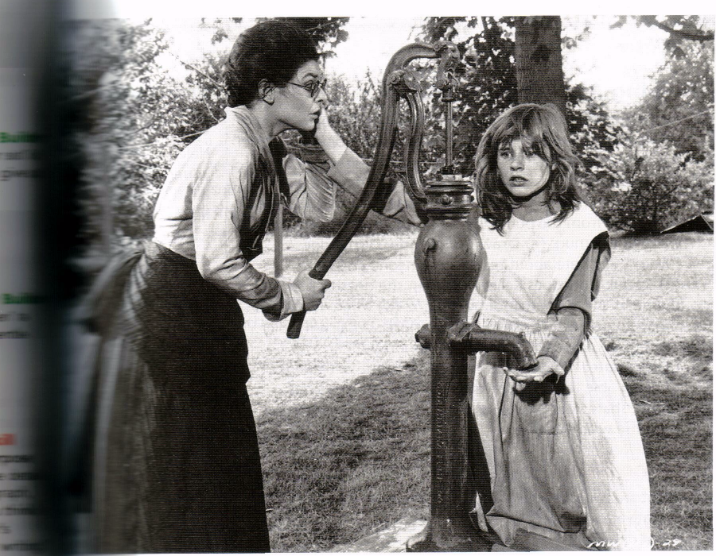

I remembered the doll I had broken. I felt my way to the heart and picked up the pieces. I tried vainly to put them together. Then my eyes filled with tears; for I realized what I had done, and for the first time I felt repentance and sorrow.
I learned many new words that day. I do not remember what they all were; but I do know that mother, father, teacher were among them—words that were to make the world blossom for me, "like Aaron's rod, with flowers”. It would have been difficult to find a happier child as I lay in my crib at the close of that eventful over the joys it had brought me, and for the first time I longed for a new day to come.

Questions About the Selection

1. Respond: Before she learned to communicate, Helen Keller shows impatience and anger by smashing her doll. Should she be excused for such behavior? Explain.

2. (a) Recall: Which event helps Helen to recognize the meaning of w-a-t-e-r? (b) Compare and Contrast: Explain how water from the pump is the same as and different from water in the mug. (c) Draw Conclusions: What does "Water" illustrate about teaching someone an idea?

3. (a) Recall: How does Keller feel when she goes to bed on the night she learned about w-a-t-e-r? (b) Infer: Why does she feel that way? (c) Draw Conclusions: What will Keller want to do when she wakes up? Support your answer.

4. (a) Evaluate: What do you think is the most valuable part of being able to communicate? (b) Discuss: In a small group, share your responses. Then, as a group, share one response with the class.

Reading Skill
5. What are two purposes Keller may have had for writing this narrative essay?

6.What details from the essay indicate each purpose?

Literary Analysis
7. What do you know about the doll breaking that you would not have known if Anne Sullivan had told the story.
ASSESSMENT PRACTICE

Directions: Read the selection. Then, answer the questions.

I don't like pickles. In fact, even thinking about pickles makes
Me crazy. Looking back, the beginning of my pickle phobia
started about seven years ago. My family and I went to a party.
Our neighbor, Mrs. Scott, brought her homemade pickles. I was four, and I couldn't reach the pickle dish. So I asked each person who came to the table to please pass me a pickle. At the of the day, my stomach felt like a big balloon that was ready to burst. I had eaten every single one of Mrs. Scott's pickles.

1) Which phrase helps the reader determine the author's purpose?
A Looking back
B Our neighbor, Mrs. Scott
C every single one
D At the end of the day

2) What is the author's general purpose for writing this essay?
A to inform
B to persuade
C to reflect on a memory
D to describe a good pickle

3) What shows that the author's purpose is to entertain?
A In fact, even thinking about pickles makes me crazy.
B My family and I went to a party.
C Our neighbor, Mrs. Scott, brought her homemade pickles.
D I couldn't reach the pickle dish.

4. What is the author's specific purpose?
A to share a personal experience
B to tell why pickles are dangerous
C to describe good pickles
D to describe a bad stomachache
Timed Writing: Interpretation [Critical Stance]

Review "Water". Identify the author's purpose his or her specific message. Support your interpretation with from the work.

Lesson Plan #3: Compare/Contrast using Graphic Organizers

Unit Objectives
- Students will select, create, and use graphic organizers to interpret information in texts (Comprehension)
- Students will make critical comparisons across texts, noting author’s style as well as literal and implied content of text. (Analysis)

Time Period Objectives
- Students will use previous knowledge to connect words on the whiteboard and discuss them.
- Students will follow along in their Literature books and answer questions regarding the text.
- Students will help the teacher fill in a Venn diagram comparing/contrasting teams in the story “Race to the End of the Earth”.
- Students will take a short quiz on comparing and contrasting and fill in their own Venn diagram for homework.

Materials
- Literature textbooks for each student.
- Paper and pencil.
- Copy of Venn Diagram for each student.
- Whiteboard and markers.
- Overhead projector and markers.

Procedure
Before the lesson begins
Have students clear their desks. (1 minute)

Engagement
Write the words compare/contrast, graphic organizers, and similarities/differences on the board. Discuss as a group what each term means and what they all have in common. Lead them toward the conclusion that you can use a graphic organizer called a Venn Diagram to compare/contrast the similarities/differences in things. (5 minutes)

Activity (Exploration and explanation)
Tell students to take out their Literature books and open to page 308. Read page 308 to the students as they follow along in their books. Explain to students the importance of reading comparison-and-contrast articles. Give them an opportunity to share a magazine article they read or advertisement they saw comparing two things. Read “Race to the End of the Earth” to the students on pages 309-312. Ask the students the questions in the margins as you read through the story. Allow them to respond as needed. When finished reading, pass out the Venn diagrams to each student. Briefly discuss the various ways in which each team carried out the expedition. Compare and contrast each team’s journey using the Venn diagram. Have the students watch as you fill in the diagram together. (25 minutes)

Summary/Closure
When finished with all possible answers, have students take out a piece of pencil and their textbook. (1 minute)

Assessment (Extension and evaluation)
Have students do page 313 #1-5 (quiz) and give them a blank Venn diagram. For homework, have the students create their own Venn diagram. Tell them they may compare/contrast a decision they are trying to make, members of their family, cats vs. dogs, Michigan vs. Ohio state, etc.
(15 minutes)

*Key Questions*
1- What do compare/contrast, graphic organizers, and similarities/differences all have in common?
2- What is a Venn diagram used for?

Name____________________________
Date______________ Period_________

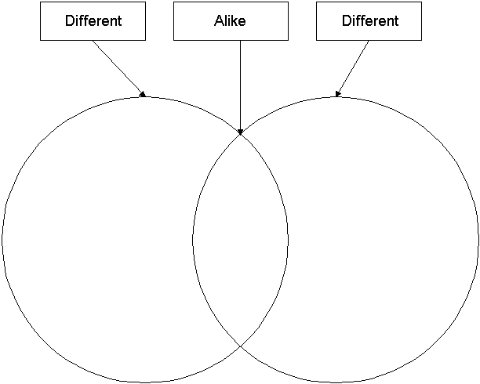
Directions: Fill out the Venn diagram using any topic you would like.

Reading Informational Materials
Comparison-and-Contrast Articles

In Part 2, you are learning to compare and contrast. Comparison-and-contrast-organization is also used in some nonfiction. If you read "The King of Mazy May," you may enjoy this article about two explorers who raced each other in a similar setting.

About Comparison-and-Contrast Articles
A comparison-and-contrast article is expository writing that identifies and examines similarities and differences. There are two common ways of organizing these articles.

• Block organization: The writer presents all the details of one subject, then all the details of the other subject.

• Point-by-point organization: The writer presents one detail about both subjects and then presents another detail about both subjects.

The writer of "Race to the End of the Earth" uses elements of block and point-by-point organization to describe two men who competed to reach the South Pole first. The article compares and contrasts the men's backgrounds, how they prepared for the trip, and what strategies they used to reach their goals.

Reading Skill
Read comparison-and-contrast articles critically by identifying and analyzing the organization. Use the pattern—block or point-by-point—to find and understand the author's main points about how the subjects are alike and different. Then analyze the information by breaking it into parts or categories. Evaluate comparisons in the article by asking yourself questions like the ones in the chart.

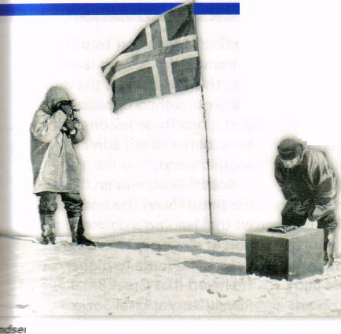
Race to the End of the Earth
William Q. Scheller

Two explorers competed against each other and a brutal environment to reach the South Pole.
The drifts were so deep and the snow was falling so heavily that the team of five Norwegian explorers could hardly see their sled dogs a few feet ahead of them. Behind rose a monstrous mountain barrier. The men had been the first to cross it. But now they and their dogs were stumbling toward a stark and desolate plateau continually blasted by blizzards. The landscape was broken only by the towering peaks of mountains that
lay buried beneath a mile of ancient ice. Led by Roald Amundsen, the men were still 300 miles from their goal': the South Pole.
On that same day, a party of 14 British explorers was also struggling across a similarly terrifying landscape toward the same destination. But they were almost twice as far from success. Their commander was Capt. Robert Falcon Scott, a naval officer. Amundsen was Scott's rival.
Both expedition leaders had long been preparing for their race to the South Pole. Amundsen came from a family of hardy sailors, and he had decided at the age of 15 to become a polar explorer. He conditioned himself by taking long ski trips across the Norwegian countryside and by sleeping with his windows open in winter.
By the time of his South Pole attempt, Amundsen was an experienced explorer. He had sailed as a naval officer on an expedition in 1897 that charted sections of the Antarctic coast. Between 1903 and 1906 he commanded the ship that made the first voyage through the Northwest Passage, the icy route that threads its way through the Canadian islands separating the Atlantic and Pacific Oceans. During that long journey Amundsen learned how the native people of the Arctic dress and eat to survive in extreme cold. He also learned that the dogsled was the most efficient method of polar transportation. These lessons would serve him well at Earth's frozen southern end.
Robert Scott was an officer in the British Navy. He had decided that leading a daring expedition of discovery would be an immediate route to higher rank. He heard that Great Britain's Royal Geographical Society was organizing such an exploration, and he volunteered in 1899 to be its commander. Now he was in command again.

The two expedition leaders had different styles. Scott followed a British tradition of brave sacrifice. He felt that he and his men should be able to reach the South Pole with as little help as possible from sled dogs and special equipment. He did bring dogs to Antarctica, as well as 19 ponies and three gasoline-powered sledges, or sturdy sleds. But his plan was for his team to "man-haul," or carry, all of their own supplies along the final portion of the route.

Roald Amundsen had spent much time in the far north, and he was a practical man. He'd seen how useful dogs were to Arctic inhabitants. He would be traveling in one of the most dangerous places on Earth, and he knew that sled dogs would be able to get his oarty all the way to the South ~ Die and make a safe return. Amundsen also placed great faith in skis, which he and his Norwegian team members had used since childhood. The British explorers had rarely used skis before this expedition and did not understand their great value. The two leaders even had different ideas about diet. Scott's men would rely on canned meat. But Amundsen's plan made more sense. He and his men would eat plenty of fresh seal meat. Amundsen may not have fully understood the importance of vitamins, but fresh meat is a better source of vitamin C, which prevents scurvy, a painful and sometimes deadly disease.
The Race Is On! After making long sea voyages from Europe, Scott and Amundsen

set up base camps in January on opposite edges of the Ross Ice Shelf. Each team spent the dark winter months making preparations to push on to the Pole when spring would arrive in Antarctica. Amundsen left base camp on October 20, 1911, with a party of four. Scott, accompanied by nine men, set off from his camp 11 days later. Four others had already gone ahead on the motorized sledges.
Scott's Final Diary Entry
Things went wrong for Scott from the beginning. The sledges broke down and had to be abandoned. Scott and his men soon met up with the drivers, who were traveling on foot. Blizzards then struck and lasted several weeks into December. Scott's ponies were proving to be a poor choice for Antarctic travel as well. Their hooves sank deep into the snow, and their perspiration froze on their bodies, forming sheets of ice. (Dogs do not perspire; they pant.) On December 9, the men shot the last of the surviving weak and frozen ponies. Two days later Scott
sent his remaining dogs back to base camp along with several members of the expedition. Over the next month, most of the men returned to the camp. Scott's plan from here on was for the five men remaining to man-haul supplies the rest of the way to the Pole and back.
For Scott and his men, the journey was long and brutal. To cover only ten miles each day, the team toiled like dogs—like the dogs they no longer had. Food and fuel were in short supply, so the men lacked the energy they needed for such a crushing task.
Roald Amundsen's careful planning and Arctic experience were paying off. Even so, there's no such thing as easy travel by land in Antarctica. To the men who had just crossed those terrible mountains, the Polar Plateau might have looked easy. But Amundsen's team still had to cross a
long stretch they later named the "Devil's Ballroom." It was a thin crust of ice that concealed crevasses, or deep gaps, that could swallow men, sleds, and dogs. Stumbling into one crevasse, a team of dogs dangled by their harnesses until the men could pull them up to safety.
Reaching the Goal
On skis, with the "ballroom" behind them and well-fed dogs pulling their supply sleds, Amundsen and his men swept across the ice. The going was smooth for them, and the weather was fine. The Norwegians' only worry was that they'd find Scott had gotten to the Pole first. On the afternoon of December 14, 1911, it was plain that no one was ahead of them. At three o'clock, Amundsen skied in front of the team's sleds, then stopped to look at his navigation instruments. There was no point further south. He was at the South Pole!
Assessment Practice

Directions: Choose the letter of the best answer.

1. Which statement accurately identifies a
similarity in the backgrounds of Amund-
sen and Scott?
A They were both Norwegians.
B They were both naval officers.
C They were both excellent skiers.
D They had both taken voyages through the Northwest Passage.

2. Which is a major difference between the men?
A .Amundsen was more experienced at exploring icy settings.
B Scott was more experienced at exploring icy settings.
C Amundsen brought sled dogs, but Scott did not.
D Amundsen brought ponies and sledges, but Scott did not.

3. Which statement accurately describes a difference that had a great effect on the outcome of the race?
A Amundsen was Norwegian, and Scott was British.
B By winning the race, Amundsen hoped to gain fame as an
explorer, but Scott wanted to write a book.
C Scott decided his men would carry most of the supplies, but
Amundsen decided to use dog sleds.
D Scott decided that his men would use skis, but Amundsen decided to use motorized sleds.

Comprehension and Interpretation
Write your answers on a separate sheet of paper.

4. Contrast the strategies used by each team. [Organizing]

5. Evaluate the organization of "Race to the End of the Earth."
Comment on the balance of details and the effectiveness of support for the comparisons and contrasts. [Evaluating]

Name_______________________ Date________ Period___
6th Grade Post-test -- Reading Process

Directions: Read the passage and answer the questions below.
The Ohio State University/University of Michigan rivalry in football began with their first game in 1897. UM won that game 34 to 0 and dominated the series until 1919. That year the tables were turned and the Buckeyes won 13 to 3. The Ohio State/Michigan game has always been important, but it was not always the last game of the season. This practice began in 1935 and, except for one year, the tradition has continued. Often the game has determined who is the winner of the Big Ten and who will represent the conference in the Rose Bowl. An ESPN poll rated the rivalry as the greatest of all time. “Ohio State/Michigan Week” has grown beyond the football game to include the annual blood battle, which benefits the Red Cross, food collection for food banks, and spirit events such as banner contests. OSU and UM have turned the rivalry into an event that helps people across school lines.

  - What is the author’s purpose of writing? Explain your answer in detail.

  - What kinds of details are emphasized?

  - What does the game determine?

  - What does the game mean to the local community?


  - What is the author’s purpose of this advertisement?

  - Why do you think this person was chose for this advertisement? What is the author’s influence?

Tammy and Kara were getting ready for the surprise party. Kara grabbed a long sheet of paper and spread it out across the living room floor. Kara wrote Happy Birthday in big bold letters. Tammy yelled into Kara “We need to hurry up Kara.. . Cindy will be here in fifteen minutes and the guests are already starting to arrive”. The girls looked around with wide eyes. . . the house was a disaster.

  - Predict what the girls will do next.

  - What do you predict Kara will do with the sign?

  - What is one detail that would change your prediction about whether the girls will be ready for the party?

9) Fill in the Venn diagram comparing/contrasting elementary school to middle school.

______________________________

- Summarize the four reasons author’s write.

References

Donoghue, M.R. (2008). Language arts: Integrating skills for classroom teaching.
Sage publications Inc.

Education World. (2007). EdGate (Web Site). Retrieved June 7, 2009 from: http://www.education-world.com/a_lesson/

Houghton Mifflin Harcourt (2000). Education Place (Web Site). Retrieved May 22, 2009 from: http://www.eduplace.com/graphicorganizer

Prentice Hall Literature: penguin edition.(2007). Upper Saddle River, New Jersey: Pearson Education, Inc

Quickflix. (2009). Blogspot picture (Web Site). Retrieved June 7, 2009 from:
http://blog.quickflix.com.au/2009/04/wolverines-got-milk-moustache.html

The Regents of the University of Michigan.(2002). Bentley Historical Library (Web Site). Retrieved June 7, 2009 from: http://bentley.umich.edu/athdept/football/football.htm

