3-Dimensional Shapes and Volume Worksheet
Name ___________________________________ Date _____________________
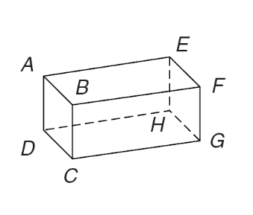
Identify the 3-dimensional object.
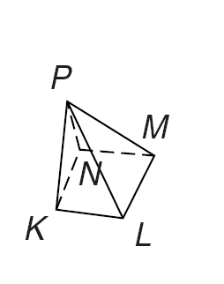
1. 2.

Number of bases: Number of bases:
Shape of base: Shape of base:
Number of faces: Number of faces
Name of object: Name of object:

3. Bernie is thinking of a three-dimensional object.
- The object has 4 faces.
- All the faces on the object are congruent.
Which figure is Bernie thinking of?
 | A. | triangular prism
 | B. | triangular pyramid
 | C. | cone
 | D. | square pyramid

4. Paul is building a three-dimensional object.
- The object has 6 faces.
- All the faces on the object are congruent.
What is the shape of the object that Paul is building?
 | A. | square pyramid
 | B. | cube
 | C. | triangular pyramid
 | D. | triangular prism

5. Alfonso is thinking of a three-dimensional object.
- The object has 6 faces.
- The object has 12 edges.
- The faces of the object are not all congruent.
Which figure is Alfonso thinking of?
 | A. | square pyramid
 | B. | cube
 | C. | rectangular prism
 | D. | triangular pyramid

Part 2: Find the volume of the following shapes.

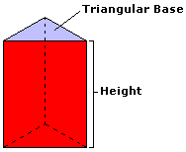
6. The area of the triangular base of the prism above is 10 cm². The height of the prism is 7 cm. What is volume of the prism?
 | A. | 27 cm³
 | B. | 490 cm³
 | C. | 88 cm³
 | D. | 70 cm³
 | E. | 108 cm³

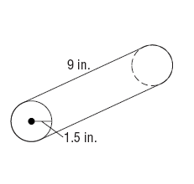
7. 8.
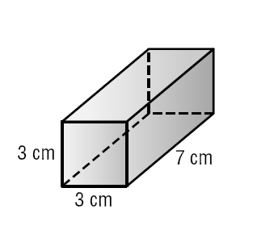

9. If X=8 inches, Y=14 inches, and Z=3 inches, what is the volume of the box?
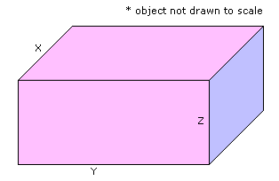
 | A. | 1,120 cubic inches
 | B. | 25 cubic inches
 | C. | 224 cubic inches
 | D. | 112 cubic inches
 | E. | 336 cubic inches

10. If X=8 inches and Y=14 inches, what is the volume of the cylinder to the nearest cubic inch?
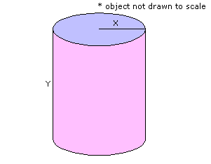
 | A. | 1,692 cubic inches
 | B. | 4,578 cubic inches
 | C. | 201 cubic inches
 | D. | 703 cubic inches
 | E. | 2,813 cubic inches

