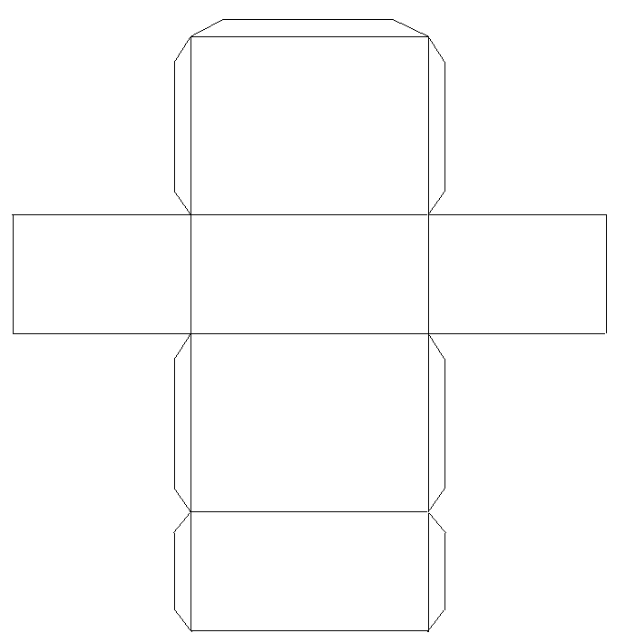
Find the length and width of each rectangle in this rectangular prism. Then find the area of each rectangle.
Did you notice any similarities between any of the area and dimensions of any of the rectangles? If so, explain.

Add up all of the areas of the rectangles. What is the sum of the areas?

Can you come up with a shorten way to add up the areas of the rectangles?

