Pythagorean Theorem Worksheet

Name__________________________________ Date ________________________
Find the square of each number.
1. 8 2. 20 3. 32

Find the square root of each number.
4. √100 5. √441 6. √3,600

Solve for x.
7. What value for x makes the equation true?
x = 7

8. What value for x makes the equation true?
x² = 169
9. What value for x makes the equation true?
x = 3
Find the missing measure of each right triangle. Round to the nearest tenth if necessary.
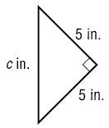
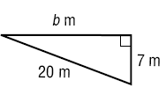
10. 11.

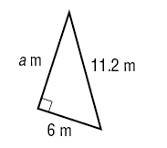
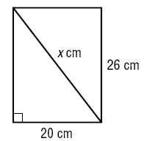
12. 13.

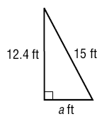
14. 15.
COMPUTERS In a computer catalog,
a computer monitor is said to be 19 inches. This distance is the diagonal distance across the screen. If the screen is 10 inches high, what is the width of the screen? Round to the nearest tenth.

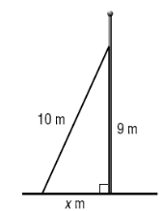
16.
ANTENNAS A wire 10 meters long is
supporting a utility pole. The wire is
anchored to the ground and is attached
to the pole 9 meters above the ground.
What is the distance from the bottom of
the pole to the point where the wire is
attached to the ground? Round to the
nearest tenth.

