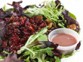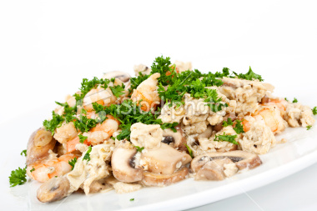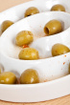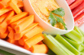Carbohidratos

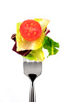C:\Documents and Settings\USER\Escritorio\ADRIANA\ist1_8844947-spinach-salad-zoom[1].jpg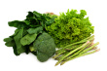Carbohidratos