Instructional Design
English Language Learners

By
Kathybel Ortiz
EDTL 710
BGSU
J. Haney

March 29, 2009

Rationale for English Language Learners Unit
Today more than ever educators face the challenge of the realization that school populations across many urban cities are vastly becoming multicultural in ethnicity and bilingual education. Overall, the United States school population ethnic makeup has demised from solely being a monolingual cultural society. Instead, teachers who lack experience and training in working with linguistically and culturally diverse students must make a commitment to address student needs by learning strategies that can fulfill the dual function of presenting academic content while also providing opportunities for English language learners to develop their language skills naturally. Diversity in our classrooms represents opportunities for expanding ideas and cultural exchange among students. Teachers must embrace the educational benefits attained through understanding how diversity enhances the learning experience of English language learners especially when striving toward a global perspective in a multicultural classroom.
The demand on teachers working with linguistically diverse students is further compounded by having to address academic content standards, implementing the curriculum, and increased achievement on standardized test all while learning a second language. A way to address that challenge is through effective lesson planning. Depending on their different stages of English proficiency and literacy, English language learners will benefit from the skills that a well-designed lesson can address. Effective lessons plans for English language learners should include: building background knowledge, explicit instruction and modeling, guided practice, peer practice, and assessment of content learned. Although, English language learners in any given classroom may range at varying stages of proficiency; it is not necessary for every student to understand every word rather be immersed in a language rich environment.

ENGLISH LANGUAGE PROFICIENCY STANDARDS

Listening Standards in English for ELL Students
1. ELL students will develop the English listening skills required both for academic achievement and for communication in socially and culturally appropriate ways.
1.1 Comprehend spoken instructions
1.2 Identify main ideas and supporting details of spoken English
1.3 Determine speaker attitude and point of view
1.4 Comprehend the meaning of academic and/or specialized vocabulary when spoken
1.5 Make inferences and predictions when listening to speakers

Speaking Standards in English for ELL Students
2. ELL students will develop the English speaking skills required both for academic achievement and for communication in socially and culturally appropriate ways.
2.1 Speak fluently, using clear pronunciation and with appropriate intonation and stress
2.2 Speak using appropriate grammar and vocabulary
2.3 Speak for varied purposes, both formal and informal, with focus, relevance and cohesion

Reading Standards in English for ELL Students
3. ELL students will develop the English reading skills required both for academic achievement and for communication in socially and culturally appropriate ways.
3.1 Demonstrate reading strategies
3.2 Identify the meaning of written vocabulary
3.3 Read with comprehension
3.4 Read for varied purposes

Writing Standards in English for ELL Students
4. ELL students will develop the English writing skills required both for academic achievement and for communication in socially and culturally appropriate ways.
4.1 Write using appropriate conventions and grammar
4.2 Write for varied purposes and audiences, with appropriate tone and voice, using various media
4.3 Write using the writing process
4.4 Write using a range of vocabulary, sentence structures and verb tenses
INSTRUCTIONAL SUBUNIT
English Language Learners (ELL)
UNIT OUTCOMES

Subunit One: Listening
- The ELL student will apply listening skills when given simple oral directions in English. (Analysis)
- The ELL student will evaluate verbal and nonverbal cues when listening for meaning in English. (Synthesis)
- The ELL student will decode "chunks" of words when listening in conversation. (Analysis)
- The ELL student will identify key vocabulary words to construct meaning when listening to read aloud story. (Analysis)
- The ELL student will apply main ideas in the story supported by visuals cards. (Application)
- The ELL student will practice listening through repetition of story in audio text. (Application)
- The ELL student will evaluate a variety of media for understanding of language in context. (Synthesis)
Subunit Two: Speaking
- The ELL student will communicate through English language to convey feelings, needs, or wants. (Application)
- The ELL student will articulate clarification of oral directions when unclear.( Application)
- The ELL student will apply basic vocabulary words in context.( Application)
- The ELL student will ask questions using who, what, where, when, why.( Analysis)
- The ELL student will practice pronunciation of common words. (Application)
- The ELL student will restate main ideas with familiar words or phrases. (Comprehension)
Subunit Three: Reading
- The ELL student will differentiate reading for a variety of purposes such as narrative or expository text. (Analysis)
- The ELL student will apply learned to vocabulary to context for meaning. (Application)
- The ELL student will analyze contextual clues, pictures, and charts for meaning when reading.( Analysis)
- The ELL student will decode simple text for independent reading. (Analysis)
- The ELL student will demonstrate fluency and comprehension of content reading material. (Comprehension)

Subunit Four: Writing
- The ELL student will create simple sentence structures selecting key vocabulary words. (Synthesis)
- The ELL student will consider writing for a variety of purpose and audience. (Synthesis)
- The ELL student will develop a short writing prompt using a graphic organizer. (Synthesis)
- The ELL student will compare and contrast native language and English using a Venn diagram.(Evaluation)

PRE-ASSESSMENT SURVEY

“What I Like About My Family”

 |  | Always | Sometimes | Never
I like to learn with my family.
I like talk to my family.
I talk to my grandpa.
I like to laugh with my mother.
I like my family.
I play with my brother and sister.
I like to laugh with my family.
I like to sing with my father.
I like to learn new words.
I like to listen to my friends.
I like dance with my family.
I like to walk with my family.
I like my home.

Lesson Plan – Day One
Unit Outcome:
The ELL student will apply basic vocabulary words in context. (Application)
The ELL student will identify key vocabulary words to construct meaning when listening to read aloud story. (Analysis)
Objectives:
- The ELL student will describe basic vocabulary words associated with families.
- The ELL student will talk about activities they enjoy with their family.
Materials:
- Pre-assessment Survey- used to introduce “Family Unit”
- Picture cards of families
- Notebooks/writing journals
- Graphic Organizer
- Chart paper/Smartboard
- My Family and I / Mi familia y Yo by Gladys Rosa Mendoza
Introduction (10 minutes)
- The teacher will build background by having students complete the pre-assessment to elicit discussion about families.
- The teacher will build background by introducing and previewing the vocabulary words: family, sisters, brothers, people, baby, new, laughing, singing and home with the picture cards.
- The students will repeat the new vocabulary words and write then on their journals.
Activity (20 minutes)
- The teacher will preview the book My Family and I/Mi Familia y Yo by asking predicting questions- what do we think this book will be about?
- The teacher will read the book as the students listen for comprehension. The teacher will pantomime the actions described so that the students may infer meaning from the pictures as well as the actions in the story. The teacher will check for understanding by asking the following questions.
Key Questions for ELL to illicit conversation
~Who are the people in this family?
~What do they like to do with their family?
~How is their family the same/different as your family?
- The teacher will use chart paper to ask the students who are members of their family. The teacher will create a graphic organizer People in Families such as mother, father, brother, sister, etc. to enrich the vocabulary and promote discussion.
- The teacher will ask students to describe what they like to do with their family.
- The teacher will use Total Physical Response (TPR) to have students participate in conversation. What do you like to do with your family?
“I like to eat with my family.” (the teacher pantomimes eating motion and students repeat)
”I like to dance with my family.” (the teacher pantomimes dancing motion and students repeat)
- The teacher will guide students to write about a favorite family activity they enjoy in their journals.
Assessment: (10 minutes)
- The beginning student will respond nonverbally with picture cue cards, drawing, or vocabulary word bank in journal.
- The intermediate student will respond with one-word answers and graphic organizer in journal.
- The advance student will respond with phrases and sentences in graphic organizer in journal.

What does my family like to do?
Who is in my family?

People
in my
Family
Lesson Plan – Day Two
Unit Outcome: The ELL student will apply basic vocabulary words in context. (Application)
Objectives:
- The ELL student will use prior knowledge to develop meaning in English.
- The ELL student will describe basic vocabulary words associated with families.
- The ELL student will practice speaking in the present tense, a basic language structure.
Materials:
- Picture cards of families
- Action Word cards (talking, walking, running, sleeping)
- Notebooks/writing journals
- Action Words Handout
- Chart paper/Smartboard
- My Family and I / Mi familia y Yo by Gladys Rosa Mendoza

Introduction (10 minutes)
- The teacher will revisit the book, My Family and I / Mi familia y Yo and the students will identify objects and people in the story.
- The teacher will say: “I see a table.”
- The students will repeat the sentence, adding the name of another person or object to the end of the sentence. (ex. I see a father clapping.)
Activity (20 minutes)
- The teacher will pantomime talking on the phone and say: “I am talking on the phone to my brother”
- The teacher will explain to student that when they want to talk about an action that is happening now, they should use as form of the helping word be, followed by an action word with an –ing ending.
- The teacher will write the forms of be on the board and the action words talking, walking, and running.
- The teacher will use TPS the action and model forming sentences in the present progressive tense for students. “I am walking to my home”, “I am running to play outside.
- The students will repeat the action sentences through TPS. The students will take turns pointing to and telling what the family members are doing at the end of the story. (ex. They are laughing. He is singing.)
- The students will create and write sentences describing actions words in journals.
- The students will complete the worksheet matching action words and then practice conversation with a partner of at least five action phrases.
Assessment: (10 minutes)
- The beginning student will pantomime action words.
- The intermediate student will respond with one-word answers.
- The advance student will respond with phrases and sentences that describe action words.

Draw a line to the word that describes the action then in teams act out the action and have your team members guess which action phrase it is.

Lesson Plan – Day Three
Unit Outcome: The ELL student will differentiate reading for a variety of purposes such as narrative or expository text. (Analysis)
Objectives:
- The ELL student will determine a purpose for listening.
- The ELL student will listen to text read aloud to enjoy and appreciate language.
- The ELL student will apply vocabulary in context.
Materials:
- Magazine cut out picture cards of families
- Notebooks/writing journals
- Family Tree Diagram
- Chart paper/Smartboard
- Families, Families (poem)
Introduction (10 minutes)
- The teacher will write the Families, Families poem on chart paper and have the students echo read each line with the teacher.
- The students will reread the rhyme, and monitor their ability to read the words on their own.
- The students will point out words that describe different kinds of families.
Activity (20 minutes)
- The teacher will develop prior knowledge asking students to share what they know about poems.
- The teacher will tell students that some poems rhyme and other do not rhyme. The teacher will tell students that poems used words to help readers form mind movies.
- The teacher will ask questions to guide students’ understanding. “What do you think the poem is about?” “Name some people in a family.” “Do the people in these pictures look happy? How can you tell?”
- The teacher will explain the meaning of relationships to the students. The teacher will explain that a family tree show how people in a family are related.
- The teacher will elicit active listening strategies to help students set a purpose for listening. “I will listen for sounds, word, and rhythm so I can enjoy this poem.”
- Have students read the poem aloud in whole group for fluency.
- Students will work in teams to write a poem about their families. They begin with a prompt that describes their own family. (Ex. In families, there are birthday parties…)
- Then students can begin creating a family tree about their own family.
Assessment: (10 minutes)
- The beginning student will echo read to identify family members.
- The intermediate student will create and apply some elements of a poem.
- The advance student will respond with sentences that describe their family in a poem and create a family tree.

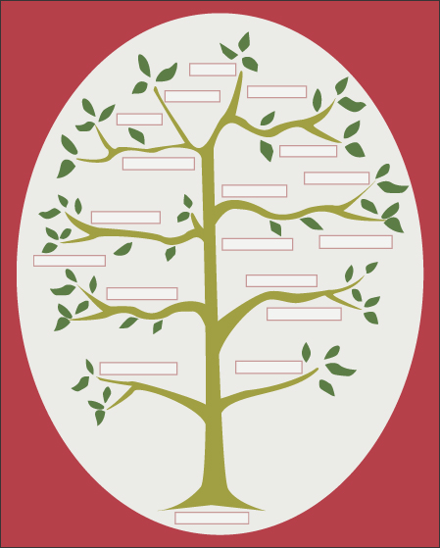

Lesson Plan – Day Four
Unit Outcome: The ELL student will practice listening through repetition of story in audio text. (Application)
The ELL student will evaluate a variety of media for understanding of language in context. (Synthesis)
Objectives:
- The ELL student will develop vocabulary through reading in context.
- The ELL student will create a Venn Diagram compare/contrast families.
Materials:
- Magazine cut out picture cards of families
- Notebooks/writing journals
- Venn Diagram
- Little House on the Big Woods by Laura Ingalls Wilder
- http://www.youtube.com/watch?v=3vo3aFvD0fE&feature=related (Little House on the Prarie)
- Chart paper/Smartboard
Introduction (10 minutes)
- The teacher will read a short excerpt from the novel Little House on the Big Woods showing the illustrations to the students.
- The teacher will build background by discuss the setting of the story.
- The students will view a youtube video clip from Little House on the Prairie to compare families then and now.
Activity (20 minutes)
- The teacher will create a list of similarities and differences of families in the past and present.
- The students will ask questions that compare and contrast similarities and differences within family.
- The students will discuss in teams how their families are the same from the novel and different from the novel.
- The teacher will facilitate teams through modeling on chart paper using the Venn diagram.
- The students will share a sentence of how families were the same or different.
Assessment: (10 minutes)
- The beginning student will with picture cards and drawing of past and present families.
- The intermediate student will create and apply some elements of the Venn diagram.
- The advance student will respond with sentences and phrases in a Venn diagram that compare/contrast families of the past and today.
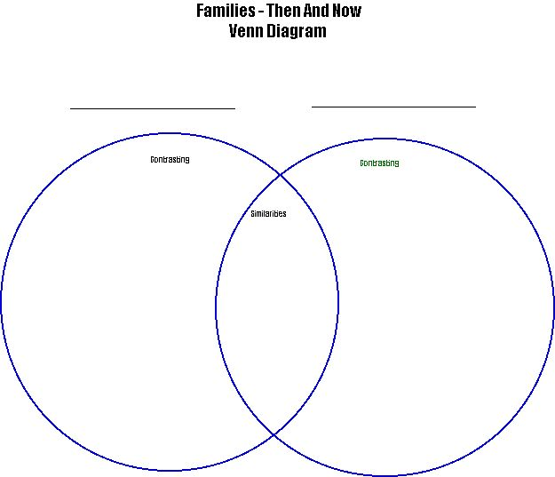
Lesson Plan – Day Five
Unit Outcome: The ELL student will differentiate reading for a variety of purposes such as narrative or expository text. (Analysis)
Objectives:
- The ELL student will use a pre-writing strategy to develop a writing prompt.
- The Ell student will write a narrative paragraph about families.
Materials:
- Magazine cut out picture cards of families
- Action vocabulary Words
- Notebooks/writing journals
- We Are Family (song)
- Independent reading books (level 1)
Introduction (10 minutes)
- The teacher will play the song We Are Family to the whole class.
- The students will chant the chorus with the teacher.
- The teacher will write “we are family” on chart paper.
Activity (20 minutes)
- The teacher will review with students the pictures that show family members engaged in different activities. (ex. Mom is cooking. Dad is washing the car.)
- The students will use the vocabulary to complete the cloze statements.
- The teacher will write: There are _______________ members in my family.
- The teacher will write: My family is special because __________________.
- In teams, students will describe actions that make their families special. Then those teams will orally share and pantomime the actions. (ex. My family is special they love me. My family buys me clothes.)
- The student will practice for fluency with their team.
- Then the student will use the writing prompt to develop the writing final piece.

Assessment: (10 minutes)
- The beginning student will with picture cards and drawing of families.
- The intermediate student will create and apply some elements of the writing prompts.
- The advance student will respond with sentences and phrases in a paragraph.
-------------------------------------------------------------------------------------

Students will create a card for their family telling them why they are special to them.
My family is special because……………

POST-ASSESSMENT SURVEY

“What I Like About My Family”

 |  | Always | Sometimes | Never
I like to learn with my family.
I like talk to my family.
I talk to my grandpa.
I like to laugh with my mother.
I like my family.
I play with my brother and sister.
I like to laugh with my family.
I like to sing with my father.
I like to learn new words.
I like to listen to my friends.
I like dance with my family.
I like to walk with my family.
I like my home.

Assessments
English language learners benefit most from assessments that are performance based. Teachers should use observation and inform conversation with student to determine where they are and how much progress they have made. As students work individually, in pairs or in small group, it is important to balance both independence and language support. Teachers can monitor students understanding by asking them to paraphrase what they have just learned. Teachers need to provide many opportunities for practice of new language patterns, concepts, and vocabulary acquisition. In the classroom, it is critical to allow for extensive student interaction in native language when needed for clarification of meaning. Teachers must elicit responses in ways that do not always require oral response so that beginning students may feel comfortable participating. The portfolio assessment provides a diverse snapshot of the ELL academic and social language development in the over time.

