C-Map Unit
Carie Likavec
BGSU

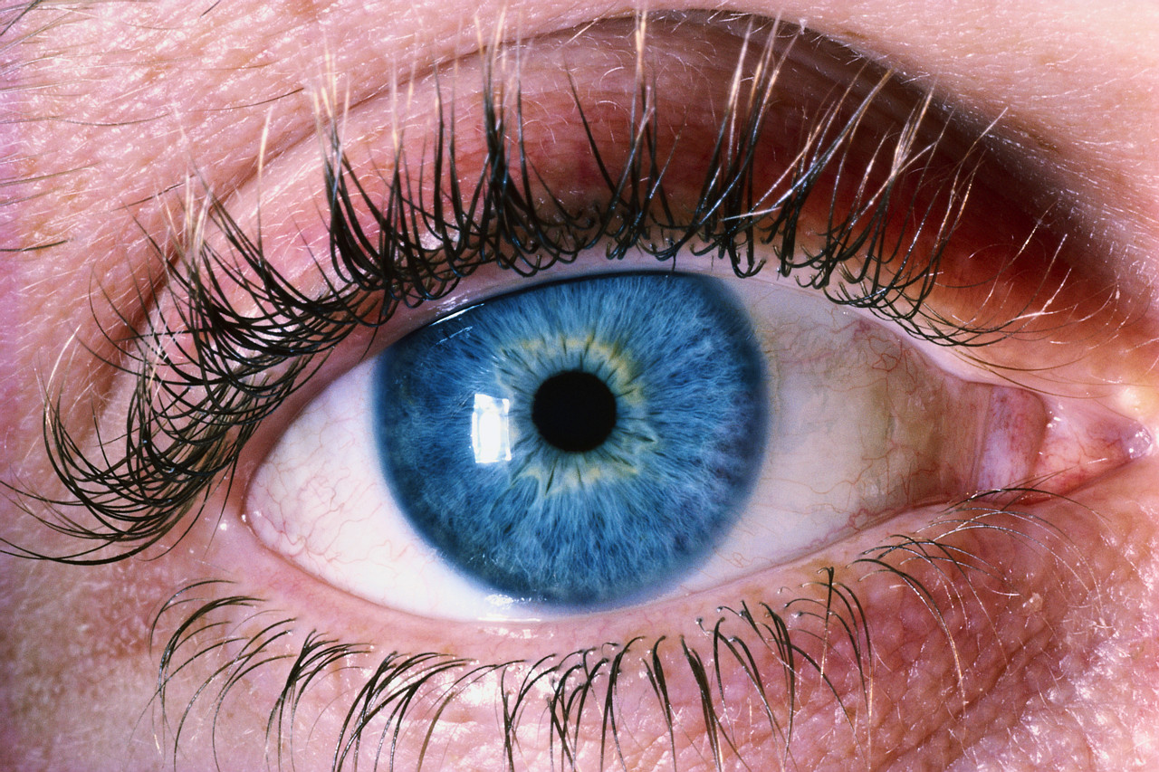
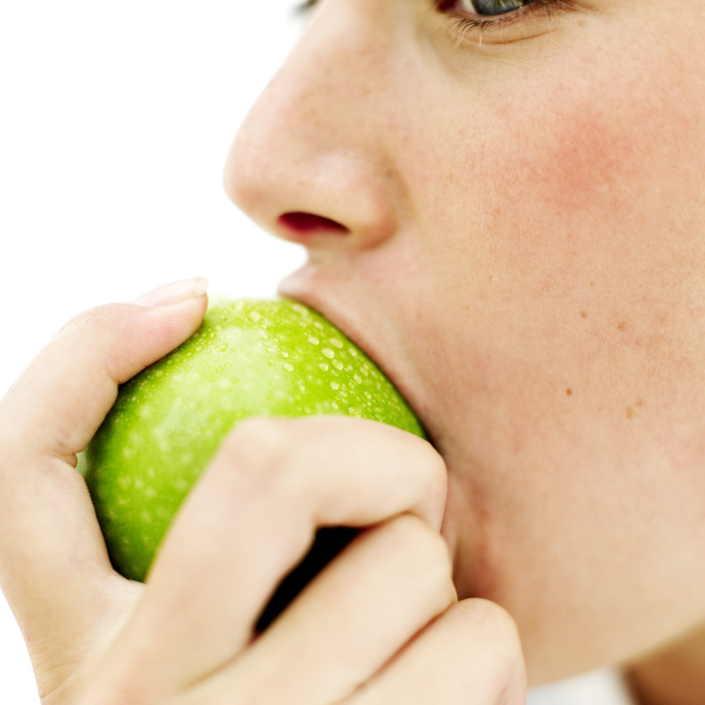


The Five Senses

Senses Unit
Lesson 1

Name: Judith Kelly/Carie Likavec Instructional Time Used: 40 minutes

Lesson Objective(s): By the end of the lesson, the students will be able to identify the five body parts (eyes, ears, nose, mouth, fingers) and their function.

Academic Content Standard: Scientific Ways of Knowing
Benchmark: A
Functional Curriculum: F1HS

Activity/Procedures:

- Introduction: Discuss what our five senses are and what we use them for. Also, ask what body parts we use our senses for.
- Pass out index cards and have students write vocabulary words (eyes, fingers, mouth, nose, ears).
- Have non writers/readers match vocabulary cards with words/pictures that are already shown.
- Put vocabulary words into individual baggies.
- Have students color the cover page with body parts on it and put names on the page.

Closure: Discuss how next lesson we will be doing an experiment using our noses to smell.

Materials Needed:
- Packet of Senses Unit
- Index Cards
- Baggies
- Pencils

Assessment: I will assess them by reviewing the vocabulary words and what five senses we have.

Self Reflection and Evaluation;
- How did the lesson flow?

- Did the students enjoy the lesson?

- Did they comprehend the concepts?

- Were my directions clear and understandable?

- What could use improvement?

Senses Unit
Lesson 2

Name: Judith Kelly/Carie Likavec Instructional Time Used: 40 minutes

Lesson Objective(s): Students will guess the five body parts function relating to the five senses.

Academic Content Standard: Scientific Inquiry
Benchmark: A
Objective: 1
Functional Curriculum: MS1

Activity/Procedures:
Remind students what “function” is
- Using the chart, ask the students:
  - “What is the body part’s function?”
  - “What does each body part do?”
  - “When do we use our eyes, ears, nose, tongue/mouth, skin/fingers?”

- Record their answers in the first column of the chart.

Closure: Discuss how we are going to be doing some activities that will give us these answers and next lesson we will be doing an eye station.

Materials Needed:
- What Is the Body Part’s Function chart

Assessment: Use the chart to guide lessons, as well as, to see what the students already know.

Self Reflection and Evaluation;
- How did the lesson flow?
- Did the students enjoy the lesson?
- Did they comprehend the concepts?
- Were my directions clear and understandable?
- What could use improvement?

What Is the Body Part’s Function?

Guess Fact

eyes

nose
fingers
ear
mouth

Senses Unit
Lesson 3

Name: Judith Kelly /Carie Likavec Instructional Time Used: 40 minutes

Lesson Objective(s): Students will be able to identify eyes and the function of them, as well as, which sense is used by them.

Academic Content Standard: Scientific Ways of Knowing
Benchmark: A
Functional Curriculum; MS2, HS1

Activity/Procedures:
- Hold up the picture of the eyes and ask, “What does the orange look like?” to gain their interest.
- Explain that we will be doing an experiment our eyes using oranges.
- Pass around 2-3 oranges.
- Ask the students what they see: Color? Texture? Shape? Size?
- Pass out prompts with colors, textures, and shapes for non verbal students.
- Have students write down answers in the “Fact” column of the chart.

Closure: Discuss the findings of the experiment and compare the answers on the Guess side of the chart to the Fact side.

Materials Needed:
- 2 oranges
- Knife
- Cutting board
- Napkins
- Experiment strips (for nonverbal/nonreader students)

Assessment: Have students share their charts with the rest of the class.

Self Reflection and Evaluation;
- How did the lesson flow?
- Did the students enjoy the lesson?
- Did they comprehend the concepts?
- Were my directions clear and understandable?
- What could use improvement?

Station One

Eyes

Senses Unit
Lesson 4

Name: Judith Kelly/Carie Likavec Instructional Time Used: 40 minutes

Lesson Objective(s): Students will be able to identify nose and the function of them, as well as, which sense is used by it.

Academic Content Standard: Scientific Inquiry
Benchmark: A
Functional Curriculum: MS1, HS3

Activity/Procedures:
- Hold up the picture of the nose and ask, “What does the orange smell like?” to gain their interest.
- Explain that we will be doing an experiment with our noses using oranges.
- Slice one orange in half and pass the halves around the group (watch out for students who try to eat the demonstration orange).
- Ask the students what they smell: Good/bad? Sweet/stinky? Do you like the smell? (prompts for nonverbal students)
- Have students write down/ point to answers in the “Fact” column of the chart

Closure: Discuss the findings of the experiment and compare the answers on the Guess side of the chart to the Fact side. Tell them they can eat the oranges if they would like.

Materials Needed:
- 2 oranges
- Knife
- Cutting board
- Napkins

Assessment: Have students share their charts with the rest of the class.

Self Reflection and Evaluation;
- How did the lesson flow?
- Did the students enjoy the lesson?
- Did they comprehend the concepts?
- Were my directions clear and understandable?
- What could use improvement?

Station Two

Nose

Senses Unit
Lesson 5

Name: Judith Kelly/Carie Likavec Instructional Time Used: 40 minutes

Lesson Objective(s): Students will be able to identify their fingers and the function of them, as well as, which sense is used by it.

Academic Content Standard: Scientific Inquiry
Benchmark: A
Functional Curriculum: MS5, HS3

Activity/Procedures:
- Hold up the picture of the fingers and ask, “How does the orange feel?” to gain their interest.
- Explain that we will be doing an experiment our fingers using oranges.
- Pass around pieces of the orange peel. Have the students feel the inside and the outside of the peel.
- Ask the students what they feel: Hot/cold? Smooth/Rough? Do you like the way it feels? (prompts for nonverbal students)
- Have students write down/point to answers in the “Fact” column of the chart

Closure: Discuss the findings of the experiment and compare the answers on the Guess side of the chart to the Fact side. Tell them they can eat the oranges if they would like.

Materials Needed:
- 2 oranges
- Knife
- Cutting board
- Napkins
- Prompt Cards (for nonverbal/nonreader students)

Assessment: Have students share their charts with the rest of the class.

Self Reflection and Evaluation;
- How did the lesson flow?
- Did the students enjoy the lesson?
- Did they comprehend the concepts?
- Were my directions clear and understandable?
- What could use improvement?

Station Three

Fingers

Senses Unit
Lesson 6

Name: Judith Kelly/Carie Likavec Instructional Time Used: 40 minutes

Lesson Objective(s): Students will be able to identify their ears and the function of them, as well as, which sense is used by it.

Academic Content Standard: Scientific Inquiry (Number, Number Sense and Operations, Measurment)
Benchmark: A
Functional Curriculum: HS1

Activity/Procedures:
- Hold up the picture of the ear and ask, “How does the orange sound?” to gain their interest.
- Give each student a quarter of the orange and show them how to squeeze it into a glass. Ask students how many quarters make up the whole orange?
- Ask the students to be very quiet and listen to each student takes his/her turn making the orange juice.
- Ask the students what it sounds like: Loud/quiet? Nice/not nice?
- Have students write down answers in the “Fact” column of the chart
- After squeezing orange for juice into cup, measure amount of liquid.

Closure: Discuss the findings of the experiment and compare the answers on the Guess side of the chart to the Fact side. Tell them they can drink the orange juice if they would like.

Materials Needed:
- 2 oranges
- Knife
- Cutting board
- Napkins
- Measuring cups
- Glasses

Assessment: Have students share their charts with the rest of the class.

Self Reflection and Evaluation;
- How did the lesson flow?
- Did the students enjoy the lesson?
- Did they comprehend the concepts?
- Were my directions clear and understandable?
- What could use improvement?

Station Four

Ears

Senses Unit
Lesson 7

Name: Judith Kelly/Carie Likavec Instructional Time Used: 40 minutes

Lesson Objective(s): Students will be able to identify their mouth and the function of it, as well as, which sense is used by it.

Content Standard: Scientific Ways of Knowing/(Physical Science)
Benchmark: A/I
Functional Curriculum: HS1, MS4/I 1

Procedures:
- Hold up the picture of the mouth and ask, “How does the orange taste?” to gain their interest.
- Give each student a glass of orange juice and a few slices of orange.
- Give the students time to eat the orange slices and then ask them what they taste like: Good/bad? Sweet/sour? Soft/hard? Chewy/mushy?
- Talk to the students about the juice and the orange slices. They are both oranges, but how are they the same and how are they different?
- Have students write down answers in the “Fact” column of the chart

Closure: Discuss the findings of the experiment and compare the answers on the Guess side of the chart to the Fact side. Tell them they can drink the orange juice and eat the orange slices if they would like.

Materials Needed:
- 2 oranges
- Knife
- Cutting board
- Napkins
- Glasses

Assessment: Have students share their charts with the rest of the class.

Self Reflection and Evaluation;
- How did the lesson flow?
- Did the students enjoy the lesson?
- Did they comprehend the concepts?
- Were my directions clear and understandable?
- What could use improvement?

Station Five

Mouth

Senses Unit
Lesson 8

Name: Judith Kelly/Carie Likavec Instructional Time Used: 40 minutes

Lesson Objective(s): Students will be able to identify their body parts and the function of them.

Content Standard: Scientific Inquiry
Benchmark: A
Functional Currriculum: E1, MS5, HS4

Lesson Objective(s): Students will be able to identify their body parts and the function of them.

Procedures:
  - Tell students we will be playing Body Parts Bingo game to gain interest.
  - Pass out bingo boards.
  - Call out and show pictures and have students cover that body part with a matching square.
  - The students who have the board filled first wins.

Closure: Discuss the body parts with the students and the senses associated with them.

Materials Needed:
- Bingo boards
- Chips

Assessment: Assess the students by correct answers on the bingo board, as well as, answers to the senses.

Self Reflection and Evaluation;
- How did the lesson flow?
- Did the students enjoy the lesson?
- Did they comprehend the concepts?
- Were my directions clear and understandable?
- What could use improvement?

* Bingo game also used as a performance assessment

*Board Maker Communications software was used to produce the Bingo Game.
The Five Senses

Teacher: | Ms. Likavec | Student:
School: | Valley Forge High School | Class:
Objective #1: Upon completing this assignment, you will By the end of the lesson, the students will be able to identify the five body parts (eyes, ears, nose, mouth, fingers) and their function. | Total = / 5
 | 1. By the end of the lesson, the students will be able to identify one out of the five body parts. | 2
 | 2. By the end of the lesson, the students will be able to identify three out of the five body parts. | 3
 | 3. By the end of the lesson, the students will be able to identify four out of the five body parts. | 4
 | 4. By the end of the lesson, the students will be able to identify the five body parts (eyes, ears, nose, mouth, fingers). | 5
 | 5. By the end of the lesson, the students will be able to identify the five body parts (eyes, ears, nose, mouth, fingers) and their function. | 6

 | Final Mark = |  | / 5
Comments:

Other Activities
Here are some other activities that you can find from these great websites that can be reproduced to enhance the above lessons. There are many more if you go directly to the site.

http://www.childcarelounge.com/diva/LearningFoundationssample-5Senses%5B1%5D.pdf
Stations
Taken from: http://www.tryscience.org/teachers/teachercontest16.html
1. Station #1 ~ Mystery Box
Materials: large cardboard box that has four holes cut out with socks covering the holes, so that students can reach in without seeing the object; any common object, such as a stuffed animal, to place in the box
2. Station #2 ~ Eye Spy
Materials: Two similar pictures where six features are slightly different in picture one than in picture two.
3. Station #3 ~ Exploring with Sound
Materials: shoe box with, tape, marble, two rectangular blocks, each about one-third the width of the shoe box.
4. Station #4 ~ Yummy (Taste)
Materials: Cotton Swabs, four cups with 10 ounces of water in each, four spoons to stir (one per cup). Place vinegar (1 ounce) into cup one, one tablespoon of each of the following: Epsom salts (cup two), sugar (cup three), table salt (cup four).
5. Station #5 ~ The Nose Knows (Smell)
Materials: Five cups with 10 ounces of water in each, five spoons for stirring, 5 drops each of the following: peppermint extract (cup one), vanilla extract (cup two), cherry extract (cup three), cinnamon extract (cup four), and perfume (cup five)
Science Activity: "It Smells Like..."
Taken From: http://www.preschoolrainbow.org/5senses.htm#Sense%20of%20Touch
This science activity encourages children to observe, compare and use language skills as they describe scented items.
You will need:
One 35 mm film canister with pinholes in the top for each of the following scented items: (use cotton balls for the liquid scents)
onions  vanilla extract  vinegar  cinnamon | rubbing alcohol  coffee grounds  perfume  peanut butter | banana chunk  lemon oil  peppermint extract  mothballs
In advance, put pinholes in the top of each film canister. Then put a scented item or scented cotton ball in each canister.
Start your group talking about the sense of smell by asking everyone to close their eyes and spraying a little perfume into the air. When the children open their eyes ask them what they smell. Talk about how our noses help us smell things and introduce one canister. While each child smells the scent, talk about what it smells like.
Encourage the use of descriptive words.
Next, introduce the other film canisters, making certain each child has one. Allow time for children to talk about the smells and encourage older youngsters to exchange canister. Ask, "Can you guess what it is by the way it smells?" After children have opportunities to guess, open each canister. Show them how you poured the liquid onto cotton balls to create the "smelliest"
Finally, place the closed canisters in the science area for future smell investigations.

Reference Page
Abraham, C. (2008). Learning Foundations Curriculum. Retrieved July 30, 2008, from Child
Care Lounge. Web site: http://www.childcarelounge.com/diva/LearningFoundationssample-
5Senses%5B1%5D.pdf
Bafile, C. (2005). Ten Activities for Teaching the Five Senses. Retrieved July 30, 2008, from
Education World® Copyright © 2005 Education World. Web Site: http: // www.preschool
rainbow.org/5senses.htm#Sense%20of%20Touch
Colling, M. (2008). How Sharp Are Your Senses? Retrieved July 30, 2008, from The Try
Science Teacher Page. Web site: http://www.tryscience.org/teachers/teachercontest16.html
Max Teaching. (2006). Max Teaching with Reading and Writing. Retrieved August 22, 2008,
from http://www.maxteaching.com/services.html
Office of Curriculum and Instruction. (2003). Academic Content Standards: K-12 Science.
Columbus: The Ohio Department of Education.
Parma City School Website. (2008). Parma City School District. Retrieved August 22, 2008,
from http://www.parmacityschools.org/
Staugler, K., Clevidence, T. (2003). Standards-Based Curriculum Guidelines for Students with
Multiple Disabilities. West Central Ohio : Special Education Regional Resource Center.

