This is the Danish findings (spring 2008) regarding Entrepreneurship related education in 8 Danish Universities (programme autumn 2007).

First we have the different stages of a company life cycle, next is a list of different disciplines related to the content of the different education programmes and last but not least how the education (pedagogic) is practiced.

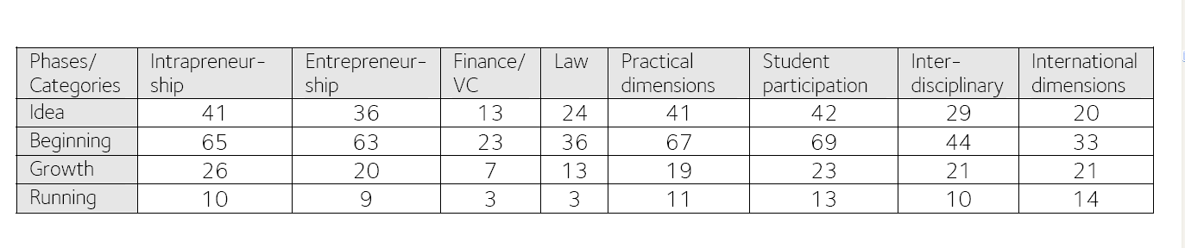

The above disciplines are rated in 63 different education programmes from 1 to 3 point, 3 being the best, maximum will therefore be 189 points in each cell.

Main conclusion of the research
Mayor part of the education programmes are concentrated on the start-up-phase.
Also showing the pedagogical teaching form is rather traditional (practical and student participation while interdisciplinary and international dimensions are low)

They also found that only app. 4% of the enrolled university students received entrepreneurship related education during their entire study period. In some of the countries Denmark would like to compare with the share of students receiving entrepreneurship related education are as high as 15 – 20 %.

Segmentation
Practical dimen

