Methods/Procedures
- Rectal Rings for tissue that is already necrotic
Of the various sizes, choose the largest fit. Use a clamp to hold the ring and position it so that the slot in the ring is directly at the anus. Insert the tube into the rectum and tie off the prolapse next to the body with an elastrator band or umbilical tape to secure the ring. Trim the excess tissue. Prolapsed section should slough off in 4 5 days
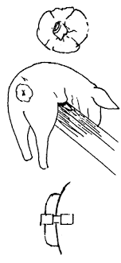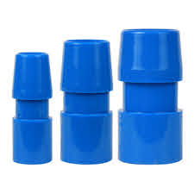
2. Purse String for tissue that is still fresh
Replace the prolapse, suture around the anus, leave an approximately ¾ inch opening to enable defecation. Do sutures 3mm apart, to minimize trauma, reduce capillarity and reduce bacterial colonization. Incision site for rectal resection is 1cm proximal to healthy margin.

Rectal resection is performed outside the patients’ body to excise diseased tissue, so contamination of sterile tissues during surgery is minimized. Rectal resection has the advantage of removing the diseased portion of the rectum and additionally it eliminates redundant rectum, thereby decreasing the risk of re-prolapse. Rectal resection: the inner tube of the prolapse is often under considerable tension, so complete excision of the affected prolapsed tissue should only commence after the prolapse is fixed in position with stay sutures or long pins. If the prolapse is excised circumferentially without some form of fixation, the inner tube will slip back into the pelvic or abdominal cavity and become lost. If excess tension is placed on the anastomosis, there will be increased risk of stricture formation or dehiscence. When excess rectal tissue is removed, partial or complete fecal incontinence may occur.

