Items | Small intestine | Large intestine
Parts | Duodenum, Jejunum& Ileum | Caecum,colon, rectum&anus
Intestinal villi | Present | Absent
Blood supply | Celica & Cranial mesenteric arteries | Cranial and Caudal mesenteric arteries
Taeniae | Absent | present
THE SMALL INTESTINE
- Starts from the pylorus to the caecum.
- Duodenum
  - Part of the small intestine has a short mesentery
    - Cranial (Between the cranial & descending parts)
    - Descending (Between the descending & ascending parts )
    - Ascending
  - Flexures
    - First flexure (Between the cranial & descending parts)
    - Second flexure (Between the descending & ascending parts )
    - Duodenojeujenal flexure (Between the ascending part and jejunum)
THE MESENTERIC PART OF THE SMALL INTESTINE

Items Jejunum Ileum | Items Jejunum Ileum | Items Jejunum Ileum
Def. Longest part of small intestine Short end part | Def. Longest part of small intestine Short end part | Def. Longest part of small intestine Short end part
wall Thin wall | wall Thin wall | Thick wall
opening | Continues with ileum without line of demarcation externally | Open with caecum by ileocaecal opening in horse opening in all animals (ileocaecocolic) Ileocolic caecocolic

THE LARGE INTESTINE
Parts of the large intestine caecum, colon, rectum and anus.

THE CAECUM
It is a blind sac in which the small intestine ends and the colon begins. It communications with the ileocaecocolic orifice.

THE COLON
It has 4 parts ; Ascending, transverse and descending colon, sigmoid colon

THE ASCENDING COLON
The longest part of the colon

Ascending colon:
- It is disc like situated in the intestinal recess has no taeniae no hustra . it consists of 3 loops: proximal, spiral and distal (terminal) loops.
  - The proximal loop or (ansa proxmalis): Has s-shape. Three gyri (ventral, middle and dorsal).
    - 1-The ventral gyrus: passes cranially form the ileo-caeco-colic opening.
    - 2-The middle gyrus: the caudal continuation of the ventral gyrus after it bends dorsally on itself.
    - 3- The dorsal gyrus: it is continued by ansa spiralis.
  - The spiral loop or (ansa spiralis): Consists of a double spiral coils arranged in the form of disc). The first coil is centripetal gyrus and the 2nd loop is centrifugal gyrus (anticlock wise). The two loops are closely united together and are continued with each other at a central flexure or ansa centralis

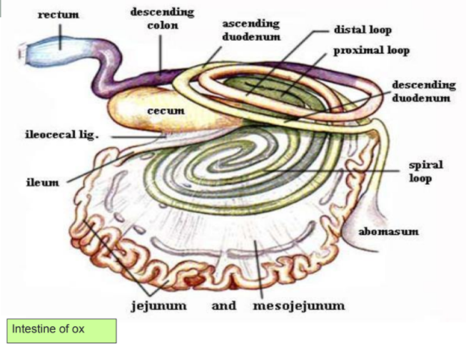
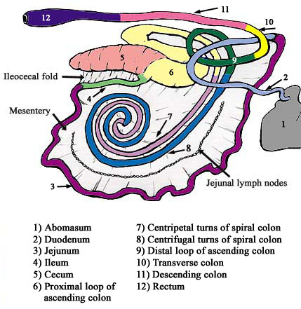
THE TRANSVERSE COLON
The shortest part of the large intestine and joins the ascending colon and descending colon, it presents just cranial the cranial mesenteric artery in all animals and it has neither taeniae nor sacculations. And it fixed by Meso-colon transversus.

THE DESCENDING COLON
The terminal part of the colon extends between the transverse colon cranially and the rectum caudally (on the left side). : It forms an S-shaped flexure called “sigmoid colon” at the promontory of the sacrum. The meso-colon becomes wide ventral to the last lumbar vertebra and give free movement during rectal palpation.

