Anesthesia of the Flank

Infiltration anesthesia

Line block
Area blocked: skin and muscle layers of the flank and parietal peritoneum along the line of incision
Needle: 18-gauge, 7.6- to 10.2-cm
Anesthetic: 10 to 100 mL of 2% lidocaine
Method: make multiple subcutaneous injections of 0.5 to 1.0 mL of anesthetic, 1 to 2 cm apart with a 20-gauge, 2.54-cm needle; then infiltrate the muscle layers and parietal peritoneum through the desensitized skin.

Advantages
a. Easy to perform
b. Use of routinely sized needles (2.5-cm, 20-gauge or smaller for skin block; 7.6- to 10.2-cm, 18-gauge for infiltrating the muscle layers and peritoneum).
Disadvantages
a. Large volume of anesthetic
b. Lack of muscle relaxation
c. Incomplete block of deeper layers of the abdominal wall
d. Formation of hematomas along the incision line
e. Increased cost because of larger amounts of anesthetic used and time required
Possible Complications
a. Toxicity can occur if a large amount of anesthetic of 2% lidocaine (e.g., 250 mL [5 g] is inadvertently administered intraperitoneally to a 450 kg cow or 10 mL [200 mg] is administered intraperitoneally to an adult goat)
b. Can interfere with healing

Inverted L block
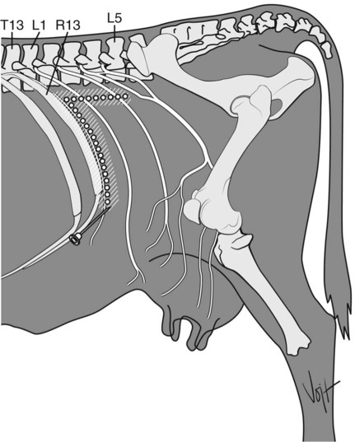
Regional anesthesia of a cow’s left flank using inverted L infiltration pattern.
Area blocked: flank caudal and ventral to site of injection
Site: a line along the caudal border of the last rib and along a line ventral to the lumbar transverse processes from the last rib to the fourth lumbar vertebra (inverted L)
Needle: 18-gauge, 7.6-cm
Anesthetic: up to 100 mL of 2% lidocaine in adult cattle, evenly distributed
Method: inject dorsal caudally in to the tissues bordering the last rib and ventral laterally in the tissue surrounding the lumbar transverse processes

Advantages
a. Similar to line block
b. Absence of anesthetic agent from the incision line minimizes edema, hematoma, and possible interference with healing
Disadvantages
a. Large volume of anesthetic required
b. Length of time required to infiltrate such a long line
c. Incomplete block of the deep layers of the abdominal wall (particularly the peritoneum)
Complications: Toxicity with large amounts

Specific nerve anesthesia

Proximal paravertebral anesthesia (Farquharson, Hall, or Cambridge technique)
Area blocked: flank of side on which technique is performed
Nerves blocked: dorsal and ventral branches of T13, L1, and L2 and occasionally L3 and L4
Site: 2.5 to 5 cm from midline. T13 immediately in front of transverse process of L1; L1 immediately in front of transverse process of L2; L2 immediately in front of transverse process of L3
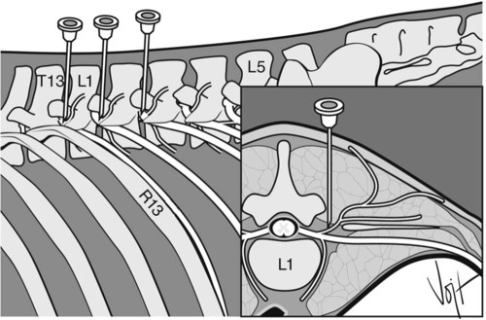
Needle placement for proximal paravertebral nerve block in cattle.

Left lateral aspect and cranial view of a transection of the first thoracolumbar vertebra at the location of the intervertebral foramen. R13 is the last rib;

Needle: 14-gauge, 1.3-cm needle, creating passage for a 16- or 18-gauge, 3.81- to 15.2-cm needle
Anesthetic: 20 mL of 2% lidocaine at each site
Method: the skin overlying the spinal column on the side to be desensitized is clipped, surgically scrubbed, and disinfected;
- palpate the lumbar transverse processes, starting from L5 and moving forward to L1;
- measure 5 cm from midline; palpate the lumbar dorsal processes;
- injection site is at a 90-degree angle to the spaces between the dorsal processes; pass the needle vertically until it hits the cranial edge of the transverse process, by walking of each transverse process.
- Pass the intertransverse ligament and inject 10 to 15 mL of 2% lidocaine below the ligament to block the ventral branch of the nerve.
- withdraw the needle 1 to 2.5 cm sufficiently to inject 5 mL of 2% lidocaine above ligament, level with dorsal surface of transverse process to block the dorsal branch
- if the first lumbar transverse process cannot be palpated, anesthetize the other nerves first and then measure the distance between injection sites to find the site for blocking nerve T13
- In sheep and goats, T13, L1, and L2 are desensitized in a fashion similar to the cattle method, but 2.5 to 3 cm off the midline and with less anesthetic (2 to 3 mL per site)

Advantages over local block
- Anesthesia of skin, musculature, and peritoneum;
- muscle relaxation
b. No additional restraint required
c. Large quantities of local anesthetic not required
d. Shorter postsurgical convalescent period; incision site avoided
Disadvantages
a. Difficult in fatter cattle
b. Arching of the spine caused by paralysis of back muscles
c. No anesthesia of abdominal viscera
d. Bowing out toward the area of incision (after unilateral blockade), making the closure of the incision more difficult
Considerations
- The cow will bend toward the opposite side as muscles are relaxed. The flank will also be warmer due to related vasodilation.
- Desensitization of L3 and L4 can produce analgesia of the caudal part of the paralumbar fossa. This can be used for cesarean section or ipsilateral for teat and mammary glands;
- If L3 and L4 are blocked, the animal may become unable to stand

Complications
a. Possible penetration of the aorta
b. Possible penetration of the thoracic longitudinal vein (posterior) or vena cava
c. Loss of motor control of the pelvic limb caused by caudal migration of drug (femoral nerve block)

Distal paravertebral anesthesia (Magda, Cakala, or Cornell technique)
Area blocked: flank of side on which technique is performed
Nerves blocked: dorsal and ventral rami of T13, L1, and L2
Site: distal ends of lumbar transverse processes of L1, L2, and L4

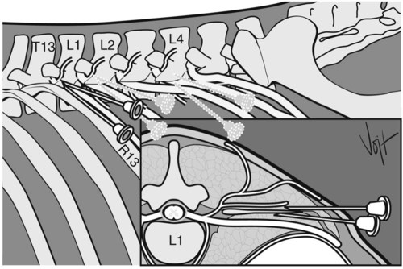
Needle placement for distal paravertebral nerve blockade in cattle.

Left lateral aspect and cranial view of a transection of the first lumbar vertebra at the location of the intervertebral foramen.

Needle: 18-gauge, 7.6-cm
Anesthetic: 10 to 20 mL of 2% lidocaine at each site
Method: the skin overlying the spinal column on the side to be desensitized is clipped, surgically scrubbed, and disinfected;
- insert the needle ventral to the tips of the respective transverse process;
- inject anesthetic (up to 20 mL) in a fan-shaped infiltration pattern;
- withdraw the needle a short distance, reinsert it dorsal and caudal to the transverse process,
- inject approximately 5 mL of the anesthetic.
Advantages of distal paravertebral nerve block over proximal paravertebral block
a. Use of routinely sized needles
b. Minimizes risk of penetrating a major blood vessel
c. Lack of scoliosis
d. Minimal ataxia or weakness in the pelvic limb
Disadvantages
a. Larger volume of anesthetic
b. Variations in efficacy, particularly if the nerves follow a variable anatomic pathway
Complications: none

Segmental dorsolumbar epidural block (Arthur block)
Area blocked: the skin area caudal to the T13 or L1 spinous process and flank on both sides
Nerves blocked: T13 and anterior lumbar nerves, depending on the total dose administered
Site: epidural space between L1 and L2 vertebrae
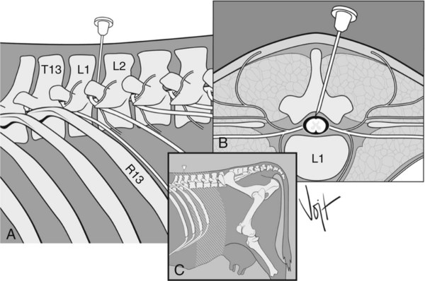
Needle placement for segmental dorsolumbar epidural block.

A, Left lateral aspect.
B, Cranial view of a transection of the first lumbar vertebra.
C, (inset) Desensitized area of skin after segmental epidural anesthesia (lightly shaded area).

Needle: spinal, preferably 18-gauge, 12.7-cm
Anesthetic: 8 mL of 2% lidocaine in a 500-kg cow, no more than 1 mL/50 kg of 2% lidocaine in sheep and goats
Method: the skin overlying the spinal column is clipped, surgically scrubbed, and disinfected;
to reach the epidural space, insert the spinal needle 8 to 12 cm ventral and cranial at an angle of 10 to 15 degrees.
Enter the interarcuate ligament (slight resistanceif felt). There should be no blood of CSF if in the correct positions. They anesthetic should be given without resistance.

Advantages over proximal or distal paravertebral anesthesia
a. one injection site
b. Small amount of anesthetic
c. Uniform anesthesia and relaxation of the skin, musculature, and peritoneum (begins 10 to 20 minutes after administration and continues for 45 to 120 minutes)
Disadvantages
a. Difficult technique to perform
b. Potential for trauma to the spinal cord or venous sinuses
Complications
a. Loss of motor control of the pelvic limbs caused by overdose or subarachnoid injection
b. Physiologic disturbance caused by overdose or subarachnoid injection
c. Potential for trauma to the spinal cord or venous sinuses

Adapated from Veteriniary Key
https://veteriankey.com/local-anesthesia-in-ruminants-and-pigs/
https://open.lib.umn.edu/largeanimalsurgery/chapter/local-anesthesia/

