Diagnosis of equine lameness- regional anesthesia

Begin the exam with medical history- breed, age, training regimen, onset of lameness, use of medication (specifically analgesic medication).

Key points to note
- To localize the lameness to a specific limb/site, examine the horse during exercise.
- Diagnostic regional anesthesia should not be performed if there is suspected fracture of the limb.
- Insert needles detached from syringe to avoid bending or breaking.
- Direct needles distally to avoid proximal migration of anesthetic solution

Lidocaine HCL (2%), mepivacaine (2%), and bupivacaine HCL are the most commonly used anesthetic agents used.

Distal limb- use 25g ⅝ inch needle
Proximal limb, 22/20g 1 ½ inch needle

Diagnostic regional anesthesia of the forelimb

- Palmar digital nerve (PDN) block/ heel block (limb in hand)
- Insert needle directly over the palpable neurovascular bundle (approximately 1cm proximal to the cartilage of the foot)
- Direct needle distally and deposit 1.5ml anesthetic agent near the junction of the nerve and cartilage of the foot.
- If there is no improvement some clinicians do a semi ring block at the pastern to anesthetize the dorsal branches of the digital nerve. Doing a semi ring block may be ineffective since the dorsal branches of the digital nerve contribute little to sensation of the foot.

- Basisesamoid nerve block/ abaxial sesamoid nerve block ( used when PDN block did not reduce lameness)
- Palmar nerves anesthetized at the level of the proximal sesamoid bones before the nerve branches into the dorsal and palmar digital nerves.
- Deposit 2.5-3ml anaesthetic solution at the base of the proximal sesamoid bones over the neurovascular bundle. (Proximal deposition of local anesthetic solution can lead to the fetlock joint becoming anesthetized)
- This localizes the site of pain to the pastern.

- Low palmar nerve block/ low 4-point block (used when basisesamoid nerve block was negative)- limb in hand/ horse bearing weight on it
- Used to anesthetize the medial and lateral palmar nerves which lies dorsal to the border of the deep digital flexor tendon.
- Deposit 2ml local anesthetic solution using a 25g ⅝ inch needle at the level of the metacarpus to block the medial and lateral palmar nerves.
- After blocking the palmar nerve at the level of the metacarpus, the ramus communicans is blocked using 1ml anesthetic solution
- 1-2ml anesthetic solution is deposited subcutaneously at the distal end of each splint bone to block the palmar metacarpal nerve which lies next to the periosteum of the 3rd metacarpal bone. This completes the 4 point block and localizes the site of pain to the fetlock.
Avoid misdirecting the needle into the digital flexor sheath.

- High palmar nerve block/ high 4-point block (used when low 4-point nerve block is ineffective) - limb bearing weight
- Anesthetize the medial and lateral palmar nerves by injecting 3-5ml anesthetic solution using a 25g ⅝ inch needle through the fascia distal to the carpometacarpal joint where the nerves lie near the dorsal border of the deep digital flexor tendon.
- Anesthetize the palmar metacarpal nerves by injecting 3-5ml anesthetic solution using a 20/22g 1 ½ inch needle into the angle formed by the junction of the 3rd metacarpal and the 2nd/4th metacarpal bone.
Anesthetizing the medial and lateral palmar nerves alone desensitizes the flexor tendons and inferior check ligament. Anesthetizing the medial and lateral palmar metacarpal nerves alone desensitizes the splint bones, interosseous lig., and proximal part of the suspensory lig.

When these aforementioned nerve blocks are ineffective, clinicians perform joint blocks of the carpus, elbow or shoulder. The median and ulnar nerves are anesthetized simultaneously to exclude pain below the elbow as the cause of lameness.

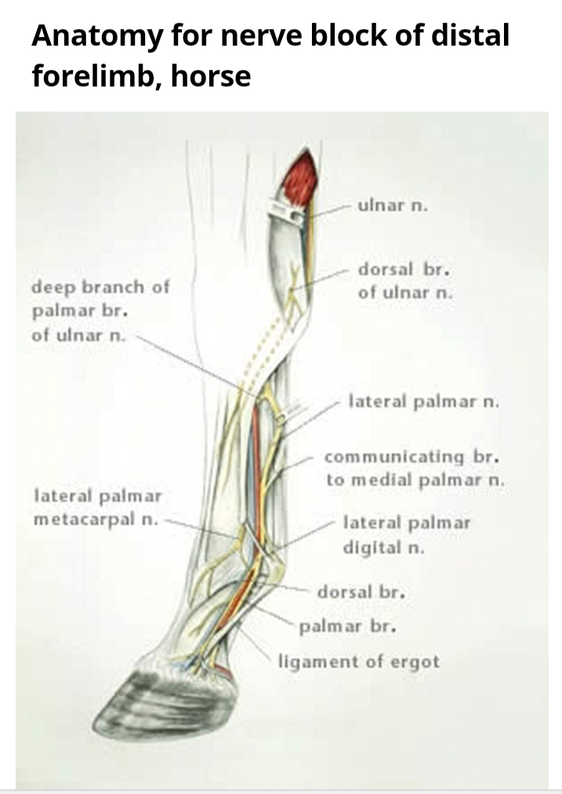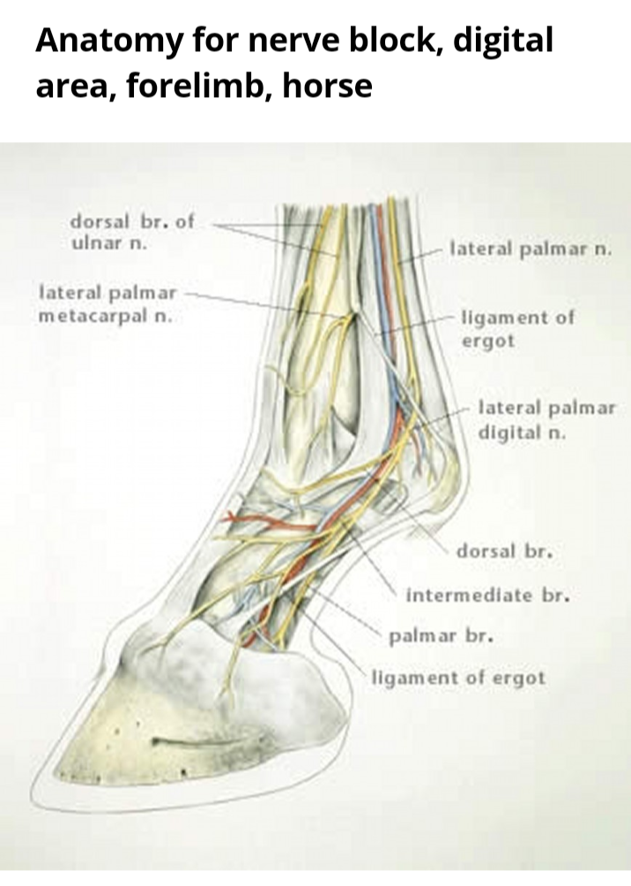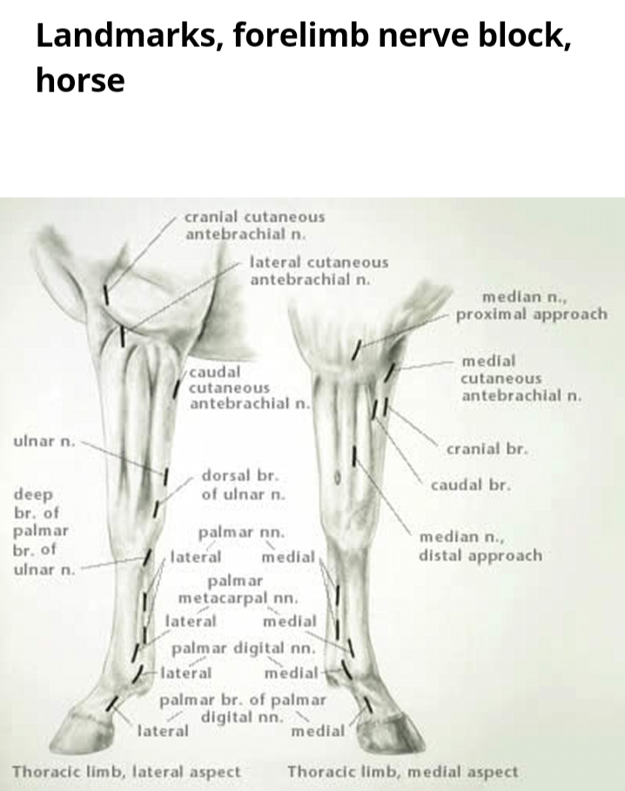

Diagnostic regional anesthesia of the hindlimb

These techniques are slightly different than that of the forelimb.

- Low 4-point nerve block- same as forelimb except when at the level of the distal aspect of the splint bones, redirect the needle dorsolaterally or dorsomedially, parallel to the surface of the foot. Inject an additional 2ml anesthetic solution subcutaneously to anesthetize the medial or lateral dorsal metatarsal nerves.

- High plantar nerve block
- Similar to high palmar approximately 1cm distal to the tarsometatarsal joint.
- 3-4ml anesthetic solution using a 20-23g 1 inch needle is deposited axial to the lateral splint bone approximately 1cm distal to the tarsometatarsal joint between the deep digital flexor tendon and suspensory lig.
- Used to assess the proximal aspect of the suspensory lig.

- Tibial nerve block
- The tibial nerve is blocked about 10cm above the point of the hock on the medial aspect of the limb. It lies in fascia on the caudal surface of the deep digital flexor muscle cranial to Achilles tendon.
- Inject 20ml anesthetic solution using a 20g 1 ½ inch needle in several planes of the fascia surrounding the nerve.
- Deep peroneal nerve block
- Done on the lateral aspect of the limb about 4 inches above the hock in the groove formed by the lateral and long digital extensor muscles. Use a 20g 1 ½ inch needle directed caudally until it reaches the caudal edge of the tibia and deposit 20ml anesthetic solution.

Tibial and peroneal nerves can be blocked simultaneously to exclude pain in the hock or regions distal to the hock.

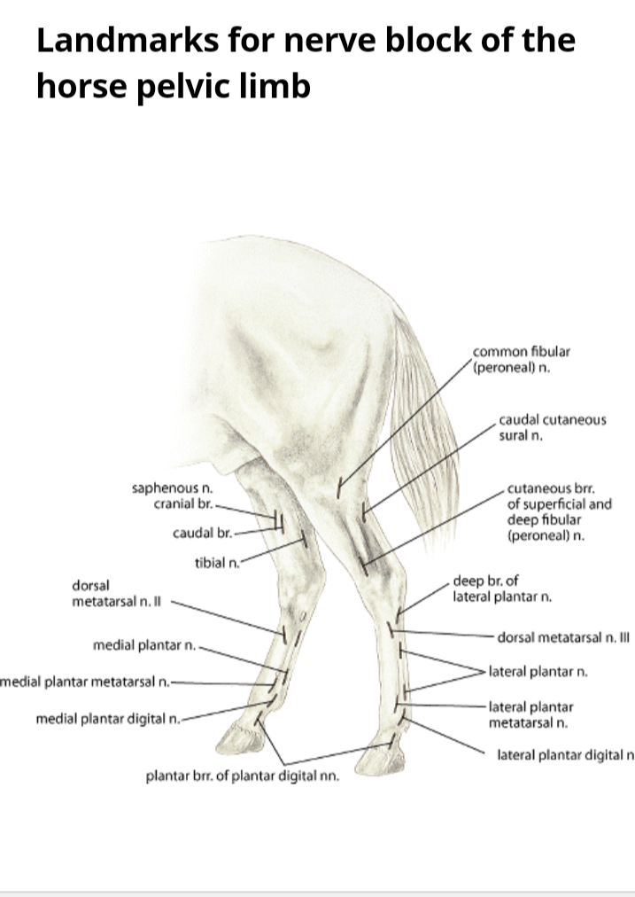
L
VIDEO LINK:
https://youtu.be/6MVNcy9YE0I

References

https://www.msdvetmanual.com/musculoskeletal-system/lameness-in-horses/regional-anesthesia-in-equine-lameness?query=Lameness%20in%20horse
https://www.msdvetmanual.com/horse-owners/bone,-joint,-and-muscle-disorders-in-horses/lameness-in-horses?query=Lameness%20in%20horse

Joint blocks

- Navicular bursa block/ podotrochlear bursa block
- Using a 20g 2inch needle, inject 5ml anesthetic solution via a subcutaneous injection on the midline just above the bulb of the heel.
- Predisposes to deep infection
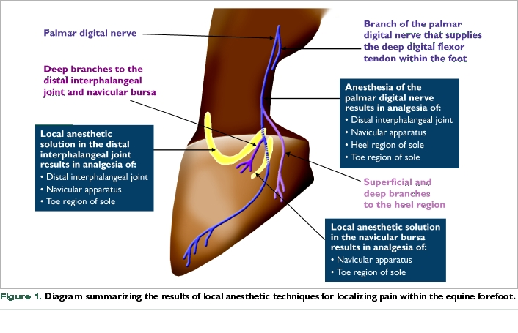
- Dorsal approach to fetlock, pastern and coffin joints
- Using a 20g 1 ½ inch needle, inject 5ml anesthetic solution proximal to the joint, under the common/long digital extensor tendon laterally while passing obliquely into the dorsal pouch.
- Same procedure for all 3 joints except coffin joint, needle is inserted above the coronet , laterally to and under the extensor tendons.
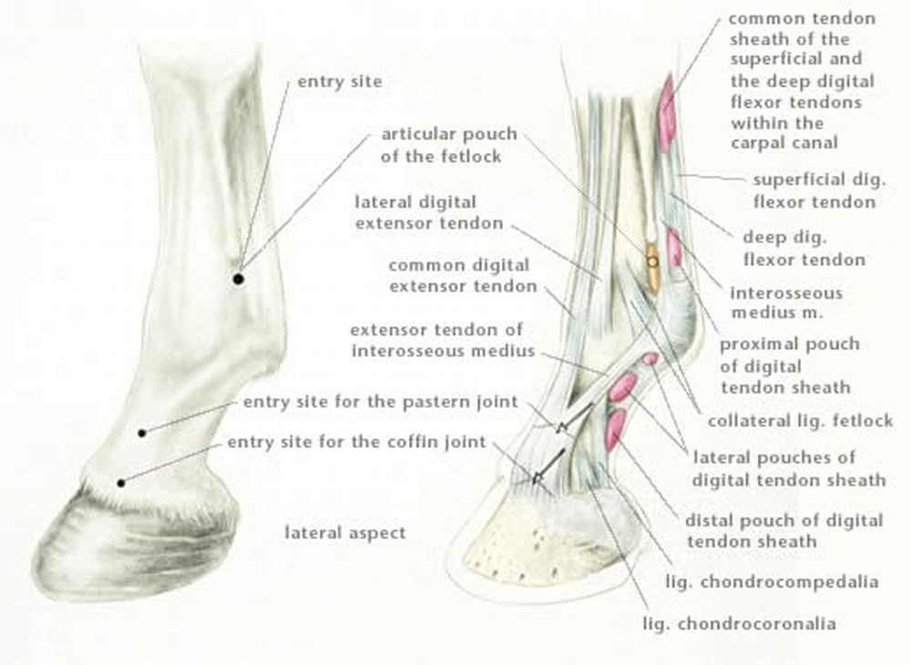
- Palmar approach to fetlock joint
- Boundaries-
a) dorsal pouches: proximal to the joint and obliquely under the extensor tendon.
b) palmar pouch of fetlock; proximal- button of splint bone
Dorsal-cannon bone
Distal- proximal sesamoid bone
Palmar- suspensory lig.
- Begin by flexing the fetlock and palpating the boundaries of the palmar pouch. Inject 5ml anesthetic solution dorsal to suspensory lig. and palmar to the cannon bone using an 18g 1 inch needle.

- Carpal joint injection- dorsal and palmar approach
3 joints - antebrachiocephalic, middle carpal and carpometacarpal
Dorsal approach, antebrachiocephalic and middle carpal.
- Flex the carpus to open the joint. Palpate the depression of both joints on either side of the tendon of the extensor carpi radialis muscle.
- Using a 20g 1 inch needle, remove 10ml synovial fluid and inject 10 more anesthetic solution medially or laterally to the tendon and into the depression.
Palmar/ palmarolateral pouch approach
- Insert the 20g 1 ½ inch needle perpendicular into the depression and joint space located between the accessory carpal bone, ulnaris lateralis muscle and lateral digital extensor muscle. Remove synovial fluid and inject 10mls anesthetic solution.
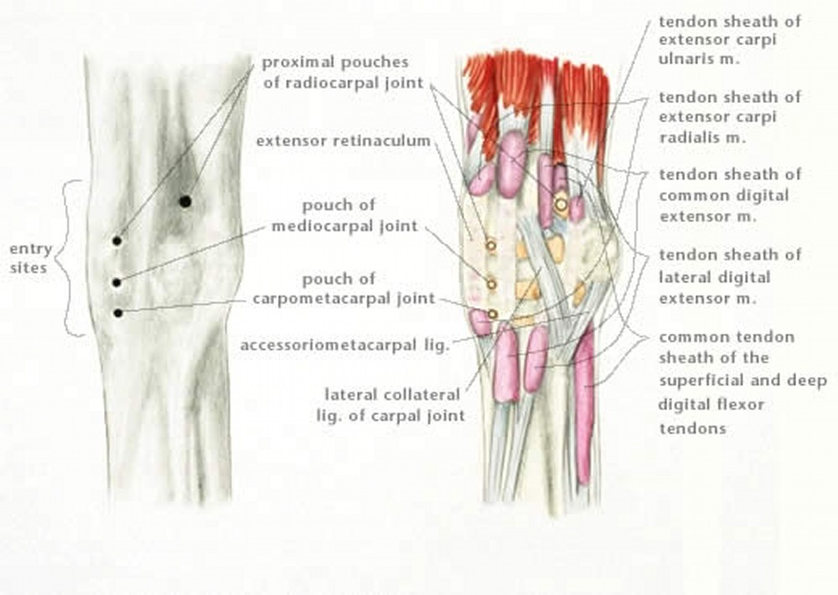

- Elbow joint block
- Lateral approach- A 2 ½ inch 18g needle is directed into the space either cranial or caudal to the collateral ligament. The collateral lig. is located between the palpable lateral epicondyle proximally and the origin of the lateral digital extensor distally. Aspirate and inject 10mls anesthetic solution at the site.
- Caudolateral approach- insert 18g 3 ½ inch needle from the caudolateral side proximal to the elbow joint. The needle is directed between the olecranon process of the ulnar and the lateral epicondyle of the humerus into the caudal pouch over the olecranon fossa.
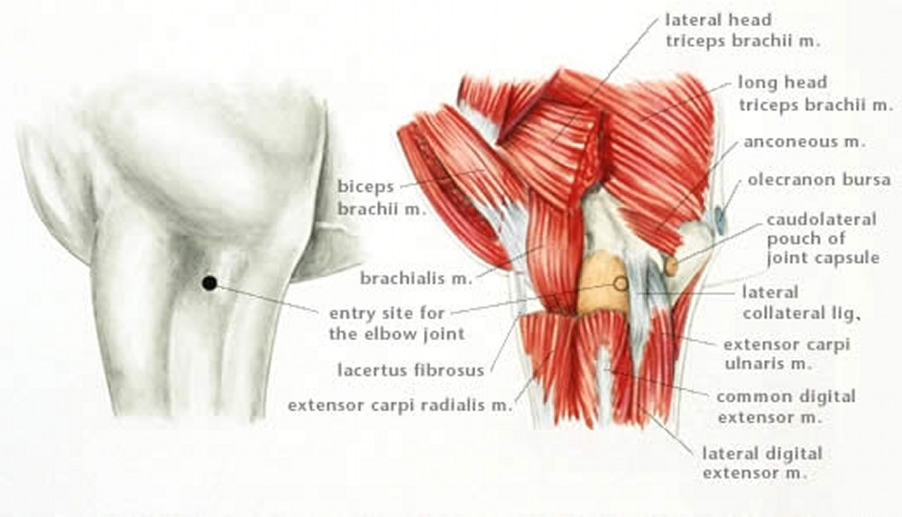
- Shoulder joint block
- Using a 3 ½ inch 18g spinal needle, direct it through the notch present on the greater tubercle at an angle caudal, distal and medial. Then aspirate a liberal amount of synovial fluid and inject 10-20mls anesthetic solution.
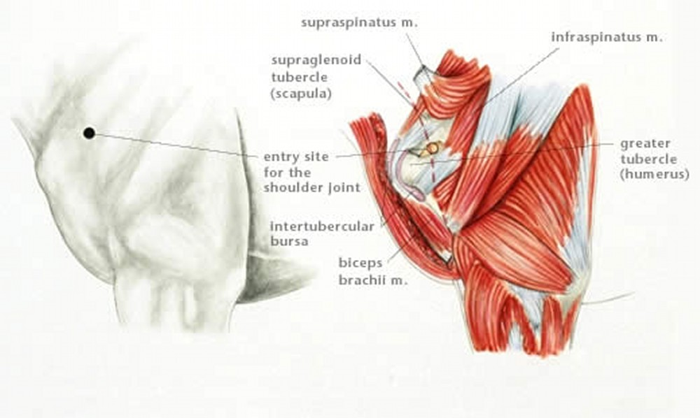

- Distal intertarsal joint block
- Using a 22g 1 inch needle, inject 5ml anesthetic solution subcutaneously in the gap between the 1st, 2nd, 3rd and central tarsal bone on the medial side of the hock.
- Tarsometatarsal joint block
- Inject anesthetic solution using a 20g 1 inch needle between the distal row of the tarsal bones.
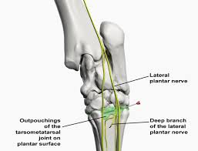
- Hip block
- Palpate the summit of the greater trochanter ⅔rds of the way from the tuber coxae to the ischiatic tuberosity. Palpate the convexity and estimate the location of the notch between the 2. Use a 16g 6 inch needle through the notch and walk the needle up the neck of the femur into the joint. Aspirate synovial fluid and inject 10-15ml anesthetic solution.
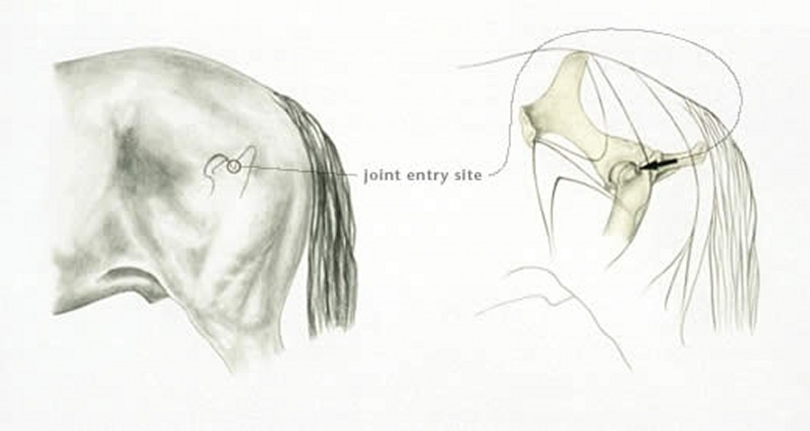
- Trochanteric block
- Locate the greater trochanter cranial part and insert a 18g 3 inch needle 2inches distal to the convexity and it is directed proximomedially over the convexity into the bursa. Inject 10ml anesthetic solution.
- Stifle blocks
- Medial femorotibial pouch block
- 3 inch 18g needle is inserted between the medial collateral and medial patellar ligaments at the level of the joint. Synovial fluid is aspirated and 10-20 mls anesthetic solution is injected at the site.
- Lateral femorotibial pouch block
- Visualize where the long digital and peroneus tertius extensor muscle runs between the 2 prominence of the extensor groove of the tibia.
- Palpate the lateral collateral lig. between the lateral epicondyle of the femur and the origin of the lateral digital extensor.
- Using a 3 inch 20g needle, aspirate synovial fluid and inject 10-20 mls anesthetic solution caudal to the tendons pointing proximally.
- Femoropatellar pouch block- lateral approach
- Stifle is extended and the patellar is grasped and pulled to widen the joint space. A 2 inch 18g needle is inserted on either side of the intermediate patellar lig.
- The needle is then advanced 2 inches between the patellar and patellar surface of the femur where synovial fluid is aspirated and 20ml anesthetic solution is injected.
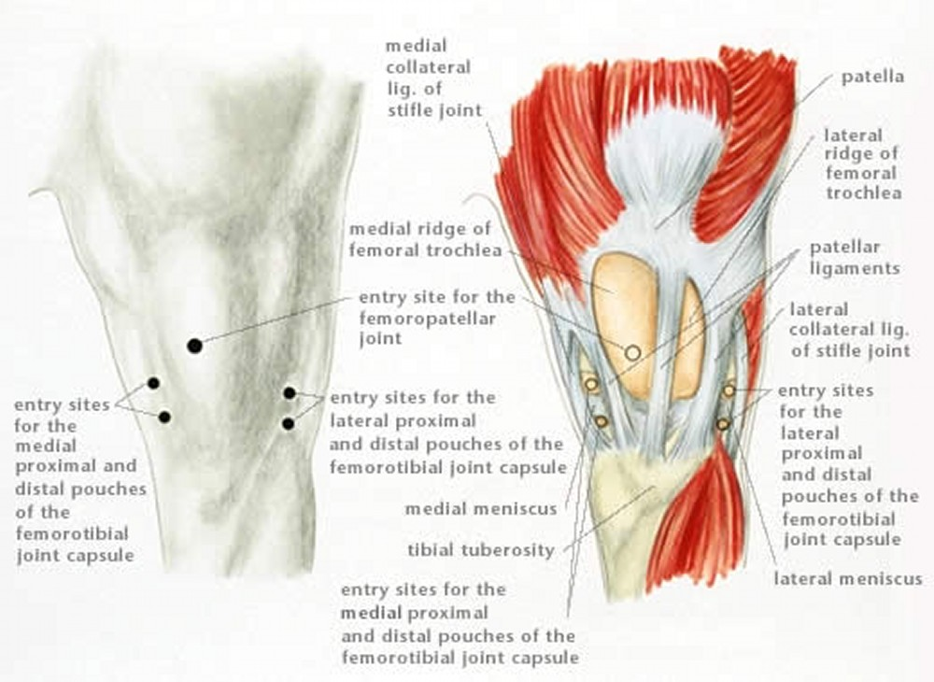

VIDEO LINKS
https://youtu.be/D4hQ5VX95EE
https://youtu.be/owfRyDQhfWk
https://youtu.be/S0dv9GsR4-I
https://youtu.be/PJlCew5UM6M
https://youtu.be/X3rLRgyKFrU

