Exploring Matter Fourth Grade Physical Science By Andrea Panning

Rationale:
This unit focuses on the conservation of matter as objects undergo physical change. Students in fourth grade commonly rely on their ‘perceptual experiences’ to help them understand the world around them. Student perceptions, however, can lead to scientific misconceptions. Studies by Piaget and Inhelder found that children’s scientific reasoning is primarily governed by these ‘perceptual experiences’ (Ozman & Ayas, 2003). In the study, children observed that sugar dissolved in water simply disappeared; therefore they predicted no change in the mass of the water. Through contextual teaching and learning, students will be able to rely on hands-on, concrete experiences to rectify these common misconceptions.
The instructional design employs a 5-E Learning Cycle Model, which facilitates exploration and constructive teaching and learning. This model emphasizes the role of teacher as a guide as students construct meaningful learning (Chiarelott, 2006). Student participation in each of the 5E phases, Engagement, Exploration, Explanation, Extension, and Evaluation, allows students the opportunity for a deeper, self-constructed understanding of scientific concepts. The Inquiry instructional model is infused into this unit, as it allows students to discover the meanings of new concepts, as opposed to having the teacher simply telling students (Chiarelott, 2006). This model invites students to be inquisitive about science and elicits excitement about asking questions and making discoveries.
Chiarelott, L. (2006). Curriculum in Context. Belmont, CA: Thomson Wadsworth. Pgs. 91, 118. Ozman, H. & Ayas, A. (2003). Students’ Difficulties in Understanding of the conservation of Matter in Open and Closed-System Chemical Reactions. Chemical Education: Research and Practice, Vol. 4, No. 3, pp. 279-290. Retrieved from http://www.uoi.gr/cerp/2003_October/pdf/04Ozmen.pdf.
Learner Outcomes:
[4.PS.1a] Students will be able to explain how when an object is broken into smaller pieces, when a solid is dissolved in a liquid or when matter changes state (solid, liquid, gas), the total amount of matter remains constant.

Solid, Liquid, and Gas Pre-Assessment
Name ____________________________________________

Agree or Disagree?
 | Before |  |  | After
 | Agree | Disagree |  | Agree | Disagree
1 |  |  | When you get out of the shower, water droplets on the mirror are due to evaporation.
2 |  |  | One morning on the way to school, you notice that all the cars parked on your street are wet but the street  is dry. It did not rain during the night. This is due to condensation.
3 |  |  | A glass of water and a glass of ice cubes are the same thing.
4 |  |  | If a container of water was placed in the sun all day long, the amount of water in the container would not change.
5 |  |  | After dissolving sugar in a glass of water, the sugar simply disappears.

Lesson 1: Solid, Liquid, and Gas
Lesson Summary:
Students will review the three states of matter. They will draw atom arrangements for each. Students will then work in groups, focusing on a specific state of matter. Each group will gather information and present it to their classmates.
Ohio Revised Academic Content Standard:
- [PS4.1] The total amount of matter is conserved when it undergoes a change. a. When an object is broken into smaller pieces, when a solid is dissolved in a liquid or when matter changes state (solid, liquid, gas), the total amount of matter remains constant.

Learning Objectives:
Students will be able to...
- give examples of each state of matter, as well as identify which state of matter different objects belong to;
- describe each state of matter in depth.

Materials:

- Ziploc bags
- water
- food coloring
- Popsicle sticks
- digital images of solid/liquid/gas atom arrangements
- laptop/projector
- Solid, Liquid, and Gas activity (Appendix A)

- Three States of Matter activity (Appendix B)
- poster paper
- markers/colored pencils
- Solid, Liquid, and Gas Post-Assessment (Appendix C)
- Solid, Liquid, and Gas Post-Assessment Rubric (Appendix D)

References/Resources:
- Adapted from Gold Seal Lesson submitted by Connie Schmidt/ Darla Paynter/Sherree Svancara/Cathy Sullivan-Sloan, Parkridge Elementary School, coschmidt@peoriaud.k12.az.us

Instructional Procedures:
“5-E” Phase | Planned Activities/Events | Guiding Questions | Questions Students May Ask | Materials/Safety/Notes
Engagement  - Spark interest in the topic  - Tap prior knowledge  - Focus learner’s thinking | Day 1  - Offer popsicles to a couple students in class. Then hand them a Ziploc bag containing melted water that is colored with food coloring and Popsicle sticks to represent the Popsicle. Discuss what form they expected the Popsicle to be in [answer: frozen].  - Review what matter is and the 3 forms of matter (solid, liquid, gas). Ask students to give a few examples of each. | In what state of matter is the Popsicle I gave you? [liquid]  Is it still a Popsicle even though it’s melted? [yes]  How so? [Even though it has changed from a solid to a liquid, a new substance has not been formed, so it is still considered a Popsicle] | Why is a liquid Popsicle still considered a Popsicle? [Even though it has changed from a solid to a liquid, a new substance has not been formed, so it is still considered Popsicle] | - Ziploc bags  - water  - food coloring  - Popsicle sticks  *Caution students against actually opening and ingesting the “Popsicles”.
“5-E” Phase | Planned Activities/Events | Guiding Questions | Questions Students May Ask | Materials/Safety/Notes
Exploration  - Provide learners with common, concrete, experiences with skills and concepts  - Observe and listen to students  - Ask probing question  - Act as a consultant | - Display pictures of solids, liquids and gasses with atom arrangements. Students will identify each picture as a solid, liquid or gas by holding up 1 finger for solid, 2 fingers for liquid, and 3 fingers for gas.  - Students will practice drawing the atom arrangement for a solid, liquid and a gas using Solid, Liquid, and Gas activity (Appendix A).  - Have students share their drawings with a partner to check each other for accuracy. | What are properties of solids? Liquids? Gasses?  [liquids take the shape of their containers, gasses do not have a definite shape, solids have a definite shape, all three have volume and mass] | If gasses like Oxygen are invisible, how can we tell they take up space? [use real examples to show how gas can take up space, such as filling up a balloon, placing a cup upside-down in water with a crumpled paper taped to the bottom] | - digital images of solid/liquid/gas atom arrangements  - laptop/projector  - Solid, Liquid, and Gas activity (Appendix A)
Explanation  - Use students’ exploration experiences as the basis for explaining concepts  - Encourage students to explain concepts in their own words  - Ask for justification  - Introduce vocabulary  - Explain concepts  Clarify conceptual understanding to dispel misconceptions | - Students will be divided into 3 groups: solid, liquid, and gas. Each group will write a paragraph explanation of their state of matter using Three States of Matter activity (Appendix B). They will also determine two examples for their state of matter. | How would you describe the particle arrangement for your assigned state of matter? [solid: organized into rows, liquid: particles slip and slide past each other, gas: particles are moving quickly and are more spread out] | How can you tell if an object is solid or liquid? [some objects are more difficult to differentiate; refer to properties of solids, liquids, and gasses. For example, does it take the shape of its container? | - Three States of Matter activity (Appendix B)
“5-E” Phase | Planned Activities/Events | Guiding Questions | Questions Students May Ask | Materials/Safety/Notes
Extension  - Actively apply same concepts and skills in a new context resulting in deeper and broader understanding  Involve inquiry or problem-solving | Day 2  - Students will compile their explanation information onto a poster that includes their description, examples, and pictures.  - Students will present their state of matter posters to the class.  - Display around classroom. |  |  | - poster paper  - markers/colored pencils
Evaluation  - Observe the students as they apply new concepts and skills  - Assess, formally and/or informally, student progress toward achieving the learner outcomes (knowledge and/or skills)  - Allow students to assess their own learning and group-process skills | Informal and formal assessments employed throughout all phases  Formative Assessment: Check for student understanding by observing student answers on the Solid, Liquid, and Gas activity (Appendix A)  Summative Assessment: Formally assess Solid, Liquid, and Gas Post-Assessment (Appendix C) using Post-Assessment Rubric (Appendix D)

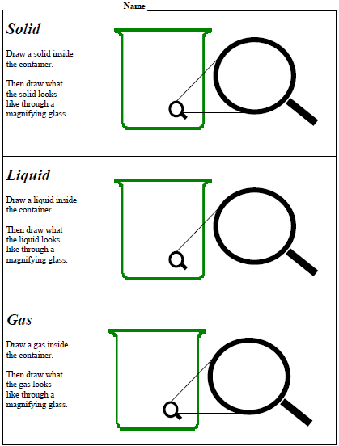
Appendix A: Solid, Liquid, and Gas
Appendix B: Three States of Matter
Write a paragraph explanation of your assigned state of matter.
Paragraph should include:
- how particles are arranged;
- how they move;
- and two examples of your assigned state of matter.
Include any other details necessary to demonstrate what you understand about the assigned state of matter.
***Paragraph should include 3 – 5 sentences. Use correct grammar and punctuation. Remember to indent.

State of Matter: _______________________________________________

______________________________________________________________
______________________________________________________________
______________________________________________________________
______________________________________________________________
______________________________________________________________
______________________________________________________________
______________________________________________________________
______________________________________________________________
______________________________________________________________
______________________________________________________________

Appendix C: Solid, Liquid, and Gas Post-Assessment
Name ______________________________________________
Directions: Draw three pictures. Draw one solid, one liquid and one gas. Show the atom arrangement in each picture. Answer the questions in each box.
What did you draw?  __________________________  What state of matter does your picture represent?  __________________________ | What did you draw?  ____________________________  What state of matter does your picture represent?  ____________________________ | What did you draw?  ___________________________  What state of matter does your picture represent?  ___________________________

Why would a crayon break if you hit it hard on your desk? Your answer should include information about the states of matter and the atom arrangements. _________________________________________________________________________________________________
_______________________________________________________________________________________________
Appendix D: Solid, Liquid, and Gas Post-Assessment Rubric

Name ___________________________________________

Score each of the following criteria on a scale of 4 to 0, where
4 = surpasses expectations; 3 = high quality performance;
2 = satisfactory performance; 1 = minimum quality performance;
0 = does not meet expectations
Characteristic | Criteria | Score
Solid atom arrangement | Atoms are arranged in a tight regular pattern.
Liquid atom arrangement | Atoms move past each other easily.
 | The atoms are close together but are not in a neat even arrangement.
Gas atom arrangement | Atoms are constantly moving and do not stay close together.
Group Work | Student worked well with group
Presentation | Student was an active part of group presentation

Comments:

Lesson 2: Phase Changes
Lesson Summary:
In this lesson, students will explore phase changes, specifically; melting, freezing, evaporation, and condensation. Now that students have an understanding of solids, liquids and gases, they will take matter properties to the next step by investigating how matter can change from one form to another.

Ohio Revised Academic Content Standard:
- [PS4.1] The total amount of matter is conserved when it undergoes a change. a. When an object is broken into smaller pieces, when a solid is dissolved in a liquid or when matter changes state (solid, liquid, gas), the total amount of matter remains constant.

Learning Objectives:
Students will be able to...
- identify the phase changes of matter;
- discuss the relationship between heat and phase change.

Materials:

- digital images of freezing, melting, condensation, and evaporation
- laptop/projector
- large poster paper
- markers
- timer
- Phase Change Questions (Appendix E)
- boxes of Jell-o
- mixing bowls
- plastic spoons
- measuring cups
- measuring spoons
- Styrofoam cups
- rubber bands
- straws
- Dixie cups
- markers
- sugar
- salt
- boiling water
- ladle
- thermometer
- refrigerator
- microwave
- cold water
- Thinksheet (Appendix F)
- Phase Changes Summative Assessment (Appendix G)

References/Resources:
- Farmer, John (2011). What’s the Matter with My Jell-O? Science for Ohio. Retrieved from http://www.cas.muohio.edu/scienceforohio/Jello/L.html.
- Haydt, M (2003). What’s the Matter? Where Did it Go? Retrieved from http://www.cmu.edu/gipse/materials/pdf-2003/8-9/phase-M_HAYDT.pdf.

Instructional Procedures:
“5-E” Phase | Planned Activities/Events | Guiding Questions | Questions Students May Ask | Materials/Safety/Notes
Engagement  - Spark interest in the topic  - Tap prior knowledge  - Focus learner’s thinking | - Recall the melted Popsicle from the previous lesson and emphasize just how much we are affected by the phase changes of the states of matter.  - Invite students to share familiar phase changes. | How are day-to-day activities affected by phase changes? [having to use a coaster because of condensation on a glass of ice water, school delays because of fog, school closing because of ice]
“5-E” Phase | Planned Activities/Events | Guiding Questions | Questions Students May Ask | Materials/Safety/Notes
Exploration  - Provide learners with common, concrete, experiences with skills and concepts  - Observe and listen to students  - Ask probing question  - Act as a consultant | - Display pictures of freezing, melting, condensation, and evaporation.  - Students will identify each picture by standing for freezing, sitting in their chair for melting, kneeling for condensation, and sitting on the floor for evaporation. | What are some other examples you can think of for freezing? Melting? Condensation? Evaporation? [a frozen pond, melting ice cream, water droplets on a mirror, dew evaporation from the grass] | What causes phase change? [adding or taking away heat] | - digital images of freezing, melting, condensation, and evaporation  - laptop/projector
Explanation  - Use students’ exploration experiences as the basis for explaining concepts  - Encourage students to explain concepts in their own words  - Ask for justification  - Introduce vocabulary  - Explain concepts  - Clarify conceptual understanding to dispel misconceptions | - Each of the questions listed in Appendix E will be posted on large poster paper around the room.  - Students will work in groups of 3. Each group will be given a different colored marker to record their response on the paper.  - Students will have two minutes at each poster and will rotate at the sound of the timer.  - Students need to be able to explain their answers.  - After each group has rotated to each poster, engage students in a large group discussion in which they will share their answers. |  |  | - large poster paper  - markers  - timer  - Phase Change Questions (Appendix E)
“5-E” Phase | Planned Activities/Events | Guiding Questions | Questions Students May Ask | Materials/Safety/Notes
Extension  - Actively apply same concepts and skills in a new context resulting in deeper and broader understanding  Involve inquiry or problem-solving | Extension Day 1:  - Next, students will further extend their learning by investigating phase changes as they relate to Jell-o.  - Ask students to complete the "Question" and “Think it Through” sections of the Thinksheet (Appendix F) by filling in their assigned treatment (Group 1: room temp., Group 2: salt, Group 3: Styrofoam, Group 4: sugar).  - Have groups prepare their Jell-o according to their assigned treatment.  - Next, have students record a hypothesis on their Thinksheets.  Extension Day 2:  - Students should use their Thinksheets to record their observations.  - Discuss results (whole class), looking for similarities and differences among tests.  - Discuss the connection to salting roadways in the winter to lower the freezing point of water and prevent freezing. | What do you already  know about salt?  What do you already know about Jell-o?  What do you already know about Styrofoam?  Why is salt sprinkled on the roadways in the winter? Why not sugar? |  | - boxes of Jell-o  - mixing bowls  - plastic spoons  - measuring cups  - measuring spoons  - Styrofoam cups  - rubber bands  - straws  - Dixie cups  - markers  - sugar  - salt  - boiling water  - ladle  - thermometer  - refrigerator  - microwave  - cold water  - Thinksheet (Appendix F)
Evaluation  - Observe the students as they apply new concepts and skills  - Assess, formally and/or informally, student progress toward achieving the learner outcomes (knowledge and/or skills)  Allow students to assess their own learning and group-process skills | Informal and formal assessments employed throughout all phases  Formative Assessment: Use Jell-o investigation Thinksheet to informally assess understanding. Anecdotal notes of teams in progress, student questions during activity, observation of teamwork.  Summative Assessment: Formally assess using Phase Change Summative Assessment (Appendix G)

Appendix E: Phase Change Questions

1. When you set a glass of full ice cubes on a table, water droplets appear on the outside of the glass. Where does the water come from? Be sure that you can explain why you think so.

2. You are sitting on your porch drinking a glass of lemonade when your friends come over. They want you to play a game of basketball. You finish the drink and leave the glass on the porch. Later that day you find that the inside of the glass is completely dry. Explain all the things you think could have caused the inside of the glass to dry up.

3. A container of water was placed in the sun. What might we expect to find if we checked on it 2 hours later?

4. On December 15th, the temperature outside is below freezing – 15 degree Fahrenheit. On your way to school you see a small patch of ice. On your way home at 3:00pm, the patch of ice is now a puddle of water. What caused this to happen?

5. There has been a bad storm. The power lines are broken. There is no electricity to run a dryer and your family needs to dry the laundry. Would it make a difference to put the wet clothes outside or in the house? Explain.

6. Is a glass of water and a glass of ice cubes the same thing? Explain.

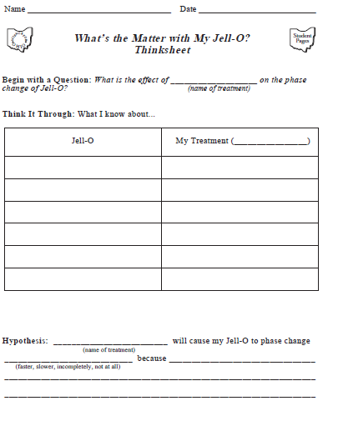
Appendix F: Thinksheet
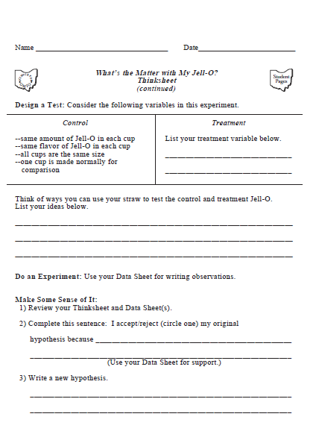
Appendix F: Thinksheet, continued
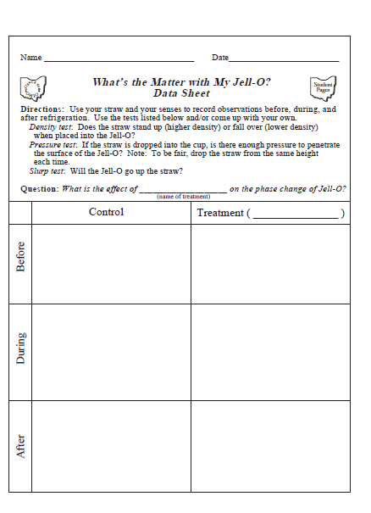
Appendix F: Thinksheet, continued

Appendix G: Phase Change Summative Assessment
Name _________________________________
Directions: Complete 30 points in choices on a separate sheet of paper. Place a
checkmark by the taks that you complete. The due date is _______________.

Knowledge (5 points)
_____ List the steps in making Jell-O.

Comprehension (10 points each)
_____ Explain the meaning of the term phase change. Give two examples.
_____ Explain the meaning of the term freezing point. Give two examples.

Application (15 points)
_____ Explain what happens when we salt roadways. Use the term melting point in your response.

Analysis (20 points)
_____ Conduct an experiment at home to determine the least amount of salt you can
have in 100 milliliters of Jell-O and still prevent phase change. Create your own Thinksheet to record your investigation. Bring your Jell-O samples to class to share.

Synthesis (25 points)
_____ Create a song, poem, or rap that illustrates the connection between matter and
Jell-O. A 25 point response will use the following words in a meaningful way: phase change, density, measurement, matter, and physical change. Be prepared to present your artistic creation to the class.

Evaluation (30 points)
_____ Does salting roadways harm the environment? Find three or more resources
that describe the effects of salt on ecosystems. Write a 100+ word response that uses research to support your informed opinion. Complete a bibliography card for each resource used.

Lesson 3: Conservation of Matter

Lesson Summary:
Students will investigate what happens to the total amount of mass during many types of changes (e.g., ice melting, salt dissolving, paper tearing, candle burning, Alka-Seltzer® in water). Then, students will propose reasons for any difference in the final weight (mass).
Ohio Revised Academic Content Standard:
- [PS4.1] The total amount of matter is conserved when it undergoes a change. a. When an object is broken into smaller pieces, when a solid is dissolved in a liquid or when matter changes state (solid, liquid, gas), the total amount of matter remains constant.

Learning Objectives:
Students will be able to...
- explain why the total amount of matter is conserved when matter undergoes a change;
- test hypotheses about differences in mass after matter undergoes a change.

Materials:

- Ziploc bags
- M&Ms
- nuts
- raisins
- pretzels
- large bowl
- 3 oz. paper cups (one for each student)
- scrap paper
- water
- scissors
- loose-leaf paper
- pencils
- glasses
- spoons
- Kool-aid mix
- ice cubes
- small trays
- candles
- paper
- salt
- Alka-seltzer tablets
- Conservation of Matter Lab activity (Appendix H)

References/Resources:
- Adapted from Gold Seal Lesson submitted by Connie Schmidt/ Darla Paynter/Sherree Svancara/Cathy Sullivan-Sloan, Parkridge Elementary School, coschmidt@peoriaud.k12.az.us
Instructional Procedures:
“5-E” Phase | Planned Activities/Events | Guiding Questions | Questions Students May Ask | Materials/Safety/Notes
Engagement  - Spark interest in the topic  - Tap prior knowledge  - Focus learner’s thinking | - Hold up baggies that have trail mix ingredients in them. For example: one bag filled with M&Ms, one filled with nuts, one with raisins, one with pretzels.  - Now pour all of these into a bowl and stir up. Give each child a small cup of trail mix.  - Have students to pull out one of the ingredients from their cup. Can the ingredients go back to their original state? Could we make a baggie of just raisins again, if we wanted to? That is a physical property. | Can you describe each product according to its physical properties?  [Physical properties include color, shape, odor, and texture.]  Can the ingredients go back to their original state? [yes]  Could we make a baggie of just raisins again, if we wanted to? [yes] | Would burning any of the ingredients be considered a physical change? [No, because burning creates a chemical change, since a new substance is formed] | - Ziploc bags  - M&Ms  - nuts  - raisins  - pretzels  - large bowl  - 3 oz. paper cups (one for each student)  *Consider children who have allergies to peanuts when assembling ingredients for this activity. Peanuts can be substituted or omitted.
“5-E” Phase | Planned Activities/Events | Guiding Questions | Questions Students May Ask | Materials/Safety/Notes
Exploration  - Provide learners with common, concrete, experiences with skills and concepts  - Observe and listen to students  - Ask probing questions  - Act as a consultant | - Have students physically change a piece of paper by tearing, folding, crumpling, rolling etc.  - Have students share how they physically changed their piece of paper.  - Encourage students to observe how the piece of paper is still paper after these physical changes.  - Help students hypothesize about the mass of the paper after the physical change it has undergone.  - Use the paper activity to help with any misconceptions. | How can you physically change a piece of paper?  [Fold, tear, bend, roll, etc.]  What evidence proves that the paper is still paper? [No new substance was formed]  Does the paper have the same amount of mass after undergoing physical changes? [yes] | Is mixing paper with water to create pulp a physical change? [Yes, because if you evaporate the water, you are left with paper, still] | - scrap paper  - water  - scissors
“5-E” Phase | Planned Activities/Events | Guiding Questions | Questions Students May Ask | Materials/Safety/Notes
Explanation  - Use students’ exploration experiences as the basis for explaining concepts  - Encourage students to explain concepts in their own words  - Ask for justification  - Introduce vocabulary  - Explain concepts  Clarify conceptual understanding to dispel misconceptions | - Have students write an explanation for how an object’s mass stays the same after undergoing physical change.  - Allow students 3 minutes to write 5 lines.  - Walk around while students write, affirming their efforts by writing a “+” on top of their paper if they are demonstrating understanding.  - After 3 minutes, have students draw a line across their paper, under their writing.  - Explain to students that they will have a chance to share one idea from their explanation. Instruct students to write 2 more ideas shared by their classmates under the line. | Why does the amount of matter stay the same when an object undergoes a physical change?  [matter is never actually lost during a physical change; however, its properties may change, causing a difference in mass] |  | - loose-leaf paper  - pencils
“5-E” Phase | Planned Activities/Events | Guiding Questions | Questions Students May Ask | Materials/Safety/Notes
Extension  - Actively apply same concepts and skills in a new context resulting in deeper and broader understanding  Involve inquiry or problem-solving | - Students will have the opportunity to apply their understanding of conservation of matter by observing the mass of various objects before and after undergoing physical changes.  - Separate students into groups of 4 and explain to them that they will be rotating to various physical change stations.  - They will get 15 minutes at each station to conduct the investigation and to make observations by completing Conservation of Matter Lab activity (Appendix F) | What do you propose could cause a difference in the mass of an object after undergoing a physical change? [evaporation, residual water left in a container, etc.] | What types of observations should we make before the physical change? [color, odor, texture, size, but most importantly for this investigation, mass] | - water  - glasses  - spoons  - Kool-aid mix  - ice cubes  - small trays  - candles  - paper  - salt  - Alka-seltzer tablets  - Conservation of Matter Lab activity (Appendix H)  *Caution students against tasting any of the ingredients.
Evaluation  - Observe the students as they apply new concepts and skills  - Assess, formally and/or informally, student progress toward achieving the learner outcomes (knowledge and/or skills)  Allow students to assess their own learning and group-process skills | Informal and formal assessments employed throughout all phases  Formative Assessment: Check for student understanding by observing student answers while they write their explanations for how amount of matter stays the same after a physical change.  Summative Assessment: Formally assess Conservation of Matter Lab (Appendix H).

Appendix H: Conservation of Matter Lab
Name _______________________________________________
Kool-aid Investigation
1. Observations of matter before change:
______________________________________________________________________
______________________________________________________________________
______________________________________________________________________
2. Observations of matter after change:
______________________________________________________________________
______________________________________________________________________
______________________________________________________________________
3. Propose reasons for any difference in final mass after change:
______________________________________________________________________
______________________________________________________________________
______________________________________________________________________

Salt Water Investigation
1. Observations of matter before change:
______________________________________________________________________
______________________________________________________________________
______________________________________________________________________
2. Observations of matter after change:
______________________________________________________________________
______________________________________________________________________
______________________________________________________________________
3. Propose reasons for any difference in final mass after change:
______________________________________________________________________
______________________________________________________________________
______________________________________________________________________

Candle Wax Investigation
1. Observations of matter before change:
______________________________________________________________________
______________________________________________________________________
______________________________________________________________________
2. Observations of matter after change:
______________________________________________________________________
______________________________________________________________________
______________________________________________________________________
3. Propose reasons for any difference in final mass after change:
______________________________________________________________________
______________________________________________________________________
______________________________________________________________________

Alka-seltzer Investigation
1. Observations of matter before change:
______________________________________________________________________
______________________________________________________________________
______________________________________________________________________

2. Observations of matter after change:
______________________________________________________________________
______________________________________________________________________
______________________________________________________________________
3. Propose reasons for any difference in final mass after change:
______________________________________________________________________
______________________________________________________________________
______________________________________________________________________

Ice Cube Investigation
1. Observations of matter before change:
______________________________________________________________________
______________________________________________________________________
______________________________________________________________________
2. Observations of matter after change:
______________________________________________________________________
______________________________________________________________________
______________________________________________________________________
3. Propose reasons for any difference in final mass after change:
______________________________________________________________________
______________________________________________________________________
______________________________________________________________________

Appendix I: Solid, Liquid, and Gas Post-Assessment
Name _____________________________________________________

Design an experiment to test conservation of matter.

Problem: Why does the amount of matter stay the same when an object undergoes a physical change?

1. Hypothesis:
______________________________________________________________________
______________________________________________________________________

2. Procedures:
______________________________________________________________________
______________________________________________________________________
______________________________________________________________________
______________________________________________________________________

3. Observations:
______________________________________________________________________
______________________________________________________________________
______________________________________________________________________

4. What evidence can you use to prove that the amount of matter stays constant during a physical change?
______________________________________________________________________
______________________________________________________________________

5. Provide an explanation for any differences in mass after conducting the test.
______________________________________________________________________
______________________________________________________________________
______________________________________________________________________

6. Conclusion:
______________________________________________________________________
______________________________________________________________________
______________________________________________________________________

7. Explain why the volume of water decreases when placed in an open container and left to sit for an extended period of time.

______________________________________________________________________

______________________________________________________________________

______________________________________________________________________

8. Explain why you are likely to observe droplets of water on the outside of a glass of ice cold lemonade on a hot summer day.
______________________________________________________________________
______________________________________________________________________
______________________________________________________________________

