Community Garden Subunit: Preservation

Development of a community garden space has the potential to provide a significant amount of produce which may or may not be used before it spoils. With proper plant selection and care and maintenance of the community garden space, garden participants will have the opportunity the preserve some of this abundance for later use. Preservation will only be successful if participants have the knowledge and understanding of techniques available to save this produce for future use. This can be done through instruction in the various preservation techniques and their potential benefits and deficits. Careful consideration of each preservation technique and the proper use of each will ensure food safety and viability at a later time (Jarden, 2006).
Food safety is a significant concern especially when related to preservation techniques and will be discussed in detail during each lesson (Jarden, 2006). Spoilers including mold and bacteria are a threat to the viability of preserved food and can cause significant health problems if eaten. Instruction in preservation techniques will ensure participants will properly preserve and store their produce with little to no concern for the safety of the produce for later use. By identifying potential deficits to preserving food, participants will be better equipped to recognize damaged or tainted food to ensure their health and well-being is maintained.
Due to the need for thorough student understanding of preservation techniques before attempting them independently, instruction will be delivered using the 5-E Learning Cycle Model (Chiarelott, 2006). This model will allow for guided opportunities to explore each technique, its benefits and deficits, and the opportunity for individual explanation and expansion during each lesson. This will also allow students to ask questions and evaluate their understanding of each technique before attempting them independently. By allowing students opportunities to practice the techniques in a structured setting, students will be better able to take the techniques learned and apply them for future use.
Subunit Nine: Preservation
- Students will identify a variety of preservation options available for specific produce from the project garden (Bloom’s Taxonomy: Knowledge).
- Students will describe the blanching process (Bloom’s Taxonomy: Knowledge).
- Students will describe the general canning process (Bloom’s Taxonomy: Knowledge).
- Students will describe the dehydrating process (Bloom’s Taxonomy: Knowledge).
- Students will describe the freezing process (Bloom’s Taxonomy: Knowledge).
- Students will analyze each preservation technique to determine the benefits and deficits of the method (Bloom’s Taxonomy: Analysis).
- Students will evaluate each process to determine their preferred method of preservation (Bloom’s Taxonomy: Evaluation).
- Students will utilize preservation techniques to preserve produce from the project garden (Bloom’s Taxonomy: Application).

References
Jarden Home Brands. (2006). Ball blue book of preserving. Muncie, IN: Author.
Chiarelott, L, 2006. Curriculum in context. Belmont, CA: Wadsworth, Cengage Learning.

Preservation: Pre-Assessment

List any preservation techniques you have tried to use and your success with the technique.
____________________________________________________________________________________________________________________________________________________________________________________________________________________________________________________________________________

Rate your level of comfort with the following preservation techniques and concepts:

Preservation  Technique | Uncomfortable | Some Experience | Very Comfortable
Canning | 1 2 3 | 4 5 6 7 | 8 9 10
Blanching | 1 2 3 | 4 5 6 7 | 8 9 10
Drying | 1 2 3 | 4 5 6 7 | 8 9 10
Freezing | 1 2 3 | 4 5 6 7 | 8 9 10
Understanding food safety | 1 2 3 | 4 5 6 7 | 8 9 10

If you indicated ‘Uncomfortable’ for any technique, what would make you more comfortable? _________________________________________________________
___________________________________________________________________

What process interests you the most (Circle all that apply)?

Canning Freezing Blanching Juicing Drying

What reservations do you have regarding preserving food? _______________________
______________________________________________________________________________________________________________________________________

What kinds of produce would you use if it was preserved? ________________________
___________________________________________________________________
Subunit Lesson 1: Preservation Techniques: Food Safety and the Canning Process
Concept to be taught:  -How to select produce for canning  -Proper safety considerations  -Preparation of produce for canning  -How to pack a canning jar  -How to process a canning jar  -Maintaining the viability of preserved food |  | Objectives:  - Students will identify appropriate produce for use with the canning process.  - Students will describe the general canning process for most produce.  - Students will analyze the process to determine its potential benefits and deficits.  - Students will evaluate its potential ease of use for future usage.  - Students will use the canning process to preserve a selected type of produce.
Time Requirements:  60-90 minutes, plus 15-30 minutes processing time |  | Materials:  Canning jars, lids, seals, large pot, canning rack, canning jar tongs, magnet, small pot, water, towels, selected recipes/directions, previously canned produce, produce for canning, handout indicating viability of canned produce
Engagement (10 minutes): | I will ask students to share their previous experiences with the canning process including opportunities for canning as well as memories of canned food from their past. I will ask each student to share how preserving food can impact their current situation.
Exploration (30 minutes): | I will provide 6 different kinds of canned produce for students to evaluate. They will use their handout to determine if the produce in each jar is safe for consumption. They will look at the vacuum seals, rings, and jars to determine if any part is tainted and will measure the head space for each kind of produce.
Explanation (15 minutes): | Students will explain to the group if their canned produce is viable and how they determined its safety for consumption. They will then use recipe cards to find the recipe for the produce they evaluated. They will identify the proper head space, processing length and any other information specific to the produce.
Extension (30-35 minutes, plus 15-30 minutes processing time): | Students will then use produce from the project garden to complete the canning process for that produce. They will fill the jars, measure the head space, and then seal and process the jars for the correct amount of time. Students will work in pairs so two different types of produce can be used be each pair. This will allow for additional experience.
Evaluation (5 minutes): | Students will use a rubric to determine their understanding of the skill and identify additional learning they would need to feel comfortable performing the canning process independently. Students will also identify a peer to contact for information or assistance when performing the canning process independently.
Closing (5-10 minutes): | Summary:  -Canning can be a safe alternative to purchasing store-bought produce.  -Canning is safe, simple when done following specific protocol.  -Canning can provide nutritious produce well into the winter months.
Notes: | Key Questions  -How can the canning process help you maintain a healthy lifestyle even when fresh, local food is difficult to find?  -What are some of the significant drawbacks to canning your own food?  -How can food safety be maintained when preparing home-canned food items?

Handout: Learning about canning: Just one step beyond cooking (p. 3-4) from
Jarden Home Brands. (2006). Ball blue book of preserving. Muncie, IN: Author.

Recipes: Selected text from
Jarden Home Brands. (2006). Ball blue book of preserving. Muncie, IN: Author.

Rubric for Food Safety and the Canning Process
My Comfort Level and Understanding of:  (Place a checkmark in the appropriate column for your ability level.) | I can do this! | I think I can do this. | I need more information!
Potential hazards:
Completing the canning process:
Food safety concerns:
The canning process:

An area I may need a little more work on: ____________________________________________

Who could I ask for help with canning or for more information?

Name: _________________________ Contact information: _____________________________

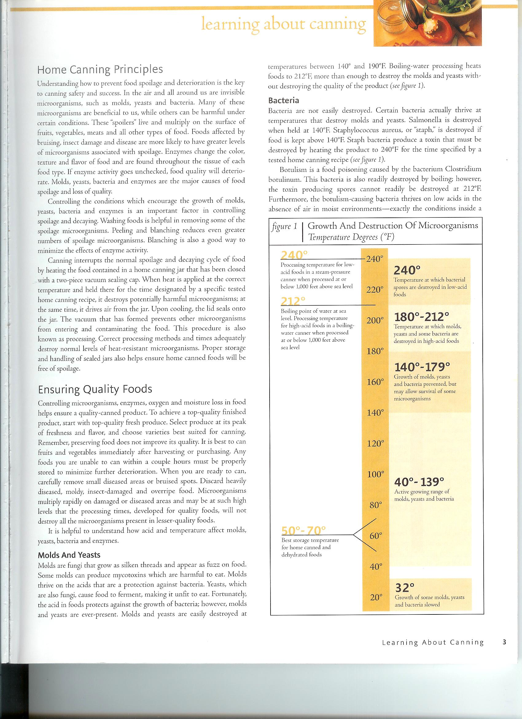
Handouts for Food Safety and the Canning Process

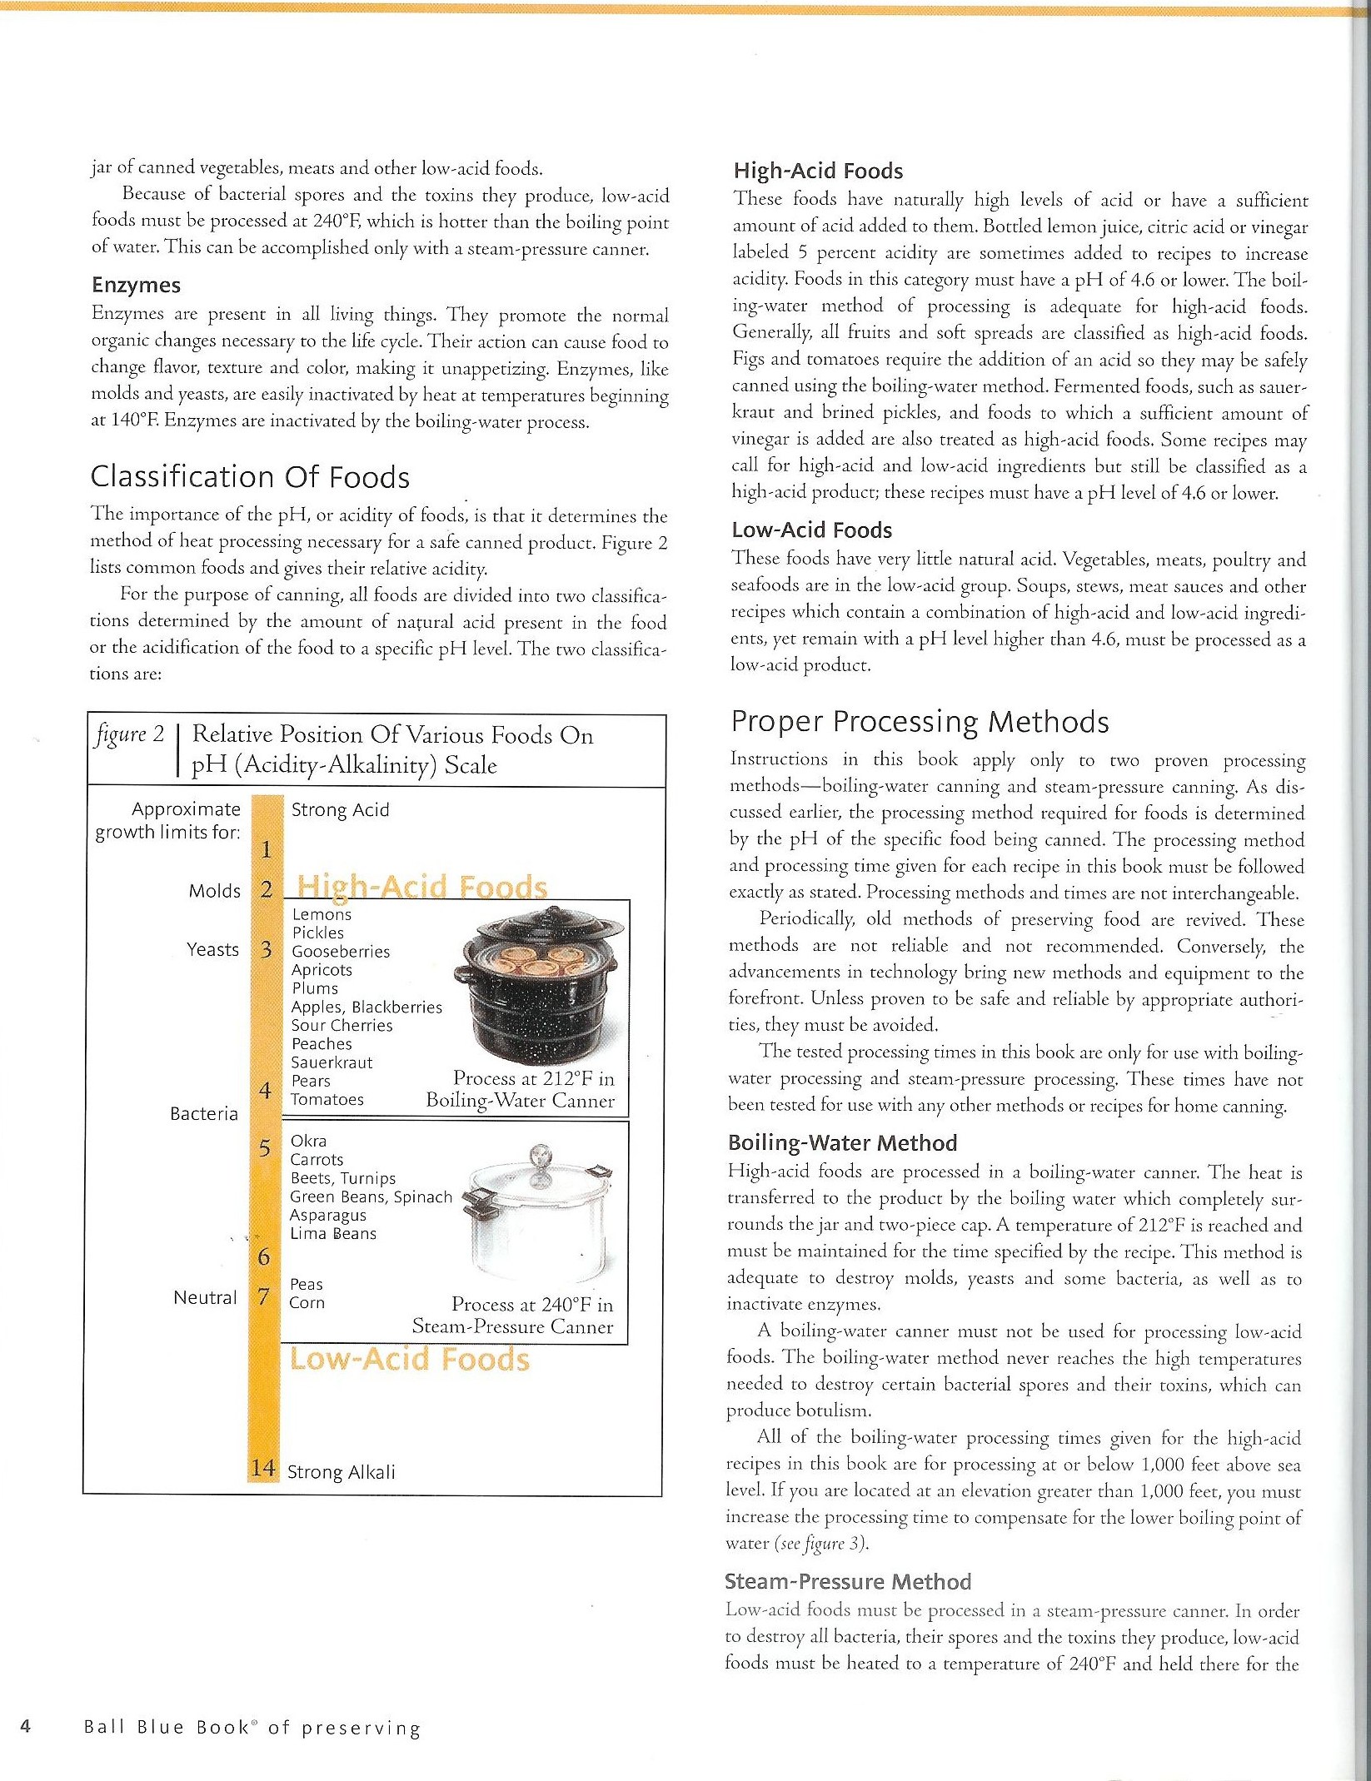
Subunit Lesson 2: Preservation Techniques: Food Safety and the Freezing Process
Concept to be taught:  -How to select produce for freezing  -Proper safety considerations  -Preparation of produce for freezing  -How to completing the blanching process  -How to pack freezer containers  -Maintaining the viability of preserved food |  | Objectives:  - Students will identify appropriate produce for use with the freezing process.  - Students will describe the general freezing process for most produce.  - Students will analyze the process to determine its potential benefits and deficits.  - Students will evaluate its potential ease of use for future usage.  - Students will use the freezing process to preserve a selected type of produce.
Time Requirements:  60-90 minutes, plus 10-12 hours for freezing |  | Materials:  Previously frozen produce for evaluation, selected recipes/directions, produce for Freezing, handout indicating viability of frozen produce, pan, water, utensils for produce, freezer containers to store produce, freezer space
Engagement (10 minutes): | I will ask students to share their previous experiences with the freezing process including opportunities for freezing their own produces as well as memories of frozen produce from their past. I will ask each student to share how preserving food by freezing can impact their current situation. We will also discuss storage issues associated with freezer space.
Exploration (30 minutes): | I will provide 4 different kinds of frozen produce for students to evaluate. They will use their handout to determine if the produce in each container is safe for consumption. They will look at the quality of the food, the ability to separate it while frozen, the quality of the container and any tainted portions for group discussion.
Explanation (30 minutes): | Students will explain to the group if their frozen produce is viable and how they determined its safety for consumption. They will then use recipe cards to find the recipe for the produce they evaluated. They will identify the proper container, preparation for freezing, and any other information specific to the produce. Students will watch and practice the blanching technique for use on their own produce.
Extension (15 minutes, plus freezing time): | Students will then use produce from the project garden to complete the freezing process for that produce. They will blanch the produce, pack it in storage containers and place it in the freezer. Students will work in pairs so two different types of produce can be used be each pair. This will allow for additional experience.
Evaluation (5 minutes): | Students will use a rubric to determine their understanding of the skill and identify additional learning they would need to feel comfortable performing the freezing process independently. Students will also identify a peer they could refer to for information if needed once students perform the freezing process independently.
Closing (5-10 minutes): | Summary:  -Freezing produce is a safe and effective method for providing food during winter months.  -Blanching produce to prepare it is vital for its safety when freezing food.  -Freezing produce saves time and energy when compared to canning methods.
Notes: | Key Questions:  -What is the main difference in food quality between canning methods and freezing methods?  -Does freezing produce effectively provide food during non-growing months?  -Is freezing food a safe and reliable alternative to the canning method?  -What are the food safety concerns with the freezing method?

Handout: Just one step beyond cooking: Learning about canning (p. 88-90) from
Jarden Home Brands. (2006). Ball blue book of preserving. Muncie, IN: Author.

Recipes: Selected text from
Jarden Home Brands. (2006). Ball blue book of preserving. Muncie, IN: Author.

Rubric for Food Safety and the Freezing Process
My Comfort Level and Understanding of:  (Place a checkmark in the appropriate column for your ability level.) | I can do this! | I think I can do this. | I need more information!
Potential freezer hazards:
Completing the blanching process:
Food safety concerns:
The freezing process:
Selecting and packing freezer containers:

An area I may need a little more work on: ____________________________________________

Who could I ask for help with freezing or for more information?

Name: _________________________ Contact information: _____________________________

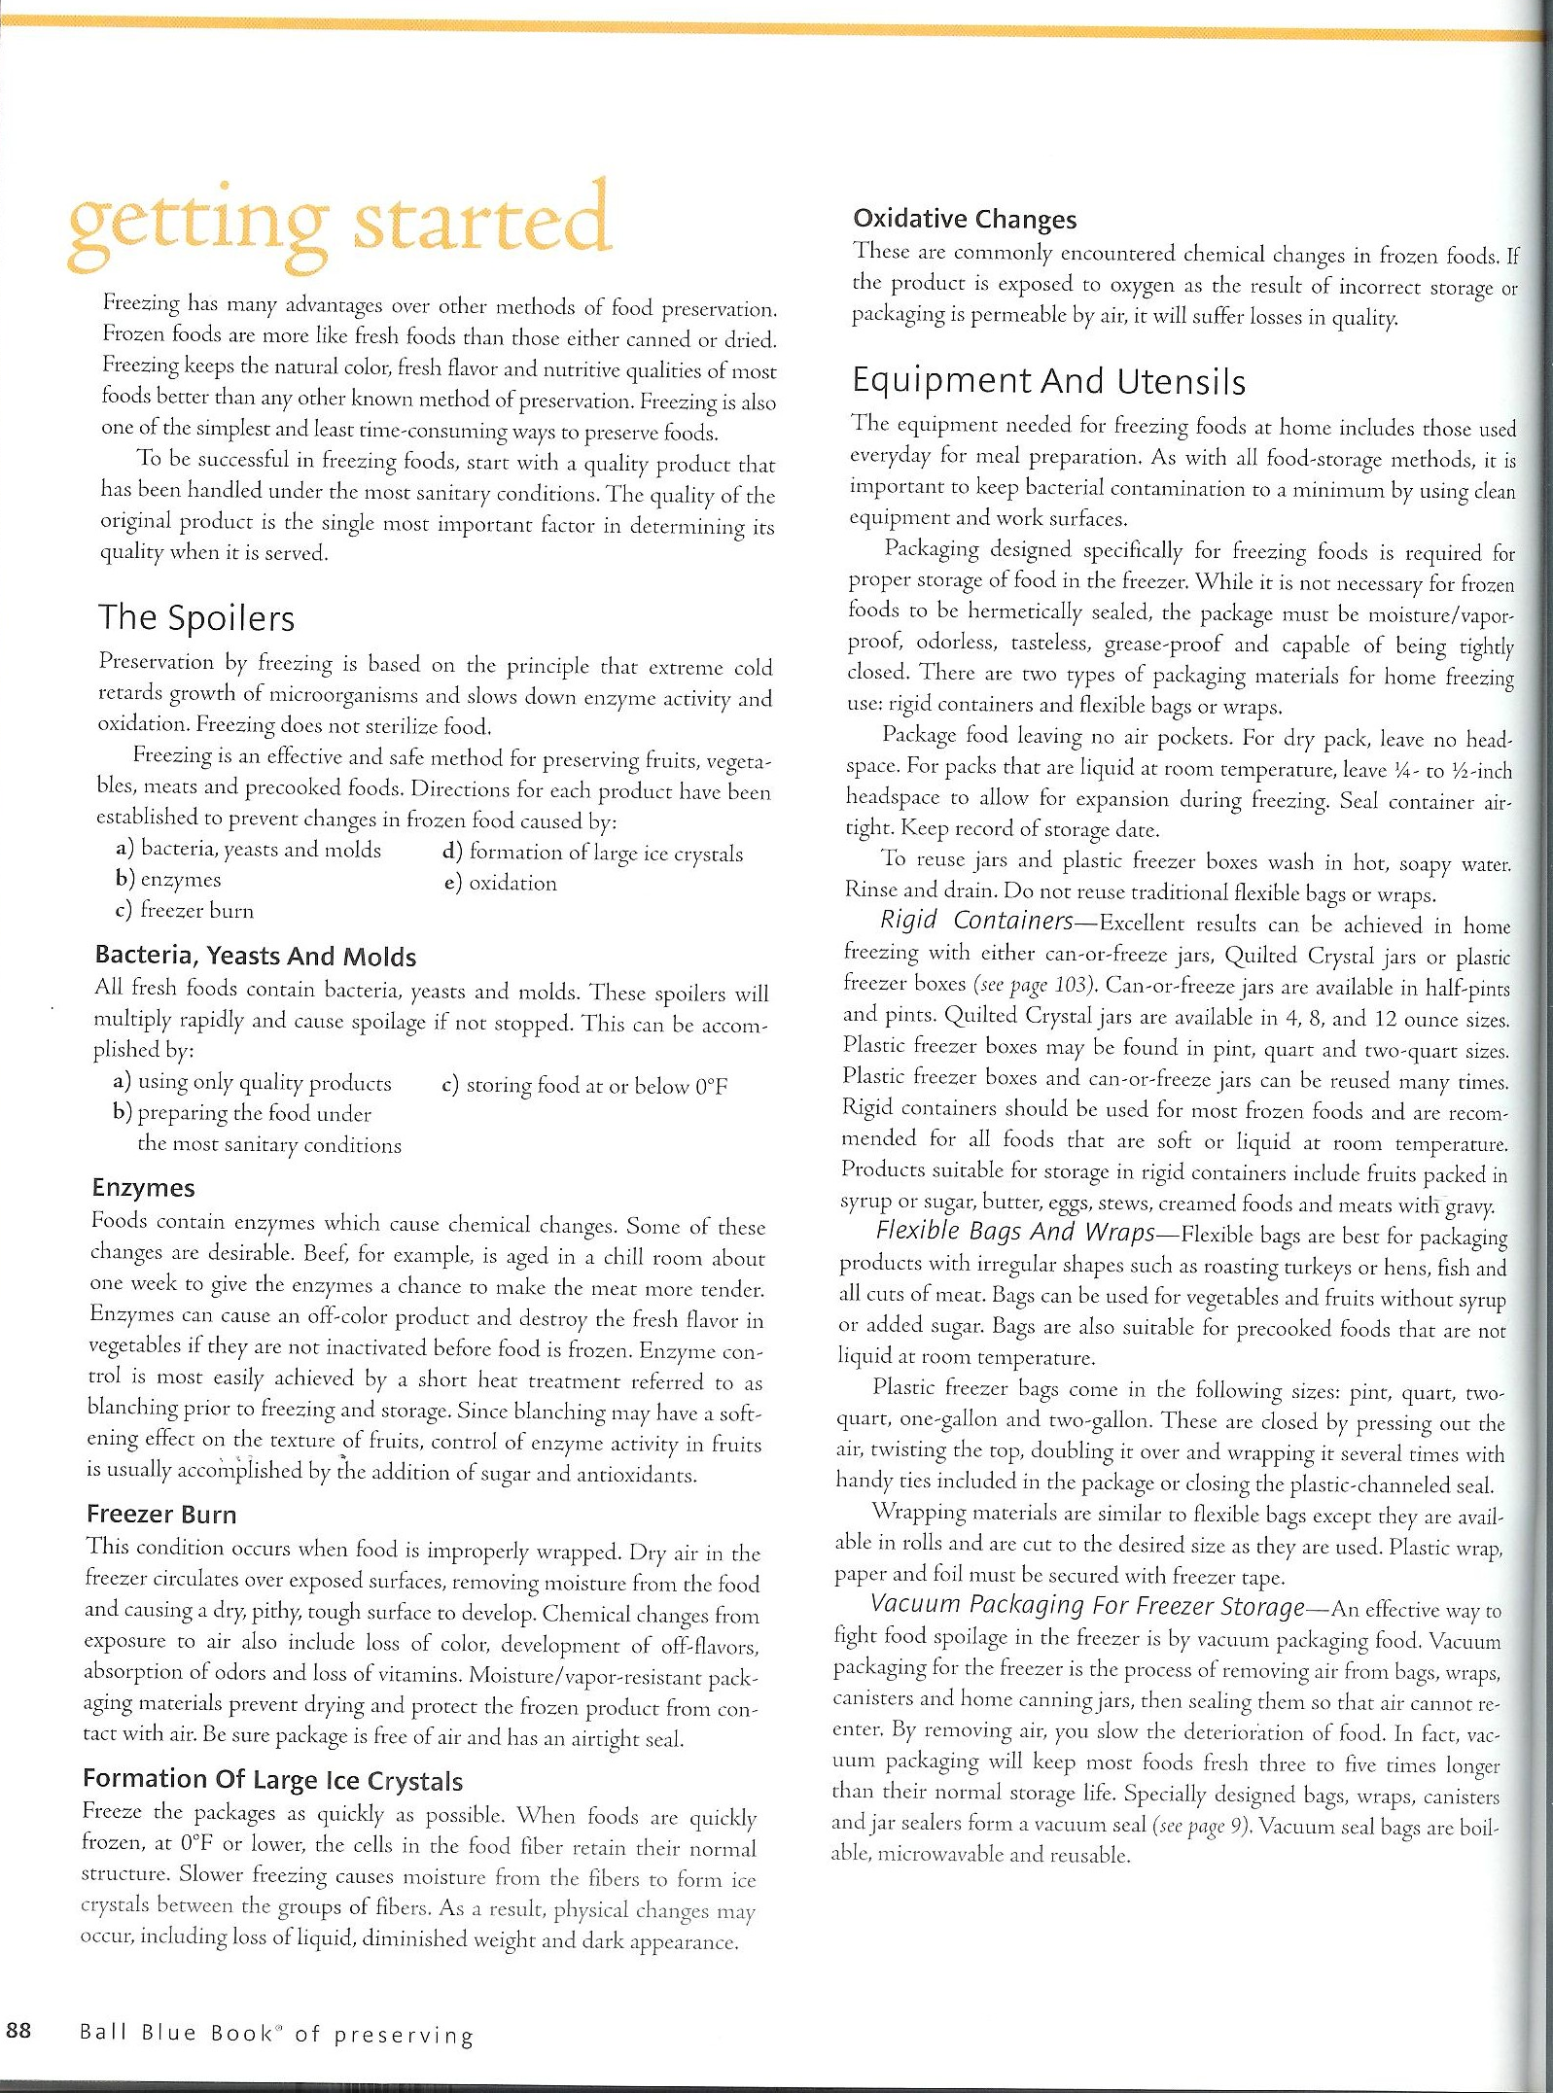
Handouts for Food Safety and the Freezing Process

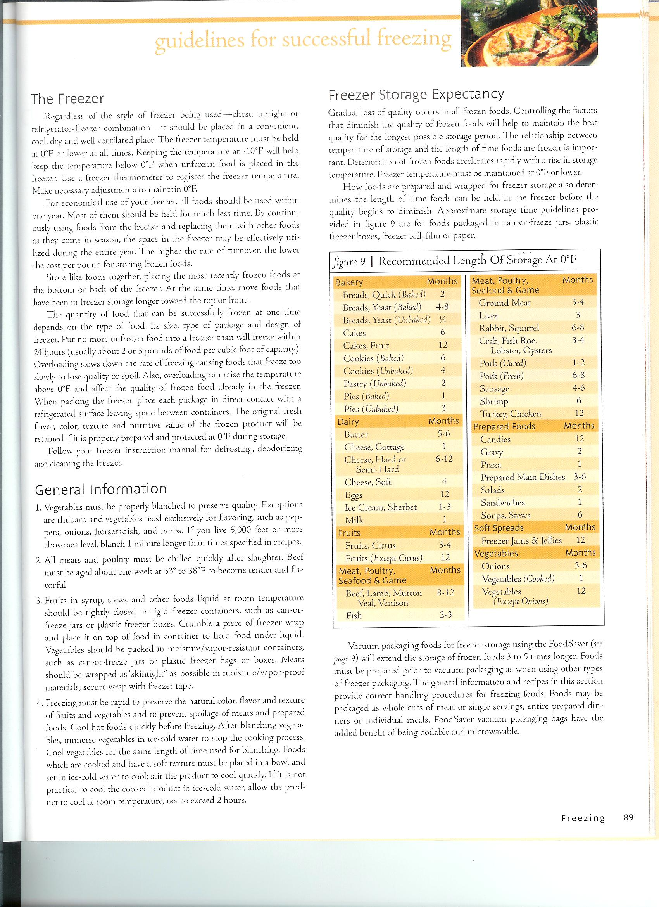
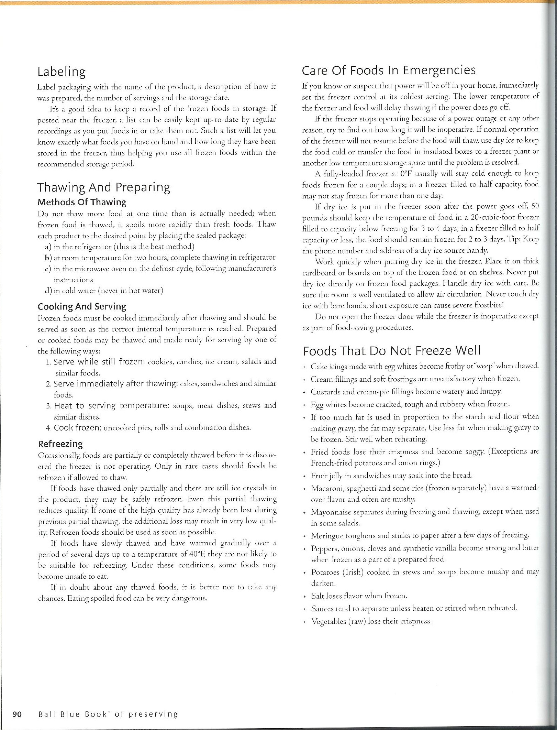
Subunit Lesson 3: Preservation Techniques: Food Safety and the Dehydrating Process
Concept to be taught:  -How to select produce for dehydrating  -Proper safety considerations  -Preparation of produce for dehydrating  -How to store dehydrated produce  -Maintaining the viability of preserved food |  | Objectives:  - Students will identify appropriate produce for use with the dehydrating process.  - Students will describe the general dehydrating process for most produce.  - Students will analyze the process to determine its potential benefits and deficits.  - Students will evaluate its potential ease of use for future usage.  - Students will use the dehydrating process to preserve a selected type of produce.
Time Requirements:  90-100 minutes, plus 10-12 hours for dehydrating |  | Materials:  Previously dehydrated produce for evaluation, selected recipes/directions, produce for dehydrating, handout indicating viability of dehydrated produce, cutting boards, knives, dehydrator, citrus juice
Engagement (10 minutes): | I will ask students to share their previous experiences with dehydrating their own food or eating store-bought dehydrated food. I will ask each student to share how preserving food by dehydrating can impact their current situation. We will also discuss storage issues associated with dehydrated food.
Exploration (30 minutes): | I will provide 3 different kinds of dehydrated produce for students to evaluate. They will use their handout to determine if the produce is safe for consumption. They will look at the quality of the food, the ability to rehydrate it for use in cooking/baking, the quality of the storage container and any tainted portions for group discussion.
Explanation (20 minutes): | Students will explain to the group if their dehydrated produce is viable and how they determined its safety for consumption. They will then use recipe cards to find the recipe for the produce they evaluated. They will identify the proper container, preparation for dehydrating, and any other information specific to the produce. They will indicate how the dehydrated produce could be used in cooking/baking.
Extension (30 minutes, plus dehydrating time): | Students will then use produce from the project garden to complete the dehydrating process for that produce. They will chop the produce to the indicated size, add citrus juice as necessary to prevent discoloration of the produce then put it in the dehydrator. Students will work in pairs so two different types of produce can be used be each pair. This will allow for additional experience.
Evaluation (5 minutes): | Students will use a rubric to determine their understanding of the skill and identify additional learning they would need to feel comfortable performing the dehydrating process independently. Students will also identify a peer they could refer to for information if needed once students perform the dehydrating process independently.
Closing (5-10 minutes): | Summary:  -Dehydration is a safe method for preserving certain kinds of produce for later use.  -Dehydration is designed to be used with a limited number of produce items.  -Dehydration is a quick and safe way to preserve certain kinds of produce that will store for many weeks.
Notes: | Key Questions:  -What are some drawbacks to dehydrating produce versus other whole-food preservation methods?  -How can food safety be maintained with the dehydration process?  -What are the main differences between the dehydration and canning/freezing methods?

Handout: Dehydrating: Fruit leathers, jerky & rubs (p. 106-107) from
Jarden Home Brands. (2006). Ball blue book of preserving. Muncie, IN: Author.

Recipes: Selected text from
Jarden Home Brands. (2006). Ball blue book of preserving. Muncie, IN: Author.

Rubric for Food Safety and the Dehydrating Process
My Comfort Level and Understanding of:  (Place a checkmark in the appropriate column for your ability level.) | I can do this! | I think I can do this. | I need more information!
Potential dehydrating hazards:
Preparing food for dehydrating:
Food safety concerns:
The dehydrating process:
Storage of dehydrated food:

An area I may need a little more work on: ____________________________________________

Who could I ask for help with freezing or for more information?

Name: _________________________ Contact information: _____________________________

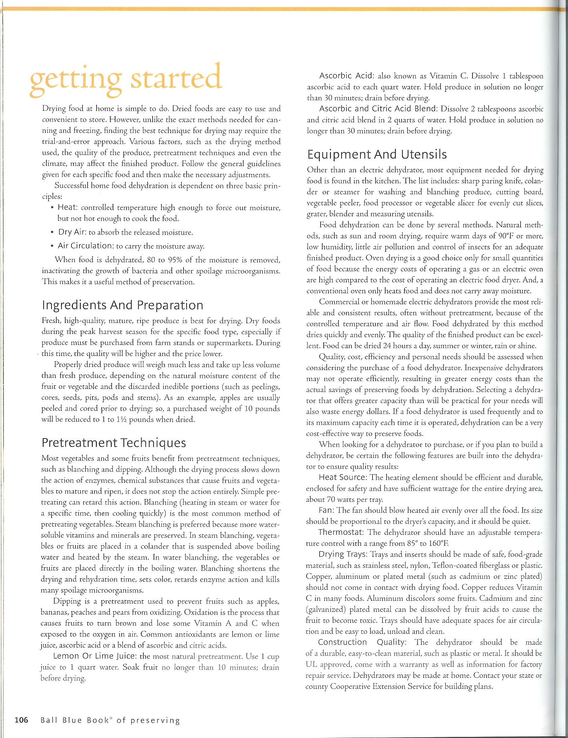
Handout for Food Safety and the Dehydrating Process

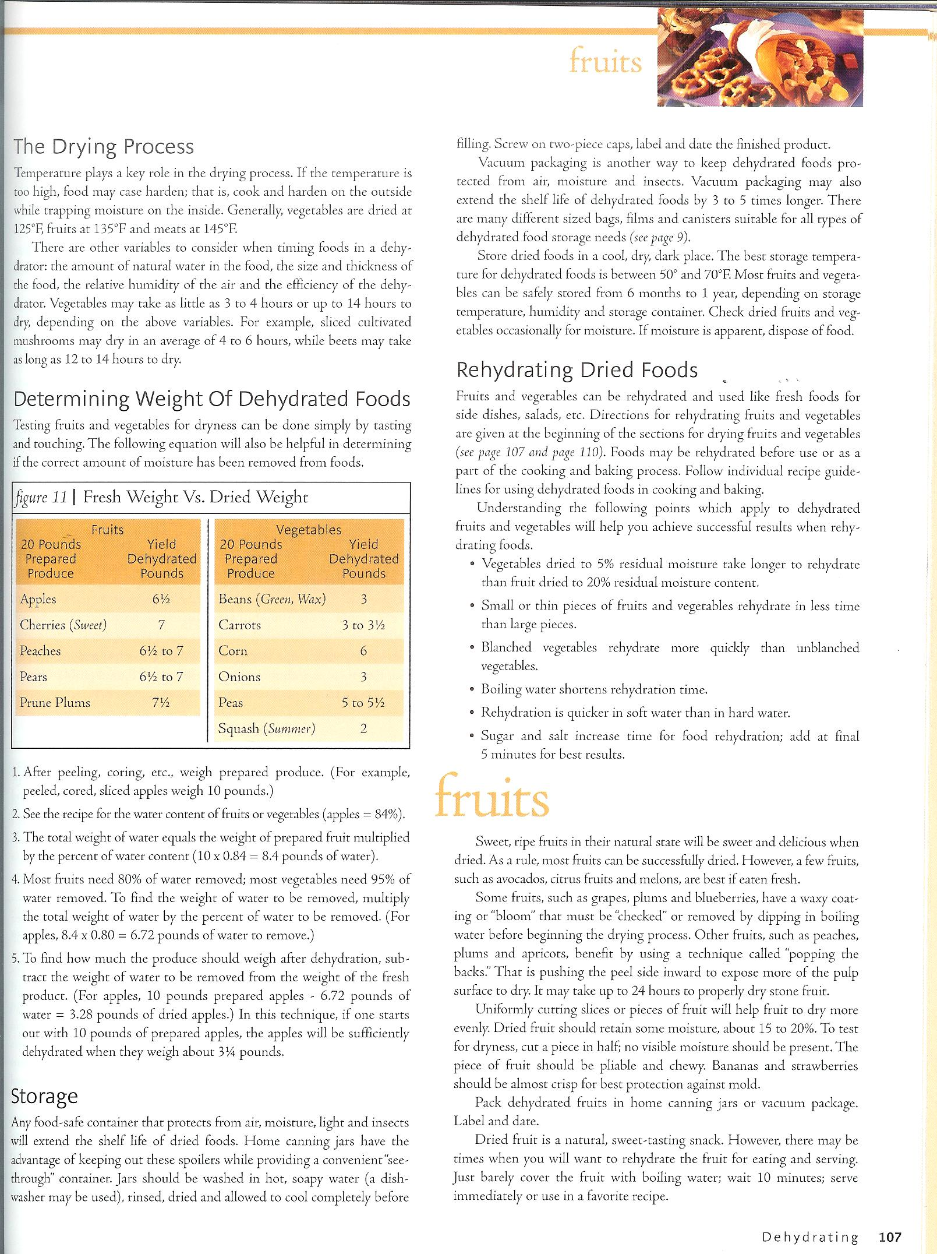
Preservation: Feedback Form

List the preservation techniques you have learned and two kinds of produce you could preserve using each method.
____________________________________________________________________________________________________________________________________________________________________________________________________________________________________________________________________________

Rate your level of comfort with the following preservation techniques and concepts:

Preservation  Technique | Uncomfortable | Some Experience | Very Comfortable
Canning | 1 2 3 | 4 5 6 7 | 8 9 10
Blanching | 1 2 3 | 4 5 6 7 | 8 9 10
Drying | 1 2 3 | 4 5 6 7 | 8 9 10
Freezing | 1 2 3 | 4 5 6 7 | 8 9 10
Understanding food safety | 1 2 3 | 4 5 6 7 | 8 9 10

If you indicated ‘Uncomfortable’ for any technique, what information or instruction do you still feel you need to be confident? _________________________________________
___________________________________________________________________

What process do you think you will use in the future (Circle all that apply)?

Canning Freezing Blanching Juicing Drying

What process seems to be the easiest and will take up the least storage space for you? ___________________________________________________________________
What reservations do you still have regarding preserved food now that you have practiced each method? _________________________________________________________
______________________________________________________________________________________________________________________________________
Preservation: Key Assessment Name ____________________________________

Directions: Answer the questions to the best of your ability.

List the three main types of preserving and three types of produce that can be preserved using each method.
Preserving method: Types of produce
_______________________ ________________________________________________
_______________________ ________________________________________________
_______________________ ________________________________________________
What is a significant difference between the freezing and canning technique?
__________________________________________________________________________________________________________________________________________________________________________________________________________________________________________
What are the main steps to complete the dehydrating technique (list 4).
1. ____________________________________________________________________________
2. ____________________________________________________________________________
3. ____________________________________________________________________________
4. ____________________________________________________________________________
What are three health risks associated with home-preserved food?
________________________________________________________________________________________________________________________________________________________________________________________________________________________________________________________________________________________________________________________

What is one way to prevent the health risks associated with home-preserved food? ___________
______________________________________________________________________________
How is quality food selected for preserving? _________________________________________
______________________________________________________________________________

