Instructional Design Project
Third Grade Life Science
Diversity and Interdependence of Life
Bowling Green State University
EDAS 7100
Spring 2012

Rationale

I have chosen to base my Instructional Design Project on my Third Grade Life Science Unit, Diversity and Interdependence of Life. This unit will be divided into four sub-units which will include Animal Classification of Vertebrates, Animal Classification of Invertebrates, Needs of Plants and Animals, and Survival Functions of Plants and Animals.
I have found that the children are very interested in life sciences, especially animals, and they like to see where they “fit” in the grand scheme of things. I will help them to be able to classify animals into vertebrate and invertebrate groups being sure they are able to relate them based on the criteria within their categories as mentioned earlier. I do not need to go as far into plant classification, but will touch on the subject focusing on how they produce seeds and their other basic identifying characteristics.
When focusing on the survival functions of plants and animals I will place great importance on how the creatures we had studied actually make it in the world that we know and love. I will focus on plant and animal needs for survival, their adaptations, and the food chain that exists, being careful not to leave out the importance of the Sun being the essential first link in any food chain. I will touch on the concept of food webs, but will not go much further into that, for I know it is stressed more in the next grade.
As stated in my curriculum design, moving through my units using the concept related sequencing pattern with a focus on class relations and logical prerequisites will be extremely beneficial for the students because it is clear that the information can be organized easily and effectively in this way. I look forward to helping my students to explore the world around us and our place in it while following this rationale.
When putting this Instructional Design Project together I put much consideration into the types of lessons I am accustomed to teaching, and those which I think I should be striving to teach more. I have to admit that many of my lessons seem to fit best with the Concept Attainment and Inductive Models described in our text (Chiarelott, 2006). I know that these are more teacher directed, and I think I teach many of my lessons this way out of habit and the "old school" teaching that I was trained to do so many years ago.
Over the past 5 years or so, I truly have branched out and have incorporated more of the group investigation types of lessons (Chiarelott, 2006). I have experienced the challenges of group work that were mentioned in our text, seeing that many students either do not understand their role in the group or do not pull their own weight by choice. I think this is something we cannot give up on though, because one of the most important skills we need to help these children to develop is that of working with others.
I would also love to use the self-directed learning model (Chiarelott, 2006) more often so I am also trying to incorporate more of these lessons into this instructional design. I see great value in teaching the children to find things on their own and to be as resourceful as humanly possible. At this point I find myself encouraging the students to do this, but more in the miscellaneous areas which they express being curious about than in the regular areas of the curriculum that I am delivering to them on a daily basis.
Many times students come to me with such wonderful topics they are curious about. This is a healthy and dynamic part of being a human being in our complex society. It should be our goal to use not just one, but several of the models of teaching highlighted in our text to appeal to each and every learner we come in contact with. Some may respond much better to the teacher directed models, some to the more independent models. Regardless of which ones they respond "better" to, it's important for them to have experience with each. We want to teach them to be life-long learners who are comfortable and successful in applying their skills in a wide variety of situations. Keeping all of this in mind, I plan to incorporate as many of the different types of lessons as possible in this instructional design.

References
Chiarelott, Leigh. Curriculum in Context: Designing Curriculum and Instruction for Teaching and Learning in Context. Belmont, CA: Thompson Wadsorth, 2006.

Unit Learner Outcomes
Diversity and Interdependence of Life

Subunit One: Animal Classification – Vertebrates
- The students will be able to state what a vertebrate is and name the five main groups including mammals, fish, reptiles, birds, amphibians. (memory/recall)
- The students will be able to explain the characteristics of the five types of vertebrates. (comprehension)
- The students will be able to use the characteristics of the vertebrates to determine which group they as humans belong in, and they will create a Kidspiration graphic organizer showing their knowledge of group characteristics. (application)
- When finding and cutting out magazine pictures of animals from different vertebrate groups, the students will be able to determine which ones belong together based on their characteristics. (analysis)
- The students will be able to create and name their own imaginary animal from one of the vertebrate groups, writing a short story about it, being certain that their animal possesses the characteristics necessary for belonging to that group. (synthesis)
- After looking at peer illustrations and reading their stories, the students will be able to judge whether the other children had classified their imaginary animals accurately based on what is known about each group. (evaluation)

Subunit Two: Animal Classification – Invertebrates
- The students will be able to state what in invertebrate is and name five of them. (memory/recall)
- The students will be able to explain the differences between two of the main invertebrate groups, insects and spiders. (comprehension)
- The students will be able to use the characteristics of invertebrates to determine which group popular cartoon characters would belong to (Charlotte from Charlotte’s Web, characters from the movie Antz, and A Bug’s Life, James and the Giant Peach, SpongeBob, Patrick, Squidward etc.) (application)
- The students will be able to sort pictures of insects and spiders in their appropriate groups based on their characteristics. (analysis)
- The students will be able to create and name their own imaginary insect or spider, being certain that their animal possesses the characteristics necessary for belonging to that group. (synthesis)
- The students will be able to judge whether the other children had classified their imaginary animals accurately based on what is known about each group. (evaluation)

Subunit Three: Needs of Plants and Animals
- The students will be able to name what all plants and animals need to have in their environments to survive. (memory/recall)
- The students will be able to explain why the animals need certain things in their environments to survive. (comprehension)
- The students will be able to use what they know about animal needs to describe a habitat that would be conducive to healthy life for a given plant or animal. (application)
- When shown an unhealthy environment for plants or animals, the students will be able to determine which need is not being met. (analysis)
- The students will be able to create a model of a habitat that would be conducive to a healthy life for a given plant or animal. (synthesis)
- Using criteria established in their creation of a healthy animal habitat, the students will be able to judge whether their peers’ creations would be sufficient for supporting plant or animal life. (judgment)

Subunit Four: Survival Functions of Plants and Animals
- The students will be able to define the characteristics of producers and consumers (including herbivores, carnivores, and omnivores), adaptations, food chains, and food webs. (memory/recall)
- The students will be able to explain what the main purposes of adaptations are. (comprehension)
- The students will be able to use what they know about producers, consumers, and food chains to make a 5 part mobile showing the sun and animals of a food chain in the proper order. (application)
- When given a scenario involving a predator and its prey, the student will be able to determine what helps the predator to be successful in defeating its prey. (analysis)
- The student will be able to create an animal story in which the characters use adaptations in their roles as predators and prey. (synthesis)
- Using criteria learned in this subunit about survival functions of plants and animals, the students will be able to judge as to which animal(s) may be the strongest, and which may be the weakest in our animal kingdom. (evaluation)

PRE-ASSESSMENT SURVEY
WHAT I ALREADY KNOW ABOUT
VERTEBRATES/INVERTEBRATES
THE NEEDS AND SURVIVAL OF PLANTS AND ANIMALS

Circle the letter that best describes how you feel about the sentence:
A=Agree D=Disagree NS=Not Sure

1. Vertebrates are animals that have a backbone. A D NS
2. Invertebrates are animals that have a backbone. A D NS
3. The five main groups of vertebrates are fish, mammals,
insects, birds, and reptiles A D NS
4. Humans are mammals. A D NS
5. Fish breathe air with lungs. A D NS
6. Two of the invertebrate groups are insects and spiders. A D NS
7. Spiders have 6 legs and insects have 8 legs. A D NS
8. All plants and animals need air, water, and food to survive. A D NS
9. The sun and plants are “producers”. A D NS
10. Herbivores eat only plants. A D NS
11. Omnivores eat only animals. A D NS
12. Carnivores eat both plants and animals. A D NS
13. An example of an adaptation is camouflage. A D NS
14. In a food chain including the sun, a plant, a grasshopper,
a lizard, a snake, and an owl, the owl is the final consumer. A D NS
15. In that same food chain the snake is both a predator and prey. A D NS

16. Why do you think it is important that we learn as much as we can about plants and animals?
______________________________________________________________________________
______________________________________________________________________________
17. Which do you enjoy learning about more, plants or animals? Why?
______________________________________________________________________________
______________________________________________________________________________
18. What are some of your favorite animals or plants to learn about?
_____________________________________________________________________________
______________________________________________________________________________
19. Do you have any fun or interesting things you would like to share that you already know
about plants or animals?
______________________________________________________________________________
______________________________________________________________________________
20. What would you like to learn about animal characteristics, the needs that they have, and how
they survive in their environments?
______________________________________________________________________________
______________________________________________________________________________
______________________________________________________________________________

Lesson Plans
I have chosen to write out lesson plans for my first subunit, Animal Classification-Vertebrates. This would probably consist of about 4 lessons of at least 60 minutes each maybe more, depending on the number of tangents we are known to go off on as a result of our exploration and discussion.

LESSON ONE:
Introduction - Getting to Know Vertebrates
(memory/recall, comprehension)
Objective: The students will be able to identify what all vertebrates have in common, what the five main groups of vertebrates are, and what the main characteristics are of each group.
Concepts/Skills: All vertebrates have a backbone. The five main groups of vertebrates
are mammals, fish, birds, reptiles, and amphibians. The characteristics
of each group are as follows: mammals-breathe air with lungs,
hair or fur, born alive, feed milk to young, warm blooded, fish-breathe air through gills, cold blooded, scales, live entire life in water, hatch from eggs, birds-breathe with lungs, warm blooded, hatch from eggs, feathers, most can fly, reptiles-dry, scaly skin, live most of life on land, hatch from eggs, breathe with lungs, cold blooded, reptiles-hatch from eggs, breathe with gills at first then with lungs, moist skin, live on land and in water, cold blooded.
Materials: United Streaming Video (Animal Groups: Beginning Classification.
© 2000 100% Educational Videos), Smartboard graphic organizer, handout graphic organizer, pencils
Procedures:
Introductory Activity (25 minutes)
- Display pictures of many types of vertebrates on the Smartboard
- Inform the students that they are all vertebrates and have them
Brainstorm with their tables what they think they all have in common.
- Create a list as a class of what they think they all have in common.
- Inform the students that the backbone is the one thing you were
looking for.
- Display a partially filled in graphic organizer on the Smartboard
- Give the students the same thing to fill out at their seats. Explain
that this is a sloppy copy and will be filled with cross outs and erasures etc.

- Fill in the main heading of VERTEBRATES in the middle.
- Guide the students in filling in the five types of vertebrates, then
have them work with their groups on at least 4 things they think
they know about each.
Developmental Activity (25 minutes)
- Watch United Streaming Video on Vertebrates and have the students fill cross reference what they had thought the characteristics would be and what they actually are, taking notes on any additional things they found
to be interesting.
Concluding Activity (10 minutes)
- After the video, have the students discuss their findings with their groups.
- Ask students to come up to the Smartboard to fill in characteristics for each group, discussing as we go along.
- Summarize our combined class findings, other interesting notes taken, and close with a comment per table regarding today’s lesson.
Assessment:
Classwork: Collect all sloppy copies for assessment and future use.
LESSON TWO:
Review of Vertebrates and Their Characteristics
Comprehension/Application
Objective: The students will be able to use the characteristics of vertebrates to determine which group they as humans belong in and they will be able to create a Kidspiration graphic organizer showing four characteristics of each of the five groups.
Concepts/Skills: See Lesson Two
Materials: Netbooks, Kidspiration, Printouts of completed Graphic Organizers
Procedures:
Introductory Activity (5 minutes)
- Return sloppy copies of graphic organizers from previous lesson
- Show master graphic organizer from yesterday on Smartboard and discuss groups and characteristics we had named for each group.
Developmental Activity (45 minutes)
- Have the students discuss with their tables which group they believe
we as humans belong to.
- Ask the students to write their thoughts on a small sheet of paper which
will be turned in and discussed as a class.
- Collect and discuss
- Review Kidspiration and pass out Netbooks for students to sign in on and
begin creating their own graphic organizer based on their sloppy copies and today’s discussion. They may be as creative as they’d like, adding
graphics, colors, etc.
Closure Activity (10 minutes)
- Print out individual graphic organizers and share with class.
- Comment and Discuss.
Assessment:
- Completed Kidspiration Graphic Organizers

LESSON THREE:
Classification of Vertebrates
(analysis)
Objective: When looking through magazines, the students will be able to gather pictures of various vertebrates, determine which ones belong together based on their characteristics, and create a poster showing their groupings.
Concepts/Skills: Some examples of mammals may be humans, dogs, cats, lions, rodents, etc.; birds may be sparrows, eagles, owls, cardinals, penguins, etc.; fish may be trout, goldfish, sharks, flounder, angelfish; reptiles may be snakes, turtles, iquanas, lizards, etc.; amphibians may be frogs, toads, newts, salamanders etc.
Materials: Smartboard 18 pictures of various vertebrates to classify, magazines (preferably National Geographic, Ranger Rick, etc.), 11 x 17 paper, glue stick, markers
Procedures:
Introductory Activity (10 minutes)
- Show students examples of various types of vertebrates on the Smartboard, have students name the vertebrate group the animal belongs to when you or a student point to it.
- Discuss why they chose particular groups for each picture.
Developmental Activity (30 minutes)
- Instruct the students to create a poster with 5 columns, each headed in marker with the name of a vertebrate group (mammal, fish, bird, reptile, amphibian)
- Have the students to look through magazines, cutting out pictures of
any vertebrates they can find.
- Have the students glue the pictures into the correct columns to show the
vertebrate group they belong to (at least 3 pictures per group).
Closure Activity (20 minutes)
- When all are finished, have the students share their posters to the class, highlighting one of their favorite pictures from each group.
Assessment:
Classwork – completed posters

LESSON FOUR
Our Own Imaginary Vertebrates
(synthesis/evaluation)

Objectives: The students will be able to create, name, and write a story about their own imaginary animal from one of the vertebrate groups, being certain that their animal possesses the characteristics necessary for belonging to that group and will be able to judge whether the other children had classified their imaginary animals accurately based on what is known about each group.
Concepts/Skills: The imaginary animal should be creative and unique, possessing the characteristics of the vertebrate group the student had named. The animal should have a name and be illustrated well. A short paragraph about the animal should accompany the illustration. The students will also be evaluating the other students’ creations, telling if the vertebrates were categorized correctly.
Materials: paper, crayons, markers, colored pencils, chart to evaluate peer creations
Procedures:
Introductory Activity (10 minutes)
- Review the vertebrate groups and their characteristics
- Pique the children’s interest by showing a drawn picture of your own
creative and unique imaginary vertebrate. Tell them what its name is, what vertebrate group it belongs to, and what it is best known for.
Developmental Activity (30 minutes)
- Give the students plenty of time to brainstorm their own ideas for
an imaginary invertebrate.
- Instruct them to draw a picture on the top half of the paper with no lines.
- Instruct them to write a short paragraph (3-5 sentences) telling what the name of their vertebrate is, what group it belongs to, and what it is best known for.
Closure Activity (20 minutes)
- Pass out a feedback sheet to each student.
- Have the students share their illustrations and paragraphs out loud
to the class.
- Ask the other students check off on their feedback sheet whether the
imaginary animal belonged to the vertebrate group the author had stated, citing the reasons for their thinking.
Assessment:
- Classwork: completed illustrations paragraphs, and feedback sheets

POST-ASSESSMENT SURVEY
WHAT I NOW KNOW ABOUT
VERTEBRATES/INVERTEBRATES
THE NEEDS AND SURVIVAL OF PLANTS AND ANIMALS

Circle the letter that best describes how you feel about the sentence:
A=Agree D=Disagree NS=Not Sure

1. Vertebrates are animals that have a backbone. A D NS
2. Invertebrates are animals that have a backbone. A D NS
3. The five main groups of vertebrates are fish, mammals,
insects, birds, and reptiles A D NS
4. Humans are mammals. A D NS
5. Fish breathe air with lungs. A D NS
6. Two of the invertebrate groups are insects and spiders. A D NS
7. Spiders have 6 legs and insects have 8 legs. A D NS
8. All plants and animals need air, water, and food to survive. A D NS
9. The sun and plants are “producers”. A D NS
10. Herbivores eat only plants. A D NS
11. Omnivores eat only animals. A D NS
12. Carnivores eat both plants and animals. A D NS
13. An example of an adaptation is camouflage. A D NS
14. In a food chain including the sun, a plant, a grasshopper,
a lizard, a snake, and an owl, the owl is the final consumer. A D NS
15. In that same food chain the snake is both a predator and prey. A D NS
16. Why do you think it is important that we learn as much as we can about plants and animals?
______________________________________________________________________________
______________________________________________________________________________
17. Which did you enjoy learning about more, plants or animals? Why?
______________________________________________________________________________
______________________________________________________________________________
18. What are some of your favorite animals or plants we learned about?
_____________________________________________________________________________
______________________________________________________________________________
19. Do you have any other fun or interesting things you would like to share that you learned about plants or animals?
______________________________________________________________________________
______________________________________________________________________________
20. What else would you like to learn about animal characteristics, the needs that they have, and how they survive in their environments?
______________________________________________________________________________
______________________________________________________________________________
______________________________________________________________________________

POST ASSESSMENT
Fill in the blanks.
1. The one thing that ALL vertebrates have in common is that they all have a _____________.
2. The five main vertebrate groups are __________________, _____________________,
_________________, _______________________, and ________________________.
3. _________________________ is the name of the vertebrate group that breathes air with
lungs, gives live birth and feeds milk to their young, has hair or fur at some point in their
lives, and is warm blooded.

4. __________________________is the name of the vertebrate group that breathes air with gills
when they are young, then they use lungs, they have moist skin, spend their lives in land and
in the water, and are cold blooded.
5. Humans belong to the group of vertebrates called _____________________________.
6. Animals with no backbone are called _________________________________.
7. Insects have _______ body parts and ________ legs.
8. Spiders have _______ body parts and ________ legs.
9. One invertebrate cartoon character we discussed was named ______________ and he/she
was a ________________.
10. All plants and animals need ___________________, ___________________, and
____________________ to survive.
11. Describe the ideal habitat for a hamster to live in. _________________________________________________________________________________________________________________________________________________________________________________________________________________________________________.

Circle the correct answer.
12. These animals eat only plants. omnivores carnivores herbivores
13. These animals eat only animals. omnivores carnivores herbivores
14. These animals eat both plants and animals. omnivores carnivores herbivores
15. Please place the following in the food chain correctly.
grasshopper - owl – lizard – sun – owl – plant – snake
__________-> __________-> __________-> _________->_________->________->_________
16. Explain why the lion is said to many times be at the “top of the food chain”.
__________________________________________________________________________________________________________________________________________________________________________________________________________________________________________
17. Describe in your own words how camouflage helps and animal to survive in its environment.
____________________________________________________________________________________________________________________________________________________________
Please circle True or False.
18. An animal can be both a predator and prey. True False
19. The sun is considered to be a consumer. True False
20. Write a short paragraph of 3-5 sentences describing what you learned in this unit. What were your favorite and least favorite parts? Is there anything else you would still like to learn about this topic?
__________________________________________________________________________________________________________________________________________________________________________________________________________________________________________________________________________________________________________________________________________________________________________________________________________________________________________________________________________________________________________________________________________________________________

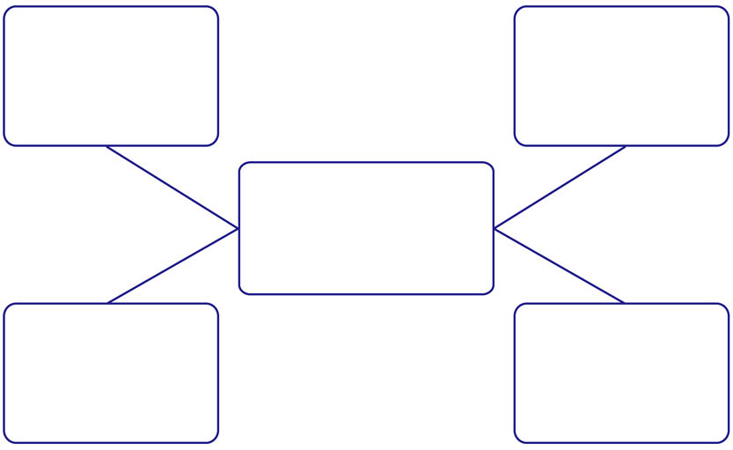
Graphic organizer to use with LESSON ONE

My  Handout to use with LESSON FOUR  Friend’s  Imaginary  Vertebrate  Name  Is: | Group it is  Supposed  to be in:  Mammal, Fish, Reptile, Amphibian, Bird | Is this  Vertebrate  Really in  this Group?  Yes or No? | How do you  Know  the Group  is Correct  or  Incorrect?

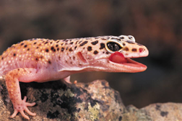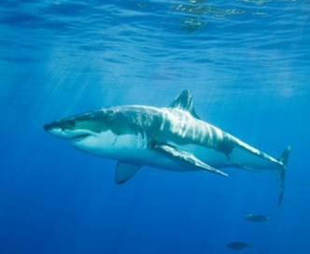
SmartBoard
Activity
For
LESSON
THREE
Name the VERTEBRATE…is it a
Mammal? Fish? Bird? Reptile, Amphibian?
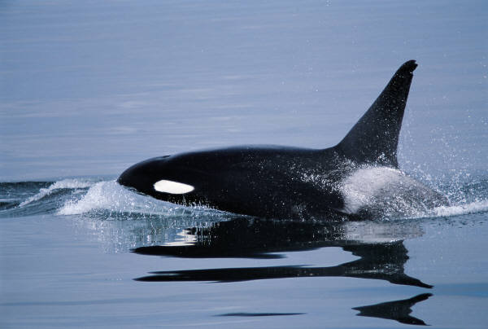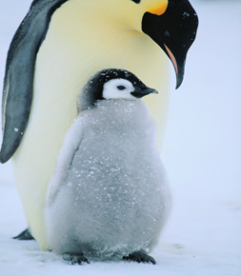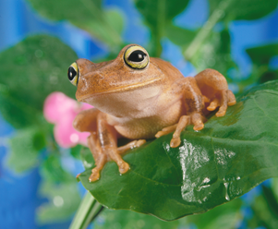
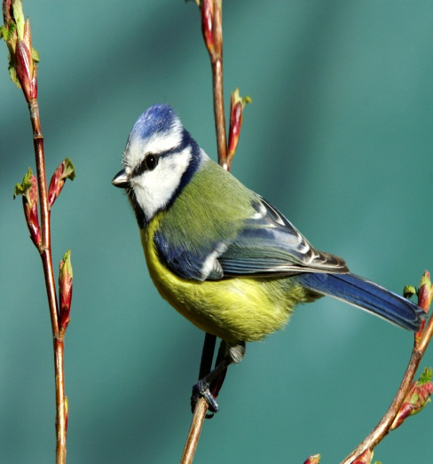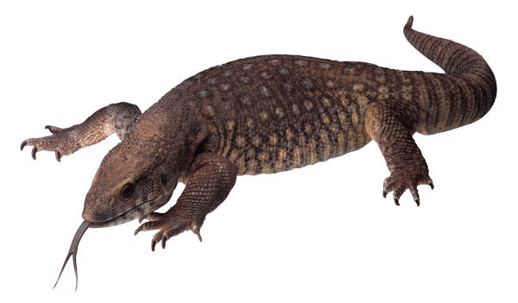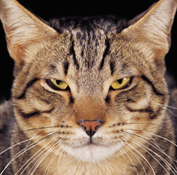
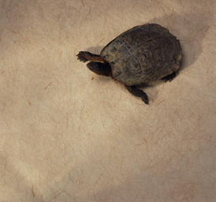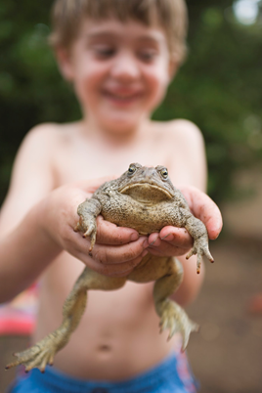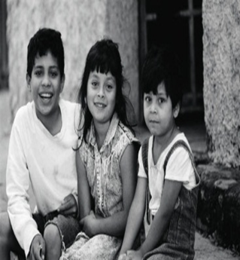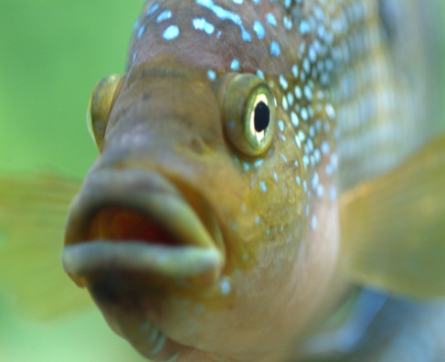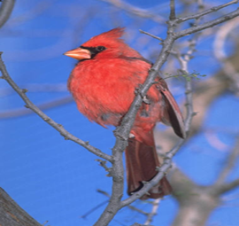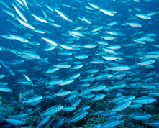
SmartBoard
Activity
For
LESSON
THREE
Name the VERTEBRATE…is it a
Mammal? Fish? Bird? Reptile, Amphibian?
