Instructional Design

11th grade American Literature

Jason S. Kaczay

EDTL 710

**Rationale**

In our society it is becoming ever more important for students to relate to the material we cover in class. As our world begins to change and information is right at our fingertips we being to want the answers right away. Students in today’s literature classroom are no different. When they sit down to read a story, poem, or novel they want results immediately. The new age of technology has changed the face of education for years to come and teachers must be able to keep the new learners engaged in the material. William Richardson, author of “Are You an Old School or a Bold School?” said, “It’s clearer than ever that the Web has fundamentally undermined the main premise upon which our schools and systems were built—namely, the assumption that access to teachers and information is scarce.” (2012) We as teachers must stay ahead of student needs.

The techniques that we use must be capable of activating the schema of students in our classes. One must use approaches that allow students to connect ideas to previous thoughts. If we are unable to bridge the gap between old information and new information then learning will suffer. According to *Classroom Instruction that Works*, “The more we use both systems of representation-linguistic and nonlinguistic- the better we are able to think about and recall knowledge.” (Marzono 2001) Teachers need to find these systems and relate them to students on a constant basis. This idea is also expected from the new Common Core standards. Students are often asked to analyze themes and determine meaning. (2011) Using this approach will help them form this meaning.

The things that become evident from looking at the Common Core standards give teachers a guide for unit planning. Ideas like cooperative learning and the Inductive Model make these goals easier to accomplish. The Inductive Model calls for students to construct ideas based off presented information. (Chiarelott 2006) When students work with cooperatively on these tasks there is significant growth in the learning as a whole. Accodring to David and Roger Johnson (1999), “cooperative learning has an effect size of .78 when compared with instructional strategies in which students work on tasks individually.” (Marzono 2001) When students are separated in the Literature Circles they benefit from both of these concepts. They work together while forming their own thoughts through the process.

As the novel progresses they look deeper into the metaphors and the choices made by the author. These items both are important in grasping concepts and can be found in the Common Core standards. (2011) Students will analyze the development of Holden Caulfield as he travels around New York City. During this journey, the will see how his relationships develop based on the previously stated concepts. It is important for them to see his relationships with friends, teachers, and family. (Salinger 1950)

This instructional plan is set up to expand as the concepts in the novel become more important. The beginning allows for the teacher to setup groundwork of information and build on it during later lessons. The cooperative learning aspects gives the students a more instant, connected approach. With the ideas used they are able to get instant information from peers. Students find in easier to use information that is taken from people they can relate to, hence the ease of the internet. If the teacher remains as a guide students will flourish during this unit.

**Learning Goals**

**Vocabulary**

1. Students will be able to recognize and define new words based on context clues. (analyze)

2. Students will interpret and analyze figurative language. (analyze)

3. Students will determine the impact the language used has on elements of the story. (evaluate)

4. Students will determine the meanings of unknown words by using dictionaries, thesauruses, glossaries, and technology. (analyze)

**Reading**

1. Students will answer literal, inferential, evaluative, and synthesizing questions to demonstrate an understanding of text. (remember-evaluate)
2. Students will analyze characters, including narrator or other characters’ point of view; and character’s own thoughts, words, or actions. (analyze, evaluate)

3. Students will identify the aspects of text and explain the importance in novel. (evaluate)

4. Students will identify sections of the plot, and explain how event connects to the next. (evaluate)

5. Students will identify and analyze universal themes in literature (archetypes). (apply, analyze)

6. Students will distinguish how the author establishes tone. (analyze, evaluate)

7. Students will analyze character relationships as well as character development. (analyze)

**Writing**

1. Students will produce clear and coherent writing in which the development, organization, and style are appropriate to task, purpose, and audience. (create, apply)

2. Students will produce different styles of writing to meet requirements of that style. (create)

3. Students will follow proper spelling conventions. (apply)

4. Students will follow proper conventions of spelling. (apply)

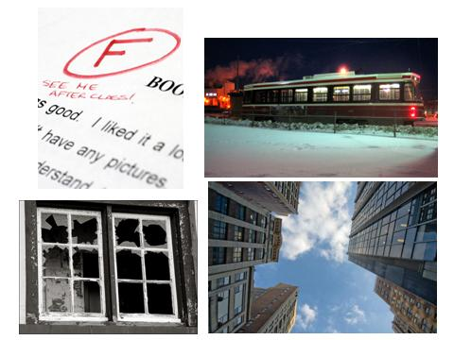**Catcher in the Rye Pre-assessment**

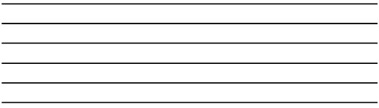

**January 28, 2010, 5:27 pm**

**Catcher in the Rye Pre-Assessment**

**KWL Chart**

**Directions:** *Fill out the following chart based on the columns provided.*

|  |  |  |
| --- | --- | --- |
| **What do you know about the 1950s?** | **What do you think would be interesting to find out about the 1950s?** | **What information did you confirm (provide reliable resources)?** |
|  |  |  |

**Lesson Plan 1: Novel Introduction**

**Unit Objective:**

Students will interpret how time period and life events impact the author’s choices.

**Time Period Objectives:**

1. Students will complete the pre-assessment of the basic concepts of plot.
2. Students will determine the importance of setting.
3. Students will examine author’s life and how it impacted the novel.
4. Students will analyze the impact time period has on the novel.

**Materials:**

1. Journal pictures
2. Interactive whiteboard
3. Computers
4. Paper and pencil.

**Procedure: (Day 1)**

**Before the Novel**

Students complete the journal/short fiction assignment as a part of pre-assessment. **(20 minutes)**

**Engagement**

When students are finished with assignment they will be split into groups to discuss the outcome of their thoughts. **(10 minutes)**

**Activity**

When the groups are done discussing we will have people volunteer to read and explain their stories. **(15 minutes)**

**Key Questions for Lesson**

1. Why did we determine the order that we did for the picture?
2. How could we relate to the person involved in this story?

**Assessment**

Assessment will come from student stories and discussion.

**Procedure: (Day 2)**

**Intro**

We will discuss how characters journeys change the course of their development.**(10 mins)**

**Engagement**

Students will read the article from the New York Times called “Taking a Walk Through J. D. Salinger’s New York”. This article discusses the novel and its impact the big city it was set in.

* [*http://cityroom.blogs.nytimes.com/2010/01/28/taking-a-walk-through-jd-salingers-new-york/*](http://cityroom.blogs.nytimes.com/2010/01/28/taking-a-walk-through-jd-salingers-new-york/)**(10 mins)**

**Activity**

Students will view the interactive map and compare (with the same groups) to the stories that they wrote yesterday.

* [*http://www.nytimes.com/interactive/2010/01/28/nyregion/20100128-salinger-map.html*](http://www.nytimes.com/interactive/2010/01/28/nyregion/20100128-salinger-map.html)**(25 mins)**

**Key Questions for Lesson**

1. How does the setting impact the novel?
2. How may this story vary if it was set in Cleveland?

**Assessment**

Assessment will come from discussion and group reports.

**Procedure (Day 3)**

**Intro**

We will discuss how the idea of plot and setting impact the character’s development. We will lead into how these choices are made for a reason, and we will examine time period and the author’s life. **(5 mins)**

**Engagement**

Students will view a PowerPoint of the author’s life and make judgments based and previously formed opinions of the story. **(15 mins)**

**Activity**

Students will use the internet to complete a KWL type exercise about the 1950s. They will first put down what they think they know about the time period. Then they will write what they want to know. When they are finished they will go on the internet to discover sources to supports the information that they put first and the answers to their questions. **(25 mins)**

**Key Questions for Lesson**

1. How did the time period impact the outcome of what we know so far?
2. How did the events of the author’s live change the character?

**Assessment**

Assessment will come from the KWL exercise and the discussion that the class will have.

**Taking a Walk Through J. D. Salinger’s New York**

***By*** [***JAMES BARRON***](http://cityroom.blogs.nytimes.com/author/james-barron/)

Edward Keating/The New York Times Many places Holden Caulfield visited survive, at least in name, among them the Seton Hotel on East 40th Street.

Holden’s New York

A reading tour of Holden Caulfield’s experiences “The Catcher in the Rye.”

Hey, listen. You know those ducks in that lagoon right near Central Park South? That little lake? By any chance, do you happen to know where they go, the ducks, when it gets all frozen over?

There it is: the Holden Caulfield question. Sara Cedar Miller gets it all the time.

“Everybody’s read that book,” said Ms. Miller, the historian for the Central Park Conservancy. It went without saying that the book in question — the book with the question, on Page 60 — was “The Catcher in the Rye.”

And the answer, according to Ms. Miller, is that the ducks never go anywhere.  
  
“I have no idea what J. D. Salinger was thinking,” said Ms. Miller, who remembered reading “The Catcher in the Rye” as a high school student in Sharon, Mass. “I’ve worked for the park for 26 years, and I’ve always seen ducks.” She saw them in the subfreezing cold on Thursday morning: “I photographed them sitting on the ice.”

Those ducks are perhaps the most memorable New York image in a slim little book that is full of them.

Before he went into seclusion in New Hampshire, Mr. Salinger, [who died on Wednesday at 91,](http://www.nytimes.com/2010/01/29/books/29salinger.html?hp) had a deep relationship with the city, having moved from Harlem to the Upper West Side to Park Avenue as a youngster and later to East 57th Street. As our colleague [Clyde Haberman noted last year](http://www.nytimes.com/2009/06/19/nyregion/19nyc.html), the city itself was a character in “Catcher.”

So “Catcher” could almost serve as a guide to the city of a certain time, a city that has been lost forever, but still somehow exists: dark, enigmatic, grown up.

“I wouldn’t say it’s a cross section of New York, but it’s a cross section of what a kid like that who grew up in New York would be interested in doing,” said Peter G. Beidler, the author of “A Reader’s Companion to J. D. Salinger’s ‘The Catcher in the Rye’” (Coffeetown Press, 2008) and a retired professor at Lehigh University. “A 40-year-old man walking around New York would see different things. But he describes the things a 16-year-old would notice.”

Salinger started with Pennsylvania Station — 58 pages after promising not to tell “where I was born, and what my lousy childhood was like,” Holden Caulfield alights there and heads for a phone booth. A 16-year-old taking the train to New York nowadays would arrive in a different, less inspired place: Holden was in McKim, Mead & White’s extraordinary station, the one whose destruction in the 1960s kindled the historic preservation movement.

“One entered the city like a god,” the architecture historian Vincent Scully said. The dingy, workaday one that replaced it is no match: “One scuttles in now like a rat.”

And what modern 16-year-old would need a phone booth? Even his parents have cellphones.

Mr. Beidler made a map to go with his book that traces Holden’s perambulations around Manhattan, even to nonexistent places like the Edmont Hotel, where Holden has an awkward encounter with Sunny the hooker. Mr. Beidler places the Edmont in the West 50s, between Fifth Avenue and what is now officially known as the Avenue of the Avenues *d’oh!* Americas. In Holden’s day, it was just Sixth Avenue.

“Because it is in this hotel that Holden sees ‘perverts’ and later encounters a pimp and a prostitute,” Mr. Beidler wrote, “it is likely that Salinger did not want to use the name of a real hotel.” But he gave a clue: He said it was “41 gorgeous blocks” from Ernie’s nightclub in Greenwich Village. Ernie’s, too, was a made-up place.

“You kind of triangulate a little bit,” Mr. Beidler said. “He goes so many blocks away, goes here, goes there. I was always able to figure out more or less where he was.”

Holden mentions the McBurney School, a private school that Salinger had attended. After Salinger came students like the actor Henry Winkler, the television journalist Ted Koppel and the financier Bruce Wasserstein. [But McBurney closed in the 1980s.](http://www.nytimes.com/1988/08/04/nyregion/private-school-after-closing-sells-all-it-has.html)

“The good thing about New York is, as much as it changes, there are so many things that never change,” said Will Hochman, a professor at Southern Connecticut State University and an author of the forthcoming “A Critical Companion to J.D. Salinger.” “I had a student who read ‘Catcher in the Rye’ and told me she felt like she lived in Grand Central Terminal. I could relate that to Holden’s feelings of being lost.”

And there is a timelessness to the problems of navigating the confusing place that New York can be, with its strange streets and its stranger rhythms and rituals. “At one point Holden is worried he’s going to fall because he’s stepping off a curb,” Mr. Hochman said. “I think Salinger intended that to convey the smallness. You’re aware of how many great people are there, how many great things are there. At Ernie’s, where he’s recognized by one of his brother’s old girlfriend, he gets some status because he’s recognized but he feels belittled. In some ways New York overwhelms him.”

At another point, Holden waits near the clock at the Biltmore for his date. The Biltmore was turned into an office building more than 15 years ago, the couches where he sat, girl-watching, gone. “Girls with their legs crossed, girls with their legs not crossed, girls with terrific legs, girls with lousy legs, girls that looked like swell girls …” Salinger wrote. “It was nice sightseeing.”

“Grand Central Terminal stands, though coin-operated lockers that Holden uses were removed long ago for security reasons,” Clyde Haberman wrote last year. “Radio City Music Hall goes on, in its fashion. For sure, so do the book’s two museums that abut Central Park — ‘the one where the pictures are’ and ‘the one where the Indians are.’ ”

As for the pond where the ducks are, long after “The Catcher In the Rye” had become the kind of forced reading in school that ruined it for so many teen-agers, there was one person who could have told Salinger that the ducks never really left.

That person was was Adrian Benepe, a longtime Parks Department official who is now the commissioner. Salinger, Mr. Benepe said, “was our immediate next-door neighbor in Cornish, N.H., where I spent part of my childhood.”

“I would have told him that the ducks don’t go anywhere in winter—they mainly stay right here and head for the Reservoir, where recently counted them.”

And the Hotel Seton, where Holden goes for a drink?

“We get high school kids coming in and asking and they want to know if it’s the Seton Hotel,” said Leslee Heskiaoff, the owner of the hotel by that name on East 40th Street. “It isn’t. We have no bar.”

**Screen Shot of Interactive Map**

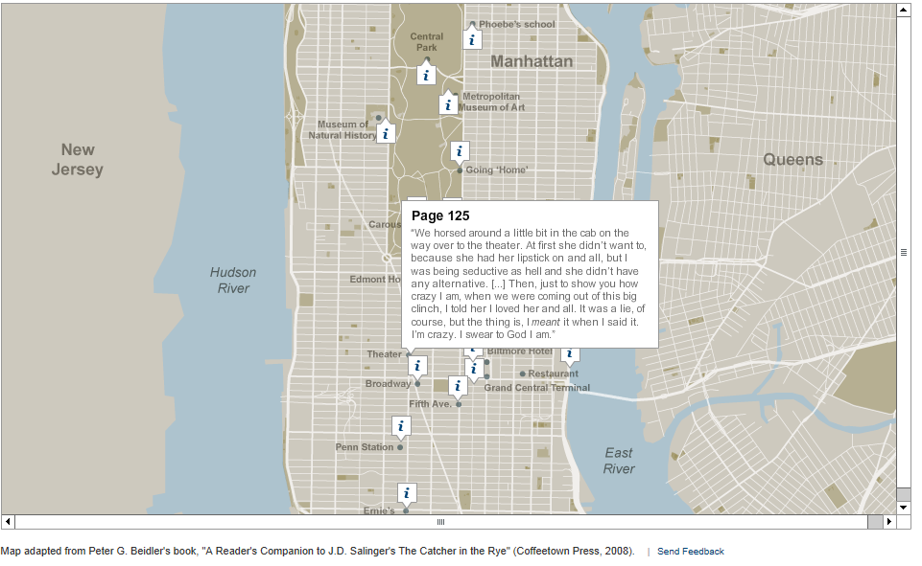

**PowerPoint Slides**

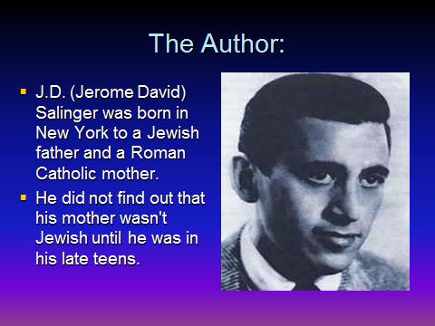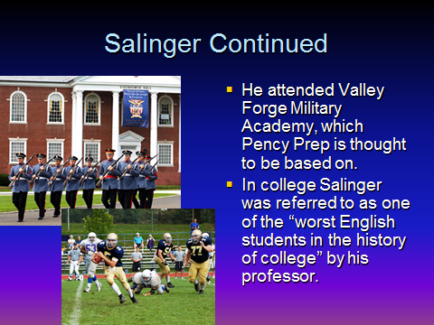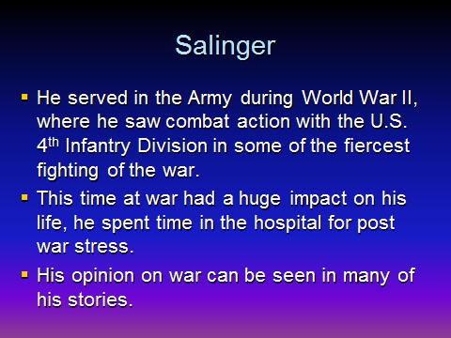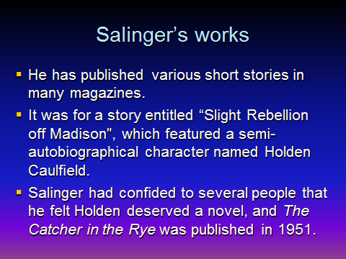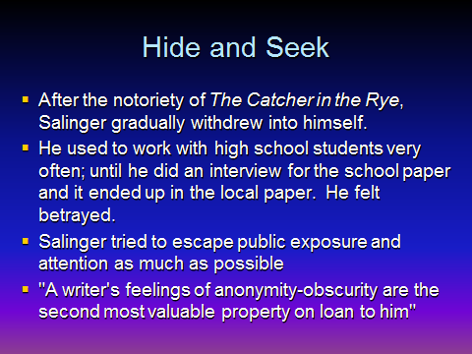

**Lesson Plan 2: Introduction to Holden Caulfield**

**Unit Objective**

Students will analyze the impact the previous concepts have on Holden’s life.

**Time Period Objectives**

1. Determine the author’s choices and the impact on character.
2. Analyze character development.
3. Compare and contrast character relationships.
4. Determine the meaning of symbols.

**Materials**

1. Novels
2. Literature Circle handouts
3. Self-Assessment sheets

**Procedure (Day 1)**

**Intro**

As a class we will discuss the previous concepts and how they played out together.

**(10 mins)**

**Engagement**

I will read the first couple lines of the novel and we will discuss the first impression of Holden and how it connects the scaffolding we have formed about the novel. **(10 mins)**

**Activity**

Students will read the first chapter while completing an “active reading” activity.

**(25 mins)**

**Assessment**

The active reading chart will serve as assessment for the class.

**Procedure (Day 2)**

**Intro**

We will discuss the items from the chapter one chart and see how the tie to the opinions that were previously formed. **(10 mins)**

**Engagement**

Students will be introduced to the literature circle roles and will select roles for each member of the group. **(15 mins)**

**Activity**

Students will read the novel and complete their literature circle roles. **(20 mins)**

**Assessment**

Students will fill out a self-assessment and complete their roles according to their group.

**Procedure (Day 3)**

**Intro**

Students will be directed on the proper topics for discussion and be separated into their groups. **(10 mins)**

**Engagement**

The “Ring Leader” will lead the group with key questions selected from his/her reading.

**(10 mins)**

**Activity**

Students will report to the group about their role and field questions. **(25 mins)**

**Procedure (Day 4-last)**

*Steps will repeat until the final assessment (see attached).*

Literary Analysis and Multi-Genre

Name:\_\_\_\_\_\_\_\_\_\_\_\_\_\_\_\_\_\_\_

**Active reading guide**

*AS you read the first chapter, fill out this chart based on our active reading exercise.*

|  |  |
| --- | --- |
| Page #\_\_\_\_\_\_\_\_\_\_\_  Paragraph \_\_\_\_\_\_\_\_\_\_\_ | Page #\_\_\_\_\_\_\_\_\_\_\_  Paragraph \_\_\_\_\_\_\_\_\_\_\_ |
| Page #\_\_\_\_\_\_\_\_\_\_\_  Paragraph \_\_\_\_\_\_\_\_\_\_\_ | Page #\_\_\_\_\_\_\_\_\_\_\_  Paragraph \_\_\_\_\_\_\_\_\_\_\_ |

**Catcher in the Rye**

**Quiz Chapters 1-4**

1. Who is Holden Caulfield?
2. Why was Holden trying to “feel” some kind of good-bye?
3. Why did Holden write Mr. Spencer a note at the end of his examination paper?
4. What excuse did Holden give Mr. Spencer for having to end the visit?
5. What does Ackley usually do when he comes to visit Holden?
6. Why does Ackley not like Stradlater?
7. What favor does Stradlater ask of Holden?
8. What was unique about the way in which Jane Gallagher played checkers?
9. Why is Holden glad to see Ackley return to his room?
10. Why does Holden ask so many question about Jane?

**Quiz 2**

***Complete Sentences***

1.       What did Holden write a composition about?

2.       What did Holden do with the composition and Why?

3.       Why did Stradlater punch Holden?

4.       Where did Holden go immediately after the fight?

5.       When does Holden say, "Sleep tight, ya morons!"

6.       The final tripping on the discarded peanut shells is Holden's comment on

            "Man's inhumanity to man."  Is this truly the disrespect of man or is

            another example of the real problem with Holden?  Does Holden accept

            responsibility for his own actions?  ***Cite examples.***

7. Holden recalls a summer with Jane and the time he kissed her when she

            was crying.  Why do you think she was crying?

**Extended Response**

***Answer one in a paragraph (that means you should have AT LEAST 8-10 sentences)***

What is the significance of Holden’s hunting hat? How does it serve as a metaphor? What does it mean to Holden?

What is the significance of the ducks? How do they serve as a metaphor?

**Quiz**

**Complete sentences**

How many names are in Holden’s address book?

What does Holden want to talk to Carl Luce about; what does Luce call

            "a typical Holden Caulfield conversation"?

What happens to Phoebe’s record?

What does the record symbolize?

In what room did Phoebe sleep?

How does Holden feel when he sees Phoebe?

Holden tells Phoebe that he wants to be a "catcher in the rye"; what does

            he mean by this?

What did Holden give Phoebe, and what does she represent in his life?

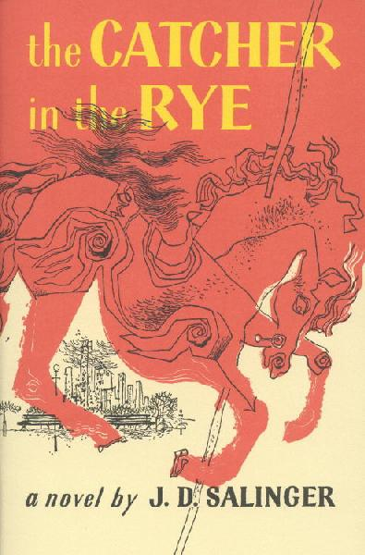Week 1

Novel Introduction

Weekly tasks:

* Work on character charts
* Study guide due Friday

|  |  |
| --- | --- |
| April 10  \_\_\_\_/5 | Intro to Novel  Pass out books  Today’s to-do list: |
| April 11  \_\_\_\_/5 | Explain unit assignments  Intro to roles  Assign groups  Today’s to-do list: |
| April 12  \_\_\_\_/5 | Pass out character charts  Lit Circle Meeting  Contracts  Today’s to-do list: |
| April 13  \_\_\_\_/5 | Review project choices  Read  Today’s to-do list:  Today’s to-do list: |

* Read to page\_\_\_\_\_\_

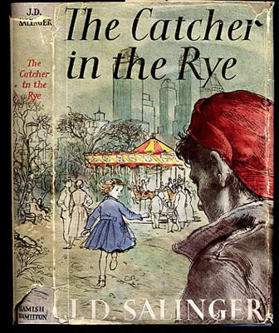Week 2

Weekly tasks:

Chapters 5-12

* Quiz on Monday
* Study Guide #2 Due Tuesday
* First Multi-Genre Due Friday

|  |  |
| --- | --- |
| April 16  \_\_\_\_/5 | Quiz Ch 1-4  Lit Circles  Pick Roles  Today’s to-do list:  Set Weekly Goals |
| April 17  \_\_\_\_/5 | Work Day  Today’s to-do list: |
| April 18  \_\_\_\_/5 | Work Day  Today’s to-do list: |
| April 19  \_\_\_\_/5 | Character Charts Due  Lit Roles Due  Today’s to-do list:  Lit Circle Meeting |
| April 20  \_\_\_\_/5 | Lab Time  Self-Assessment Due  Today’s to-do list: |

* Read to page\_\_\_\_\_\_

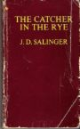Week 3

Weekly tasks:

Chapters 13-17

* Quiz on Monday
* Study Guide #2 Due Tuesday
* First Multi-Genre Due Friday

|  |  |
| --- | --- |
| April 23  \_\_\_\_/5 | Quiz Ch 5-12  Lit Circles  Pick Roles  Today’s to-do list:  Set Weekly Goals |
| April 24  \_\_\_\_/5 | Study Guide #2 Due  Work Day  Today’s to-do list: |
| April 25  \_\_\_\_/5 | Work Day  Today’s to-do list: |
| April 26  \_\_\_\_/5 | Lit Roles Due  Lit Circle Meeting  Today’s to-do list: |
| April 27  \_\_\_\_/5 | Lab Time  Self-Assessment Due  Today’s to-do list:  First Multi-Genre Due |

* Read to page\_\_\_\_\_\_

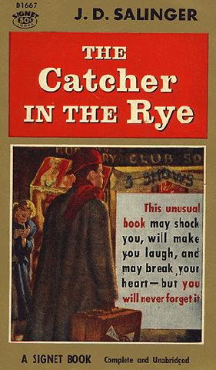Week 4

Weekly tasks:

Chapters 18-23

* Quiz on Monday
* Quote Sheet Due Tuesday
* Topics Due Friday

|  |  |
| --- | --- |
| April 30  \_\_\_\_/5 | Quiz Ch 13-17  Lit Circles  Pick Roles  Today’s to-do list:  Set Weekly Goals |
| May 1  \_\_\_\_/5 | Quote Sheet Due  Work Day  Today’s to-do list: |
| May 2  \_\_\_\_/5 | Work Day  Today’s to-do list: |
| May 3  \_\_\_\_/5 | Lit Roles Due  Lit Circle Meeting  Today’s to-do list: |
| May 4  \_\_\_\_/5 | Lab Time  Today’s to-do list:  Self-Assessment Due  Topics Due |

* Read to page\_\_\_\_\_\_

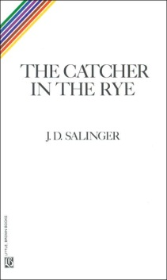Week 5

Weekly tasks:

Chapters 24-26

* Quiz on Monday
* Quote Sheet Due Tuesday
* Topics Due Friday

|  |  |
| --- | --- |
| May 7  \_\_\_\_/5 | Quiz Ch 18-23  Lit Circles  Pick Roles  Today’s to-do list:  Set Weekly Goals |
| May 8  \_\_\_\_/5 | Work Day  Today’s to-do list: |
| May 9  \_\_\_\_/5 | Final Study Guide Due  Today’s to-do list: |
| May 10  \_\_\_\_/5 | Lit Roles Due  Lit Circle Meeting  Today’s to-do list: |
| May 11  \_\_\_\_/5 | Lab Time  Today’s to-do list:  Self-Assessment Due  Topics Due |

* Read to page\_\_\_\_\_\_

rLiterature Circle Roles

**BD14577_Ring Master**: The student in this role directs the group discussions. The Ring Master makes sure that everyone has an opportunity to share, discussions remain on target, and group members treat each other with respect as they work together. This student should come to Lit Circles with a page of notes and questions that he or she has prepared based on the pages assigned.

**Passage Master**: The Passage Master will summarize the key points of the reading to make sure the group understands the main idea. This student also helps the group recall earlier reading assignments for a selection.

**Sketcher**: The Sketcher captures the meaning of a passage or the entire selection in a visual form that can range from a stick-figure cartoon to a charcoal drawing. The emphasis is not on the Sketcher’s artistic skills, but on the image or concept he or she shares.

**Literary Luminary**: This student helps group members examine AT LEAST two or three passages from the selection that deserve a closer look. Read these passages out loud for the group discussion. For example, one passage might be puzzling, while another might be disturbing or memorable for some reason. A creative way to handle this role would be to team up with the *Sketcher* and help explain one of the passages they have selected.

**New Historicist:** A New Historicist is one who believes that a literary work (i.e. our novel) should be seen as a product or direct reflection of the time period. They believe that the events of a time shaped the course of the writing and that a piece should not be forced to stand on its own. The person who takes this role will be asked to study the novel for its historical context. Clothing, events, and even people/places are a good indication of the shaping of a novel.

**Travel Tracer**: This student researches and shares information about how the physical and cultural settings affect the selection’s characters or conflict. The setting of our novel shifts at various points, so this should be interesting to see how it has impacted our story. The Travel Tracer could work closely with the *New Historicist* to come up with creative ideas.

**Vocab Enhancer**: This student focuses on (at least 8) unfamiliar words or words used in unusual ways. In order to fill this role you must think “outside” of yourself. There may be words that you understand, but your classmates may find strange or difficult. The goal is to help group members not only recognize and understand new words, but also begin to use them in their writing and speaking. WORDS MUST BE SCHOOL APPROPRIATE!

**Metaphor Master:** This novel is full of symbolism/metaphors, as well as themes. The Metaphor Master will guide each group member in the understanding of metaphors and/or themes throughout the novel. The Metaphor Master also compares events with the same theme and makes connections between a theme, a selection, and students’ own lives.

**BD14576_Character Captain:** This student is responsible for revealing specific personality traits of the character(s) within the novel. This means he/she will find examples in the assigned reading of behaviors/actions that help group members to know the character(s). He/she will assist group members in filling out character charts.

**BD14577_**Literature Circle Role Sheet

**Ring Master**

The student in this role directs the group discussions. The Ring Master makes sure that everyone has an opportunity to share, discussions remain on target, and group members treat each other with respect as they work together. This student should come to Lit Circles with a page of notes and questions that he or she has prepared based on the pages assigned.

***While you read…***

|  |  |
| --- | --- |
| **Page Number** | **Note** |
|  |  |
|  |  |
|  |  |
|  |  |
|  |  |

***After you read…***

List a minimum of five thought provoking questions below. (Think of these starters: Why, If, What, Who and How)

1.)\_\_\_\_\_\_\_\_\_\_\_\_\_\_\_\_\_\_\_\_\_\_\_\_\_\_\_\_\_\_\_\_\_\_\_\_\_\_\_\_\_\_\_\_\_\_\_\_\_\_\_\_\_\_\_\_\_\_\_\_\_\_

2.)\_\_\_\_\_\_\_\_\_\_\_\_\_\_\_\_\_\_\_\_\_\_\_\_\_\_\_\_\_\_\_\_\_\_\_\_\_\_\_\_\_\_\_\_\_\_\_\_\_\_\_\_\_\_\_\_\_\_\_\_\_\_

**PE01832_**3.)\_\_\_\_\_\_\_\_\_\_\_\_\_\_\_\_\_\_\_\_\_\_\_\_\_\_\_\_\_\_\_\_\_\_\_\_\_\_\_\_\_\_\_\_\_\_\_\_\_\_\_\_\_\_\_\_\_\_\_\_\_\_

4.)\_\_\_\_\_\_\_\_\_\_\_\_\_\_\_\_\_\_\_\_\_\_\_\_\_\_\_\_\_\_\_\_\_\_\_\_\_\_\_\_\_\_\_\_\_\_\_\_\_\_\_\_\_\_\_\_\_\_\_\_\_\_

BD14576_5.)\_\_\_\_\_\_\_\_\_\_\_\_\_\_\_\_\_\_\_\_\_\_\_\_\_\_\_\_\_\_\_\_\_\_\_\_\_\_\_\_\_\_\_\_\_\_\_\_\_\_\_\_\_\_\_\_\_\_\_\_\_\_

**BD14577_**Literature Circle Role Sheet

**Passage Master**

The Passage Master will summarize the key points of the reading to make sure the group understands the main idea. This student also helps the group recall earlier reading assignments for a selection.

***Before you read…***

List some ideas that you think will come up in the assigned reading

\_\_\_\_\_\_\_\_\_\_\_\_\_\_\_\_\_\_\_\_\_\_\_\_\_\_\_\_\_\_\_\_\_\_\_\_\_\_\_\_\_\_\_\_\_\_\_\_\_\_\_\_\_\_\_\_\_\_\_\_\_\_\_\_

\_\_\_\_\_\_\_\_\_\_\_\_\_\_\_\_\_\_\_\_\_\_\_\_\_\_\_\_\_\_\_\_\_\_\_\_\_\_\_\_\_\_\_\_\_\_\_\_\_\_\_\_\_\_\_\_\_\_\_\_\_\_\_\_

***While you read…***

List the key points of the reading passage below***:***

Page #\_\_\_\_ What makes this a “key point” \_\_\_\_\_\_\_\_\_\_\_\_\_\_\_\_\_\_\_\_\_\_\_\_\_\_\_\_

\_\_\_\_\_\_\_\_\_\_\_\_\_\_\_\_\_\_\_\_\_\_\_\_\_\_\_\_\_\_\_\_\_\_\_\_\_\_\_\_\_\_\_\_\_\_\_\_\_\_\_\_\_\_\_\_\_\_\_\_\_\_\_\_

Questions and points to bring up \_\_\_\_\_\_\_\_\_\_\_\_\_\_\_\_\_\_\_\_\_\_\_\_\_\_\_\_\_\_\_\_\_\_\_\_\_\_

\_\_\_\_\_\_\_\_\_\_\_\_\_\_\_\_\_\_\_\_\_\_\_\_\_\_\_\_\_\_\_\_\_\_\_\_\_\_\_\_\_\_\_\_\_\_\_\_\_\_\_\_\_\_\_\_\_\_\_\_\_\_\_\_

Page #\_\_\_\_ What makes this a “key point” \_\_\_\_\_\_\_\_\_\_\_\_\_\_\_\_\_\_\_\_\_\_\_\_\_\_\_\_

\_\_\_\_\_\_\_\_\_\_\_\_\_\_\_\_\_\_\_\_\_\_\_\_\_\_\_\_\_\_\_\_\_\_\_\_\_\_\_\_\_\_\_\_\_\_\_\_\_\_\_\_\_\_\_\_\_\_\_\_\_\_\_\_

Questions and points to bring up \_\_\_\_\_\_\_\_\_\_\_\_\_\_\_\_\_\_\_\_\_\_\_\_\_\_\_\_\_\_\_\_\_\_\_\_\_\_

\_\_\_\_\_\_\_\_\_\_\_\_\_\_\_\_\_\_\_\_\_\_\_\_\_\_\_\_\_\_\_\_\_\_\_\_\_\_\_\_\_\_\_\_\_\_\_\_\_\_\_\_\_\_\_\_\_\_\_\_\_\_\_\_

Page #\_\_\_\_ What makes this a “key point” \_\_\_\_\_\_\_\_\_\_\_\_\_\_\_\_\_\_\_\_\_\_\_\_\_\_\_\_

\_\_\_\_\_\_\_\_\_\_\_\_\_\_\_\_\_\_\_\_\_\_\_\_\_\_\_\_\_\_\_\_\_\_\_\_\_\_\_\_\_\_\_\_\_\_\_\_\_\_\_\_\_\_\_\_\_\_\_\_\_\_\_\_

Questions and points to bring up \_\_\_\_\_\_\_\_\_\_\_\_\_\_\_\_\_\_\_\_\_\_\_\_\_\_\_\_\_\_\_\_\_\_\_\_\_\_

j0234360\_\_\_\_\_\_\_\_\_\_\_\_\_\_\_\_\_\_\_\_\_\_\_\_\_\_\_\_\_\_\_\_\_\_\_\_\_\_\_\_\_\_\_\_\_\_\_\_\_\_\_\_\_\_\_\_\_\_\_\_\_\_\_\_

***During Literature Circles…***

BD14576_Be ready to give your group a good summary of the events of the passage.

BD14577_Literature Circle Role Sheet

**Sketcher**

The Sketcher comes up with a way to display the meaning of a passage or selection using visuals. This can range from a painting, sketch, collage, or even a picture drawn of the individual characters.

***Before you read…***

Review your responsibilities and become familiar with what your role is during Lit Circle meetings.

***While you read…***

Visualize what scenes you can create to make the discussion more enriching for the other group members. You could even try to bring a character to life. In the space below jot down ideas as you read the selection that may help you to create your masterpiece.

\_\_\_\_\_\_\_\_\_\_\_\_\_\_\_\_\_\_\_\_\_\_\_\_\_\_\_\_\_\_\_\_\_\_\_\_\_\_\_\_\_\_\_\_\_\_\_\_\_\_\_\_\_\_\_\_\_\_\_\_\_\_\_

\_\_\_\_\_\_\_\_\_\_\_\_\_\_\_\_\_\_\_\_\_\_\_\_\_\_\_\_\_\_\_\_\_\_\_\_\_\_\_\_\_\_\_\_\_\_\_\_\_\_\_\_\_\_\_\_\_\_\_\_\_\_\_

\_\_\_\_\_\_\_\_\_\_\_\_\_\_\_\_\_\_\_\_\_\_\_\_\_\_\_\_\_\_\_\_\_\_\_\_\_\_\_\_\_\_\_\_\_\_\_\_\_\_\_\_\_\_\_\_\_\_\_\_\_\_\_

\_\_\_\_\_\_\_\_\_\_\_\_\_\_\_\_\_\_\_\_\_\_\_\_\_\_\_\_\_\_\_\_\_\_\_\_\_\_\_\_\_\_\_\_\_\_\_\_\_\_\_\_\_\_\_\_\_\_\_\_\_\_\_

\_\_\_\_\_\_\_\_\_\_\_\_\_\_\_\_\_\_\_\_\_\_\_\_\_\_\_\_\_\_\_\_\_\_\_\_\_\_\_\_\_\_\_\_\_\_\_\_\_\_\_\_\_\_\_\_\_\_\_\_\_\_\_

\_\_\_\_\_\_\_\_\_\_\_\_\_\_\_\_\_\_\_\_\_\_\_\_\_\_\_\_\_\_\_\_\_\_\_\_\_\_\_\_\_\_\_\_\_\_\_\_\_\_\_\_\_\_\_\_\_\_\_\_\_\_\_

***During Literature Circles…***

It is important to remember that your ideas and concepts are more valuable than your ability to draw or create art. Present your work to the group and explain why you decided to “capture” this image as your part of the group.

**j0232065**

BD14577_Literature Circle Role Sheet

**Literary Luminary**

This student helps group members examine AT LEAST two or three passages from the selection that deserve a closer look. Read these passages out loud for the group discussion. For example, one passage might be puzzling, while another might be disturbing or memorable for some reason. A creative way to handle this role would be to team up with the *Sketcher* and help explain one of the passages they have selected.

***Before you read…***

Think about the scenes that have shaped the novel so far. If you had to go back and point out important parts, what would they be? Write down some ideas that you think will come up as important parts of your reading.

\_\_\_\_\_\_\_\_\_\_\_\_\_\_\_\_\_\_\_\_\_\_\_\_\_\_\_\_\_\_\_\_\_\_\_\_\_\_\_\_\_\_\_\_\_\_\_\_\_\_\_\_\_\_\_\_\_\_\_\_\_\_\_

\_\_\_\_\_\_\_\_\_\_\_\_\_\_\_\_\_\_\_\_\_\_\_\_\_\_\_\_\_\_\_\_\_\_\_\_\_\_\_\_\_\_\_\_\_\_\_\_\_\_\_\_\_\_\_\_\_\_\_\_\_\_\_

\_\_\_\_\_\_\_\_\_\_\_\_\_\_\_\_\_\_\_\_\_\_\_\_\_\_\_\_\_\_\_\_\_\_\_\_\_\_\_\_\_\_\_\_\_\_\_\_\_\_\_\_\_\_\_\_\_\_\_\_\_\_\_

***While you read…***

Think about passages that may have stuck out to you and mark it in your book to read for the meeting. Find something that was puzzling or funny, and right down ideas to discuss after you read to the class.

Page #\_\_\_\_ Reason you picked this passage \_\_\_\_\_\_\_\_\_\_\_\_\_\_\_\_\_\_\_\_\_\_\_\_\_\_

\_\_\_\_\_\_\_\_\_\_\_\_\_\_\_\_\_\_\_\_\_\_\_\_\_\_\_\_\_\_\_\_\_\_\_\_\_\_\_\_\_\_\_\_\_\_\_\_\_\_\_\_\_\_\_\_\_\_\_\_\_\_\_\_

Page #\_\_\_\_ Reason you picked this passage \_\_\_\_\_\_\_\_\_\_\_\_\_\_\_\_\_\_\_\_\_\_\_\_\_\_

\_\_\_\_\_\_\_\_\_\_\_\_\_\_\_\_\_\_\_\_\_\_\_\_\_\_\_\_\_\_\_\_\_\_\_\_\_\_\_\_\_\_\_\_\_\_\_\_\_\_\_\_\_\_\_\_\_\_\_\_\_\_\_\_

Page #\_\_\_\_ Reason you picked this passage \_\_\_\_\_\_\_\_\_\_\_\_\_\_\_\_\_\_\_\_\_\_\_\_\_\_

\_\_\_\_\_\_\_\_\_\_\_\_\_\_\_\_\_\_\_\_\_\_\_\_\_\_\_\_\_\_\_\_\_\_\_\_\_\_\_\_\_\_\_\_\_\_\_\_\_\_\_\_\_\_\_\_\_\_\_\_\_\_\_\_

DD01564_***During Literature Circles…***

Read one passage to the group and discuss why you picked it. Discuss the other passage(s) with them as well. Tell them why you thought it had an impact on the book or why it was funny.

BD14577_Literature Circle Role Sheet

**New Historicist**

A New Historicist is one who believes that a literary work (i.e. our novel) should be seen as a product or direct reflection of the time period. They believe that the events of a time shaped the course of the writing and that a piece should not be forced to stand on its own. The person who takes this role will be asked to study the novel for its historical context. Clothing, events, and even people/places are a good indication of the shaping of a novel.

***Before you read…***

Think about the time period this novel is set in, and look at how it has impacted the novel so far. Write down some ideas that you think will be affected by the time period.

\_\_\_\_\_\_\_\_\_\_\_\_\_\_\_\_\_\_\_\_\_\_\_\_\_\_\_\_\_\_\_\_\_\_\_\_\_\_\_\_\_\_\_\_\_\_\_\_\_\_\_\_\_\_\_\_\_\_\_\_\_\_\_

\_\_\_\_\_\_\_\_\_\_\_\_\_\_\_\_\_\_\_\_\_\_\_\_\_\_\_\_\_\_\_\_\_\_\_\_\_\_\_\_\_\_\_\_\_\_\_\_\_\_\_\_\_\_\_\_\_\_\_\_\_\_\_

\_\_\_\_\_\_\_\_\_\_\_\_\_\_\_\_\_\_\_\_\_\_\_\_\_\_\_\_\_\_\_\_\_\_\_\_\_\_\_\_\_\_\_\_\_\_\_\_\_\_\_\_\_\_\_\_\_\_\_\_\_\_\_

***While you read…***

Write down ideas that show how this reading has been shaped by the time period. Be sure to look at clothes, trends, places, events, etc.

\_\_\_\_\_\_\_\_\_\_\_\_\_\_\_\_\_\_\_\_\_\_\_\_\_\_\_\_\_\_\_\_\_\_\_\_\_\_\_\_\_\_\_\_\_\_\_\_\_\_\_\_\_\_\_\_\_\_\_\_\_\_\_

\_\_\_\_\_\_\_\_\_\_\_\_\_\_\_\_\_\_\_\_\_\_\_\_\_\_\_\_\_\_\_\_\_\_\_\_\_\_\_\_\_\_\_\_\_\_\_\_\_\_\_\_\_\_\_\_\_\_\_\_\_\_\_

\_\_\_\_\_\_\_\_\_\_\_\_\_\_\_\_\_\_\_\_\_\_\_\_\_\_\_\_\_\_\_\_\_\_\_\_\_\_\_\_\_\_\_\_\_\_\_\_\_\_\_\_\_\_\_\_\_\_\_\_\_\_\_

\_\_\_\_\_\_\_\_\_\_\_\_\_\_\_\_\_\_\_\_\_\_\_\_\_\_\_\_\_\_\_\_\_\_\_\_\_\_\_\_\_\_\_\_\_\_\_\_\_\_\_\_\_\_\_\_\_\_\_\_\_\_\_

BD04953_***During Literature Circles…***

Come to class with idea about the time period and the significance it has played in the novel. Provide some support for your ideas (for example: a picture)

BD05629_

BD14577_Literature Circle Role Sheet

**Travel Tracer**

This student researches and shares information about how the physical and cultural settings affect the selection’s characters or conflict. The setting of our novel shifts at various points, so this should be interesting to see how it has impacted our story.

***Before you read…***

Think about where the story line has gone so far. Write down all of the previous locations so you are familiar with his journey.

\_\_\_\_\_\_\_\_\_\_\_\_\_\_\_\_\_\_\_\_\_\_\_\_\_\_\_\_\_\_\_\_\_\_\_\_\_\_\_\_\_\_\_\_\_\_\_\_\_\_\_\_\_\_\_\_\_\_\_\_\_\_\_

\_\_\_\_\_\_\_\_\_\_\_\_\_\_\_\_\_\_\_\_\_\_\_\_\_\_\_\_\_\_\_\_\_\_\_\_\_\_\_\_\_\_\_\_\_\_\_\_\_\_\_\_\_\_\_\_\_\_\_\_\_\_\_

\_\_\_\_\_\_\_\_\_\_\_\_\_\_\_\_\_\_\_\_\_\_\_\_\_\_\_\_\_\_\_\_\_\_\_\_\_\_\_\_\_\_\_\_\_\_\_\_\_\_\_\_\_\_\_\_\_\_\_\_\_\_\_

***While you read…***

Keep notes of where he has gone and what he has done in each of these places.

Place: \_\_\_\_\_\_\_\_\_\_\_\_\_\_\_\_\_\_ Notes: \_\_\_\_\_\_\_\_\_\_\_\_\_\_\_\_\_\_\_\_\_\_\_\_\_\_\_\_\_\_\_\_\_\_

\_\_\_\_\_\_\_\_\_\_\_\_\_\_\_\_\_\_\_\_\_\_\_\_\_\_\_\_\_\_\_\_\_\_\_\_\_\_\_\_\_\_\_\_\_\_\_\_\_\_\_\_\_\_\_\_\_\_\_\_\_\_\_

Place: \_\_\_\_\_\_\_\_\_\_\_\_\_\_\_\_\_\_ Notes: \_\_\_\_\_\_\_\_\_\_\_\_\_\_\_\_\_\_\_\_\_\_\_\_\_\_\_\_\_\_\_\_\_

\_\_\_\_\_\_\_\_\_\_\_\_\_\_\_\_\_\_\_\_\_\_\_\_\_\_\_\_\_\_\_\_\_\_\_\_\_\_\_\_\_\_\_\_\_\_\_\_\_\_\_\_\_\_\_\_\_\_\_\_\_\_\_

Place: \_\_\_\_\_\_\_\_\_\_\_\_\_\_\_\_\_\_ Notes: \_\_\_\_\_\_\_\_\_\_\_\_\_\_\_\_\_\_\_\_\_\_\_\_\_\_\_\_\_\_\_\_\_

\_\_\_\_\_\_\_\_\_\_\_\_\_\_\_\_\_\_\_\_\_\_\_\_\_\_\_\_\_\_\_\_\_\_\_\_\_\_\_\_\_\_\_\_\_\_\_\_\_\_\_\_\_\_\_\_\_\_\_\_\_\_\_

BD04912_***During Literature Circles…***

You should provide the discussion with an outline of our character’s journey. Provide some support for your ideas (for example: some type of visual, a picture, or map.)

**BD14577_**Literature Circle Role Sheet

**Vocab Enhancer**

This student focuses on (at least 8) unfamiliar words or words used in unusual ways. In order to fill this role you must think “outside” of yourself. There may be words that you understand, but your classmates may find strange or difficult. The goal is to help group members not only recognize and understand new words, but also begin to use them in their writing and speaking. WORDS MUST BE SCHOOL APPROPRIATE!

***While you read…***

Fill out the chart below whenever you come to a word that you find to be unfamiliar, critical, made-up, etc.

|  |  |  |
| --- | --- | --- |
| ***Word and Page #*** | ***Sentence from book*** | ***Definition*** |
|  |  |  |
|  |  |  |
|  |  |  |
|  |  |  |
|  |  |  |
|  |  |  |
|  |  |  |
|  |  |  |
|  |  |  |
|  |  |  |

***During Literature Circles…***

BD14576_Guide group members through your chart, while pointing out where you found the words and why you picked them.



**BD14577_**Literature Circle Role Sheet

**Metaphor Master**

This novel is full of symbolism/metaphors, as well as themes. The Metaphor Master will guide each group member in the understanding of metaphors and/or themes throughout the novel. The Metaphor Master also compares events with the same theme and makes connections between a theme, a selection, and students’ own lives.

***Before Reading the Selection***

Think about/ list developing themes or metaphors used in the novel. Consider how these new selections relate to previously developing themes or ideas. Write your conclusions below.

\_\_\_\_\_\_\_\_\_\_\_\_\_\_\_\_\_\_\_\_\_\_\_\_\_\_\_\_\_\_\_\_\_\_\_\_\_\_\_\_\_\_\_\_\_\_\_\_\_\_\_\_\_\_\_\_\_\_\_\_\_\_\_\_\_\_\_\_\_\_\_\_\_\_\_\_\_\_\_\_\_\_\_\_\_\_\_\_\_\_\_\_\_\_\_\_\_\_\_\_\_\_\_\_\_\_\_\_\_\_\_\_\_\_\_\_\_\_\_\_\_\_\_\_\_\_\_\_\_\_\_\_\_\_\_\_\_\_\_\_

\_\_\_\_\_\_\_\_\_\_\_\_\_\_\_\_\_\_\_\_\_\_\_\_\_\_\_\_\_\_\_\_\_\_\_\_\_\_\_\_\_\_\_\_\_\_\_\_\_\_\_\_\_\_\_\_\_\_\_\_\_\_\_\_\_\_\_\_\_\_\_\_\_\_\_\_\_\_\_\_\_\_\_\_\_\_\_\_\_\_\_\_\_\_\_\_\_\_\_\_\_\_\_\_\_\_\_\_\_\_\_\_\_\_\_\_\_\_\_\_\_\_\_\_\_\_\_\_\_\_\_\_\_\_\_\_\_\_\_\_

***While Reading the Selection***

Jot down your ideas about how this selection relates to the theme or the use of symbols.

\_\_\_\_\_\_\_\_\_\_\_\_\_\_\_\_\_\_\_\_\_\_\_\_\_\_\_\_\_\_\_\_\_\_\_\_\_\_\_\_\_\_\_\_\_\_\_\_\_\_\_\_\_\_\_\_\_\_\_\_\_\_\_\_\_\_\_\_\_\_\_\_\_\_\_\_\_\_\_\_\_\_\_\_\_\_\_\_\_\_\_\_\_\_\_\_\_\_\_\_\_\_\_\_\_\_\_\_\_\_\_\_\_\_\_\_\_\_\_\_\_\_\_\_\_\_\_\_\_\_\_\_\_\_\_\_\_\_\_\_\_\_\_\_\_\_\_\_\_\_\_\_\_\_\_\_\_\_\_\_\_\_\_\_\_\_\_\_\_\_\_\_\_\_\_\_\_\_\_\_\_\_\_\_\_\_\_\_\_\_\_\_\_\_\_\_\_\_\_\_\_\_\_\_\_\_\_\_\_\_\_\_\_\_\_\_\_\_\_\_\_\_\_\_\_\_\_\_\_\_\_\_\_\_\_\_\_\_\_\_\_\_\_\_\_\_\_\_\_\_\_\_\_\_\_\_\_\_\_\_\_\_\_\_\_\_\_\_\_\_\_\_\_\_\_\_\_\_\_\_

**Add your own questions:**

\_\_\_\_\_\_\_\_\_\_\_\_\_\_\_\_\_\_\_\_\_\_\_\_\_\_\_\_\_\_\_\_\_\_\_\_\_\_\_\_\_\_\_\_\_\_\_\_\_\_\_\_\_\_\_\_\_\_\_\_\_\_\_\_\_\_\_\_\_\_\_\_\_\_\_\_\_\_\_\_\_\_\_\_\_\_\_\_\_\_\_\_\_\_\_\_\_\_\_\_\_\_\_\_\_\_\_\_\_\_\_\_\_\_\_\_\_\_\_\_\_\_\_\_\_\_\_\_\_\_\_\_\_\_\_\_\_\_\_\_

\_\_\_\_\_\_\_\_\_\_\_\_\_\_\_\_\_\_\_\_\_\_\_\_\_\_\_\_\_\_\_\_\_\_\_\_\_\_\_\_\_\_\_\_\_\_\_\_\_\_\_\_\_\_\_\_\_\_\_\_\_\_\_\_\_\_\_\_\_\_

BD04963_***During the Group Discussion***

*Ask the questions you prepared. You might also discuss the points below to help group members explore the theme and apply it to their own lives. Remember to respect others’ opinions at all times and especially during the discussion. People will answer the questions based on their own values and experiences.*

BD14576_

BD14577_Literature Circle Role Sheet

**Character Captain**

This student is responsible for revealing specific personality traits of the character(s) within the novel. This means he/she will find examples in the assigned reading of behaviors/actions that help group members to know the character(s). He/she will assist group members in filling out character charts.

***Before you read…***

Make note of the character’s behavior and personality from the past. Show how it has changed. Mention new characters from the reading passage.

\_\_\_\_\_\_\_\_\_\_\_\_\_\_\_\_\_\_\_\_\_\_\_\_\_\_\_\_\_\_\_\_\_\_\_\_\_\_\_\_\_\_\_\_\_\_\_\_\_\_\_\_\_\_\_\_\_\_\_\_\_\_\_

\_\_\_\_\_\_\_\_\_\_\_\_\_\_\_\_\_\_\_\_\_\_\_\_\_\_\_\_\_\_\_\_\_\_\_\_\_\_\_\_\_\_\_\_\_\_\_\_\_\_\_\_\_\_\_\_\_\_\_\_\_\_\_

\_\_\_\_\_\_\_\_\_\_\_\_\_\_\_\_\_\_\_\_\_\_\_\_\_\_\_\_\_\_\_\_\_\_\_\_\_\_\_\_\_\_\_\_\_\_\_\_\_\_\_\_\_\_\_\_\_\_\_\_\_\_\_

***While you read…***

Fill out the following chart.

|  |  |  |  |
| --- | --- | --- | --- |
| **Character Name** | **Personality** | **Relationship with Holden** | **Change** |
|  |  |  |  |
|  |  |  |  |
|  |  |  |  |
|  |  |  |  |

***During Literature Circles…***

You should provide the discussion with an outline of our character’s journey. Provide some support for your ideas (for example: some type of visual, a picture, or a passage to read for support.)

BD14576_

Literary Analysis Activities

Choices of Literary ANALYSIS ASSIGNMENTS

**Choose 1** of the following assignments. Write an essay for the subject chosen. ***Spelling, grammar and punctuation all count, and essays must be typed (Times New Roman 12 point type), double-spaced and 2- 4 pages in length.***

**All papers should also include a proper heading in the top left corner of the paper (single spaced) as follows:**

Name

English 3

Date

“Character Analysis” (or other topic choice)

1. **Character Analysis**. Pick the three most important characters from your novel. Fully describe each character. Also, explain why each is important to the story. Finally, write a paragraph describing the least important character in the novel. Should the author have included this character at all? Why or why not?
2. **Conflict Analysis**. Write an essay describing 3 different conflict situations in the novel. Why are these conflicts important to the story? Three examples of conflict are man v. man, man v. himself, and man v. nature.
3. **Setting Analysis.** Describe the setting of your novel. Why is it important? Could your story have taken place at another time, in another place? Explain.
4. **Genre Assignment**. What genre is your novel (romance, mystery, science fiction, horror, etc.)? What characteristics does this genre have? Explain the parts of your novel that fulfill these requirements. How does your book compare to other books you have read in this genre? Would you read another book in this genre?
5. **Themes Assignment.** Explain the main themes used in your novel. Give examples from the story to show the theme being illustrated. How do the themes from this book compare to other works we have read this year?
6. **Plot Assignment.** How does the plot unfold in your book (standard, flashback, frame story, etc.)? Why did the author use this method to illustrate the plot of the story? Does this method make the book easier or harder to understand? Would you have written it the same way?

You must also use AT LEAST:

* 1 outside source in this project and include citations
* 5 examples from the novel and include citations
* 2 direct quotes

**References**

(2011). In *Common Core Standards Initiative*. Retrieved February 17, 2012, from [www.corestandards.org](http://www.corestandards.org)

Chiarelott, L. (2006). *Curriculum in context*. Belmont, CA: Thomson Wadsworth.

Marzano, R. J., Pickering, D. J., & Pollock, J. E. (2001). *Classroom instruction that works: Research-based strategies for increasing student achievement.* Alexandria, VA: Association for Supervision and Curriculum Development.

Richardson, William. (2012). *Are You an Old School or Bold School?* District Administration.

Salinger, J. D. (1951). The Catcher in the Rye. Boston: Little, Brown.