BITACORA 1
My bizarre and wonderful experience in second life!
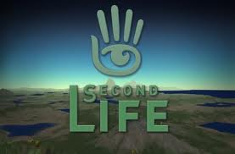
First of all, I want to say that this is the first time I immersed my self in second life; it was a nice experience, but at the beginning I had some problems. These problems made me felt uncomfortable but I did my best and tried to be calm and at the end I realized and understood lot of things that maybe some of my classmates realized since the beginning.
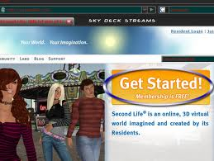
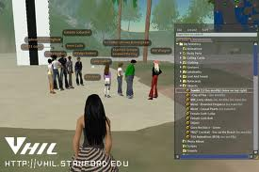
Before proceeding I have to say that I read all the tutorials that our teacher sent to us and also I saw all the videos and I found more about what to do and how in this fantastic world.

Second of all, I did not have the opportunity to explore Second life before I know that maybe that was a big problem, but the thing was that I had problems when I tried to download the program and when finally I did my computer does not have a great video card driver. However, I immersed my self very early, but I could not find anyone else at the arriving part. Therefore, I contacted some of my classmates who helped me a lot. At the end of everything when I almost started to cry and I felt like I could not do anything “Angela Mora” sent me the invitation to go to the Sena’s island and finally I arrived. However, my computer was to slow and my avatar looked like a ghost I could not see anyone just their names, but some minutes later I started to see them. Also, at the end I would see all of them as they really were. I did not take pictures at the beginning to show you how I saw them, but most of them were without clothes, but this was nothing compare with what happed next.
As everything in my immersion I was too late and when I arrived everyone was in a group and Akiles Thespian told me where to go. Following the instructions I went to the first station, but something was interesting with all of the stages and the thing was that I started to ask my self “what they were talking about” and I started to read what they were typing and I felt like nothing, powerless, helpless, and really bad. Anyway, I never left my group and I read everything of they wrote in each station, but I never said anything because I did not understand what they were talking about, I was really lost.
When I was in the last station I suddenly “like a miracle” I started to see everything as never before and I said “Oh gosh what I missed” the thing was that I could not see the questions, I just saw the wall where the questions were posted, but in white. Also, I started to see everyone with clothes and I started to laugh because I felt like I was doing something in Chinese, like I was blind. As I said before I did not take some pictures to show how I saw everything, but at the end I took advantage of the free time and I took many pictures in every single stations to know and finally understand what they were talking about.

Also, I changed my avatar’s appearance, clothing and all their small details here are some pictures of my avatar looked before and how looks now.

Allie Blanche Before. Allie Blanche now.
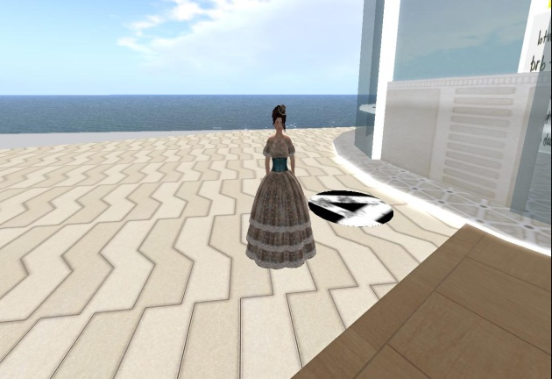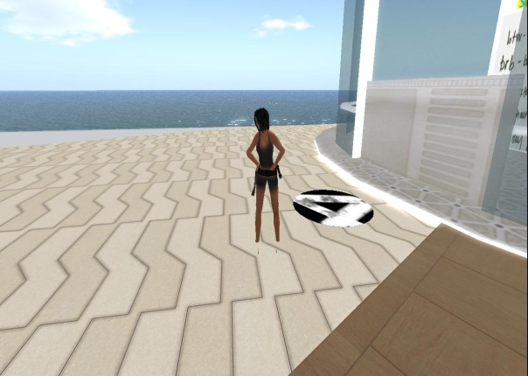
However, I want to make other changes to my avatar because this one looks like me and I want to make it like a wanted to be like the dreamed avatar.

I also want to explain why I named my avatar like “Allie Blanche”. Firstly, because “Allie” sounds like all my friends and my family call me “Ali” it is my nickname and because this is a name of a girl whose performance in a movie was excellent and I love it. Secondly and finally, “Blanche” because is how I have to write my surname in French and I like how it sounds.
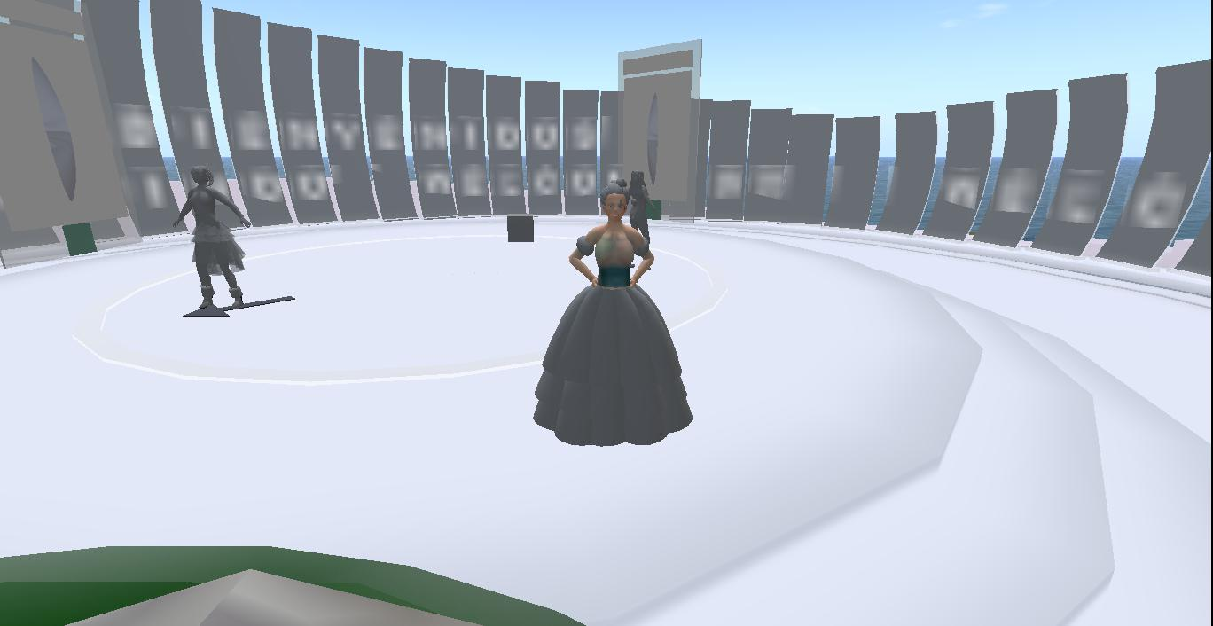
To conclude, I have to say that I was very afraid because of the immersion and the reason is that I like this type of virtual words where you can explore different things and where you can meet different people and learn from them new topics. Nevertheless, I am sure of something and it is that I did not like too much second life but it was because of the problems I had with my computer’s hardware and software.
Nonetheless, I have to say that I have a great experience in this immersion and I am sure that next time it will be better in all the aspects. I loved all the scenarios, the graphics and I went to different island trying to look for everybody and I had the opportunity to talk with some people, and also they added me. Also, looking around everything and understand the reason why is it called second life and it is because it is like a real world and also because you can create whatever you want like build you dream world.
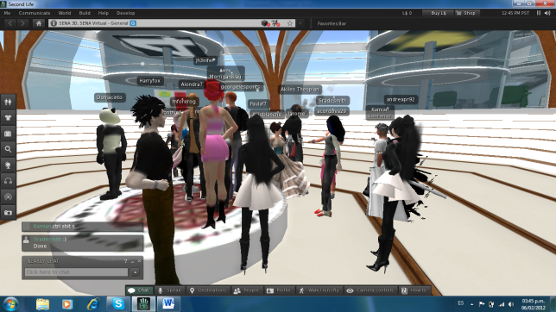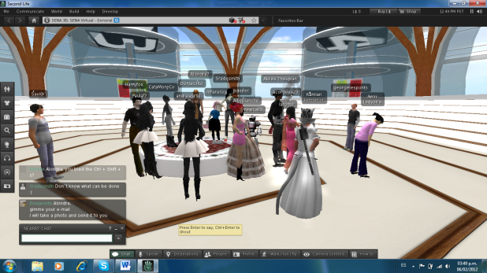

Finally, I want to say that I want to work on this by my own and try to learn as much as possible and that this is a new way to learn different subjects and we have to explore it as much as possible and then we will see the results.
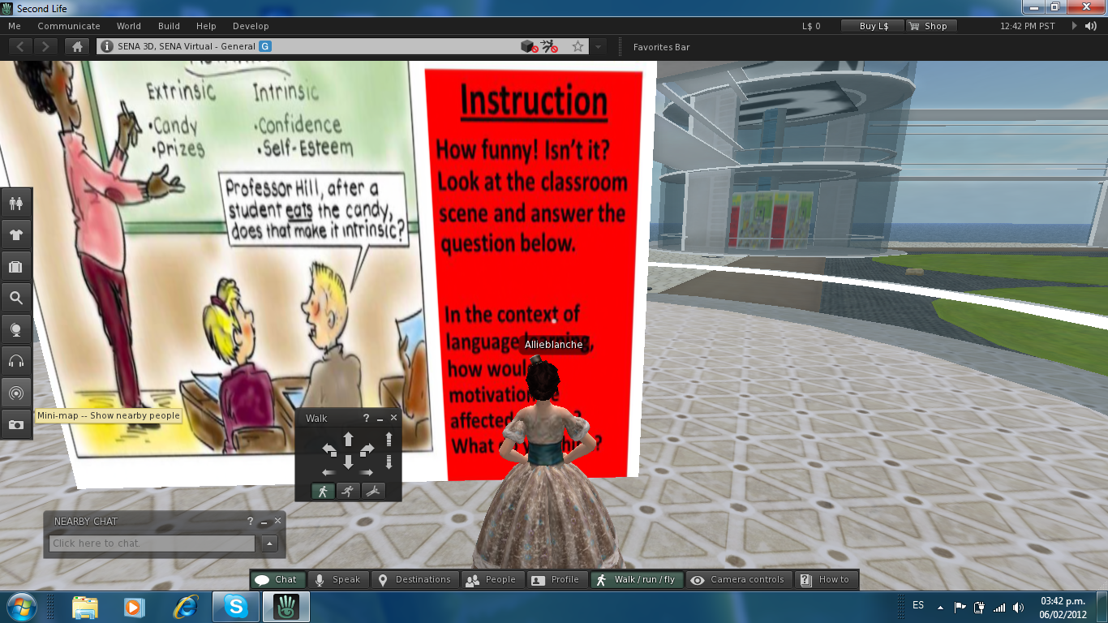
Alison,
I was not aware of all the things you went through but I am so happy knowing how you coped with everything!! Yes, next time you might need a different pc! Thanks for sharing all this!!! Good job and the pics in the other file you sent are really nice.
4.3/5.0
H

