BITACORA ZERO
Ángela Mora.
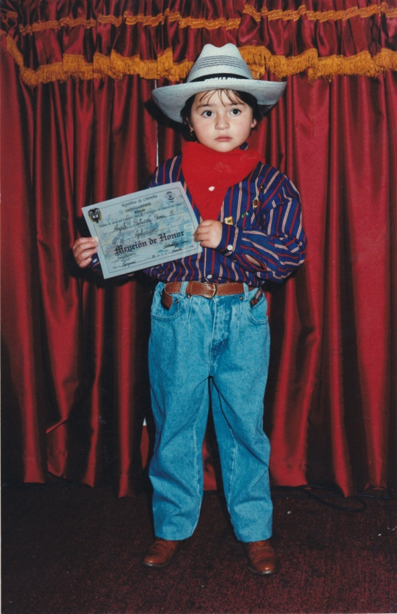
This is me getting my diploma for having finished the grade “B” in my school Liceo Catedral Bilingüe. I wanted to remember this because thanks to several teachers that I had, I decided to become myself a teacher too. It has been a long process since I graduated from school and decided to study Modern Languages. I remember that when I was studying at school we hadn´t had such things as several electrical appliances but still we (me and my friends), managed to learn the basics and even more.
I ask myself why we were able to learn and I think it´s due to the fact that teachers used to go beyond, putting things into practice and creating in us a self confidence that allowed us to believe that we would learn everything not always having the most expensive things or getting several technologies. But as time passed by technologies have taken a great influence in learning and education politics. Nowadays, students have the possibility to use several technological devices that might make easier or at least make the learning process a more pleasant process.
Now students can connect themselves with new technologies, worlds and kinds of cultures. I think that the problem with technologies is that create more dependant kids, they now need technologies for everything and the whole learning process has changed in a very different way.
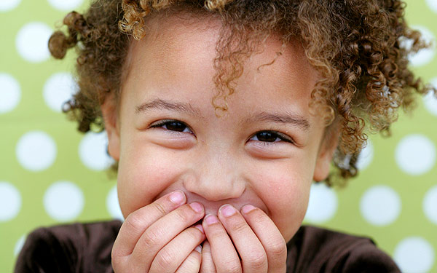

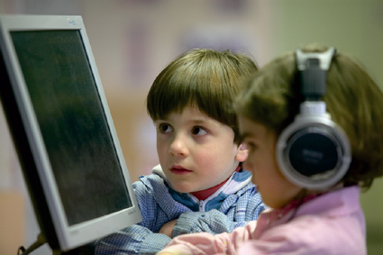But what I really like about new technologies is that they might change several ways o thinking, learning and teaching. As a teacher to be I consider important to be in touch with new technologies, techniques and appliances that might ease the way in which we do our jobs.
Now, about the course I see it as an opportunity to open ourselves to new paths in life, to consider other aspects and to adapt our methodologies to the new demands of this world. I guess this course might be a great compliment for the class preparations and to construct ourselves as modern and even better teachers. Also, it´s important to teach that the new technologies are tools not the basis; we cannot let our kids to be dependant of these devices, we have a great responsibility in our hands, so it´s just about time for us to take charge….

