TOWARDS AN INTENTIONAL DESIGN OF THE INTERNATIONAL HOUSE FOUNDATION STRATEGY,

Background

The International House Foundation Board established a task group of Dr Carla Tromans, Peter Fraser, Peter Forday, Walter Buchanan and Bill Brown to design an innovative framework to inform the governance practices of the Board.

This paper identifies an interdependent set of propositions that balance the best of “what is” with the task groups "best guess "of “what might be”. They are deliberately provocative to the extent that they intend to stretch perceptions of the status quo and challenge common assumptions about the power relationships within and across stakeholder groups.

These provocative propositions have been integrated into a fit for purpose, prototype system designed to

* Access the strengths of increasingly sophisticated stakeholders who hold diverse views about means and ends, evidence and preferences, policy decisions and implementation pragmatics.
* Enable a rapid responses to emergent ,innovative enterprise opportunities,
* Maximise the "soft steering " required to enable networked relationships with boundary partners
* Assure the capacity to command and control the non negotiable accountability/compliance requirements of the legislative base of a company limited by guarantee.

The prototype framework will be presented to the Board together with the decision support evidence that has informed the recommended approach.

The full Board will populate the framework to set the strategic direction for the next twelve months. A participative action learning approach will establish quick feedback loops to adjust the guidelines and protocols as we learn together.

The goal is to establish a highly professional governance system that capitalises on our collective wisdom and delivers the results we were established to produce.

**IDENTITY**  MISSION +VISION + VALUES = long term, stability of purpose & direction

**LOGIC 1** The enterprises we initiate to generate a sustainable resource base & deliver the mission /vision

**STRENGTHS**

**&**

**OPPORTUNITIES**

Provide an agreed focus oncredible/feasible/acceptable focus areas that we hypothesise will deliver the results we want

**ASPIRATIONAL RESULTS**

The domains we think will indicate the effectiveness of our strategy; the metrics of our success

**LOGIC 2** The traditional friend and fun raising activities we choose to commit resources towards.

**LOGIC**  The enabling sub systems that support the delivery of 4.1 & 4.2

The input capabilities & output metrics of **efficiency** & ROI

RECOMMENDATIONS

PROVOCATIVE PROPOSITION IDENTITY

The mission, vision and values of the Foundation are congruent with International House mission and take a bold leap that challenges, motivates and unifies [1] Board practices over a three year period and provides the unique buying proposition for stakeholders.

DECISION SUPPORT EVIDENCE BASE

PURPOSE IH from the constitution

The purpose of the College is to promote international understanding, tolerance and goodwill by providing residential and educational facilities and meeting places that enable university students from a wide range of countries to live together and to interact in a variety of settings.

PURPOSE from Constitution

Make money

Peter Forday's suggestion

Developing intercultural leaders /leadership for tomorrow today.

DECISION REQUIRED

Mission

Vision

Values

PROVOCATIVE PROPOSITION STRENGTHS & OPPORTUNITIES

"No one person holds all the wisdom No one person can do all the work ". We will build on the considerable experience and expertise each member of the board brings to this enterprise. Our networked relationships will extend our influence beyond

organizational boundaries and be flexible enough to grasp profitable opportunities as they arise.

DECISION SUPPORT EVIDENCE BASE

What are our greatest assets? What are the best possible market opportunities?

Meta analysis

<http://cmapspublic3.ihmc.us/rid=1JMB4DG30-WSD62Z-1QZ/PHEEST%20ANALYSIS%20IHFB.cmap>

Theory of change

<http://cmapspublic3.ihmc.us/rid=1JK3N5PBX-ST6532-27DZ/IHFB%20STRATEGIC%20PLANNING%20FRAMEWORK.cmap>

Conscious choice of the elements of design

<http://cmapspublic3.ihmc.us/rid=1JM1FGFD2-1SDZHFS-RHC/CONSCIOUS%20CHOICE%20OF%20AN%20APPROACH.cmap>

Strengths/Opportunities/Aspirations/Results SOAR

PHE*e*ST analysis of the context in which we operate Global/National/Internal

* Political
  + Become the community leaders in the new NFP legislation
  + Maximise connectivity of IH& IHFB through common membership
  + Engage people through meaningful action
* Historical
  + Re-engage the networks of alumni
  + Strengthen relationships with UQ & ANZ as priority boundary partners
* Economic
  + Recognise and reward those who have contributed to date
  + Dream big in financial terms
  + Build enterprises for sustainable income
* *e*-ducational
  + Support the IH student leadership program as a unique selling point
* Social
  + Map the network of core connectors to influential people and potential boundary partners.
* Technological
  + Use cloud computing opportunities

DECISION REQUIRED

Agree on the 5/10 KEY OPPORTUNITIES that will drive our strategy and practice

OPPORTUNITY 1

Engage increasingly sophisticated students , alumni & potential boundary partners/contributors through our leadership and marketing our collective wisdom ..

OPPORTUNITY 2

Become competent in the use of disruptive technologies to provide the means for transformation of marketing/brand exposure / business modeling/internal protocols through Web2 /3 tools and mechanisms

OPPORTUNITY 3

Do business as a social enterprise

OPPORTUNITY 4

Use tight compliance subsystems available within IH as Management tools. To exceed compliance requirements.

Apply the results of the Peter Forday analysis to team operation

PROVOCATIVE PROPOSITION ASPIRATIONAL RESULTS

We are committed to making a difference in the lives of our students though our lifelong connectivity .We have accumulated the resource base ( Money ;capability ;time ) to strengthen the leadership capacity of our student partners We have captured evidence of our success and disseminated it in story, images and agreed metrics of success.

DECISION SUPPORT EVIDENCE BASE

Evaluation methodology options

<http://cmapspublic.ihmc.us/rid=1JGD3JBY7-1D85PNX-1KCT/DOING%20%26%20EVALUATING%20THINGS%20DIFFERENTLY.cmap>

Metrics of success

DECISION REQUIRED

Choose the domains of success (These are directly linked to the opportunities we choose.); Develop the metrics and the collection methodologies.

Output efficiencies

* Financial Performance

**MUST HAVE**

* System compliance
* Action products

Outcome effectiveness

**LIKE TO HAVE**

* Boundary partner relationships
* Strategy delivery

Impact influence

**LOVE TO HAVE**

* Student and boundary partner perceptions

Of IHF value added

PROVOCATIVE PROPOSITION LOGIC

Every member of the IHF Board has been engaged in the design, delivery and review of our enterprise. Each person can articulate why we are in business, who benefits and who makes complementary contributions to our endeavours, what results we actually deliver how we go about our business.

DECISION SUPPORT EVIDENCE BASE

Logic Map

DECISION REQUIRED

Agree to working party prototype presented

PROVOCATIVE PROPOSITION ENABLING SYSTEMS

Form follows function in that we have tight systems that enable action at the levels of

* Access the strengths of increasingly sophisticated stakeholders who hold diverse views about means and ends, evidence and preferences, policy decisions and implementation pragmatics.
* Enable a rapid responses to emergent ,innovative enterprise opportunities,
* Maximise the "soft steering " required to enable networked relationships with boundary partners
* Assure the capacity to command and control the non negotiable accountability/compliance requirements of the legislative base of a company limited by guarantee.

DECISION SUPPORT EVIDENCE BASE

PLAN/DO/REVIEW

* Appreciative Inquiry
* Outcome mapping

DECISION REQUIRED

Agreement about

What subsystems we need to enable Board effectiveness

* Planning ,doing, reviewing cycles
* Financials
* Reporting under requirements of Company Acts
* Agenda setting ,minute taking and reporting
* Enterprise design ,approval, review
* Learning subsystem to build Board capacity
* ??

Who develops and applies these

What resource allocations are necessary to make the sub-systems sustainable?

PROVOCATIVE PROPOSITION CAPABILITIES

Our collective wisdom is our greatest asset. We know what we know and can do; we appreciate the gaps in our capabilities and engage boundary partners to help deliver our mission and vision.

DECISION SUPPORT EVIDENCE BASE

Capabilities

DECISION REQUIRED

Who else can help us deliver?

STAGES OF GROUP DEVELOPMENT

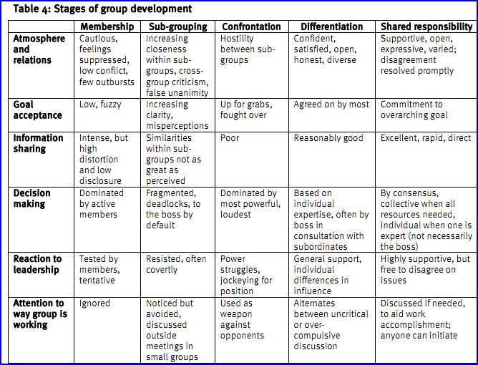

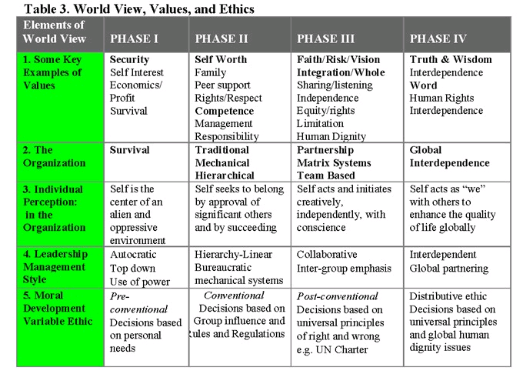

SOAR

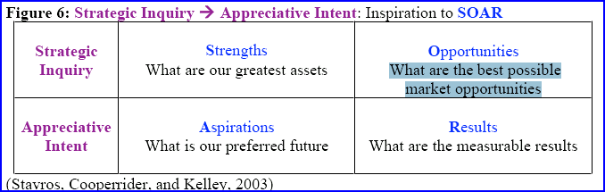

METRICS OF SUCCESS

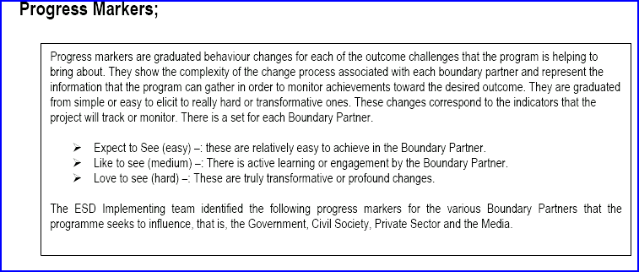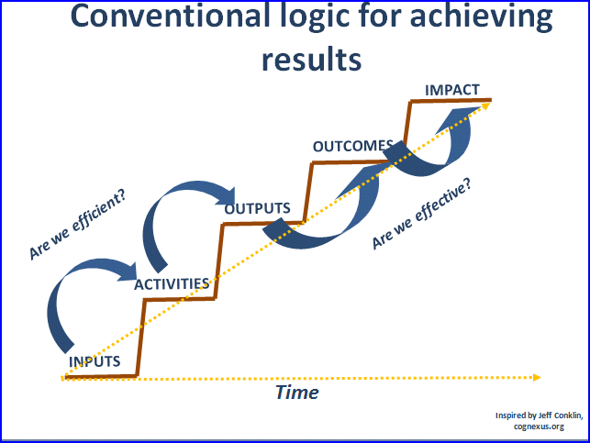

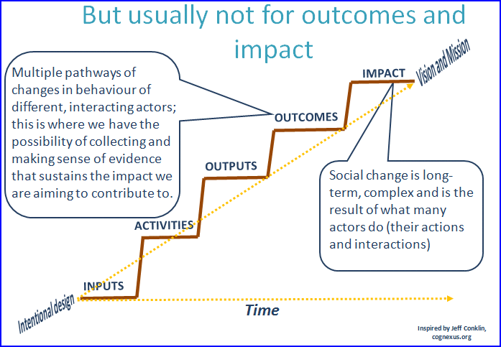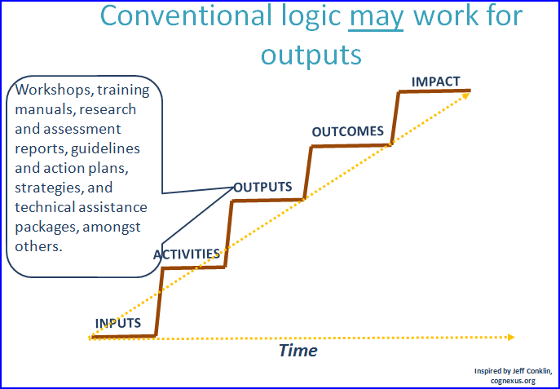

LOGIC MAPPING

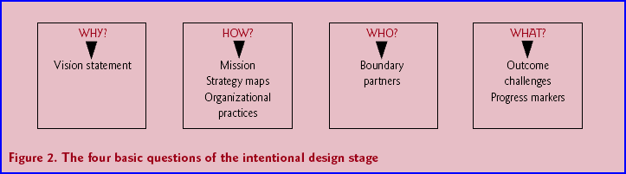

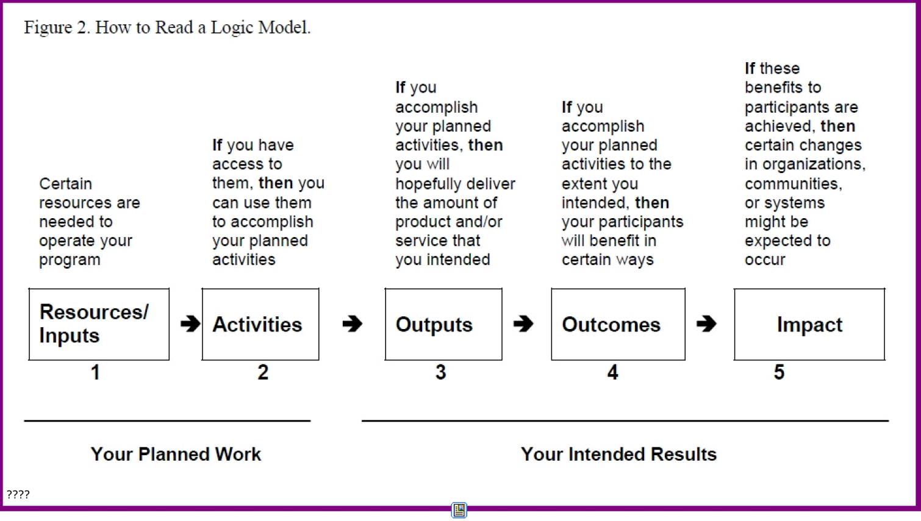



PLAN/DO/REVIEW

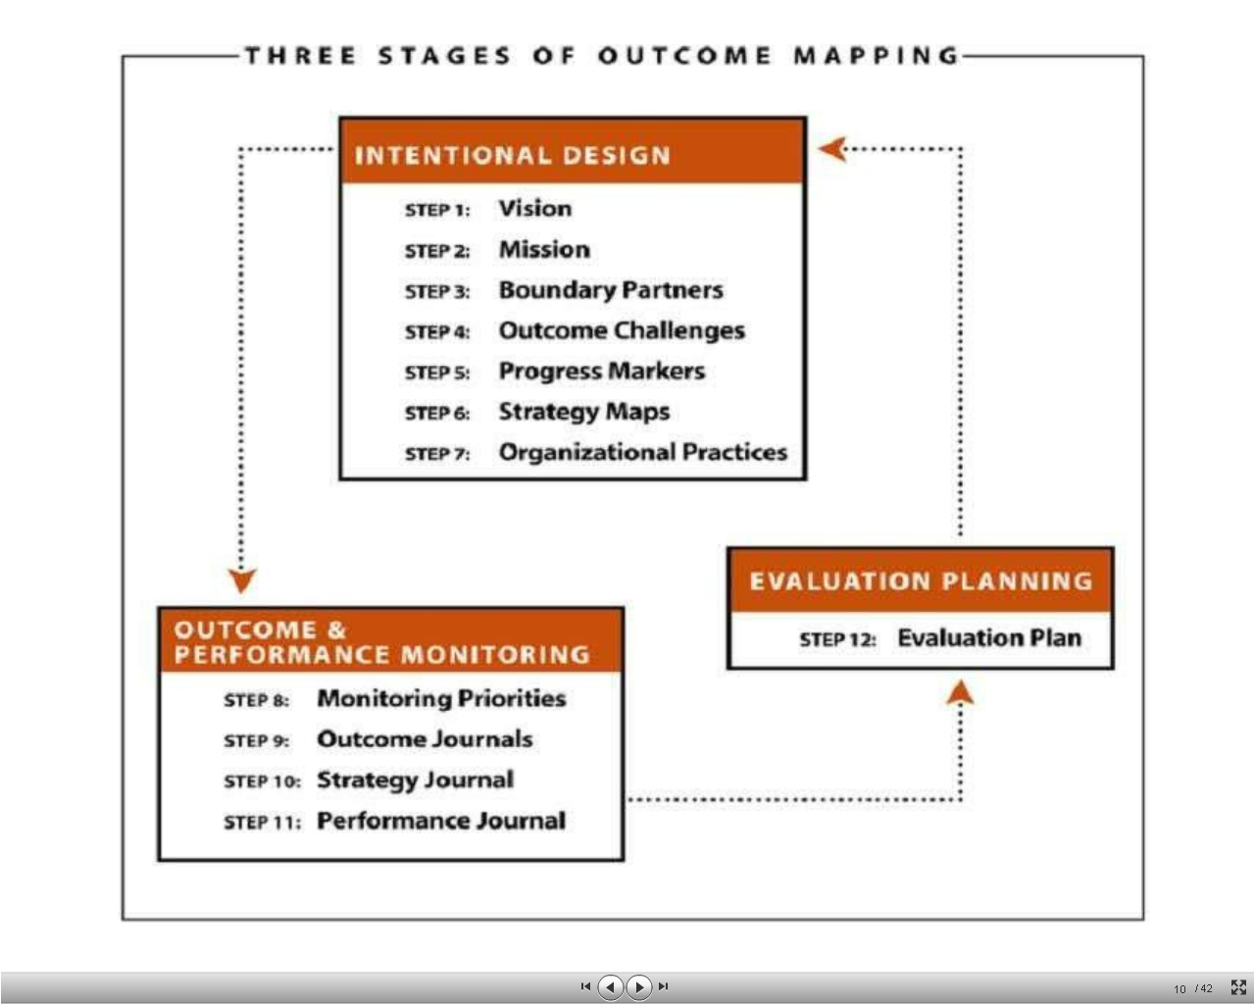

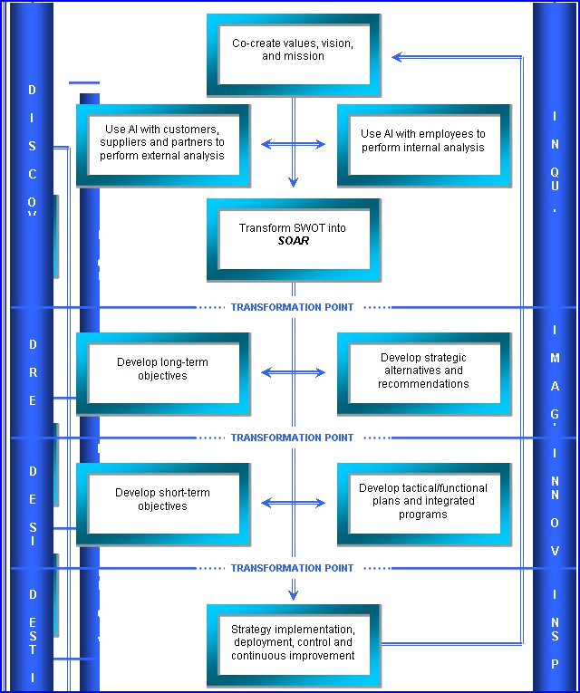

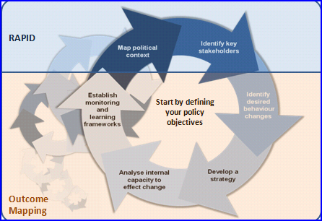

CAPABILITIES

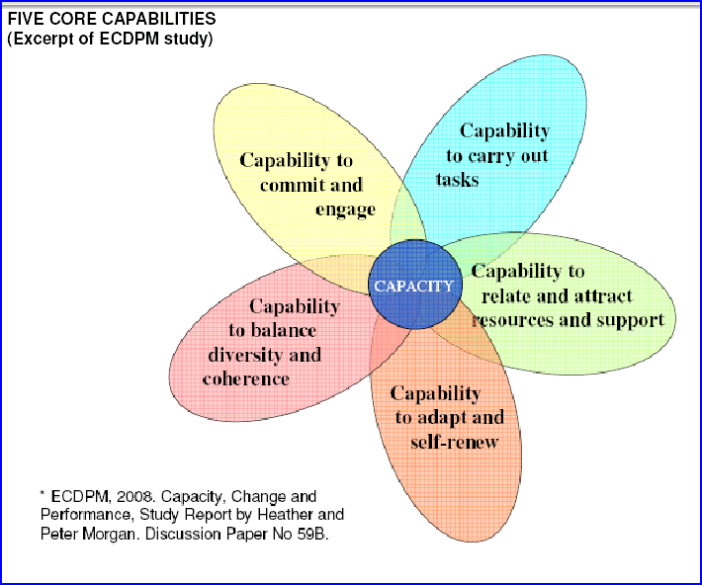

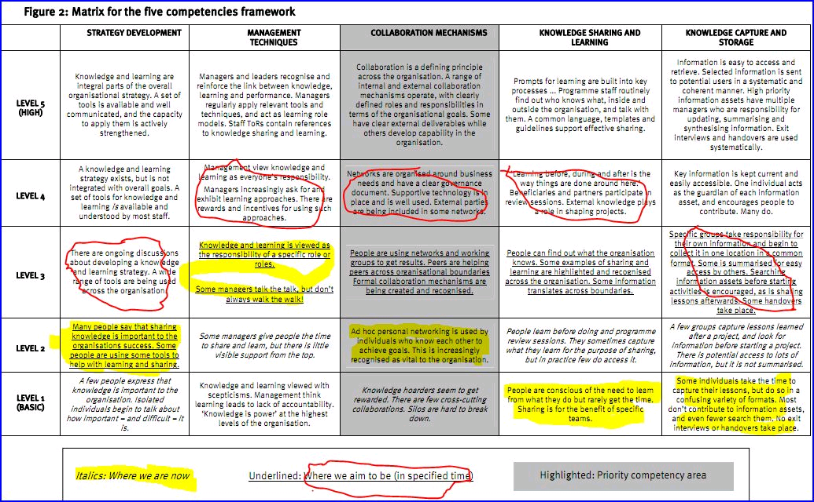

1. Non-profit Boards and Governance Review™

   **SOAR don't SWOT: Asset Based Strategic Planning**

   *Wednesday, June 13, 2007* by Cassandra O’Neill, MA