Microsoft Office Groove Server 2007
March 2006

Table of Contents

Cover is for
position only

Introduction to Microsoft Office Groove Server 2007 2
Team Collaboration in the New World of Work 2
The IT Challenge 2
The Office Groove Platform 3
Office Groove 2007 4
Office Groove Server 2007 5
Office Groove Server 2007 Manager 7
Navigating Office Groove Server 2007 Manager 7
Setting Up Your Groove Domains 9
Setting Up Domain Groups 10
Managing Groove Identities 10
Managing Groove Devices 11
Establishing Identity and Device Policies 11
Backing Up Groove User Accounts 12
Monitoring Groove Usage 13
Office Groove Server 2007 Relay 15
Permitting Offline Use 16
Traversing Firewalls 16
Optimizing Bandwidth 17
Installing Multiple Relay Servers 18
Provisioning Users to an Office Groove Server 2007 Relay 20
Groove Server 2007 Data Bridge 21
How Groove Server Data Bridge Works 22
Options for Client-Side Integration 22
Types of Solutions 23
Rich Client-Side Applications 23
Basic Client-Side Forms 25
Groove Server Data Bridge and Business Process Solutions 27
Archiving Groove Workspace Data 29
Resources 30

Introduction to Microsoft Office Groove Server 2007
Welcome to Microsoft® Office Groove® Server 2007, the new suite of Microsoft server software and tools for deploying, managing, and integrating Office Groove 2007 software in your enterprise. The purpose of this guide is to familiarize you with the tools and functionality of Office Groove Server 2007. In addition, this guide provides some best practice guidelines for managing and deploying Office Groove 2007 in your organization.

Team Collaboration in the New World of Work
The work environment is not what it was 10, or even 5, years ago. With more powerful software and computing systems, wireless connectivity, and a proliferation of mobile devices from laptop computers to Smartphones, the nature of work has changed. The workplace is no longer simply an office or a building; it can be any place we create, share, and store information and collaborate with employees, partners, and customers on projects and business processes.
In such a dynamic work environment, it is harder for small teams of employees to collaborate together directly and effectively. Teams rely on a combination of e-mail, phone calls, instant messages, and in-person meetings to work together, but such a mix of tools and methods makes it more difficult to keep all team members in sync on project progress. To ensure maximum team productivity and impact, teams require a single tool that enables them to work together dynamically—in real time and over time—regardless of their locations, organizational affiliations, or network connections.

The IT Challenge
Team collaboration requirements in this new world of work create pressure for IT administrators to accomplish two seemingly contradictory goals: enable employees to work freely and autonomously with colleagues, partners, and customers on and off the corporate network, while maintaining centralized control to help ensure the integrity and confidentiality of the organization’s intellectual property. Pressure to manage IT costs makes it even more difficult to accomplish these goals.
Accommodating direct collaboration and information-sharing between colleagues on the same local area network (LAN) with greater security is a straightforward process. It’s a much greater challenge to facilitate real-time and asynchronous information flow between team members across multiple networks and organizations. Why? Because most enterprise infrastructure and collaboration technologies employ a centralized architecture that presumes team members are all on the same network with always-on, high-bandwidth access to information assets. In the new world of work, these conditions are often the exception, not the norm.
So what types of solutions are available for connecting team members to each other and key information in today’s decentralized work environment? Virtual private network (VPN) software can be provided to off-site employees, but isn’t practical for vendors or partners who need access to only select systems or information. Building extranets in the perimeter zone (also known as the demilitarized zone) for off-site employees and third parties is another option, but can introduce security risks and raise infrastructure and administration costs. A third option—particularly for small numbers of users or teams—is to invest in a workspace collaboration solution hosted by an application service provider (ASP). While ASP solutions do not require infrastructure upgrades, they often have hidden costs for additional users or data storage and raise security concerns because data is stored on third-party servers. And none of these solutions addresses the challenges faced by users who need to work while disconnected or intermittently connected to a network.
Now there is a viable, attractively priced, and effective solution that addresses all of these challenges, while offering IT the centralized management and administration they require.

The Office Groove Platform
Conceived and designed specifically to support this new decentralized work style, the Microsoft Office Groove platform provides information workers with the autonomy they require to collaborate effectively in the new world of work while helping to ensure that IT administrators can maintain central control.
The Office Groove platform consists of two primary components: the Office Groove 2007 client software that installs directly on each user’s desktop or laptop computer, and the server software that extends Office Groove 2007 client software with centralized management, data relay, and data integration services. While all enterprise customers will deploy Office Groove 2007 client software, customers have two choices for server software based on the size of deployment and required functionality: Microsoft Office Groove Server 2007, which is installed and maintained by the customer, or Microsoft Office Groove Enterprise Services, which is hosted and maintained entirely by Microsoft.
The purpose of this guide is to familiarize you with the capabilities of Office Groove Server 2007.

Office Groove 2007
Before explaining the capabilities of Office Groove Server 2007, it’s necessary to first explore the architecture of Office Groove 2007 and the role it plays in the Office Groove platform. Office Groove 2007 is a rich, Windows®-based client software application that enables small teams to work together dynamically and share information inside collaborative workspaces right on their computers. Within a workspace, teams can outline plans interactively, jointly design projects, distribute support materials for analysis, and share ideas by voice or text chat.
The rich client and decentralized premise of Office Groove 2007 is what sets it apart from other collaborative workspace software solutions. All application logic and data in this Win32 application is stored locally on the desktop of each member of a workspace, providing users with full access to content and functionality whether they are online or offline. Users create workspaces right on their computers without worrying about server space or IT assistance. They invite their team members to the workspace with a few clicks, creating a trusted, private group within or across the organization. Office Groove 2007 employs its own public key infrastructure (PKI) to help ensure data remains protected on users’ desktops as it crosses wireless or wired networks.
When in a workspace, a team can work together in context in real time and over time, whether they’re together in the same conference room or in different organizations around the world. Every change made by each member of the workspace is automatically encrypted, transmitted to the desktops of other members, and synchronized into the appropriate workspace.
The core value of Office Groove 2007 is that it enables project teams to collaborate easily and work purposefully together toward their goals anywhere, anytime, with anyone, without having to think about keeping themselves or the team up to date and without being dependent on extensive IT support.
For a more detailed overview of the user features and benefits of Office Groove 2007 client software, please see the Microsoft Office Groove 2007 Product Guide.

Office Groove Server 2007
While Office Groove 2007 itself enables teams of information workers to collaborate directly in a more secure, decentralized manner, Office Groove Server 2007 provides the server software and tools that IT organizations require to deploy, manage, and integrate Office Groove 2007 across the enterprise.
Office Groove Server 2007 can help your organization:
- Centrally deploy, manage, and monitor usage of Office Groove 2007 client software.
- Efficiently extend Office Groove 2007 software usage across firewalls and network boundaries.
- Take advantage of existing infrastructure investments by integrating Groove workspaces with line-of-business applications and data sources.

Office Groove Server 2007 is a set of three separately installed server software applications running on Microsoft Windows Server™ 2003 that extend Office Groove 2007 client software with specific centralized services. The three application components of Office Groove Server 2007 are:
- Office Groove Server 2007 Manager, which provides management services such as account configuration, policy setting, and usage reporting.
- Office Groove Server 2007 Relay, which provides data relay services to transmit data between Office Groove 2007 clients when they cannot connect directly.
- Office Groove Server 2007 Data Bridge, which provides a centralized platform for integration services to enable developers to build custom solutions that connect Office Groove workspaces with centralized enterprise data sources.
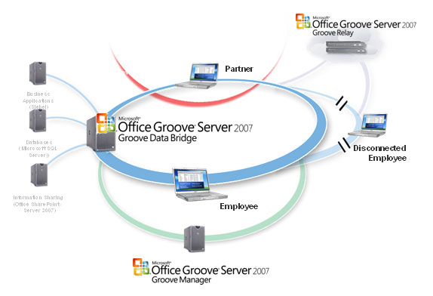

Office Groove 2007 Deployed with Office Groove Server 2007
This remainder of this guide will familiarize you with the features and functions of each of these three components of Office Groove Server 2007.

Office Groove Server 2007 Manager
While the rich desktop client architecture of Office Groove 2007 helps increase individual and team productivity, it might appear at first glance that these benefits are outweighed by the challenge IT administrators face in managing additional desktop software. Not so. Office Groove Server 2007 Manager, in combination with Office Groove 2007 software, enables you to empower teams to collaborate across organizational boundaries—on and off the network—without sacrificing centralized management and control.
Office Groove Server 2007 Manager provides a central location for managing all aspects of large Office Groove 2007 client software deployments. A single Web-based console provides easy access to all related management and administration activities, including directory integration, security policies and PKI integration, user identity management, component management, data recovery, reporting, and auditing.
Using Office Groove Server 2007 Manager, you can:
- Create and manage Office Groove 2007 user identities and devices.
- Set up multiple domains or subdomains across your enterprise, each with its own device, tool, and component policies.
- Create secure and trusted relationships between Office Groove 2007 user domains.
- Support corporate security policies, including password management.
- Control Office Groove 2007 software component access and tool usage.
- Monitor and audit Office Groove 2007 usage across your enterprise.
- Assign Office Groove Server 2007 Relays within domains.

Navigating Office Groove Server 2007 Manager
You can access Office Groove Server 2007 Manager from a single, easy-to-use Web-based administrative interface accessible from a URL that is defined when you install the software. The Office Groove Server 2007 Manager interface consists of a navigation pane and a set of tabs and tools that you can use to perform specific tasks.
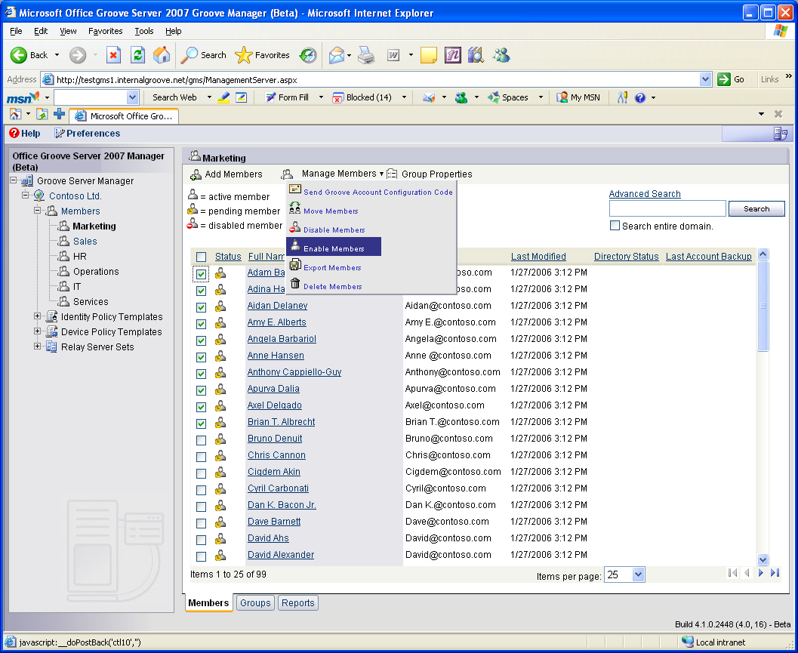
A View of a User Domain Group from Office Groove Server 2007 Manager

Tip:
You can help secure your Office Groove Server 2007 Manager administrative Web interface by enabling Secure Sockets Layer (SSL) encryption and setting the server SSL port to 443.

Setting Up Your Groove Domains
Just like Windows clients on your general network, Office Groove 2007 clients are organized into domains with their own unique parameters. Office Groove Server 2007 Manager provides an initial domain, and you can add more domains as necessary.
Each Office Groove 2007 domain includes the following types of objects:
- Groups. All Office Groove 2007 user and device information is organized into domain groups.
- Managed identities. To help ensure proper use of Office Groove 2007 within your organization, each user must have a managed identity. Managed identities help ensure proper use of Office Groove 2007 software based on defined policies.
- Managed devices. Each device or computer in your enterprise that has a copy of Office Groove 2007 installed on it should be registered in your domain. Registering each Office Groove 2007 client device with Office Groove Server 2007 Manager enables you to manage those devices through centralized device usage and security policies.
- Device and identity policy templates. Managed identities must obey all device and identity policies, including account backup, peer authentication, password creation, and cross-domain certification.
- Server sets. You can register each of your Office Groove Server 2007 Relays with Office Groove Server 2007 Manager and then assign them to specific users or domains in your enterprise. (For more information on Office Groove Server 2007 Relay, see Office Groove Server 2007 Relay.)
Tip:
It’s a good idea to establish administrative roles that govern physical access to Office Groove Server 2007 Manager, access to server-level controls, and access to domain controls.
Each Office Groove Server 2007 Manager domain you create and configure is independent of other domains; users and devices in one domain cannot access another domain’s Office Groove Server 2007 Relays or be governed by its policies. However, you can use cross-domain certification in Office Groove Server 2007 Manager to establish a trust relationship among domains, within or across your organization.

Setting Up Domain Groups
Office Groove Server 2007 Manager provides an initial top-level domain group for your use. You can add additional administrator-defined subgroups or individual Groove users to this domain, as required. For example, you may want to organize all the users in your organization by department. In this case, you could put all the members of your sales department into one group and all the members of your marketing department into another group. The members of each group would share the specific identity and device policies you set up for that group. Of course, you can add users to multiple groups as appropriate.

Managing Groove Identities
You must set up a managed identity for each Office Groove 2007 user in your organization before you can apply security and usage policies to those users. Though you can create managed identities manually, it’s more efficient to synchronize your Active Directory® directory service or other LDAP-compliant directory service with Office Groove Server 2007 Manager to automatically create Office Groove 2007 identities.
When you establish an identity for a user, Office Groove Server 2007 Manager associates that identity with an account configuration key. The key is used to securely configure the user identity on a computer that has Office Groove 2007 installed. After the key is activated on the client device, Office Groove 2007 uses the associated identity information from Office Groove Server 2007 Manager to create the managed identity for that user. This process provides the user with access to any domain products, including the Office Groove Server 2007 Relay assigned to that domain, and is subject to all policies and rules set for that domain.
Tip:
Use auto-activation to automatically configure user accounts on first use. In conjunction with Active Directory integration, auto-activation can simplify the deployment process for your users.

Managing Groove Devices
Certain security policies (such as password creation rules and component download restrictions) require device management. This process securely registers a specific client device (such as a laptop or desktop) with a managed domain in Office Groove Server 2007 Manager. Devices are registered automatically during the account configuration process, or by manually distributing a registry key to the device. As soon as the registry key is downloaded, the device becomes subject to the policies you have established.
Each managed device periodically connects to Office Groove Server 2007 Manager in order to receive provisioning, policy, and managed contact updates and to report Office Groove 2007 usage events. You can also configure domain properties to remove devices from the domain after 90 days of inactivity.

Establishing Identity and Device Policies
To simplify the process of managing Office Groove 2007 identities and devices, Office Groove Server 2007 Manager provides templates for default usage and security policies that you can apply to all the group members and devices in a particular domain. User identity policy templates include policies for client account backup scheduling and peer authentication, among others. Device policy templates include policies related to multiple account creation, importing accounts, and bandwidth usage.
Office Groove Server 2007 Manager supplies an initial identity and device policy template for each domain. You can modify the policies set in these templates or create new templates, and then apply the templates to designated management domain groups or users. These policies apply only to managed Office Groove 2007 users and devices—those defined on Office Groove Server 2007 Manager as belonging to a specific management domain group. Policies do not affect unmanaged Office Groove 2007 users.
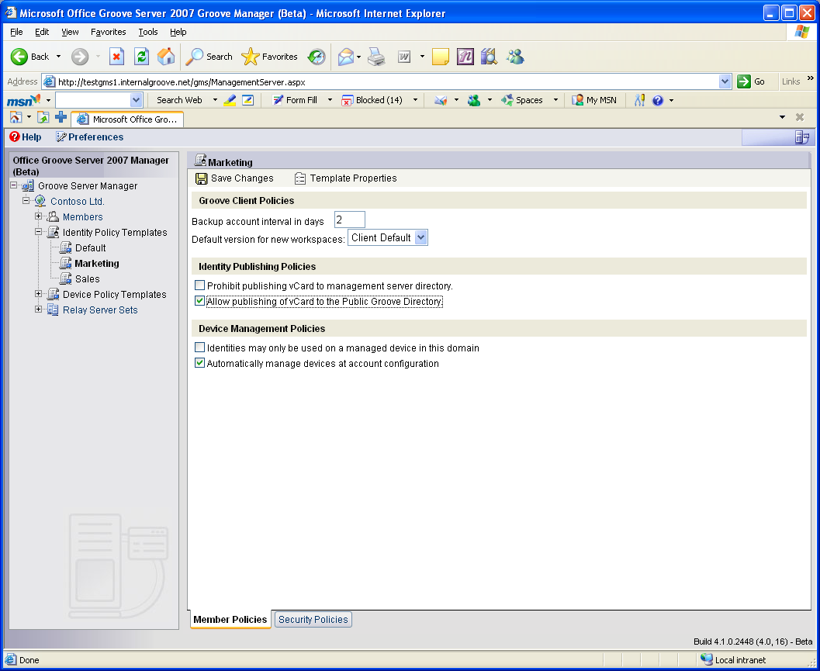

Setting Policies with Office Groove Server 2007 Manager

Backing Up Groove User Accounts
Because Office Groove 2007 is desktop software, Office Groove Server 2007 Manager helps prevent users from losing all their workspace data and account information when a laptop is lost or a desktop computer needs to be replaced. The integrated account backup identity policy enables automatic account backup at specified intervals for users in a selected domain. Office Groove Server 2007 Manager will back up each user’s contacts list, workspace lists, identities and contact information, and identity policies. When a user is unable to access his or her account, the administrator can either download a backup copy of the member’s account or send an e-mail message to the user with a copy of the account. After the user has restored the account, the user can fetch the data in his or her workspaces from any member of the workspace who is online.

Tip:
One of the most important device policies to enable is password reset. This policy provides a mechanism for users to request a password reset, a service that is frequently needed. Administrators can opt to have the password reset occur automatically or by administrator intervention.

Monitoring Groove Usage
To ensure that you are using your IT dollars wisely, it’s important to monitor how tools are being used in your organization. If you want to assess how much and how well Office Groove 2007 is being used, you can monitor and track usage directly from Office Groove Server 2007 Manager. Easy-to-use reporting tools enable you to monitor user, workspace, and tool activity in your domain. Usage statistics include the number of workspaces created by users and the amount of time users spend in a particular workspace or workspace tool. You can also monitor domain events, such as the addition of a new group to a domain.
If your organization requires that you capture specific data and activities within Office Groove workspaces, you can also take advantage of the integrated audit service in Office Groove Server 2007 Manager. With a simple managed device policy, you can instruct each Office Groove 2007 client to log specific data and events and automatically export the information to a specified Microsoft SQL Server™ database. Audit logs are quickly encrypted on clients upon event creation, and are decrypted only after arrival at the SQL Server database to help ensure a highly secure auditing environment.

Tip:
Be sure to install antivirus software on all computers running Office Groove Server 2007 Manager and Office Groove 2007. On Office Groove Server 2007 Manager, script blocking is disabled by default to help ensure proper operation of the Active Server Pages.

Office Groove Server 2007 Relay
When two or more Office Groove 2007 users are connected to the same LAN at the same time, they will transmit data bidirectionally in a peer-to-peer manner without requiring a central server. But in today’s decentralized work environment, this scenario is often the exception, not the norm. For starters, teams of information workers often include members that are not on the same network or even in the same time zone. Secondly, any member of a team that is mobile cannot receive incoming communications and data from other Office Groove 2007 clients. Finally, in today’s digital world, information workers often need to share large files, such as presentations, CAD drawings, or multimedia files. Direct transmission of large files between Office Groove 2007 clients would degrade computer performance and consume valuable bandwidth.
In a managed environment, a dedicated Office Groove Server 2007 Relay helps to ensure uninterrupted, efficient, encrypted data transfer between Office Groove 2007 users regardless of where they are, whether they’re online or offline, and whether they’re sharing a small or large amount of data. As a result, teams can work together effectively in their Office Groove 2007 workspaces anywhere, anytime, on any network. Most importantly, Office Groove Server 2007 Relay facilitates data transmission without requiring any user action or significant IT infrastructure upgrades, helping to preserve individual and team productivity while minimizing IT costs.
At its core, Office Groove Server 2007 Relay is a lightweight store-and-forward service that facilitates data transmission between Office Groove 2007 clients when:
- One or more recipient clients are offline.
- One or more recipient clients are behind a firewall.
- One client is transmitting a large amount of data or is on a slow connection.
Each of these scenarios is described in more detail in the sections that follow.

Permitting Offline Use
In today’s work environment, it’s quite common that one or more members of a work team may be disconnected from a network for periods of time, even if just for a few moments or hours. Personal productivity can suffer because users have to remember to download key documents and information before they disconnect and to upload changes to their team members when they reconnect. Office Groove 2007, with the help of Office Groove Server 2007 Relay, eliminates these productivity delays by enabling team members to work in Office Groove 2007 workspaces whether they are connected to a network or not. Workspace data will remain synchronized even if no two members of a workspace are online concurrently.
When an Office Groove 2007 user makes a change to a workspace, such as an edit to a file, the user’s Office Groove 2007 client will attempt to send the data packet to all other members of the workspace in a direct peer-to-peer manner. If one team member is offline, the sender client will encrypt the data, contact the Office Groove Server 2007 Relay or Groove Enterprise Services Relay associated with the recipient, and deposit the encrypted data packet in a queue. When the offline recipient next connects to the Internet, the recipient’s Office Groove 2007 client will automatically retrieve the data packet from the relay queue. The recipient’s Office Groove 2007 client will then decrypt the message—the change to the file—and synchronize it into the appropriate workspace.
The key value of Office Groove Server 2007 Relay is that it keeps Office Groove 2007 clients synchronized transparently, without requiring users to replicate, upload, or download changes. Each time an Office Groove 2007 user logs on while connected to the Internet, the Office Groove 2007 client will contact the Office Groove Server 2007 Relay, download all changes made by all workspace members while the user was offline, and upload the offline work to be queued for other offline members—automatically.

Traversing Firewalls
With the increase in outsourcing, home-sourcing, and employee travel, members of work teams are often separated by corporate firewalls. Team productivity can suffer because not all members of a team can connect to the same systems and information. Office Groove 2007, with the help of Office Groove Server 2007 Relay, automatically facilitates data transmission between Office Groove 2007 users even when those users are separated by firewalls that will not allow inbound communications.
When an Office Groove 2007 user saves a document to a workspace, for example, the Office Groove 2007 client will attempt to establish an outbound connection with the other members of the workspace in order to push this new file to them. If an impeding firewall prevents a direct connection with one or more recipients, the user’s Office Groove 2007 client will automatically attempt to redirect the data transfer to the assigned Office Groove Server 2007 Relay for that member. (Each Office Groove 2007 client is in frequent communication with its assigned relay, either on port 2492, the default listening port used by Office Groove Server 2007 Relay and Groove Enterprise Services Relay, or on ports 443 or 80.) If necessary, the Office Groove 2007 client will encapsulate its messages within an HTTP data stream, so that it can be transmitted to that member’s relay across port 80.
Tip:
Office Groove 2007 client data transfers are most efficient if the client can establish outbound communications on port 2492 or 443. At a minimum, all Office Groove 2007 clients need to be able to establish outbound communications to their Office Groove Server 2007 Relay on port 80 in order to synchronize workspace data. Configure your firewall and proxy ports accordingly.

Optimizing Bandwidth
Sharing large files can be one of the greater challenges confronting team members in the new world of work. Between e-mail file size restrictions and sometimes slow connections, valuable time is often lost just trying to exchange large files. Office Groove 2007, with the help of Office Groove Server 2007 Relay, enables users to easily and efficiently share large files with their team members even when they’re on slow connections.
Office Groove Server 2007 Relay optimizes bandwidth usage by “fanning out” large data transmissions between Office Groove 2007 clients across a network. Fanout is a process for conveying a stream of data from one Office Groove 2007 client to Office Groove Server 2007 Relay or Groove Enterprise Services Relay for efficient replication and distribution to other Office Groove 2007 users.
Tip:
You can achieve significant bandwidth savings by encouraging teams that need to work together on a large number of files to use Office Groove 2007 instead of e-mail to transfer the changes.
If a user adds a 3-MB file into a Groove workspace, for example, the user’s Office Groove 2007 client will assess the size of the file, the speed of the connection, and the number of recipients in the workspace. If fanout is deemed to be more efficient than sending the file directly in a peer-to-peer manner, the Office Groove 2007 client will send a single copy of the file to the user’s Office Groove Server 2007 Relay, which then groups copies of the file by the Office Groove Server 2007 Relay or Groove Enterprise Services Relay of the recipients and distributes copies to each of the recipients in the most efficient manner possible. If a recipient Office Groove 2007 client is online, it will download the file from its associated Office Groove Server 2007 Relay or Groove Enterprise Services Relay and quickly synchronize it into the file in its workspace. If the client is offline, it will download the file the next time it connects to the network.
The Office Groove 2007 client also has bandwidth-optimizing technology built in, operating independent of Office Groove Server 2007 Relay. As users make changes to data in their workspaces, each Office Groove 2007 client sends only the smallest necessary unit of change—a change to file or an updated forms record, for example—across the network. Thus, between the Office Groove 2007 client and Office Groove Server 2007 Relay, teams are assured an efficient experience in sharing and working together on files and data of any size.

Installing Multiple Relay Servers
While a single Office Groove Server 2007 Relay can support up to 10,000 concurrent users, it’s a good idea to install multiple servers if you are supporting a large client base and you want to help ensure redundancy in case of equipment failure. You can assign multiple Office Groove Server 2007 Relays to a domain from Office Groove Server 2007 Manager, and prioritize them in server sets for use by domain members. When an Office Groove 2007 client sends data to a domain member that has access to multiple Office Groove Server 2007 Relays, the client attempts delivery to the first server. If that server is down, it attempts delivery to the next server in the series, and so on.

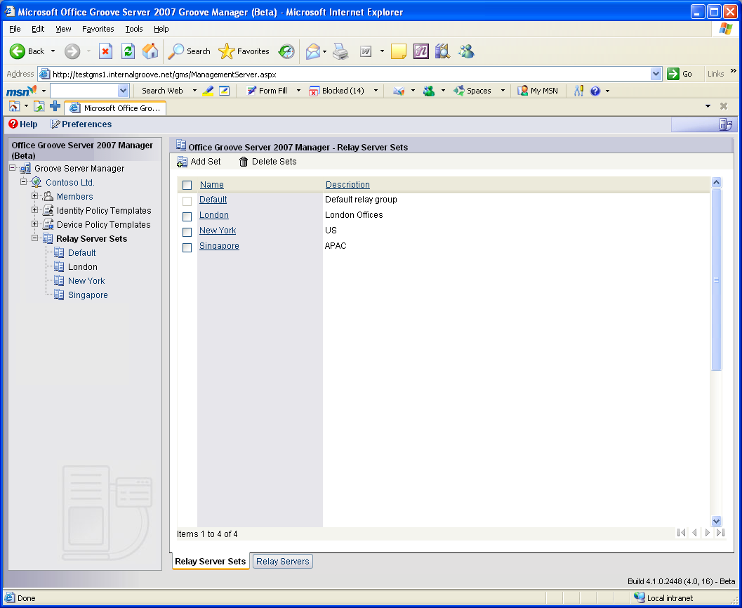
Configuring Relay Server Sets with Office Groove Server 2007 Manager
Tip:
To help ensure maximum performance, install your Office Groove Server 2007 Relay on a clean computer. Also, be sure to install Office Groove Server 2007 Relay on a computer with redundant hard disk drive capability to help protect the operating system and data from damage or loss as a result of hardware component failure. Do not try to install Office Groove Server 2007 Relay on a domain controller, a Web server such as Microsoft Internet Information Services (IIS), or a computer with any client/server application.

Provisioning Users to an Office Groove Server 2007 Relay
You can assign or provision your Office Groove 2007 managed users to a specific Office Groove Server 2007 Relay when you make them members of a domain. If you deploy only one Office Groove Server 2007 Relay, then all of your managed users will automatically be assigned to that server. If you deploy more than one Office Groove Server 2007 Relay, users are automatically assigned to the server or set of servers that you specify for their domain. The Office Groove Server 2007 Relay to which a user is assigned is noted in that user’s identity information.

Office Groove Server 2007 Data Bridge
Business teams using Office Groove 2007 often create and share data right within their shared workspace. However, sometimes a team needs to share and work with data from a centralized business system and database. The team may need to pull data into a Groove workspace from that central repository, or they may need to move data that they have gathered and tracked in the Groove workspace into a repository when a project ends. Manually exporting or importing data from an Office Groove 2007 workspace into a centralized data source can be time-consuming and error prone, and prevents automatic information updates.
With Office Groove Server 2007 Data Bridge, the third component of Office Groove Server 2007, you can link your line-of-business applications and centralized databases with Groove workspaces to reach the places your project teams work and the people they work with. Specifically, Office Groove Server 2007 Data Bridge solutions help ensure that:
- Teams can access and update structured business data right inside Groove workspaces on their computers, helping to increase both personal and team productivity.
- Customers, partners, suppliers, and other third parties have security-enhanced access to enterprise business data without requiring VPN software or extranet access, helping to reduce costs.
- Data in enterprise line-of-business applications and systems automatically stays in sync with the latest team updates, helping to increase organizational efficiency and enhance the value of existing infrastructure.
With Office Groove 2007 and Office Groove Server 2007 Data Bridge, solutions that were once considered too complex and expensive to deliver can now be deployed rapidly and cost-effectively.

How Office Groove Server 2007 Data Bridge Works
Office Groove Server 2007 Data Bridge acts as a single point of integration between project teams working in Groove workspaces and centralized data sources such as Web servers, databases, and enterprise applications, including enterprise resource planning (ERP), customer relationship management (CRM), sales force automation (SFA), and knowledge management systems. Office Groove Server 2007 Data Bridge provides a scalable, always-available platform that exposes Office Groove 2007 client-side Web Services APIs; you can use these Web Services APIs to develop custom solutions. You can develop an integration solution that “pushes” data from enterprise systems into Groove workspaces, “pulls” data from Groove workspaces into an enterprise system, or “synchronizes” data in both directions between a workspace and a centralized data source or sources. You can specify how often Office Groove Server 2007 Data Bridge integrates data between the workspace and existing enterprise systems or databases based on your team’s needs.

Options for Client-Side Integration
Though several Office Groove 2007 workspace tools provide documented Web Services APIs that can be exposed through Office Groove Server 2007 Data Bridge, the two most common tools used for integration solutions are Office Groove Forms and Office Groove InfoPath® Forms. Both tools comprise fielded data sets and are well suited for data mapping and integration with enterprise databases and other table-based or record-based systems.
Office Groove Forms
The Office Groove Forms tool enables both power users and developers to build custom forms applications that are specifically designed for a team’s needs. The development and deployment of an Office Groove Forms application occurs within the workspace itself. As soon as the final design is completed and saved to the workspace, the forms and designated data views become accessible to the team (based on their permissions in the workspace).
Office Groove InfoPath Forms
Office Groove InfoPath Forms is a new tool in Office Groove 2007 that brings together the richness and ease of use of the Office InfoPath Forms designer with the power of Office Groove Forms. It enables teams to collect rich, XML-based structured data within a Groove workspace. Rather than designing the forms within the workspace, users can import predesigned Office InfoPath 2007 Forms solutions into a Groove workspace, where team members can then fill out and share forms records.

Types of Solutions
Depending on the team and organizational requirements, Office Groove Server 2007 Data Bridge—together with either Office Groove Forms or Office Groove InfoPath Forms—can be used to create a variety of integration solutions. Three of the most common types of solutions include:
- Rich, client-side applications for gathering, tracking, and manipulating data in a workspace. Office Groove Server 2007 Data Bridge is used to periodically integrate resulting data with an enterprise system or database.
- Basic client-side forms that extend data and basic functionality from server-based collaborative applications, such as Microsoft Windows SharePoint® Services, into a Groove workspace. Office Groove Server 2007 Data Bridge periodically synchronizes the team updates with the server-based application.
- Process-specific solutions that extend a core business process directly to a Groove workspace. Office Groove Server 2007 Data Bridge synchronizes data bidirectionally between one or more enterprise applications and performs specific activities based on defined events.

Rich Client-Side Applications
In many organizations, small teams working on projects need to gather, view, and track basic structured information about their ongoing work, such as how they spend their time, what they have accomplished, and related project data. It’s beneficial to have this capability right in the workspace to keep the team’s work in context, and to enable multiple members of the workspace to update and manipulate data simultaneously. Sometimes it is also important for that data to be accessible outside of the workspace, for example, to help ensure that the data becomes part of a larger corporate record. Office Groove Forms and Office Groove Server 2007 Data Bridge provide the ideal solution for this type of situation. Consider the following two examples.
Status Reports
A global product design team, composed of both employees and design partners, is working together in a Groove workspace on the development of a new product. The project, which spans six months, requires that each member complete a weekly status report for other team members to view and track. The executive management team also needs to view these status reports on a periodic basis to monitor the project’s progress. It isn’t practical, though, to include every member of the executive team in this and all the other active Groove workspaces in the organization. Instead, the project team uses an Office Groove Server 2007 Data Bridge solution.
Working with the IT department, the team creates a Status Report form using Office Groove Forms. The fields and data views are customized specifically for the parameters of the project’s scope. The project manager in the workspace can then view the resulting fielded data in a variety of ways, such as by date, by team member, by opportunity, or by overdue items. Using Office Groove Server 2007 Data Bridge, the IT department links the Status Report form with the organization’s Windows SharePoint Services intranet. As new reports are created, Office Groove Server 2007 Data Bridge automatically uploads the team’s reports to the intranet, where the executive management team can view them to ensure that the project remains on track.
Opportunity Tracking
All the teams within a public relations agency use Groove workspaces to coordinate ongoing work and collaborate with their clients. A core component of each team’s work is tracking new press opportunities, which takes place in the team’s workspace so that multiple team members can contribute as the opportunity progresses. The resulting data captured in each workspace also must be rolled up into the agency’s systemwide press database to become part of the agency’s larger corporate record.
To accomplish this goal, the public relations firm’s IT department creates a Press Opportunity Tracking application using Office Groove Forms. The fields, the data views, and the look and feel of the form are all customized for the specific agency’s requirements. Using Office Groove Server 2007 Data Bridge, the IT department then links the Press Opportunity Tracking form within each client workspace with the agency’s internal press database. As new records are created, Office Groove Server 2007 Data Bridge automatically logs each team’s updates to the database, where they become part of the agency’s record and can be viewed by executive management.

Basic Client-Side Forms
Many organizations use Web-based applications for collecting structured information, such as time sheets, expense reports, and procurement requests. In some cases, it’s beneficial to have a subset of the functionality of these applications available to small project teams inside a Groove workspace, so that team members can easily update these forms and see each other’s updates. In addition, it’s important that this data is synchronized with the internal applications periodically so that the larger corporate records are accurate and up to date. Office Groove InfoPath Forms and Office Groove Server 2007 Data Bridge provide the ideal solution for this business requirement. Consider the following two examples.
Time Sheets
A midsized consulting firm uses Office Groove 2007 to collaborate on client projects, but has an internal system based on Windows SharePoint Services and InfoPath for capturing consultants’ time sheets. Because the consultant teams travel often and regularly work at client sites, it’s difficult for them to submit their time sheets in a timely manner. As a result, the team members working on each project lack visibility into each other’s work, and the internal time-tracking system can become out of date.
The consulting firm’s IT department has already created an InfoPath time sheet form. With Office Groove 2007, that solution can be imported into each client’s project workspace. The form is identical to the Web-based form with which the consultants are familiar. The consultants can now submit their time sheets right in their project workspace, with Office Groove 2007 synchronizing the data in a peer-to-peer manner among the consultants’ laptops while they are on-site with a client. Using Office Groove Server 2007 Data Bridge, the IT department then links the time sheet form within each client workspace with the firm’s internal tracking system. As soon as one member of a workspace gains a connection to the Internet, Office Groove Server 2007 Data Bridge integrates all time sheets with the internal system, where they can be viewed by executive management.
Knowledge Sharing and Discovery
The research and development department of a midsized pharmaceutical company often works on dozens of investigative projects to discover potential new drug compounds. Because each project involves a number of third parties, including hospitals, research labs, and partner companies, the department uses Office Groove 2007 to overcome the organizational boundaries that might otherwise impede effective teamwork. However, it’s important that the management, product development, and R&D departments can keep track of all project developments to identify domain experts, discover knowledge and best practices, and learn from others’ successes.
The IT department creates a form with Office InfoPath 2007 to collect key metadata about the purpose and contents of each Groove project workspace, such as contact information about the team, the type of compound under investigation, high-level early trial results, and the status of key milestones. The project leader then imports the form into the Groove workspace and periodically updates data as the project progresses. Office Groove Server 2007 Data Bridge automatically synchronizes new data in the form with the company’s “R&D Dashboard” Web application based on Windows SharePoint Services. The management team can then choose to be alerted by e-mail each time new data is available on the Dashboard, and can easily scan all the projects at a glance right from a browser. As a result, the project teams can focus on their individual projects, while Office Groove Server 2007 Data Bridge automates knowledge sharing and discovery across the department. With a click of the mouse, anyone can request an invitation to one or more of the Groove workspaces right from the Dashboard application if they want to engage the team directly.

Business Process Solutions
All organizations have established core business processes such as enterprise resource planning (ERP), supply chain management (SCM), customer relationship management (CRM), and sales force automation (SFA), each automated by enterprise software applications. While business processes are highly transactional in nature, each contains human-driven components that stand to benefit from collaboration tools such as Office Groove 2007.
Office Groove Server 2007 Data Bridge is an ideal solution for linking business processes with information workers inside Groove workspaces to streamline process execution, particularly when the collaboration that occurs spans organizations, time zones, and networks. With process-centric solutions, Office Groove Server 2007 Data Bridge not only integrates data between a Groove workspace and a centralized system, but also honors process workflows that require certain steps to occur when an activity or “trigger event” has been completed. Process-oriented solutions can be developed using Office Groove Forms or Office Groove InfoPath Forms, depending on the requirements. Consider the following two examples.
Sales Quoting
A large medical device manufacturer has a defined sales process for selling and fulfilling new orders of MRI machines. The company’s IT department has implemented an InfoPath-based solution running on Windows SharePoint Services that the sales force uses to track customer leads and their status. After the customer prospect has provided a request for proposal (RFP), much information needs to be synthesized by the manufacturer to prepare the quote because of the complexity of the MRI solution. Upon receiving the RFP, a pre-sales logistics team comprising employees and trusted partners must collaborate to survey the customer site, gather requirements, and develop an accurate proposal.
When the customer prospect provides an RFP, the salesperson at the device manufacturer fills out a new InfoPath form on the Windows SharePoint Services site. The form includes an option to select “Develop Proposal,” which is a trigger event that requires a cross-functional team to assemble quickly and collaborate on the proposal. Office Groove 2007 and Office Groove Server 2007 Data Bridge become an integral part of this process workflow. A custom integration application built on Office Groove Server 2007 Data Bridge accesses the appropriate enterprise systems to identify the right participants from each functional area and other pertinent information. Next, the custom application generates a Groove workspace and prepopulates it with a copy of the InfoPath form describing the opportunity, a copy of the RFP document, and other relevant data from the CRM system. Office Groove Server 2007 Data Bridge then automatically invites the appropriate participants to join the workspace. The team comes together quickly across organizations and networks to review a common set of documents and information, and works collaboratively to deliver a prompt response to the customer’s RFP. All their work is automatically synchronized back to the appropriate systems, helping to avoid errors, save time, and ensure an accurate quote.
Emergency Management
A state emergency management center (EMC) uses Office Groove 2007 to collaborate with other agencies and law enforcement when critical situations such as tornadoes or hurricanes arise. The decentralized architecture of Office Groove 2007 is well suited for supporting responders in the field who are mobile and may lack continuous connectivity to the Internet, especially during disaster situations.
In addition to using the basic collaboration tools in Office Groove 2007, the EMC’s IT department uses the Office Groove Forms tool to develop templates for the types of information they need to capture about locations, emergency response assets, and requests from the field. Given the complexity of emergency management, multiple workspaces are used for the various agencies or response functions. Using Office Groove Server 2007 Data Bridge, the IT department develops an integration application that connects the various Office Groove Forms in each workspace with its centralized incident management system.
Responders from various agencies can complete the forms right at the disaster site while disconnected from the Internet. Whenever they can gain an Internet connection or can access satellite connectivity provided by one of the EMC’s mobile command center vehicles, their reports are synchronized with the rest of the workspace participants and with the incident management system, helping to ensure a common operating picture for all responders and EMC personnel during an emergency.
Tip:
For maximum effectiveness, be sure to set up Office Groove Server 2007 Data Bridge on a computer that is available and connected to the network 24 hours a day, seven days a week.

Archiving Groove Workspace Data
In addition to developing rich data integration solutions, you can use Office Groove Server 2007 Data Bridge to archive data contained in Groove workspaces. The Archive Service is provided as an out-of-the-box service with Office Groove Server 2007 Data Bridge. When the Archive Service is included as a member of a workspace, snapshots of the workspace and all of its data are written out to storage media on a configurable schedule. Depending on the size of the workspace and the specific hardware configuration, a single Office Groove Server 2007 Data Bridge can provide archive services for a few thousand workspaces.

Resources
Groove Server 2007 Overview
Top 10 Reasons to Deploy Groove Server 2007
Groove Server 2007 FAQ
Groove Server 2007 System Requirements

This document is developed prior to the product’s release to manufacturing, and as such, we cannot guarantee that all details included herein will be exactly as what is found in the shipping product. The information contained in this document represents the current view of Microsoft Corporation on the issues discussed as of the date of publication. Because Microsoft must respond to changing market conditions, this document should not be interpreted to be a commitment on the part of Microsoft, and Microsoft cannot guarantee the accuracy of any information presented after the date of publication. The information represents the product at the time this document was printed and should be used for planning purposes only. Information is subject to change at any time without prior notice.

This document is for informational purposes only. MICROSOFT MAKES NO WARRANTIES, EXPRESS OR IMPLIED, IN THIS DOCUMENT.

© 2006 Microsoft Corporation. All rights reserved.

Microsoft, Active Directory, Groove, InfoPath, the Office logo, SharePoint, Windows, and Windows Server are either registered trademarks or trademarks of Microsoft Corporation in the United States and/or other countries. All other trademarks are property of their respective owners.

